Name:……………………………………..………...……………Adm No………………………...

Signature:…………….……………
CHEMISTRY
THEORY Date:………………….......
COMBINED PAPER
JULY/AUGUST 2016
TIME: 2 HOURS

TOP EVALUATION EXAM – 2016

FORM 1
Chemistry
2 hours

INSTRUCTIONS TO CANDIDATES
- Write your name and admission number in the spaces provided.
- Mathematical tables and non-programmable calculators may be used.
- Attempt all the questions in the spaces provided.
- ALLOW working MUST be clearly shown.

For Examiner’s Use
QUESTION | MAXIMUM SCORE | STUDENT’S SCORE
1 | 08
2 | 08
3 | 11
4 | 10
5 | 08
6 | 12
7 | 16
8 | 07
TOTAL | 80

This question paper has 9 printed pages. Check to ascertain that all pages are printed as indicated and that no question is missing.

- (a) What is a mixture? (1 mark)
…………………………………………………………………………………………………………………………………………………………………………………………………………………...
(b) Name the method of separation you would use in separating: (3 marks)
- Beans from maize beans mixture.
……………………………………………………………………………………………….
- Water from sand.
……………………………………………………………………………………………..
- Cream from milk.
…………………………………………………………………………………………..
(c) State four areas in which the knowledge of chemistry is used. (4 marks)
……………………………………………………………………………………………………………………………………………………………………………………………………………………………………………………………………………………………………………………………………………………………………………………………………………………………………………………………………………………………………………………………………………………
- (a) Define the following terms as used in chemistry. (5 marks)
- Drug
……………………………………………………………………………………………………………………………………………………………………………………
- Medicine
…………………………………………………………………………………………………………………………………………………………………………………..
- Prescription
…………………………………………………………………………………………………………………………………………………………………………………….
- Dosage
……………………………………………………………………………………………………………………………………………………………………………………
- Over the Counter drug
…………………………………………………………………………………………………………………………………………………………………………………….

(b) Name three illegal drugs that are normall abused. (3 marks)
………………………………………………………………………………………………………………………………………………………………………………………………………………………………………………………………………………………………………………………………
- (a) State three reasons why most chemistry laboratory apparatus are made of glass. (3 marks)
………………………………………………………………………………………………………………………………………………………………………………………………………………………………………………………………………………………………………………………………
(b) Name each of the apparatus below and state what it is used for. (8 marks)
(i) 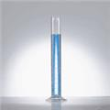
…………………………………………………………………………………………………………………………………………………………………………………………………………………..
(ii) ………………………………………………………………………………………………………………………………………………………………………………………………………………….
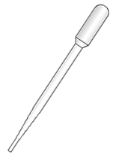
(iii)……………………………………………………………………………………………………………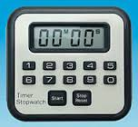
- ………………………………………………………………………………………………………………………………………………………………………………………………..
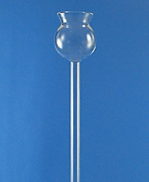
Thistle funnel.Direct liquid solution into stoppered container.
- Draw a Bunsen burner and label all its parts. (3 marks)

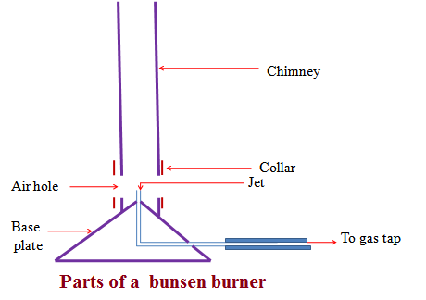
(b) Outline the procedure for lighting a Bunsen burner. (4 marks)
……………………………………………………………………………………………………………………………………………………………………………………………………………………………………………………………………………………………………………………………………………………………………………………………………………………………………………………………………………………………………………………………………………………………………………………………………………………………………………..
(c) State three characteristic differences between luminous and non-luminous flame (3 marks)
…………………………………………………………………………………………………………………………………………………………………………………………………………………………………………………………………………………………………………………………………………………………………………………………………………………………………………………………..……………………………………………………………………………………..
- Study the setup below of an experiment and then answer questions that follow.
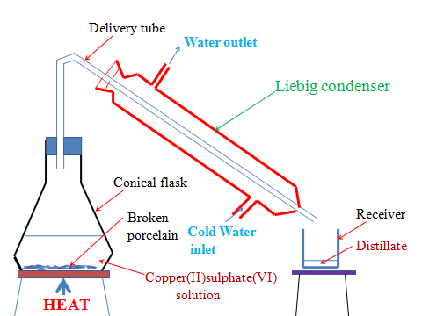
- State the purpose of the experiment. (1 mark)
…………………………………………………………………………………………………………………………………………………………………………………………………………………..
- Give a reason for each of the following.
- The solution is heated. (1 mark)
………………………………………………………………………………………………………………………………………………………………………………………………….
- Using pieces of broken porcelain (2 marks)
…………………………………………………………………………………………………………………………………………………………………………………………………….
- Liebig condenser has a cold water inlet near the receiver and cold water out let. (1 mark)
…………………………………………………………………………………………………………………………………………………………………………………………………
- Other than b(ii) above, what else can be used. (2 marks)
……………………………………………………………………………………………………………………………………………………………………………………………………………………………..

- Name the method of separation illustrated by the setup. (1 mark)
…………………………………………………………………………………………………………

- The procedure below was followed when using commercial indicators to determine acidic and basic/alkaline and neutral solutions
Procedure
- Place 5cm3 of the solutions in the table below.
- Add three drops of litmus solution to each solution.
- Repeat with phenolphthalein indicator, methyl orange, and bromothymol blue.
- Complete the table by showing the colour change. (6 marks)
Substance/  solution | Indicator Used
 | Litmus | Phenolphthalein | Methyl orange | Bromothymol  blue
wood ash | Blue | Pink
soap solution |  | Pink |  | Blue
ammonia solution | Blue |  | Yellow
sodium hydroxide |  |  | Yellow | Blue
hydrochloric acid

- Ferdinand placed 5cm3 of dilute hydrochloric acid in a small test tube. He then added 1cm length of polished magnesium ribbon. He stoppered the test tube using a thump. After this, he lit a wooden splint and Placed it on top of the stoppered test tube. He then released the thump stopper.
- Write down two observations he made. (2 marks)
………………………………………………………………………………………………………………………………………………………………………………………………………………………………………………………………………………………………………………………
- Why wouldn’t Ferdinand use copper in stead of magnesium ribbon? (2 marks)
……………………………………………………………………………………………………………………………………………………………………………………………………………….

- Write a word equation for the reaction that happens. (2 marks)

- Sodium carbonate is reacted with an acid A to produce chloride B, gas C and water.
- Name: (3 marks)
- Acid A
……………………………………………………………………………………….
- Chloride B
………………………………………………………………………………………..
- Gas C
………………………………………………………………………………………
- State the observations made in the experiment when:
- Test tube holding the mixture is directed into lime water. (2 marks)
……………………………………………………………………………………………………………………………………………………………………………………………..
- Write word equation of the reaction in above. (2 marks)

- Write word and chemical equations for the reactions if the following would have been used in stead of sodium carbonate(acid remains the same). (6 marks)
- Copper carbonate

- Potassium hydrogen carbonate

- Sodium hydrogen carbonate

- State three physical properties of acids. (3 marks)
…………………………………………………………………………………………………………………………………………………………………………………………………………………………………………………………………………………………………………………………….
- (a) Giving the approximate their percentage composition by volume, identify two main gases present in the atmosphere/air. (2 marks)
………………………………………………………………………………………………………………………………………………………………………………………………………………………………
b) the set up apparatus below was used to find out the composition of air that support combustion.

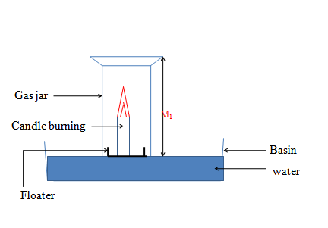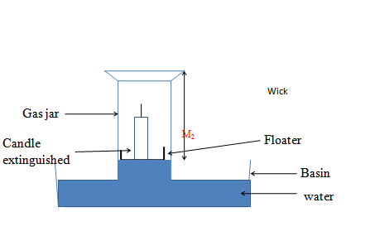

(i) What happens to the candle after a while? (1 mark)
…………………………………………………………………………………………………………………………………………………………………………………………………………………..
- If the length of M1 is 20 cm, M3 (length of the glass jar after igniting candle) is 12 cm while M2 is 15cm, determine:

I. the active part of the air. (2 marks)

II. The inactive part of the air. (2 marks)

