GATITU MIXED SECONDARY SCHOOL
END OF TERM ONE EXAM CAT 1 2015
FORM ONE
CHEMISTRY
NAME…………………………………………………………. ADM NO: ………….CLASS: …………
INSTRUCTIONS
- Write your name and admission number in the spaces provided above.
- Answer all the questions in the spaces provided
- What is chemistry? (2 marks)
……………………………………………………………………………………………………………………………………………………………………………………………………………………………………………………………………………………………....
- a) Name the two types of flames produced by the Bunsen burner. (2 marks)
…………………………………………………………………………………………………………………………………………………………………………………………………………………………………………………………………………………………….... b) Which of the two flames should be used for heating purposes in the laboratory? Give a reason why. (2 marks)
…………………………………………………………………………………………………………………………………………………………………………………………………………………………………………………………………………………………….... c) Give FOUR differences between the two flames named in 1(a) above. (4 marks)
………………………………………………………………………………………………………………………………………………………………………………………………………………………………………………………………………………………………………………………………………………………………………………………………………………………………………………………………………………………………………………………………………………………………………………………………
- Outline five roles of chemistry in the society (5 marks)
- ……………………………………………………………………………………………………………………………………………………………………………………
- ……………………………………………………………………………………………………………………………………………………………………………………
- ……………………………………………………………………………………………………………………………………………………………………………………
- ……………………………………………………………………………………………………………………………………………………………………………………
- ……………………………………………………………………………………………………………………………………………………………………………………
- Identify the following apparatus and state their uses. (8 marks)

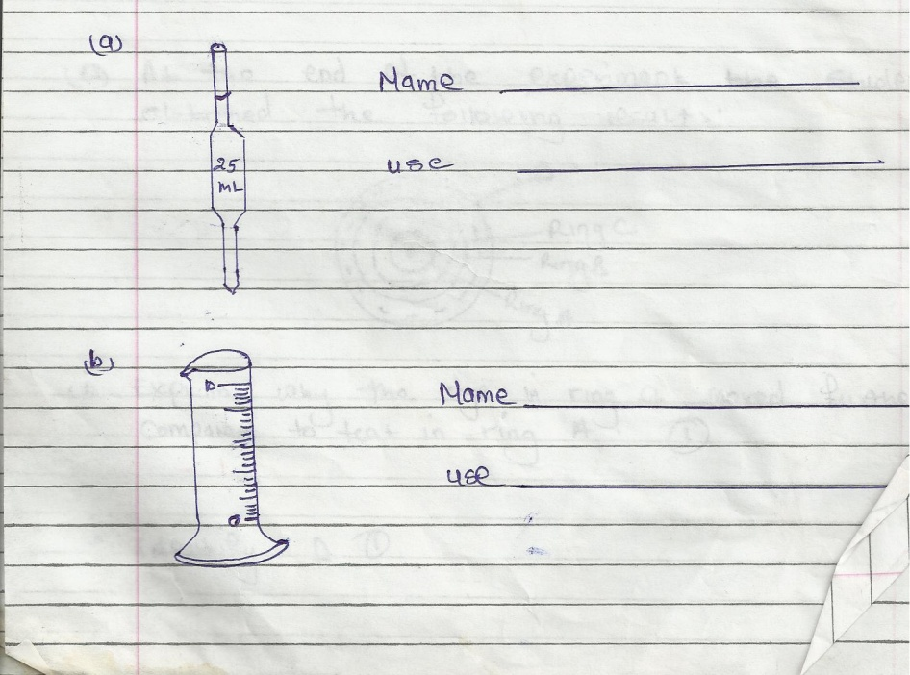
c)  d) | Name  ____________________  Use _____________________  Name ______________________  Use _________________________

- Give three reasons why laboratory apparatus are made of glass (3 marks)
- ……………………………………………………………………………………………………………………………………………………………………………………
- ……………………………………………………………………………………………………………………………………………………………………………………
- ……………………………………………………………………………………………………………………………………………………………………………………
- a) What is matter? (1 mark)
………………………………………………………………………………………………………………………………………………………………………………………………
b) State the three states of matter. (3 marks)
……………………………………………………………………………………………………………………………………………………………………………………………………………………………………………………………………………………………………………………………………………………………………………………………………………………………………………………………………………………………………………………………………………………………………………………………
- i) What is a mixture? Give three examples of mixtures (4 marks)
………………………………………………………………………………………………………………………………………………………………………………………………………………………………………………………………………………………………………………………………………………………………………………………………………………………………………………………………………………………………………………………………………………………………………………………………
ii) List any three methods used to separate mixtures. (3 marks)
………………………………………………………………………………………………………………………………………………………………………………………………………………………………………………………………………………………………………………………………………………………………………………………………
iii) Name the methods by which the following mixtures could be separated (4 marks)
- Kerosene and water
………………………………………………………………………………………………………………………………………………………………………………………………
- Iron fillings from sulphur powder.
……………………………………………………………………………………………………………………………………………………………………………………………....
- Ethanol from a solution containing a mixture of alcohols.
………………………………………………………………………………………………………………………………………………………………………………………………
- Pure water from sea water.
………………………………………………………………………………………………………………………………………………………………………………………………

- The figure below shows the effect of temperature on ice. Study it and use it to answer the questions that follow.

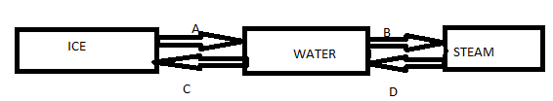
- Name the processes labeled A, B, C and D (4 marks)
………………………………………………………………………………………………………………………………………………………………………………………………………………………………………………………………………………………………………………………………………………………………………………………………………………………………………………………………………………………………………………………………………
- Name the process where ice changes directly to steam without undergoing any liquid state.(1 mk)
………………………………………………………………………………………………………………………………………………………………………………………………………………
- Give four substances that undergo the process named in (b) above (4 marks)
- ……………………………………………………………………………………………………………………………………………………………………………………………..
- ………………………………………………………………………………………………………………………………………………………………………………………………
- ……………………………………………………………………………………………………………………………………………………………………………………………...
- ……………………………………………………………………………………………………………………………………………………………………………………………..

