NAME: ………………………………………………………………………

ADM NO.:…………………………………………………………………

DATE: ………………………………………………………………………

COUNTY MULTILATERAL EXAMINAITON

CRE

FORM ONE

TERM TWO 2016

TIME: 2 ½ HOURS

SECTION A (60 MKS)
- List three physical characteristics of soii. (3mks)

- State four reasons for discouraging burning as a land clearing method. (4mks)

- Outline four main reasons for maintenance of farm tools and equipments. (4mks)

- Name three underground water sources. (3mks)

- Give three disadvantages of shifting cultivation. (3mks)

- State four reasons for carrying out primary cultivation. (4mks)
(4mks)

- List four sets of livestock tools that are used together as a pair in their operation.

- Name three surface irrigation methods. (3mks)

- List four factors that influence soil formation. (4mks)

- Name the tool used to perform each of the following. (4mks)
- Cutting thing sheets of metal______________________________
- Cutting wood along grains_________________________________
- Holding milk on transit and storage
- Pruning soft branches of coffee

- State four ways in which drainage is important as a land reclamation method. (4mks)

- Give two ways by which soil PH can be increased. (2mks)

- Name three territory operations that can be carried out on a seedbed. (3mks)

15. Distinguish between the following pairs of tools in their function. (4mks)
a) Drenching gun and bolus gun.

- Cold chisel and wood chisel.

16. State three agricultural practices that pollute water. (3mks)

17. Give four factors that contribute to minimum tillage. (4mks)

SECTION B (40 MKS)
18. Study the diagram of land preparation operation below and answer the questions that follow.
N
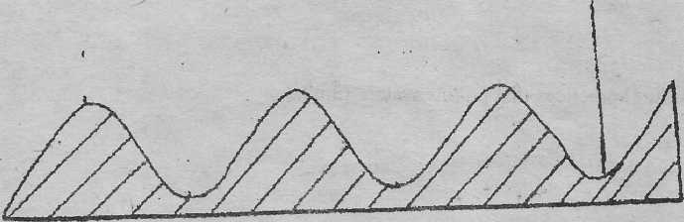
- Identify the operation. (1 mk)

- Label part N (1mk)

- List three crops that may require this operation when planting. (3mks)

- State the importance of carrying out the practice, (link)

19. The following diagram illustrates a certain too! used in the farm

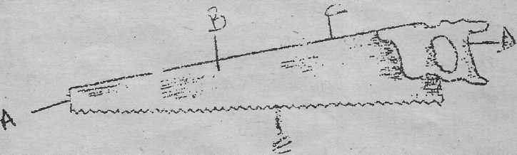

- Name the tool (lmk)

- Label parts A,B,C,D and E (5mks)

20. Study the diagram below and answer the questions that follow

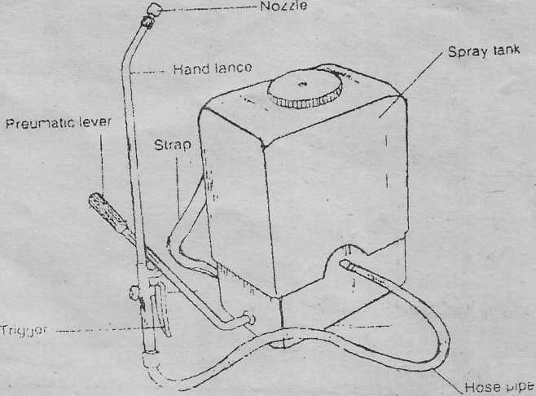

- Identify the equipment (lmk)

- State one use of the equipment (1mk)

- Explain two maintenance practices of the equipment. (4mks)

21. The following are tools used in the farm.
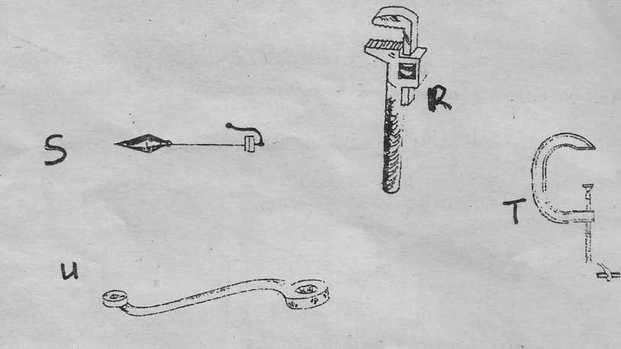
- Identify the tools R,S,T and U (4mks)
R________________________________________________________
S___________________________________________
T___________________________________________

U_______________________________________________

- State the use of tool R and S (2mks)
R
S

22. Illustrated in the diagrams Di and D2 below are methods of draining water logged soils. Study the illustrations and answer the questions that follow

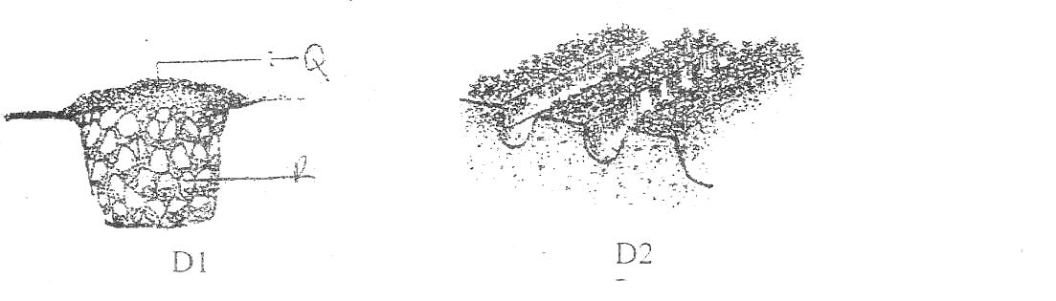
- Identify each of the methods of drainage illustrated in D1 and D2 above. (2mks)
D1

D2

- Name the materials labeled Q and R (2mks)’
Q

R

- Apart from the methods illustrated above name any other way of draining waterlogged soil, (lmk)

23. The diagram below illustrates a process carried out in a certain farm.
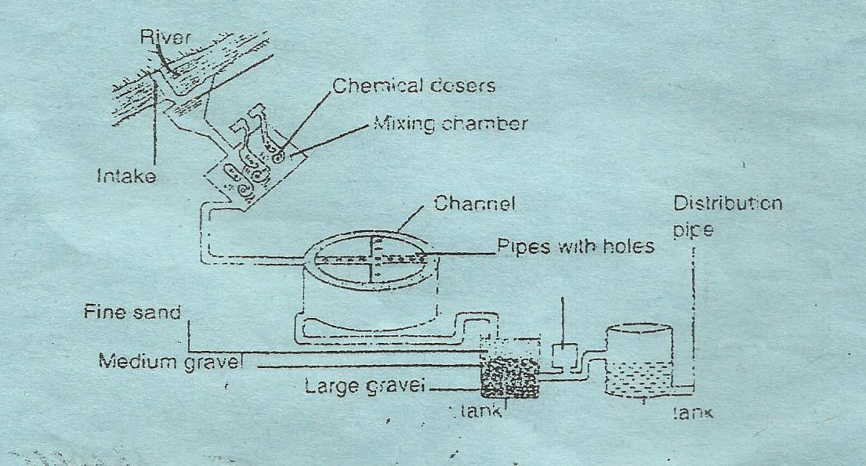

- Identify the process (1mk)

- List the stages of the process in the order in which they occur. (6mks)

- State four reasons for carrying out the process. (4mks)

