PERFECT STEPS PUBLISHERS
END TERM EXAMS 2015
0721 745374/ 0721 707626 NAIROBI
NAME.................................................................................................CLASS............ ADM.
BIOLOGY EXAMINATION. FORM TWO
TIME 2 HOURS.
Instructions to Candidates.
The paper consist of two sections, A and B
Answer all questions in sections A in the spaces provided.
1n section B answer one question only.
- State two factors which maintain transpiration stream.2marks

- a) List three forces that facilitate transport of water and mineral salts up the stem .3marks

b) Name the tissue that is removed when bark of a dicotyledonous plant is ringed .1mark
- State two functions of mucus produced along the alimentary canal.2marks
- Outline two structural differences between arteries and veins in mammals .2marks
- State two ways in which xylem vessels are adapted to their function .2marks
6 The diagram below shows the traverse section of a young stem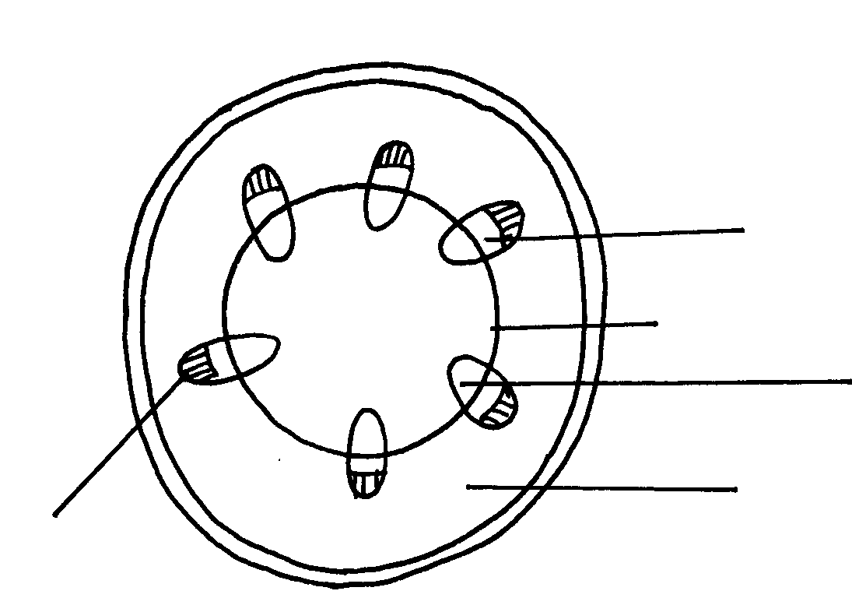
E
A
B
C
D

What are the functions of the structures labeled A, B and C
A...............................................................................
.B.............................................................................................................................................
C.................................................................................................................................3marks
(b) What type of cells are found in the parts labeled D ....................................................................................................................................1marks
(c) Name the tissue labeled E....................................................................................................................1mark
7 Identify the mode of feeding of the animal whose dental formula is given below.
- Mode of feeding..................................................................................................................................................1mark (b) Reasons...............................................................................................................................................................2marks
- 8 Define the term deamination. 1mark
9 In an investigation, the pancreatic duct of a mammal was blocked. It was found that the blood
Sugar regulation remained normal while digestion of food was impaired. Explain this observation.2marks
10 Gastrin is a hormone produced by mammals.
(a) (i) Where is the hormone produced?............................................................................(1mark)
(ii) What is the function of gastrin?...............................................................................(1mark)
(b) What stimulates the production of gastrin? ...................................................................................................................................1mark
(c) State three adaptations of the human large intestine to its functions.

................................................................................................................................................3marks
11 Why is O₂ important in the process of active transport in cells..1mark
12 The data below shows the time taken by cobalt chloride paper to turn pink on upper surface and lower surface when two species of plants labeled X and Y were used.
Species | Upper surface | Lower surface
X | 27 sec | 42 sec
Y | 35 sec | 21 sec
a) What is the likely habitat of the plant species labeled X. .................................................1mark
b) Account for the time taken by the plant species labeled Y.
.........................................................................................................................................................................
..................................................................................................................................................................3marks
13 Four specimens were grounded using mortar pestle, then placed in test tubes A,B, C and D. 1% Hydrogen peroxide was added. The table below shows the results obtained.

Test – tube | Specimen | Observation
A  B  C  D | Fresh liver  Muscle tissue  Seed coat  Boiled potato | A lot of bubbling  Bubbling less than in A  Little bubbling  No bubbling

- Why was it necessary to grind the specimen before carrying out the experiment.
.....................................................................................................................................................................1mark
b) Name the enzyme which break down hydrogen peroxide in tissues 1mark
c ) Account for the result in

Test tube A.....1mk
Test tube C
..................................................................................................................................................................................................................................................................................................................................................................................................................1mk
14. The diagram below shows a section of the functional unit of a mammalian kidney.
a) Identify the structure drawn.
.....................................................................................................................................1mark
b) Name the parts labeled J and M.
(i) J...............................................................................................................................1mark
ii) M...........................................................................................................................1mark
c) What causes the process that occurs in structure L?
..............................................................................................................................1mark
d) What is the difference in the composition of fluids in structure K and O?
.................................................................................................................................1mark
e) State four adaptations of part N to its function.
4marks
f) State two adaptations that desert animals have to reduce water loss through urine.2marks

15 The diagram below represents part of the gaseous exchange system in a cockroach.

Muscle tissue
M

a) Name the structures labeled M and N.
M............................................................................................................................................
N............................................................................................................................................2marks
b) State the function of the structure labeled M.
.................................................................................................................................................1mark
c) Describe the path taken by carbon (iv) oxide as it diffuses out of the body of a cockroach.
.............................................................................................................................................................................................................................................................................................................................................................................................................................................................................................................................................................................4marks
d) What structures in a mammalian breathing system are represented by
M:.............................................................................................................................(1mark)
N:...............................................................................................................................(1mark)
16 State the advantages of wilting in plants
...........................................................................................................................................1mark
17 State two ways in which glucose is assimilated
..........................................................................................................................................................................................................................................................................................................2marks
18 Distinguish between naturally acquired passive immunity and artificially acquired immunity. . 2marks

19 State the role of the following hormones in the human body.
Insulin...........................................................................................................................................1mark
- Antidiuretic hormone 1mark
20 a) Name the protein and a vitamin involved in blood clotting ...2marks
b) State the function of co-factors in cell metabolism .1mark
- Give two examples of metalic co-factor ....2mark
21 Explain why it is not advisable to light a jiko in a poorly ventilated room.
....................................................................................................................................................(3marks)
22 Define the following terms as used in biology autotrophism and heterotrophism 4marks
23 What happens to excess fatty acids and glycerol .1mark
24 State two functions of muscles found in the alimentary canal. ....(2marks)

Section B attempt one from this section only
25 (a) Name six methods of excretion in plants.
..............................................................................................................................................(6marks)
(b) State seven excretory products in plants and give their economic uses.
......................................................................................................................................................(14marks)
26 (a) Citing specific examples. State and explain characteristics of gaseous exchange structures or
respiratory surfaces in mammals.
............................................................................................................................................. .......(8Marks)
- In tabular form, describe the process of exhalation and inhalation in man. (12Marks)
PRINTED AND COMPILED BY
PERFECT STEPS PUBLISHERS
0721 745374/ 0721 707626 NAIROBI
END

