FORM 2 BIOLOGY DECEMBER HOLIDAY ASSIGNIMENT -2015
- What is meant by the following terms, give relevant examples: (10mks)
- Excretion?
- Egestion?
- Thermo- regulation?
- Secretion?
- Homeostasis?
- Explain why plants do not have an elaborate waste excretory system (2mks)
3 a). What are Alkaloids? (2mks)
b) What is the economic importance of plants excretory products? (18mks)
4. Using a relevant diagram, explain how unicellular organisms like Amoeba get rid of their waste products. (5mks)
5. Name three animal excretory tissues and organs, giving an example in each case. (3mks)
6. Give five main functions of the mammalian skin. (5mks)
7. Describe the structural adaptations of mammalian skin to its functions. (20mks)
8. Describe what happens in the two phases of aerobic respiration. (20mks)
9. a) List five differences between aerobic and anaerobic respiration.(5mks)
b) What is the significance of anaerobic respiration? (2mks)
c) Give examples of food in your community which provides us with a lot of energy. (3mks)
10. What is the economic importance of anaerobic respiration in industry? (10mks)
11 a) The equation below represents oxidation of a certain food substrate.
C₅₇H₁₀₄O₆ + 80 O₂ 57 CO₂ + 52 H₂O + Energy
- Calculate the respiratory quotient of the food substrate. (2mks)
- Which type of food substrate is being oxidized? (1mk)
b.) What is meant by the term oxygen debt? (2mks)
12. Describe five factors affecting the rate of respiration. (10mks)
13. Describe five respiratory diseases, their symptoms, treatment and control. (10mks)
14. Describe the mechanism of gaseous exchange in a bony fish. (20mks)
15. Explain how the mammalian heart is structurally adapted to perform its functions. (20mks)
16. Describe how structural and environmental factors affect the rate of transpiration. (20mks)
17. Describe how the small intestines are adapted to their functions. (20mks)
18. Name two nutrients that do not require digestion before they are absorbed. Explain why this is so? (3mks)
19. State the factors that determine energy requirements in human beings? (5mks)
20. Name the carbohydrate that is:
a) Found in abundant in mammalian blood. (1mk)
b) Stored in the mammalian liver. (1mk)
c) Stored in plant seeds. (1mk)
21. Explain why:
a) Red blood cells burst when placed in distilled water while plant cells remain intact. (2mks)
b) Fresh water protozoa like amoeba do not burst when placed in distilled water. (2mks)
22. Describe how the plants leaves are structurally adapted to perform their photosynthetic functions. (10mks)
23. The table below shows the approximate distribution of blood groups in a sample of 100 people in a population.
Blood group | Frequency | Rhesus +ve | Rhesus -ve
A | 26 | 22 | 4
B | 20 | 18 | 2
AB | 4 | 3 | 1
O | 50 | 43 | 8

- Calculate the percentage of Rhesus negative (Rh-ve) individuals in the population? (1mk)
- Account for
(i) The large number of blood group O individuals in a population. (2mks)
(ii) The small number of individuals with blood group AB. (2mks)
- The diagram below represents a blood smear on a glass slide.

A
B
C

(i) State the importance of structure C being large numbers in the blood smear. (1 mark)
(ii) Give a reason why structure C would be found in large numbers in high altitude than in low altitude. (1 mark)
(iii) Name the process by which structure A would engulf structure B. (1 mark)

- An experiment was carried out to investigate transpiration and absorption of water in sunflower plants in their natural environment with adequate supply of water. The amount of water was determined in two hour intervals. The results are shown in the table below.
 | Amount of water in grammes
Time of day | Transpiration | Absorption
1100-1300  1300-1500  1500-1700  1700-1900  1900-2100  2100-2300  2300-0100  0100- 0300 | 33  45  52  46  25  16  08  04 | 20  30  42  46  32  20  15  11
- Using the same axes, plot graphs to show transpiration and absorption of water in grammes against time of the day. (7 marks)
- At what time of the day was the amount of water the same for transpiration and absorption? (1 Mark)
- Account for the shape of the graph of
(i) Transpiration (3marks)
(ii) Absorption (3marks)
- What would happen to transpiration and absorption of water if the experiment was continued till 0050 hours.(2 marks)
- Name two factors that may affect transpiration and absorption at any given time. (2 marks)
- Explain how the factors you named in (e) above affect transpiration. (2marks)
- Describe the
(i) Process of inhalation in mammals (10 marks)
(ii) Mechanism of opening and closing of stomata using potassium ions theory. (10 marks)

- A student set up an experiment using soaked and dry seeds as shown below

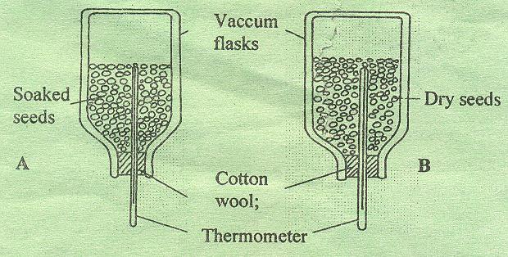

- State the objective of this experiment (1mk)
- State the observations made in each of the flask after 24 hours (2mks)
- Account for the observation made in (b) above (2mks)
- Suggest why vacuum flasks were used in this experiment (1mk)
- What alteration would you make in the set-up to make the results more reliable (1mk)
- Why should the seeds be washed with antiseptic/10% formalin? (1mk)
27. Give the name to the study of:
- The cell (1mk)
- Micro-organism (1mk)
28. State one function of each of the following cell organelles. (2mks)
- Lysosomes
- Ribosomes
29. A student drew a 3cm long diagram of a plant flower. If the actual length of the flower was 6cm, calculate the magnification of drawing made by the student. Show your working. (2mks)
30. Why are enzymes pepsin and trypsin secreted in precursor forms? (2mks)
END.

