GATITU MIXED SECONDARY SCHOOL
THIRD TERM 2015
FORM 2 BIOLOGY ENDTERM EXAMS

1.a) Explain how mammalian lungs are adapted for gaseous exchange (8mks)

b) Name two structures used for gaseous exchange in plants. (2mks)

2. Why are gills in fish highly vascularized? (2mks)
3. Describe the process of inhalation in mammals. (10 mks)

4. The diagram below represents a part of the rib cage.
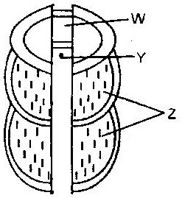

a) Label parts labeled W, Y and Z (3mks)
b) How does the part labeled Z facilitates breathing in? (2mks)

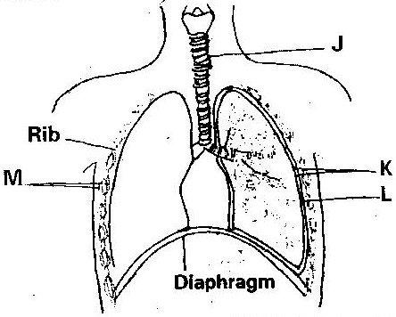
- The diagram below represents some gaseous exchange structures in humans.

a) Label parts K, L and M in the diagram above (3mks)

b) How is the structure labeled J suited to its functions? (3mks)

c) Name the process by which inhaled air moves from the structure labeled L into blood capillaries (1mk)

d) Give the scientific name of the organism that causes tuberculosis in humans. (2mks)

6. Name the main site of gaseous exchange in
a) Mammals
b) Fish
c) Leaves
d) Amoeba (4mks)

7. The diagram below shows a set up that was used to demonstrate fermentation.
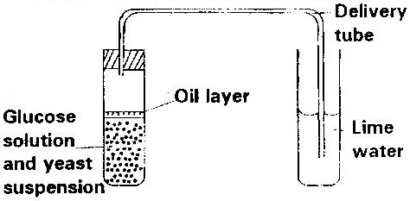

Glucose solution was boiled and oil added on top of it. The glucose solution was then allowed to cool before adding the yeast suspension.
a) Why was the glucose solution boiled before adding the yeast suspension? (1mk)

b) What was the importance of cooling the glucose solution before adding the yeast suspension? (2mks)

c) What was the use of the oil in the experiment? (1mk)

d) What observation would be made in test tube B at the end of the experiment (1mk)

e) Suggest a control for this experiment (1mk)

8. Give two reasons why accumulation of lactic acid during vigorous exercise lead to an increase in heartbeat. (2mks)

9. A process that occurs in plants is represented by the equation below.
C₆H₁₂O₆ 2C₂ H₅OH + 2CO₂+ Energy
Glucose Ethanol Carbon Dioxide
a) Name the process (1mk)
b) State the economic importance of process name in (a) above. (1mk)

MARKING SCHEME ( 50mks)
1a) - Large number of alveoli-increase surface area.
- Alveoli moist-dissolve diffusing gases.
- This walls- allow quick diffusion of gases
- Rich blood supply- transport oxygen and carbon dioxide.
b) i) Carbon dioxide diffuses into the cells. It moves in the plasma or
red blood cells.
- Carbonic acid in plasma or carbamino haemoglobin in red blood cells or hydrogen carbonate.
- At the lungs hydrogen carbonate, carbonic acid and carbomino
haemoglobin dissociates releasing cavity due to concentration gradient.
ii) Due to metabolic activities carbon dioxide is released from
mesophyll cell. It diffuses into the intercellular spaces.
- Due to concentration gradient the gas diffuses into the sub-stomatal air spaces.
- When stomata open carbon dioxide is released into the atmosphere.
2. - To facilitate transportation of gases/exchange of gases i.e. oxygen and
carbon dioxide.
- Create high concentration gradient.
3 a) - External intercostals muscle contract while internal intercostals
muscles relax.
- Diaphragm contract flattening. Volume in thoracic cavity
- Air rushes into the lungs.
b) Opening During the day photosynthesis takes place and sugar is formed in
guard cells
- Osmotic pressure increases and water is drawn from neighbouring
cells by Osmosis.
- The guard cells become turgid, bulge outward causing opening of
stomata.
Closing During the night there is no photosynthesis and sugar is converted
to starch.
- Osmotic pressure decrease and water is lost to the neighbouring
cell osmosis.
- Guard cells become flaccid, closing the stomata.
4. a) - Pneumatophores
- Aerenchyma tissues
- Cuticle
b) - The diaphragm flattens.
- Volume in thoracic cavity increase.
- Pressure decreases compared to atmospheric pressure. Air rushes into the lungs through the nostrils.
5. a) K- Pleaural membranes
L - Alveolus
M- Intercostals muscles
b) - Has c-shaped cartilage rings that support it, preventing it from
collapsing and allow free flow of air.
- Inner lining has mucus secreting cells that trap fine dust particles
and micro-organisms.
- Inner lining has hair like structures called cilia that enhance upward movement of the mucus to the larynx.
c) Diffusion
d) Mycobacterium tuberculosis
6. Support the trachea and prevent it from collapsing when there is reduced pressure.

7. a) To derive off air or oxygen
b) To avoid killing yeast/Denaturing enzymes in yeast
c) To prevent air from getting into the yeast and glucose mixture.
d) Lime water turn to white precipitate
e) Use boiled yeast/glucose without yeast/yeast without glucose
8. - Lactic acid is toxic to tissues and must be removed from muscles to liver.
- To increase supply of oxygen to tissues
9. a) Anaerobic respiration
b) Brewing/Beer making

