NAME ------------------------------------- CLASS ---------------ADM NO. -------------------------------
GATITU MIXED SEC SCHOOL
BIOLOGY FORM 2
3RD TERM 2013 TIME: 2 HRS.
SECTION A (60 MKS)
ANSWER ALL THE QUESTIONS IN THE SPACES PROVIDED
- The flow chart below shows certain products of cellular respiration. study it carefully

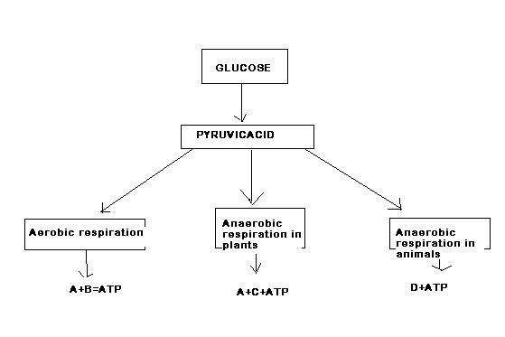

Name the substance A, B, C and D. 4mks
- A

- B

- C

- D

- Explain how vaccination makes a person immune to a disease. 4mks

- suggest two advantages of keeping the blood inside vessels 2mks

- An experiment was set up as shown below and left for one hour

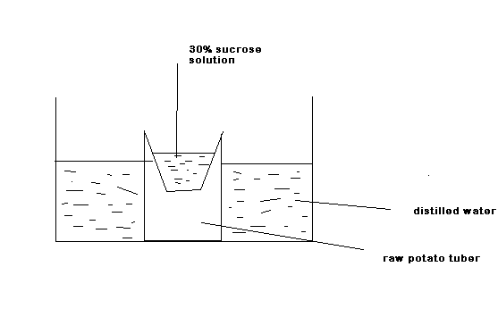

- Suggest what happens to level of sucrose solution in cavity of the potato tube after one hour. 1mk

- Explain your answer in (a) (i) above 2mks

- Suggest what happens to the distilled water level in the beaker 1mk

- Explain your answer in (b) (i) above 2mks

- What is the importance of diffusion in a living cell? 1mk

- Give the two main functions of leaves in a plant. 2mks

- Explain why in large animals such as mammals, gaseous exchange over the general body surface cannot be effective. 2mks

- Study the diagram below representing and organ found in a certain type of animal.

- Name the type of animal with the organ represented in the diagram above. 1mk

- Name the organ and state its function 2mks

- Describe two ways in which the part labeled P is adapted to its function 2mks

- Give two roles of enzymes in respiration? 2mks

- Give two uses of energy released in respiration in plants. 2mks

- Name the gases produced when a food substance such as maize is burnt. 2mks

- Name the reagents used to show the presence of each of the gases given in (a) above. 2mks

- A form two student was observing a tissue from the lower surface of a terrestrial plant leaf. She then drew the structures observed as shown in the diagram below.

- Name the parts labeled Q,R and s 3mks

- What are the functions of the part labeled S? 2mks

- Name the plant excretory products used as:
- meat renderiser 1mk

- Mild refreshing stimulant in beverages. 1mk

- insecticide 1mk

- Give the roles of the human skin in :
- homeostasis 2mks

- protection 2mks

- Name the hormone that is released when blood:
- Sodium ions level fall below the normal. 1mk

- osmotic pressure rises above the normal 1mk

- sugar level falls below the normal 1mk

- state the functions of each of the following parts of a microscope
- body tube 1mk

- objective lens 1mk

- mirror 1mk

- state the functional differences between the organelles below
- rough endoplasmic reticulum and smooth endoplasmic reticulum 1mk

- chloroplast and mitochondrion 1mk

- Name the two cells that male up the:
- phloem 2mks

- xylem 2mks

- Below is a diagram showing a circulatory system found in a certain group of animals

- Name the parts labeled W,X and Y 3mks

- Name the group of animals with the type of circulatory system shown in the diagram above. 1mk

SECTION B (40 MKS)
ANSWER ALL THE QUESTIONS IN THIS SECTION
- The figure below is a photograph of part of the outer layer of a terrestrial plant leaf.

- Identify the structures labeled A and B 2mks

- Substances that are used, or produced inside the leaf pass through B.
a. Name one of these substances that pass into the leaf in daylight 1mk

b. Name two substances that pass out of the leaf in daylight. 2mks

c. Briefly describe an experiment to demonstrate that one of the two substances that you have named in (ii) (b) above passes out of a leaf 2mks

d. Suggest why there would be no movement in or out in darkness. 1mk

- The graph below shows the level of blood glucose in a healthy person over a period of several hours. The person ate a starchy meal two hours after the start of the investigation.

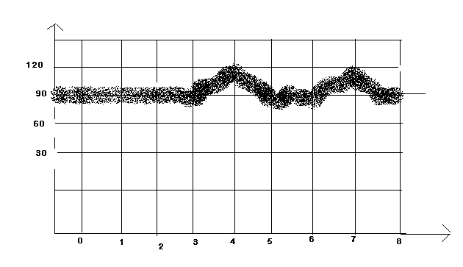

- Account for the change in blood glucose level between:
- 3 and 4 hrs 3mks

- 4 and 5 hrs 3mks

- suggest what might have caused the change between:
- 6 and 7 hrs 2mks

- 7 and 8 hrs 2mks

- The figure below shows three similar cells 10 minutes after being placed in solutions D, E and F, of different osmotic pressure. One of these solutions has the same osmotic pressure as that of the sap vacuole in the cells.

- Name :
- The chemical substance that make up the part labeled G 1mk

- The part labeled H 1mk

- Giving a reason, identify the solution that is :
- Hypertonic to the cell sap 2mks

- Isotonic to the cell sap 2mks

- state the term used to describe the condition of the cell in solution:
- D 1mk

- F 1mk

- Describe how excretion takes place in the mammalian kidney 14mks

