GATITU MIXED SECONDARY CSHOOL
ARISE &SHINE.
FORM 2 BIOLOGY
NAME…………………………………… …ADM.NO……………………………

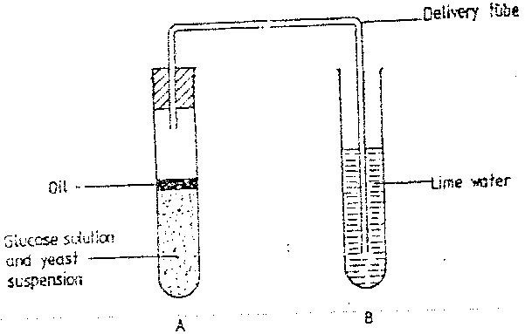
1. The diagram below shows a set – up that was used to demonstrate
Fermentation

Glucose solution was boiled and oil added on top of it. The glucose solution was then allowed to cool before suspension.
  - Why was the glucose solution boiled before adding the yeast Suspension? ( 1 mk)

  - What was the importance of cooling the glucose solution before adding the yeast suspension? ( 1 mk)

  - What was the use of oil in the experiment? ( 1 mk)

  - What observation would be made in test tube B at the end of the experiment? ( 1 mk)

  - Suggest a control for this experiment ( 1mk)

2.What are the three end products of anaerobic respiration in plants (2mks)

3. state two ways in which xylem vessels are adapted to their function(2mks)

4.Why are people with blood group O universal donors(1mk)

5.Why are gills in fish highly vascularised(1mk)

6.Give two reasons why accumulation of lactic acid during vigorous exercise leads to anincrease in heartbeat.(2mks)

7.(a) The type of circulatory system found in members of the class insecta is(1mk)

(b) Name the blood vessel that transports blood from2mks)
(i) Small intestines to the liver

(ii) Lungs to the heart
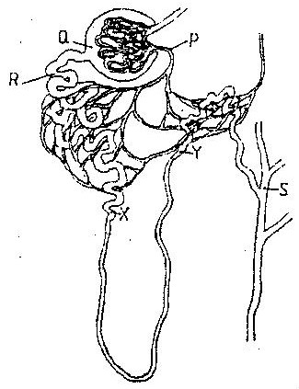
8.The diagram below represents a mammalian nephron

(a) Name the
(i) Structure labeled P(1mk)

(ii) Portion of the nephron between point X and Y1mk)

(b) Name the process that takes place at point Q(1mk)

(c) Name one substance present at point R but absent at point S in a healthy mammal(1mk)

(d) The appearance of the substance you have mentioned in (c) above is a symptom of a certain disease caused by a hormone deficiency. Name the
(i) Disease

(ii) Hormone(1mk)

(e) State the structural modifications of nephrons found in the desert mammals(1mk)

9.A process that occurs in plants is represented by the equation below.
C6H12O6 2C2H5OH + 2CO2 + Energy
(Glucose) (Ethanol) (Carbon dioxide)
a) Name the process.(1mk)
b) State the economic importance of the process named in (a) above(1mk)

10.The diagram below represents regions of a root tip.
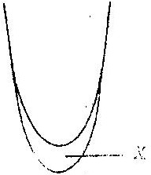

  - Name the two regions above X in ascending order(1mk)

  - State the function of the part labeled X(1mk)

11.Name the:
a)Material that strengthens xylem tissue.(1mk)

b)Tissue that is removed when the bark of a dicotyledonous plant is ringed(1mk)

12. The diagram below shows a vertical section through a mammalian heart.
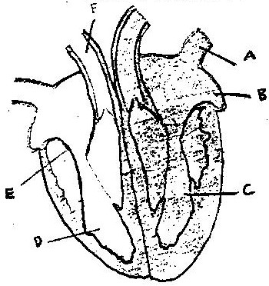

a) Name the parts labeled A,B,E and F (4mks)

b) Use arrows to show the direction in which blood flows in the heart.
(2mks)
c) Give a reason why the wall of chamber C is thicker than
chamber D (2mks)

13.Why would carboxyhaemoglobin lead to death? (2mks)

14. The diagram below shows a section through the mammalian skin.
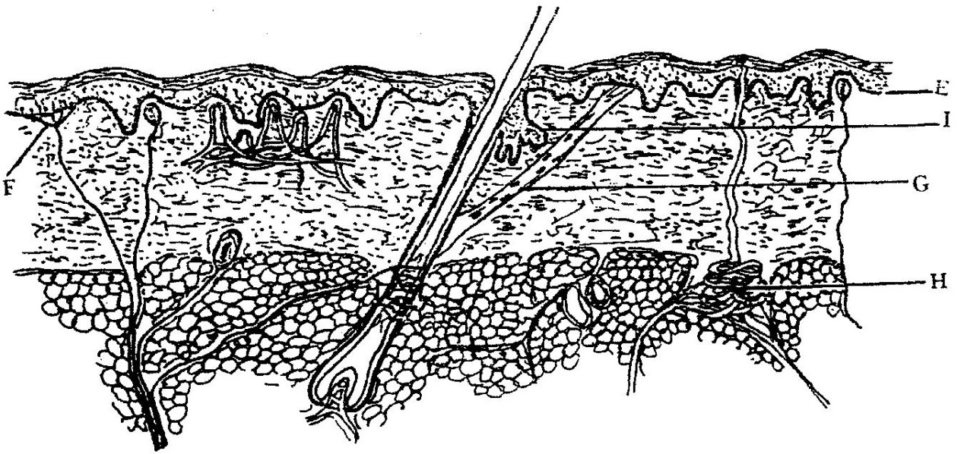

a) Name the parts labeled E, F and G. (3mks).
E …………………………………………
F …………………………………………
G …………………………………………
b) State two functions in each case of substance secreted by
the structures labeled.
(i) H …………………………………
(ii) I …………………………………. (2mks)

15.a) Name one defect of circulatory system in humans. (1mk)

b)state three functions of blood other than transport. (3mks

16.State four ways in which respiratory surfaces are suited to their function.
(4mks

17.(a) Name two structures for gaseous exchange in aquatic plants
( 2 marks)

18.State four functions of liver(2mks)

19. (a) What is the meaning of the terms
(i) Homeostatic ( 2 mark)
(ii) Secretion

20.The diagram below represents some gaseous exchange structures in humans
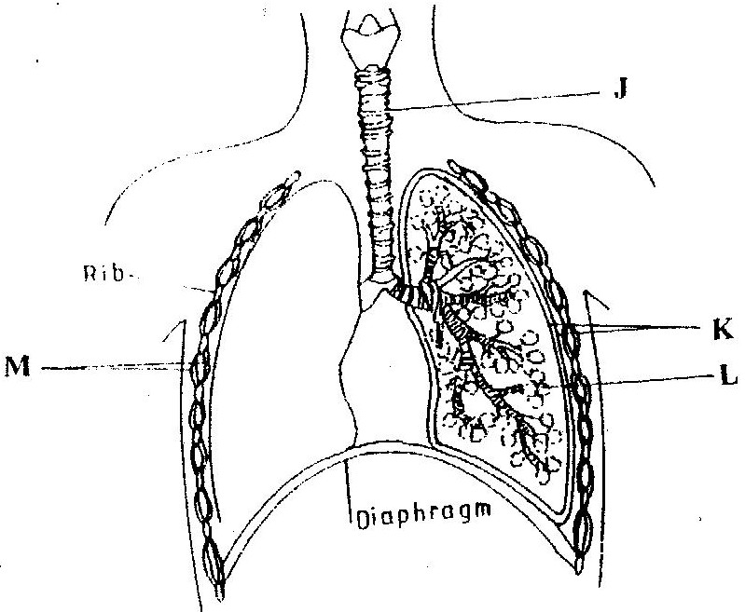

(a) Name the structures labeled K, L, and M ( 3 marks)
K…………………………………………………………………………….
L…………………………………………………………………………….
M……………………………………………………………………………
(b) How is the structure labeled J suited to its function? ( 3 marks)

(c) Name the process by which inhaled air moves from the structure labeled L into
blood capillaries ( 1 mark)

21.(a) Name the protein that determine human blood groups ( 2 mks)

(b) State the adaptation that enables the red blood cells to move in blood
Capillaries ( 1 mk)

22.(a) State three structural differences between arteries and veins in mammals
( 3 mks)

(b) Name a disease that causes thickening and hardening of arteries
( 1 mk)
23.Explain why the rate of transpiration is reduced when humidity is high(1mk)

24.In an experiment, disinfection soaked bean seeds were put in a vacuum flask which was then fitted with a thermometer as shown in the diagram below.
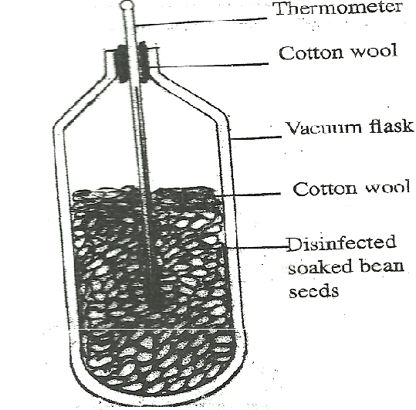
The temperature readings were taken every morning for three consecutive days.
- Which process was being investigated? (1 mark)

- i) what were the expected results? (1 mark)

ii) account for the answer in (b) (i) above? (2 marks)

- Why was a vacuum flask used in the set-up? (1 mark)
.

25.why is fat not the main respiratory substrate (2mks

Section B.(20mks)

(Choose either question 26 or 27)

26.an experiment was carried out to investigate transpiration and absorption of water in sunflower plants in their natural environment with adequate supply of water. The account of water was determined in two hour intervals. The results are as shown in the table below
Time of day | Amounts of water in grammes
 | Transpiration | Absorption
11 00 - 13 00  13 00 - 15 00  15 00 - 17 00  17 00 - 19 00  19 00 - 21 00  21 00 - 23 00  23 00 - 01 00  01 00 - 03 00 | 33  45  52  46  25  16  08  04 | 20  30  42  46  32  20  15  11

- Using the same axes, plot graphs to show transpiration and absorption of water in grammes against time of the day ( 7 mks)
- At what time of the day was the amount of water the same for transpiration and absorption? ( 1 mk)

- Account for the shape of graph of:
  - Transpiration ( 3 mks)

  - Absorption ( 3 mks)

- What would happen to transpiration and absorption of water if the experiment was continued till 05 00 hours? ( 2 mks)

- Name two factors that may affect transpiration and absorption at any given time
(2 mks)

- Explain how the factors you named in (e) above affect transpiration
( 2 mks)

Describe the:
- Process of inhalation in mammals.(10mks)

b) Mechanisms of opening and closing of stomata in plants.(10mks)

ALL THE BEST

