## PERFECT STEPS PUBLISHERS

END TERM EXAMS 2015

**0721 745374/ 0721 707626 NAIROBI**

BIOLOGY PAPER 1FORM 3 2015

231/1

***2 hours.***

1. What characteristics of life are exhibited by the following?

a) An orange tree producing juicy oranges? (1mk)

……………………………………………………………………………………………….

b) An athlete breathing heavily after running a marathon. (1mk)

………………………………………………………………………………………………..

2. Name the organelles that perform the following functions in a cell.

i) Protein synthesis.(1mk)…………………………………………………………………………………………………..

ii) Transport of secretions.(1mk)……………………………………………………………………………………………………

3. State **two** main functions of a microscope.(2mks)

……………………………………………………………………………………………………………………………………………………………………………

4. State **two** functions played by the cell wall in plant cells and give the adaptation of the cell wall to performing each of the stated functions. (4mks)

|  |  |
| --- | --- |
| FUNCTION | ADAPTATION |
|  |  |
|  |  |

5. a) State **two** importance of active transport in living organisms. (2mks)

………………………………………………………………………………………………………………………………………………………………………………………………………………………………………………………………………………………………………………………

b).Why is oxygen concentration important in active transport? (1mk)

……………………………………………………………………………………………………………………………………………………………………………………

6. State **three** features used in classifying arthropods into classes.(3mks)…………………………………………………………………………………………………………………………………………………………………………………………………………………………………………………………………………………………………………………………………………………

7. What is the importance of carrying out the following procedures when preparing temporary slides in the laboratory? (4mks)

i) Adding water to the specimen.

………………………………………………………………………………………………………

ii) Staining the specimen.

………………………………………………………………………………………………………

iii) Making very thin sections.

………………………………………………………………………………………………………

iv). Using a sharp blade to make sections.

………………………………………………………………………………………………………

8. What is the significance of each following in photosynthesis?

i) Chlorophyll in the leaf. (1mk)

……………………………………………………………………………………………………..

ii) Stomata on the leaf surfaces. (1mk)

…………………………………………………………………………………………………….

iii) Leaf midrib and veins. (1mk)

………………………………………………………………………………………………………

9. Explain how water is gained from the soil by root hairs in plants. (3mks)

……………………………………………………………………………………………………………………………………………………………………………………

10. Name the form in which carbohydrates are stored in, (2mks)

i) Plants tissues.………………………………………………………………………………………………………

ii) Animal tissues………………………………………………………………………………………………………

11. A solution of sugar cane was boiled with dilute hydrochloric acid. Sodium hydrogen carbonate was added and then heated with Benedict’s solution and an orange precipitate was formed.

a) Why was the solution boiled with dilute hydrochloric acid? (2mks)

……………………………………………………………………………………………………………………………………………………………………………………

b) To which class of carbohydrates does sugar cane belong? (1mk)

…………………………………………………………………………………………………….

12. The table below shows the percentage composition of carbon(IV) oxide and oxygen inhales and exhales air.

|  |  |  |
| --- | --- | --- |
| Gases | Inhaled air | Exhaled air |
| Oxygen | 20% | 17% |
| Carbon(IV) oxide | 0.04% | 4.0% |

Explain the differences in the percentage of the two gases in inhaled and exhaled air. (2mks)

………………………………………………………………………………………………………………………………………………………………………………………………………………………………………………………………………………………………………………………

13. The table below shows the energy use per day in kilojoules.

|  |  |  |
| --- | --- | --- |
| Age (years) | Male | Female |
| 2 | 5,500 | 5,500 |
| 5 | 7,000 | 7,000 |
| 8 | 8,800 | 8,000 |
| 11 | 10,000 | 9,200 |
| 14 | 12,500 | 10,500 |
| 18 | 14,200 | 9,600 |
| 25 | 12,100 | 8,800 |

1. From the table, explain why after age 8 years males require more energy than females. (1mk)………………………………………………………………………………………………………………………………………………………………
2. Other than sex and age, name **three** other factors that determine energy requirements in human beings. (3mks)

..............................................................................................................................................................................................................................................................................................................................................................

14. a) Name the substance that accumulates in muscles when respiration occurs with insufficient oxygen. (1mk)………………………………………………………………………………………………………

b)Give the **three** end products of anaerobic respiration in plants. (3mks)

…………………………………………………………………………………………………………………………………………………………………………………………………………………………………………………………………………………………………………………………………………………………………………

15.(a) Name **two** raw materials for the dark stage process of photosynthesis.(2mks)

……………………………………………………………………………………………………………………………………………………………………………………………………………………………………………………………………………………………………

b)The set up below shows an experiment to investigate photosynthesis.

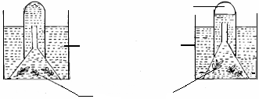

Aquatic plants

Gas collected

At the start

After the experiment

Water containing sodium hydrogen carbonate

What gas was collected in the set up above? (1mk)

………………………………………………………………………………………………………

1. What is the role of sodium hydrogen carbonate in the experiment? (2mks)

16.The diagram below represents a stage during cell division.

1. Name the stage of cell division. (1mk)

…………………………………………………………………………………………………………………………………………………………………………

1. Give two reasons for your answer in a) above.(2mks)

………………………………………………………………………………………………………………………………………………………………………………………………………………………………………………………………………………………………

c) State the significance of this stage of cell division in living organisms.(1mk) ……………………………………………………………………………………………………………………………………………………………..............

17.) Name the causative agent for the following diseases;

a) Typhoid (1mk) ……………………………………………………………………………………………….

b)Syphilis (1mk)………………………………………………………………………………………………

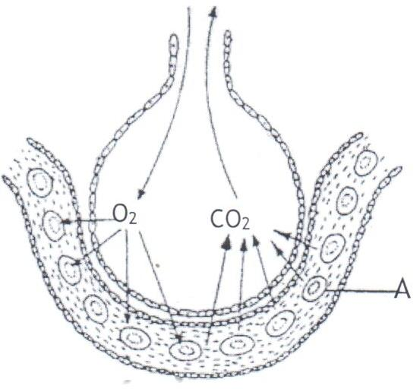18. The diagram **below** shows the exchange of gases in alveolus.

* + 1. State how the alveoli are adapted to their function. (3mks) …………………………………………………………………………………………………………………………………………………………………………

ii)Name the cell labelled **A**. (1mk) …………………………………………………………………………………………………………………………………………………………………………

19.(a) Distinguish between respiratory quotient and oxygen debt.(2mks) ………………………………………………………………………………………………………………………………………………………………………………………………………………………………………………………………………………………………………………………………………………………………

(b) Name the site where anaerobic respiration occurs in the cell.(1mk)

……………………………………………………………………………………….........

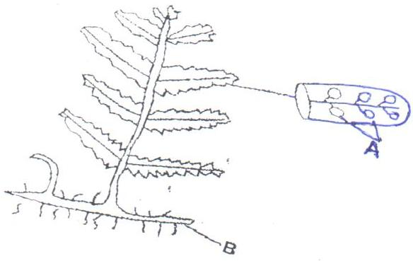 20. The diagram below represents a fern.

1. Name parts labelled A and B. (2mks)

………………………………………………………………………………………………………………………………………………………………………………

In which division does the plant belong?(1mk)

………………………………………………………………………………………………………………………………………………………………………………State the function of the part labelled A.(1mk)

…………………………………………………………………………………………………………………………………………………………………………

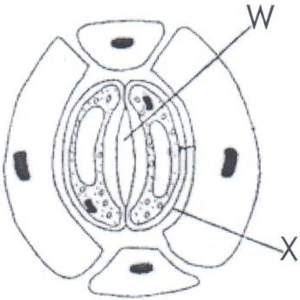21. The diagram **below** shows part of plant tissue.

* + 1. Name the cell labelled **X** and part labelled **W**.(2mks) …………………………………………………………………………………………………………………………………………………………………………ii)State **two** adaptations of cell labelled X to its functions.(2mks) …………………………………………………………………………………………………………………………………………………………………………………………………………………………………………………………………………………………………………………………………………………………22.a)What is homeostasis? (1mk)

………………………………………………………………………………………………………………………………………………………………………………

b) State **three** processes in which homeostasis is involved.(3mks)

………………………………………………………………………………………………………………………………………………………………………………

23. What causes apical dominance? (1mk)

……………………………………………………………………………………………………………………………………………………………………………………

24. State **one** function of ovaries in humans.(1mk)

……………………………………………………………………………………………………………………………………………………………………………………

25a) State **two** disadvantages of sexual reproduction.(2mks)

…………………………………………………………………………………………………………………………………………………………………………………………………………………………………………………………………………………………………………………………………………………………………………

b) State **two** adaptations of the human spermatozoa.(2mks)

26.a) What are halophytes? (1mk)

b)State **two** adaptations of halophytes to their habitats.(2mks)

BIOLOGY PP1 FORM 3 2015 MARKING SCHEME

1.a)Reproduction.(1mk)

b) Respiration/gaseous exchange.(1mk)

2>.i) Ribosomes.(1mk)Rej Ribosome.

ii) Golgi bodies/Apparatus (1mk) Rej. Singular.

3.>Magnify/enlarge image of objects/specimen.(2mks)

>To improve the resolving power/show finer details of structures that are very close to appear separate.

4.

|  |  |
| --- | --- |
| FUNCTION | ADAPTATION |
| i)Allows gases/water and other substances to pass through it. | Permeability |
| ii)Provides mechanical support to the cell/ gives cells definite shape | Composed of cellulose fibres/rigid cellulose. |

(4mks)

5.a) >Reabsorption of glucose and some salts in kidney tubules. (2mks max)

> Absorption of mineral salts by plant roots.

> Absorption of digested food materials from alimentary canal of animals into the blood stream.

> Accumulation of substances into the body to offset osmotic balance in arid and saline environment.

> Excretion of waste products from body cells.

b)>Oxidises food substrates to provide energy necessary for active transport.(1mk, max)

6.>Number of limbs.(3mks)

>Presence and number of antennae.

>Number of body parts.

7.a) To make the specimen turgid./prevent it from drying up.(4mks)

b) To make cell organelles distinct.

c) To allow light to pass through and make organelles clear.

d) Avoid distorting or damaging cell organelles.

8.i) Traps light energy.(3mks)

ii)Gaseous exchange.

iii)Has tissues, phloem and xylem for translocate food substances and transport water and dissolved mineral salts.

9.>Water exists as thin film in the soil, the cell sap is hypertonic to the soil water; water is drawn into the root hair cell by osmosis. (3mks)

10.i) Starch.(1mk)

ii)Glycogen.(1mk)

11.a) To hydrolyze the non-reducing sugars to reducing sugars.(1mk)

b) Disaccharides.(1mks)

12.>Oxygen is used for respiration hence reduced exhaled oxygen; while carbon(IV)oxide is given out more because of respiratory activities.(2mks)

13.a) Males are more muscular than females who have more fat.(1mk)

b)>Basal metabolic rate; Rej (BMR)(3mks)

> Occupation.

>Body size.

>Health.

14.a) Lactic acid.(1mk)

b)>Ethanol. Rej Alcohol (3mks)

>Carbon(IV) oxide.

>Energy.

15.a)> Carbon(IV) oxide.(2mks)

>Hydrogen atoms.

b)>Oxygen gas.(1mk)

c)>Dissociates in water to provide carbon(IV) oxide, which is necessary for photosynthesis.(2mks)

16.a) Anaphase I. (1mk)

b)> Homologous chromosomes separate at the equator/homologous chromosomes start to migrate to the opposite poles; sister chromatids attach at the centromere.(2mks)

c)>It is the reduction phase that results in haploid sex cells/gamete cells.(1mk)

17.a) Salmonella typhi.

b) Treponema palladium. (2mks)

18.i)> Have a thin film of moisture to dissolve gases for efficient diffusion.

>Have a large surface area for maximum gaseous exchange.

>Have a rich network of blood cappilaries/Highly vascularized for efficient transport of gases.(3mks)

ii) Red blood cell.(1mk)

19. Respiratory quotient is the relationship between oxygen consumed and carbon(IV) oxide produced while oxygen debt is the amount of oxygen required to break down lactic acid produced during anaerobic respiration.(2mks)

20.a). A >Sori. Rej Sorus.(1mk)

B> Rhizome.(1mk)

b)> Pteridophyta.

c) Produces spores.(1mk)

21.a) X-Guard cell.(1mk)

W- Stoma.Rej Stomata.(1mk)

b)>Have chloroplast that are involved in photosynthesis.

>Have thin outer wall and thick inner wall to enhance bulging during opening of stomata.(2mks)

22.a)The maintenance of a constant internal environment despite fluctuation in both external and internal environment.(1mk)

b)> PH balance.

>Thermoregulation.

>Osmoregulation. (3mks)

23.High concentration of auxins /IAA at the shoot tip of a plant.(1mk)

24.> Secretion of hormones.

> Formation of ovum/female gamete.(1mk,max)

\

25.a)> The process is slow as offspring develop from zygote to adult.

> when there is absence of mates/Isolation hinder reproduction.

> May produce individuals exhibiting undesirable qualities which may sooner or later be eliminated. (2mks)

b) >Has a tail that aids in swimming movement through propulsion.

> Has a large number of mitochondria to provide energy for swimming movement.

> Has acrosome with lytic enzymes that dissolve away the vitelline membrane of ovum allowing penetration by sperm.(2mks,max)

26.a)Plants which are able to tolerate very salty conditions in siol/marine water.

b)> Some have salt glands to secrete excess salt.

> Most of them have water storage tissues.

> Have root cells which concentrate a lot of salts within to gain water by osmosis in the normal way.

> Most submerged halophytes are found close to the water surface where there is sufficient light for photosynthesis while those deeper carry out photosynthesis under low light intesties.(2mks,max) END M/S

PRINTED AND COMPILED BY PERFECT STEPS PUBLISHERS: 0721 745374/0721707626 NAIROBI

## PERFECT STEPS PUBLISHERS

END TERM EXAMS 2015

**0721 745374/ 0721 707626 NAIROBI**

231/2

BIOLOGY PP2 FORM 3 2015

SECTION 1.Answer all questions. (40 MARKS)

1. (a) (i) What is meant by the term biological control? (1mk)

(ii) Give an example of biological control. (1mk)

(b) (i) What is eutrophication? (1mk)

(ii) What are the effects of eutrophication? (2mks)

………………………………………………………………………………………………………………………………………………………………………………The diagram below represents a transverse section of a plant organ.

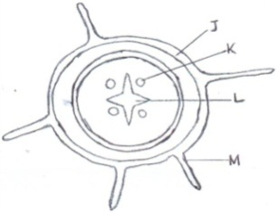

* + - 1. From which plant organ was the section obtained? (1mk)

………………………………………………………………………………………………………………………………………………………………………………

* + - 1. Give **two** reasons for your answer in (a) above. (2mks)

………………………………………………………………………………………………………………………………………………………………………………………………………………………………………………………………………………………………………………………………………………………………Name the parts labeled J, K and L. (3mks)

3.Below is a diagram of nitrogen cycle. Study it and answer the questions that follows.

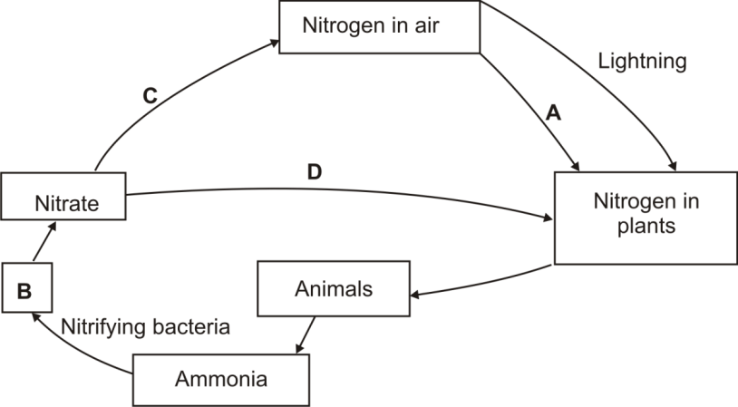

1. Name the processes represented by: A and B ( 2mks)

………………………………………………………………………………………………………………………………………………………………………………Name the compound represented by B (1mk)

………………………………………………………………………………………………………………………………………………………………………………

(c) Name the group of organisms represented by C (1mk)

......................................................................................................................................................

(d) (i) Identify the class of the plants to which the above cycle takes place (1mk)

…………………………………………………………………………………………………

(ii) Name the part of the plant where process A takes place (1mk)

…………………………………………………………………………………………………

(e) How would use of excessive pesticides affect process A (1mk)

4. The graph below show the rate of an enzyme controlled reaction against temperature (oC)

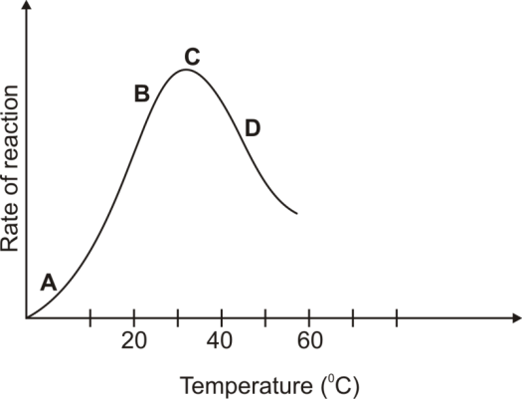

Explain the shape of the curve:

1. Between A and B. (2mks)

………………………………………………………………………………………………………………………………………………………………………………At Point C. (2mks)

.......................................................................................................................................................................................................................................................................................................................................................................... Between C and D. (2mks)

………………………………………………………………………………………………………………………………………………………………………………Other than temperature, state two factors that affect the above reaction. (2mks)

………………………………………………………………………………………………………………………………………………………………………………………………………………………………………………………………………………………………………

5. (a) Explain the fate of excess amino acids in the liver. (3mks)

(b) Name the parts of the human nephron that are only found in the cortex. (2mks)

(c) What would happen if a person secreted less antidiuretic hormone into the blood circulation. (1mk)

6. The question below represents a chemical equation that takes place in green plants under certain conditions

Carbon (IV) Oxide + water Glucose +X

1. Name substance X. (1mk)
2. Other than the conditions stated in the equation, state two other conditions necessary for the reaction. (2mks)
3. Name two types of cells in which this process occurs. (2mks)
4. Name the process represented by the equation given above. (1mk)
5. State the importance of the process named in 6(d) above. (2mks)

**SECTION B:(40 MARKS)**

Answer question **7 (Compulsory)** and **EITHER** question **8** or **9** in the spaces provided after question **9**.

7. An experiment was carried out in which red blood cells were put in salt solutions of different concentrations. The table below shows the percentage of cells which were destroyed by haemolysis in different salt concentration.

|  |  |
| --- | --- |
| Salt concentration  (g/dm³) | % of RBC destroyed  By haemolysis |
| 0 | 100 |
| 1 | 100 |
| 2 | 100 |
| 2.5 | 100 |
| 3.0 | 100 |
| 3.5 | 96 |
| 3.7 | 80 |
| 4.0 | 60 |
| 4.5 | 16 |
| 4.7 | 0 |
| 5.0 | 0 |
| 6.0 | 0 |

1. Draw a graph of percentage of red blood cells haemolysed against salt concentration.

(Draw graph on graph papers provided)

(b) Explain haemolysis of red blood cells. (3 mks)

………………………………………………………………………………………………………………………………………………………………………………………………………………………………………………………………………………………………………………………………………………………………

(c) From the graph, state:

(i) the salt concentration at which 50% red blood cells were haemolysed. (1 mk)

…………………………………………………………………………………………………………………………………………………………………………

1. the highest salt concentration when the largest number of red blood cells were haemolysed. (1 mk)

………………………………………………………………………………………………………………………………………………………………………………

(d) (i) Suggest the normal salt concentration in the blood of the mammal from which the red blood cells were obtained. (2 mks)

……………………………………………………………………………………………………………………………………………………………………………

(ii) Give a reason for your answer in (d) (i) above. (1 mk)

…………………………………………………………………………………………………………………………………………………………………………

1. What term is used to describe the solution with equal solute concentration as that of the cells? (1 mk)

…………………………………………………………………………………………………………………………………………………………………………

(e) Name the process in the human body that ensures that haemolysis of red blood cells is prevented. (1 mk)

……………………………………………………………………………………………………..……………………………………………………………

(f) State the role of osmosis in organisms. (4 mks)

8. How are respiratory gases, oxygen and carbon (IV) oxide transported to and from tissues in mammals? (20 marks)

9. State and explain how the mammalian small intestines are adapted to perform their function.

(20 marks)

231/2

BIOLOGYPP2 MARKING SCHEME 2015.

1. (a) (i) Biological control is using a living organism to regulate / control / the population of another organism.

(ii) Examples: Beetles introduced to feed on water hyacinth; fish introduced to feed on mosquito larvae.

1. (i) Eutrophication is enrichment of water bodies; with nitrate / phosphates / ammonium sulphate / nutrients due to

discharge of sewage / run off water containing fertilizers, leading to rapid growth of surface phytoplanktons;

(ii) Effects of eutrophication:

* Block light from reaching plants underneath which will not photosynthesize. The plants die and decompose leading to

lack / depletion of oxygen animals suffocate and die.

1. (a) Root (Dicotyledonous root)
2. Two reasons for your answer in (a) above.

* Presence of root hairs.
* Star-shaped xylem at the centre.
* Presence of endodermis.

1. Parts labeled:

J: Epidermis / Piliferous layer

K: Phloem

L: Xylem

1. (a) A – Nitrogen fixation (symbiotic nitrogen fixation)

D – Absorption

(b)Nitrites

(c) Denitrifying bacteria

(d)(i)Dicotyledonae

(ii)Root nodules

(e)Chemical kills nitrogen fixing bacteria; hence less nitrogen fixation leading to weak plant

4. (i)Increase in temperature increases the rate of enzyme reaction; because increase in temperature increases kinetic energy causing substrate-enzyme collision.

(ii)The rate of reaction is at maximum/best; because enzymes are working at their optimum temperature.

(iii)The rate of reaction decreases with increase in temperature; because increase in temperature above optimum denatures the enzymes.

(iv)PH; substrate concentration; enzyme inhibitors; cofactors and coenzymes (mark 1st two)

5. (a)The amino acids are broken into amino group and carboxyl group; the amino

group combines with hydrogen forming highly toxic ammonia; it then combines with carbon (IV) oxide forming urea that is less toxic; Carboxyl group is converted into carbohydrates and then oxidized or converted into neutral fats and stored in the mammalian body.

(b) Proximal convoluted tubule

Distal convoluted tubule

(c) Less water reabsorbed in the blood stream hence production of too much dilute urine

6. (a) Oxygen

(b) Chlorophyll

Temperature

Light intensity (mark 1st two)

(c) Guard cells

Palisade cells

(d) Photosynthesis

(e) Production of food for plants and animals

Air purification

Release of oxygen in the atmosphere

Basis of source of energy (mark 1st two)

7.(a) On the graph.

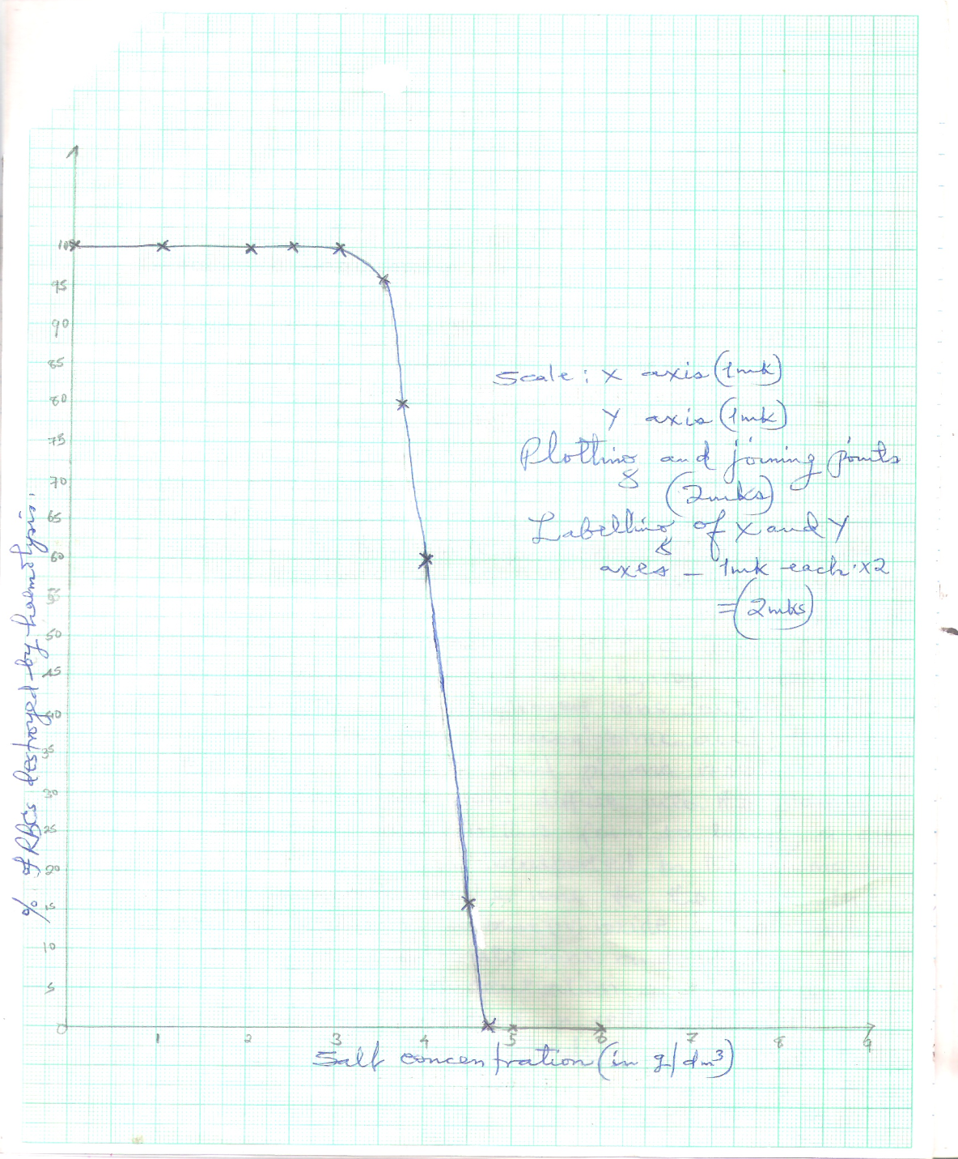

1. Haemolysis of red blood cells occurs when they are placed in a hypotonic solution;

they gain a lot of water; swell an then burst; (3 mks)

(c)(i) 4.1 g/dm3; + 0.1; (1 mk)

(ii) 3.0 g/dm3; + 1; (1 mk)

(d)(i) 4.7 g / dm3 + 0.1; (1 mk)

(ii) At 4.7 g / dm3 salt concentration; as there is no haemolysis / haemolysis was zero; (2 mks)

(iii) Isotonic solution; (1 mk)

(e) Osmoregulation; Rej. homeostasis (1 mk)

(f) - Osmosis enables movement of water from one cell to another;

- Osmosis enables closing and opening of the stomata;

- Osmosis enhances support when cells become turgid in plants;

- Osmosis enables absorption of water by the root hairs; (max 4)

8. Transport of oxygen gas.

The alveoli have a higher concentration of oxygen gas; than the blood in pulmonary capillaries; oxygen diffuses across alveoli wall, endothelium of capillaries; into red blood cells; where

it combines with haemoglobin; to form oxyhaemoglobin; a compound that dissociates easily;

it is then transported in this form to respiring tissues; in the capillaries of respiring tissues oxyhaemoglobin dissociates into oxygen and haemoglobin; Oxygen diffuse into tissue cells; along a concentration gradient.

Transport of carbon (IV) oxide.

High concentration of carbon (IV) oxide in the cells stimulates dissociation of oxyhaemoglobin in blood capillaries of the tissues; carbon (IV) oxide diffuses out of the cells tissue fluid, across the endothelium of tissue capillaries; into the red blood cells; where it combines with water to form a weak carbonic acid; which dissociates into hydrogen carbonate and hydrogen ions; hydrogen ions combine with haemoglobin to form haemoglobinic acid; thus pH of the red blood cells and plasma remains constant; the hydrogencarbonate ions diffuse into the plasma and are transported in this form to lungs; a little of carbon (IV) oxide is transported in the plasma in form of hydrogencarbonate ions to the lungs; in the pulmonary capillaries, carbon (IV) oxide is released from the hydrogencarbonate ions and diffuses into the alveoli along a concentration gradient ; the enzyme carbonic anhydrase in red blood cells speed up loading and off-loading of carbon(IV) oxide; (20 mks)

9. - It is relatively long; to increase the surface area for absorption of food and for digestion;

- Lumen has many villi per unit area to increase the surface area for absorption of food; villi have microvilli to increase the surface area for absorption of food.

- Its walls have glands which secrete enzymes that complete digestion; Acc names of enzymes.

- Walls have goblet cells; which secret mucus; for lubrication of food / walls; and to protect the walls from digestive enzymes ;

- Presence of circular and longitudinal muscles; that allow mixing of food by periotalsis;

- It is coiled / folded; to slow down movement of food / to give food enough time for digestion;

- Intestines are richly supplied with blood; to supply oxygen and carry away digested food;

- It has lacteals; for transport of fats / lipids.

- Their walls are thin / thin epithelium; for faster diffusion / absorption of food; (max 20 mks)

PRINTED AND COMPILED BY PERFECT STEPS PUBLISHERS: 0721 745374/0721707626 NAIROBI

## PERFECT STEPS PUBLISHERS

END TERM EXAMS 2015

**0721 745374/ 0721 707626 NAIROBI**

231/3

BIOLOGY PP3 (PRACTICAL)

CONFIDENTIAL

**Requirement for school:**

**Each candidate should be provided with:**

**Question 3.**

1. Iodine solution.
2. 10% Sodium hydroxide.
3. 1% Copper(II) sulphate solution.
4. 4 test-tubes on a test-tube rack.
5. DCPIP.
6. 10 ml measuring cylinder.
7. 50ml solution of substance P.
8. Distilled water in a wash bottle.

NB: Substance P is prepared by mixing egg albumin, squeezed orange juice, maize flour and water then made into a solution whose volume is based on the number of students one has.

231/3 (PRACTICAL)

BIOLOGY PP3 FORM 3 2015

1. a) Use the photograph of plant experiments below to answer the questions that follow.

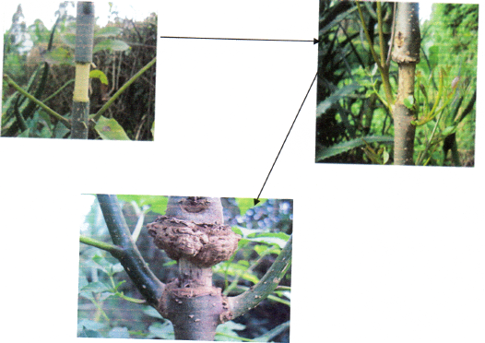

i) Name the process being investigated. (1 mk)

ii) Name the plant tissue involved in the physiological process illustrated above. (1 mk)

iii) Name the physiological process involved in the process illustrated above. (1 mk)

iv) How is the plant tissue named in 1 (a) (ii) above adapted to its function. (3mks)

b) Study photographs C and D and answer the questions.

Photograph C Photograph D

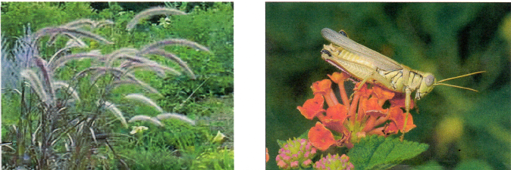

i) With a reason state the agent of pollination of each of the flowers. (4 mks)

ii) Classify the animal in photograph D using the taxonomic units below and reasons for your answer (4 mks)

**Taxonomic unit Reason**

Phylum ………………… …………………………………………………

Class……………………. …………………………………………………...

2. Below are photographs of specimen labelled L and M which were obtained from different animals.

Examine them.

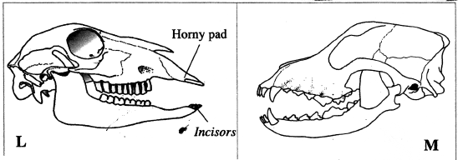

a) Suggest the diet of each of the animals whose skulls are shown in the diagram. Give reasons for your answer (6 mks)

……………………………………………………………………………………………………………………………………………………………………………………………………………………………………………………………………………………………………………………………………………………………………………………………………………………………………………………………………………………………………………

b)Write the dental formula of the animal whose skull are shown in diagrams L and M. (2 mks)

……………………………………………………………………………………………………………………………………………………………………………………………………………………………………………………………………………………………………………………………………………………

c) Examine the following diagrams labelled E and F.

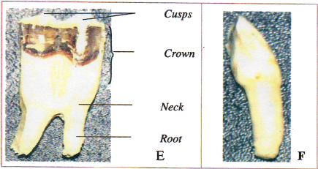

i) With reasons identify E and F

Identify E (1 mk)

……………………………………………………………………………………………..

Reasons (2 mks)

Identify F (1 mk)

…………………………………………………………………………………………………

Reasons (2 mks)

3. You are provided with a sample of food labelled P in solution form. Using the reagents, carry out tests on the food sample to identify the type of food substances present. (12 marks)

|  |  |  |  |
| --- | --- | --- | --- |
| **Food substance** | **Procedure** | **Observation** | **Conclusion** |
|  |  |  |  |
|  |  |  |  |
|  |  |  |  |

PRINTED AND COMPILED BY PERFECT STEPS PUBLISHERS: 0721 745374/0721707626 NAIRO

231/3 BIOLOGY PP3 2015 MARKING SCHEME

1. (a) (i) Translocation

(ii) Phloem tissue

(iii) Active transport/mass flow through diffusion.

(iv) - Have sieve plates that support the phloem tissue.

- Have sieve pores that acts as a pathway to allow movement of materials.

- Sieve tubes are cylindrical and joined end to end interconnected by cytoplasmic filaments.

- Sieve elements lack other cell components like nuclears.

- Has companion cells that have numerous mitochondria to supply energy needed for active transport.

- Presence of plasmodesmata between sieve elements and companion cells to facilitate movement of materials between.

(b) (i) C wind – Inconspicuous petals/large anthers loosely attached to flexible filaments/long feathery stigma which hang outside the flower.

D – Insect – Large flowers with brightly coloured petals/produce nectar (insect on diagram)

Reason

(ii) Phylum Arthropoda - Jointed appendages/presence of exoskeleton/segmented body/

3 body parts (2 mks)

Class Insecta - 3 body parts/ A pair of antennae pair of compound

eyes/spiracles for breathing.

1. (a) Skull L. Vegetation. (1 mk)

**Reasons**

(i) Presence of diastema

(ii) Presence of horny

(iii) Pronounced cusps/ridges in the molars for grinding vegetation

Skull M – Flesh. rej. carnivorous

**Reasons**

* Pronounced long curved sharp/pointed canines for grasping/grinding/tearing prey.
* Carnassial teeth for cutting and crushing bones.

(b) I $\frac{0}{3}$ C $\frac{0}{1}$ PM $\frac{3}{3}$ M $\frac{3}{3}$ = 32

M I $\frac{3}{3}$ C $\frac{1}{1}$ PM $\frac{4}{4}$ M $\frac{2}{3}$ = 42

(c) E – Molar tooth

**Reasons**

* Has two roots
* Cusps

F - Canine

**Reasons**

- Sharp

- Has one root

3.

|  |  |  |  |
| --- | --- | --- | --- |
| Food substance being tested | Procedure | Observation | Conclusion |
| Protein | To 2ml of food substance P, add equal amounts of Sodium Hydroxide solution.  Shake then add Copper (II) Sulphate dropwise | Colour changes to purple | Protein present |
| Ascorbic acid/Vitamin C | To 1cm3 of DCPIP in a test tube, add the food substance dropwise | DCPIP decolourises | Ascorbic acid present |
| Starch | Put 1cm3 of substance P into a test tube. Add 3 drops of iodine solution | Colour changes to blue black/blue/black | Starch present |
|  |  |  |  |

PRINTED AND COMPILED BY PERFECT STEPS PUBLISHERS: 0721 745374/0721707626 NAIROBI

## PERFECT STEPS PUBLISHERS

END TERM EXAMS 2015

**0721 745374/ 0721 707626 NAIROBI**

233/1

CHEMISTRY PP1 2015

1. . A piece of burning Magnesium was introduced into a jar of nitrogen.
2. State what was observed. (1mk)

........................................................................................................................................................................................................................................................................................................

1. Write an equation for the reaction that took place. (1mk)

…………………………………………………………………………………………

1. Describe how a solid sample of dry Lead (II) Carbonate can be prepared using the following reagents: dilute nitric acid, lead(II) Oxide and Sodium carbonate.(3mks)

…………………………………………………………………………………………………………………………………………………………………………………………………………………………………………………………………………………………………………………………………………………………………………………………………………………………………………………………………………………………………………...

1. Cyanogen is a gaseous compound of carbon and nitrogen only. On complete combustion is oxygen, 250cm3 of cyanogen from 500cm3 of Carbon (IV) Oxide and 250cm3 of nitrogen. Determine the formula of cyanogen. (2mks)

........................................................................................................................................................................................................................................................................................................................................................................................................................................................................................................................................................................................................................

1. Substance L, M, N and P has the following properties.

|  |  |  |  |  |
| --- | --- | --- | --- | --- |
| Substance | M.P. | Solubility in water | Electrical conductivity | |
| Solid state | Liquid state |
| L | Low | Soluble | Does not | Does not |
| M | High | Soluble | Does not | Conducts |
| N | High | Soluble | Conducts | Conducts |
| P | High | Insoluble | Does not | Does not |

1. Select the letter which represents a substance which is suitable for making kettle handles (1mk)

……………………………………………………………………………………………………………………………………………………………………………………………………

1. Which letter represents a substance which is likely to be sodium chloride? (1mk)

…………………………………………………………………………………………………

1. Name the bond structure and bond type likely to be in L. (1mk)
2. Bond structure…………………………………………………………
3. Bond type ……………………………………………………………
4. (a) The atomic number of Sulphur, hydrogen and oxygen are 16, 1 and 8 respectively. Write the electron arrangement of Sulphur in the following substances.

(i) H2S…………………………………………………………………… (1/2mk)

(ii) SO32-……………………………………………………………………. .(1/2mk)

(b) State the number of neutrons and electrons in the species of Aluminium shown below:



Neutrons ……………………………………………………………

(1mk)

Electrons …………………………………………………………… (1mk)

1. The set-up **below** was used to prepare dry chlorine gas. Study and answer the questions that follow

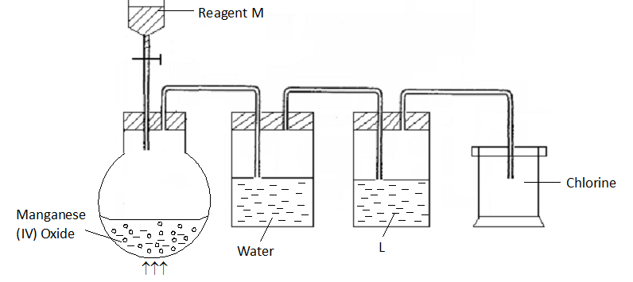

1. Name reagents **M** and substance **L**  (2mks)

…………………………………………………………………………………………………………………………………………………………………………………………………………………………………………………………....................

1. A warm red phosphorus was lowered into the gas jar of chlorine using a deflagrating spoon:
2. State any **one** observation made in this experiment. (1 mk)

……………………………………………………………………………………………………………………………………………………………………………………..

1. Identify the substance formed in the above reaction. (1 mk)

………………………………………………………………………………………..

1. Both substances in **(ii) above** undergo hydrolysis when exposed to air. Write an equation to show how anyone of them undergoes hydrolysis. (1mk)

………………………………………………………………………………………………………………………………………………………………………………………………………………………………………………………………………………………………………

1. The set up of diagram shown **below** is used to prepare dry nitrogen gas from air. Study it and answer the questions that follow.

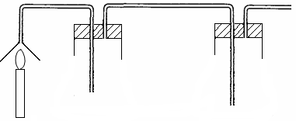

Burning candle

Sodium hydroxide

solution

Drying agent

Suction pump

1. What is the purpose of using:
2. A burning candle. (1 mk)

………………………………………………………………………………….

(ii) Sodium hydroxide solution. (1mk)

...........................................................................................................................................................................................................................................................................................................

1. Name:
2. **One** impurity present in nitrogen gas prepared. (1 mk)

…………………………………………………………………………………………………………………………………………………………………………………….

1. A suitable drying agent used (1mk).

…………………………………………………………………………………………...........................................................................................................................................

(i) Using a dot (**.**) and cross (x) show how  ion is formed from NH3 molecule and H+ ion. (2 mks)

…………………………………………………………………………………………………………………………………………………………………………………………………………………………………………………………………………………………………………………………………………………………………………………………………………………………………………………………………………………………………………….

1. State the type of bond that exists between the NH3 and H+ ion. (1 mk)

……………………………………………………………………………………………………………………………………………………………………………………………………

(iii) Molecular substances have low melting points. Give **one** reason why they have low melting points. (1 mk)

…………………………………………………………………………………………………………………………………………………………………………………………………...

1. The following diagrams show the structure of two allotropes of carbon. Study them and answer the questions that follow.

**A B**

(a) Name the allotropes. A and B . (1mk)

……………………………………………………………………………………………………………………………………………………………………………………………………

(b) Give **one** use of **A**. (1mk)

...........................................................................................................................................................................................................................................................................................................

(c)Which allotrope conducts electricity? Explain. (2mks)

………………………………………………………………………………………………………………………………………………………………………………………………………………………………………………………………………………………………………………………

1. Give **two** reasons why helium is used in weather balloons. (2mks)

………………………………………………………………………………………………………………………………………………………………………………………………………………………………………………………………………………………………………

1. Ammonia is produced in large scale by Haber process.
2. Write an equation for the formation of ammonia gas (1mk).

……………………………………………………………………………………………………………………………………………………………………………………

1. State **two** optimum conditions for obtaining a high yield of ammonia in the process. (2 mks)

…………………………………………………………………………………………………………………………………………………………………………………………………………………………………………………………………………………………………………………………………………………………………………..

1. When a hydrated sample of calcium sulphate CaSO4**.**xH2O was heated until all the water was lost, the following data was recorded:

Mass of crucible = 30.296 g

Mass of crucible + hydrated salt = 33.111 g

Mass of crucible + anhydrous salt = 32.781 g

Determine the empirical formula of the hydrated salt

(CA = 40, S = 32, O = 16 H = 1) (3mks)

……………………………………………………………………………………………………………………………………………………………………………………………………………………………………………………………………………………………………………………………………………………………………………………………………………………………………………………………………………………………………………

1. Zinc reacts with both concentrated and dilute sulphuric (VI) acid. Write equations for the two reactions. (2mks)

…………………………………………………………………………………………………………………………………………………………………………………………………………………………………………………………………………………………………………………………………………………………………………………………………………..

1. Samples of urine from three participants F, G and H at an international sports meetings were spotted onto chromatography paper alongside two from illegal drugs A1 and A2. A chromatogram was run using methanol. The figure below shows the chromatogram.

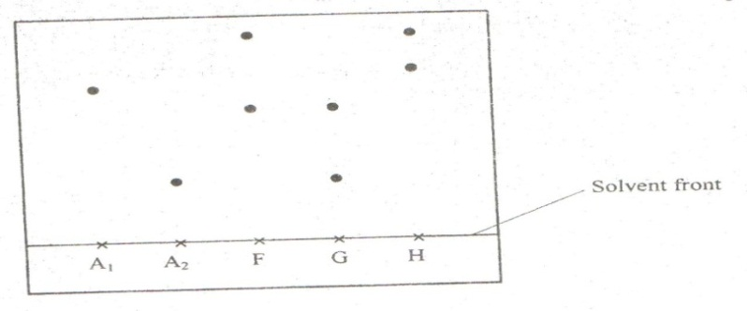

1. Identify the athlete who had used an illegal drug. (1mk)

…………………………………………………………………………………………….

1. Which drug is more soluble in methanol? (1mk)

………………………………………………………………………………………………

1. Carbon (II) oxide is described as a “silent killer”.
2. State one physical property of carbon (II) oxide that makes it a “silent killer”. (1mk)

…………………………………………………………………………………………………………………………………………………………………………………………………...

1. State and explain one chemical property that makes carbon (II) oxide poisonous to human beings. (2mks)

………………………………………………………………………………………………………………………………………………………………………………………………………………………………………………………………………………………………………

1. The diagram below represents a set up for large scale manufacture of hydrochloric acid. Study it and answer the questions that follow.

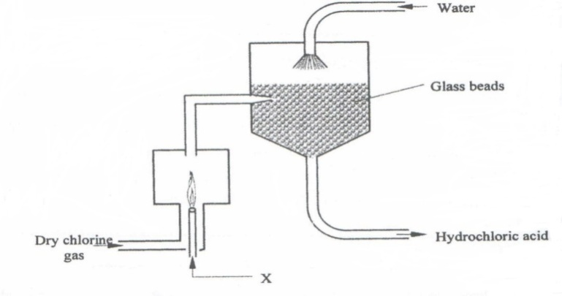

1. Name substance X. (1mk)

……………………………………………………………………………………………………………………………………………………………………………………………………

1. What is the purpose of the glass beads?(1mk)

……………………………………………………………………………………………………………………………………………………………………………………………………

1. Give two uses of hydrochloric acid.(1mk) ……………………………………………………………………………………………………………………………………………………………………………………………………............................................................................................................................................................................................................................................................................................................

16. Study the figure below and answer questions that follow.

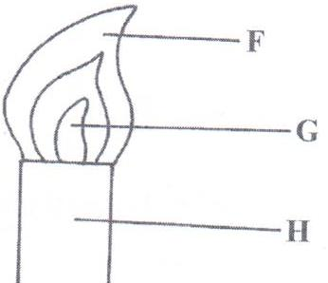

Name the parts labelled **F** and **G**. (2mks)

………………………………………………………………………………………………………………………………………………………………………………………………………………………………………………………………………………………………………

17. The table below gives information on four elements represented by K, L, M and N. Study it and answer the questions that follow. The letters do not represent the actual symbols of the elements.

|  |  |  |  |
| --- | --- | --- | --- |
| **Element** | **Electron arrangement** | **Atomic radius** | **Ionic radius** |
| K | 2, 8, 2 | 0.136 | 0.065 |
| L | 2, 8, 7 | 0.099 | 0.181 |
| M | 2, 8, 8, 1 | 0.203 | 0.133 |
| N | 2, 8, 8, 2 | 0.174 | 0.099 |

1. Which **two** elements have similar chemical properties? Explain.(2mks) …………………………………………………………………………………………………………………………………………………………………………………………………………………………………………………………………………………………………....

18. Describe how a solid sample of Lead (II) Chloride can be prepared using the following reagents:

Dilute Nitric Acid, Dilute Hydrochloric Acid and Lead Carbonate. (3mks) …………………………………………………………………………………………………………………………………………………………………………………………………………………………………………………………………………………………………………………………………………………………………………………………………......

19.The diagram below shows part of Solvay Process.

M

K

N

Brine

with ammonia

Carbon (IV) Oxide

NH4Cl(aq)

NaHCO3 (s)

Solid P

Solid Y

1. Name solid P ( 1 mk)

……………………………………………………………………………………………………………………………………………………………………………………………………

1. State the process taking place in chamber N. (1mk)

…………………………………………………………………………………………………………………………………………………………………………………………………….

1. State two uses of calcium chloride which is a by-product in this process.(1mk)

…………………………………………………………………………………………………………………………………………………………………………………………………….

20.100cm3 of methane gas diffused through a porous partition in 40 seconds. How long would it take 90cm3 of ozone gas to diffuse through the same partition?( C = 12, H = 1, O = 16) (3mks)

………………………………………………………………………………………………………………………………………………………………………………………………………………………………………………………………………………………………………………………………………………………………………………………………………………………………

21.Calculate the volume of oxygen produced when 10g of silver nitrate was completely decomposed by heating at s.t.p (Ag = 108, N = 14, O = 16) Molar gas volume at s.t.p = 22.4dm3) (3 mks)

………………………………………………………………………………………………………………………………………………………………………………………………………………………………………………………………………………………………………………………………………………………………………………………………………………………………

22.The scheme below shows some reactions starting with ethyne. Study it and answer the questions that follow.

CHBrCHBr

HC≡CH

CH2CH2

Substance N

Conc.

H2SO4

Substance X

1 mole

HBr (g)

Reagent M

Pt (s)

+

Reagent Y (1 Mole)

1. Name substance X and N (2marks)

……………………………………………………………………………………………………………………………………………………………………………………………………………………………………………………………………………………………………….

1. Name reagent M ( 1 mk)

…………………………………………………………………………………………………………………………………………………………………………………………………...

1. Ethene undergoes polymerization to form a polymer. Give an equation for the reaction and name the product.(2mks)
2. Equation; ………………………………………………………………….

(ii) Name: ………………………………………………………………………

23. The table below gives some properties of three elements X,Yand Z.

|  |  |  |  |
| --- | --- | --- | --- |
| ELEMENT | Atomic No. | Meeting point(0C) | Boiling Point (0C) |
| X | 53 | 114 | 184 |
| Y | 35 | -7 | 58.8 |
| Z | 17 | -101 | -34.7 |

1. Which element is in liquid form at room temperature? Give reason. (1mk) ………………………………………………………………………………………………

………………………………………………………………………………………………

1. Explain why the boiling point of element X is higher than that of element Z.(2mks) ……………………………………………………………………………………………… ………………………………………………………………………………………………….

24.. The diagram below is a set up for the laboratory preparation of dry oxygen gas.

Sodium peroxide

Liquid X

Liquid Y

1. Name:
2. Liquid Y (1/2 mk)

…………………………………………………………………

1. Liquid X (1/2 mk)

…………………………………………………………………….

1. Write an equation for the reaction that took place in the flask.(1mk)

……………………………………………………………………………………………………………………………………………………………………………………

(c) Complete the diagram to show how dry oxygen can be collected. (1mk)

(Do it on the diagram)

25. The graph below shows how the PH value of soil in a farm changed over a period of time.

PH

2

4

6

A

B

C

D

E

Time

1. Describe how the PH of the soil can be determined.(2mks)

…………………………………………………………………………………………………………………………………………………………………………………………………...

State one factor that may have been responsible for the change in the soil PH in the time interval AB. (1mark)

…………………………………………………………………………………………………………………………………………………………………………………………………….

26. A student put calcium carbonate and calcium hydrogen carbonate in separate test tubes and performed

the tests as shown in the table below. Complete the table by giving the expected observations.(2mks)

|  |  |  |
| --- | --- | --- |
| Salt | Adding water | Heating |
| Calcium Carbonate |  |  |
| Calcium hydrogen carbonate |  |  |

**This is the last printed page.**

233/1 CHEMISTRY PP1 MARKING SCHEME 2015.

1.(a) Magnesium continued to burn with a brilliant flame producing a white ash. (1mk)

(b) 3Mg(s) + N2(g) …………………> Mg3N2(s)

(c) Take 50cm3 of nitric acid and react it with excess Lead (II)Oxide

Filter to get the filtrate

To the filtrate add Sodium Carbonate and filter to obtain Lead (II)Carbonate as the residue. (3mks)

**2.** 2.Cx Ny(g) + 2O(g) …………….> 2CO2(g) + N2(g)

250cm3 : 500cm3 500cm3 : 250cm3

1 vol : 2 vol 2Vol : 1 Vol

XC = 2C

X = 2

yN = 2N

y= 2

Formula of Cyanogen C2 N

**3.** (i) P ✓1

(ii) M ✓1

(iii) a) Simple molecular ✓1/2

b) Covalent bonds ✓1/2

**4.**  (a) (i) S16 = 2.8.6 ✓ 1/2

(ii) S12 = 2.8.2 ✓ 1/2

(b) (i) Neutron – 14 ✓1

(ii) Electron - 10 ✓1

5.**.** (a) M – Concentrated hydrochloric acid 1mk

L – Concentrated sulphuric (VI) acid 🗸1

(b) (i) It catches fire, or presence of fumes. 🗸1

(ii) PCl3 or PCl5 Phosphorus (III) chloride or phosphorus (V) chloride 🗸1

(c) 🗸1

Or 

**6.** (a) (i) It is used to remove oxygen from air. 🗸1

(ii) It removes CO2 produced by the burning candle and also from air. 🗸1

(b) (i) Argon/Neon/Krypton 🗸1

(ii) Concentrated sulphuric (VI) acid //  🗸1

H



XO

H

H

N

XO

O+

O

H+



**7.** (i)

🗸1mk

H

••

X

•

X•H

X

•

A H

B H

+

1. Dative bond/co-ordinate bond. 🗸1

Weak intermolecular forces 🗸1

1. The molecules are held by weak van de waals forces.

**8.** A – Diamond 🗸1

B – Graphite 🗸1

(b) - Drilling metals. Any 🗸1

- Jewelling.

(c) B 🗸1 Existence of developed electrons 🗸½ when transfer electricity. 🗸½

**9.** Its light/less dense. 🗸1

It’s inert/unreactive. 🗸1

**10.** (a) N2(g) + 3H2(g) 2NH3(g)

Pressures of 200 atms

Temperature of 450 $℃$ to 500 $℃$

Finely divided iron (any two)

**11.** Mass of CaSO4 = 32.781 – 30.296

= 2.485 g

Mass of H2O = 33.111 – 32.781

= 0.33 g

CaSO4 H2O

2.485 0.33

40+32+16x4 1x2+16

2.485 = 0.0183 0.33 = 0.0183

136 18

0.0183 = 1 0.0183 = 1

0.0183 0.0183

E.F = CaSO4.H2O

**12.** Zn(s) + H2SO4(aq) ZnSO4(aq) + H2(g)

(dilute)

Zn(s) + 2H2SO4(l) ZnSO4(aq) + 2H2O(l) + SO2(g

**13.**  (a) G

(b) A1

**14**. (a) It has no smell.

(b) It combines with haemoglogin to form stable carboxyhaemoglobin.This prevents the transportation of oxygen by the

haemoglobin. The victim dies as a result of lack of oxygen.

15. (a) Hydrogen gas

(b) The glass beads increase the surface area over which absorption of hydrogen chloride gas in water takes place.

(c) To standardize pH of beers and wines.

- In pickling of metals

- Manufacture of dyes and drugs

- Manufacture of photographic materials

(any one collect as above)

16.F – Thin outer region.

G – Colourless region.

(b) A2B3

17.K and N (must state two otherwise penalize). They have the same number of electrons in he outermost energy level.

- Both react by losing two electrons.

18.- Add lead (II) carbonate to nitric acid and filter.

* + - * 1. Add sulphur (VI) acid to the filtrate.
        2. Filter and dry the residue which is PbSO4 between two filter papers.

19.(a) Calcium oxide//Quickline ✓ 1 Mark

(b) Filtration//Fractional crystallization/crystallisation of NaOH3✓ 1

(c) - In the extraction of sodium metal

- Pickling

- As a drying agent

- Anti microbial agent

- Anti cracking agent

(Any to correct answers award ½ mark each)

20.Rate of diffusion of methane gas = $\frac{{100cm}^{3}}{40 sec}$ = 2.5cmsec-1 ✓ ½ mark

Let rate of diffusion of ozone be $\frac{90}{t}$ = R

Molar mass of CH4 = 12 + 4 = 16 ½ mark

Molar mass of O3 = 16 x 3 = 48

∴ =

= ✓ ½ mark

∴R = = 1.4434cm3/sec ✓ ½ mark

∴ $\frac{90}{t}$ = 1.4434 ✓ ½ mark

∴ t = $\frac{90}{1.4434}$

= 62.3528sec ✓ ½ mark

21.2AgNO3 (s) 2Ag(s) + 2NO2(g) + O2(g) (1mk)

MM

2(108 + 14 + 16 x 3) Volume of O2 22.4dm3

= 340 ✓ ½ mark

340g of silver nitrate releases 22.4dm3 of O2 ✓ ½ mark

* 10g of silver nitrate releases $\frac{{22.4dm}^{3}}{340g}$ x 10g ✓ ½ mark

= 0.6588dm3 ✓ ½ mark

22.(i) X – Bromo ethene ✓ 1 mark

N – Ethyl hydrogen sulphate ✓ 1 mark

1. M – Bromine gas ✓ 1 mark

(c) ✓ 1 mark

=

n

=

n

Polyethene ✓ 1 mark

23.aY-At room temperature (250c) Y is a liquid since its M.P and B.P lie between -7oc and 58.80c OR

(room temperature is between M.P and B.P.)

b) The molecular mass of x is higher🗸1 than that of Z; the Vander Waals forces are stronger 🗸in X molecules than in Z molecules hence X has a higher boiling point than Z.

24.a) I water 🗸 ½ mk

II concentrated sulphuric acid🗸 1/2 mk

1. 2Na2O2(s) +2H2O(l) 4NaOH(aq) +O2(g)  🗸 1

(c)

**Gas jar🗸**1/2 **mk**

**Cardboard with a hole in it.🗸**½ **mk**

25a) Add distilled🗸1/2 water to the soil sample and stir. Add 2 drops of universal indicator🗸1/2 to the

mixture and compare with the PH chart🗸1

* Extensive use of acidic fertilizers
* Pollution by acid rain. (any 🗸1

|  |  |  |
| --- | --- | --- |
| Salt | Adding water | Heating |
| Calcium carbonate | Does not dissolve | Forms a white solid |
| Calcium hydrogen carbonate | Dissolves to form a colorless solution | Forms a white solid and a colourless liquid form on the upper cooler parts of the apparatus |

26.

END M/S.

## PERFECT STEPS PUBLISHERS

END TERM EXAMS 2015

**0721 745374/ 0721 707626 NAIROBI**

233/2 CHEMISTRY PP2 FORM 3 2015.

1.The diagram below shows the effect of heat on hydrated copper (II) sulphate.



I. (a) State the observations made in tube G. (2 marks)

……………………………………………………………………………………………………………………………………………………………………………………………………………………………………………………………………………………………………….

  (b) Identify substance F. (1 mark)

…………………………………………………………………………………………………

  (c) Explain the use of the following in the above set up

(i) Ice cold water. (1 mark)

………………………………………………………………………………………………………………………………………………………………………………………………………….......

(ii) Salt in ice cold water. (1 mark)

……………………………………………………………………………………………………………………………………………………………………………………………………………...

(iii) Boiling tube G kept at a slanting position. (1 mark)

………………………………………………………………………………………………………………………………………………………………………………………………………………

  (d) Describe a chemical test for substance F. (1 mark)

……………………………………………………………………………………………………………………………………………………………………………………………………

1. 12.5g of hydrated copper (II) sulphide were heated to constant mass 8.0g of solid residue was formed. Determine the formula of the hydrated salt. (Cu=63.5, S=32.0, O=16.0, H=1.0)(3 marks)

………………………………………………………………………………………………………………………………………………………………………………………………………………………………………………………………………………………………………………………………………………………………………………………………………………………………………………………………………………………………………………………………

2. (a) Distinguish between a thermoplastic and a thermosetting polymer. (2 marks)

………………………………………………………………………………………………………………………………………………………………………………………………………………………………………………………………………………………………………

  (b)(i) Classify the following Terylene, cellulose, perspex, proteins as either Natural polymers or synthetic polymers.

  I. Natural polymers………………………………………………………..(1 mark)

II. Synthetic polymers……………………………………………………(1 mark)

(ii) Identify an addition polymer from the list given. (1 mark)

…………………………………………………………………………………………………….

  (c) Study the scheme below and answer the questions that follow.



  (i) Identify substances.

  A …………………………………………………………………… (1 mark)

C……………………………………………………………………. (1 mark)

(ii) Name processes.

  II……………………………………. _ (2 marks)

  III……………………………………

  (iii) Name a reagent used in step I. (1 mark)

……………………………………………………………………………………………….

   (iv) Draw and name the structural formula of B. (2 marks)

……………………………………………………………………………………………………..……………………………………………………………………………………………………………………………………………………………………………………………………………………………………………………………………………………………………………………………………………………………………………………………………

**3.** The grid below shows part of the periodic table. Letters given are not the actual symbols of the element.

|  |  |  |  |  |  |  |  |  |
| --- | --- | --- | --- | --- | --- | --- | --- | --- |
|  |  |  |  |  |  |  |  |  |
|  |  |  |  |  |  | P | Q | R |
| S | T |  |  |  |  | U |  | V |
| W |  |  |  |  |  |  |  |  |
|  |  |  |  |  |  |  |  |  |

  (i) Identify an element with largest atomic radius. Give your reason. (2 marks)

……………………………………………………………………………………………………..…………………………………………………………………………………………….

(ii) Atom V is heavier than atom R. Explain. (1 mark)

…………………………………………………………………………………………………..…………………………………………………………………………………………………

   (iii) Give the electron arrangement of

  W……………………………………………………………………… (1mark)

  V……………………………………………………………………….. (1mark)

(iv) Element X is in period IV and group VII

  I. Indicate its position in the grid. (1 mark

  II. State the oxidation number of its ion. (1 mark)

…………………………………………………………………………………………………………………………………………………………………………………………………..

1. Write the formula of compound formed when X is reacted with Aluminium metal.

(1 mark)

………………………………………………………………………………………………………………………………………………………………………….

  (v) Write an equation of the reaction between S and Q. (1 mark)

………………………………………………………………………………………………….

**4.** The diagram below shows a set-up that was used to prepare and collect sulphur (IV) oxide gas. Study it and answer the questions that follow.

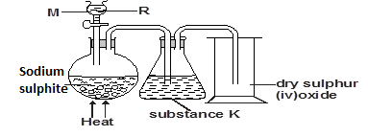

  (a) (i) Name substance R. (1 mark)

……………………………………………………………………………………………

  (ii) Name apparatus M. (1 mark)

……………………………………………………………………………………………

(iii) Write a balanced equation for the reaction between R and Sodium sulphite.(2 marks)

…………………………………………………………………………………………………………………………………………………………………………………………………….

  (iv) Why is sulphur (IV) oxide not collected by over water methods. (1 mark)

…………………………………………………………………………………………..

  (v) (i) Identify substance K. (1 mark)

……………………………………………………………………………………………

(ii) What is the function of substance K. (1 mark)

……………………………………………………………………………………………

  (b) Sulphur (IV) oxide and hydrogen sulphide react according to the equation shown below. The gases were moistened first.



  (i) Identify the oxidizing reagent. Explain your answer. (2 marks)

…………………………………………………………………………………………………….…………………………………………………………………………………………….

  (ii) What precaution should be taken during this reaction. Explain. (2 marks)

……………………………………………………………………………………………….…………………………………………………………………………………………………………………………………………………………………………………………………….

**5.** The following diagram shows the effects of heat on the physical states of substances.

(a) Identify the processes represented by the letters A, B, C, D, E and F (3 marks)

....................................................................................................................................................................................................................................................................................................................................................................................................................................................................................................................................................................................................................

  (b) Name two substances that undergo the process labelled E and F. (2 marks)

……………………………………………………………………………………………………………

(c) Name a method that can be used to extract the following:-

 (i) Common salt from a salt solution. (1 mark)

…………………………………………………………………………………………

(ii) Paraffin from crude oil. (1 mark)

………………………………………………………………………………………..

(d) A student separated liquid P (B.P 78°C) and liquid Q (B.P 100°C) wring the apparatus shown below.



  (i) Name the apparatus labelled

(a) M .......................................................................................................(1 mark)

  (b) R.........................................................................................................(1 mark)

  (ii) State one function of the glass bead in apparatus labelled R (1mark)

……………………………………………………………………………………………………………………………………………………………………………………………………

(iii) What is the reading on the thermometer when the first jar drops of the distillate appeared in the beaker. (1 mark)

…………………………………………………………………………………………………..

  (iv) Which of the liquids remains in the flask. (1mark)

…………………………………………………………………………………………………..

6.**(**a) Fractional distillation of liquid air usually produces nitrogen and oxygen as the major products.

(i) Name one substance that is used to remove carbon (IV) oxide from the air before it is changed into liquid. (1 mark)

……………………………………………………………………………………………

  (ii) Describe how nitrogen gas is obtained from the liquid air. (Boiling point nitrogen =-196°C, oxygen =-183°C) (3 marks)

…………………………………………………………………………………………………..…………………………………………………………………………………………………………………………………………………………………………………………….............

1. Study the flow chart below and answer the questions that follow.



(i) Name element M. (1 mark)

…………………………………………………………………………………………

(ii) Why is it necessary to use excess air in step 4? (1 mark)

…………………………………………………………………………………………

(iii) Identify gas Q (1 mark)

…………………………………………………………………………………………

(iv) Write an equation for the reaction in step 7. (2 marks)

……………………………………………………………………………………………………………………………………………………………………………………………..

(v) Give one use of ammonium nitrate. (1 mark)

…………………………………………………………………………………………….

  (**c)** State and explain the observation that would be made if a sample of sulphur is heated with concentrated nitric acid. (3 mark)

……………………………………………………………………………………………………..…………………………………………………………………………………………………………………………………………………………………………………………………………………………………………………………………………………………………

**7.** Study the information in the table below and answer the questions that follow. (The letters are not the actual symbols of the element.)

|  |  |  |
| --- | --- | --- |
| **Element** | **Electronic configuration** | **Ionisation energy KJmol-1** |
| J | 2 : 1 | 519 |
| K | 2 : 8 : 1 | 494 |
| L | 2 : 8 : 8 : 1 | 418 |

1. (i) What is the general name of elements J, K and L (1 mark)

………………………………………………………………………………………………………………………………………………………………………………………….

(ii) What is ionisation energy ? (1 mark)

………………………………………………………………………………………………………………………………………………………………………………………………………………

(iii) Explain why element L has lowest ionisation. (1 mark)

………………………………………………………………………………………………

(iv) When a piece of element K was placed on water, it melts a hissing sound was produced as it moves on the surface of the water. Explain these observations. (3marks)

...........................................................................................................................................................................................................................................................................................................................................................................................................................................................................................

  (v) Write an equation for the reaction between L and water. (1 mark)

…………………………………………………………………………………………………………………………………………………………………………………………………

  (b) One method of preparing salt is called neutralisation.

  (i) What is neutralization reaction. (1 mark)

…………………………………………………………………………………………………….………………………………………………………………………………………………………………………………………………………………………………………………….

(ii) Describe how you would prepare crystals of sodium nitrate starting with 200cm³ of 2M sodium hydroxide. (3 marks)

……………………………………………………………………………………………………………………………………………………………………………………………………………………………………………………………………………………………………………………………………………………………………………………………………………………………………………

(iii) Write an equation for the reaction that takes place when a solid sample of sodium nitrate is heated. (2marks)

…………………………………………………………………………………………………..…………………………………………………………………………………………………………………………………………………………………………………………………

**This the last printed page.**

## PERFECT STEPS PUBLISHERS

END TERM EXAMS 2015

**0721 745374/ 0721 707626 NAIROBI**

233/2 CHEMISTRY PP2 MARKING SCHEME

1. a) Blue copper (II) sulphate turned to white.

- Colourless liquid condenses on the cooler parts of the apparatus.

  b) Water

  c) i) Condense the vapour

  ii) Salts acts as an impurity lowers the freezing point of ice.

  iii) To prevent the condensing water from running back into the hot boiling tube and

crack it.

  d) Take a sample of substance F and add it to blue anhydrous cobalt (II) chloride which will turn to

pink.

NB: Anhydrous white copper (II)( sulphate can also be used.

II. Mass of water = 12.5 - 8.0= 4.5g ½

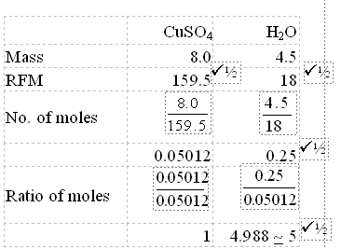

CuSO4.5H2O

**2.** (a) Thermoplastics are polymers which soften on heating and regain their original properties on cooling while Thermosetting polymers are changed irreversibly into hard and rigid materials on heating.

(b) (i) I. Natural polymers - cellulose, ½ proteins ½

II. Synthetic polymers - Terylene, ½ Perspex ½

  (ii) Perspex 1

  (c) (i) A - sodium propoxide 1

C - propane 1

  ii) II- polymerization 1

III- - cracking 1

  iii) Hydrogen bromide gas. 1

 iv)

1

propene 1

**3.** i) W, 1has more energy levels than others. 1

  ii) V has more protons and neutrons than R.1

  iii) W - 2.8.8.1 1

U - 2.8.6 1

  iv) i) Indicated two steps below Q 1

  ii) - 1 1

  iii) AlX3 1



  v) 1



**4.** a) i) dilute hydrochloric acid. 1

ii) dropping funnel 1

  iii)



iv It is soluble in water. 1

  v) Concentrated sulphuric (VI) acid 1

/H2SO4(l)

  ii) To dry sulphur (IV) oxide gas. 1

  b) (i) Sulphur (IV) oxides 1 - it gives oxygen to hydrogen sulphide oxidising it to water 1 and sulphur.

  (ii) The reaction should be done in the fume Chamber.

**5**a) A - melting ***½***

B - freezing ***½***

C - evaporation // boiling ***½***

D - condensation ***½***

E - Deposition ***½***

F - Sublimation ***½***

***award ½ mark for each correct answer***

(b) Iodine

Ammonium chloride

Solid carbon (IV) oxide

***any two correct for two marks.***

c) i) Simple distillation // evaporation method ***½***

ii) Fractional Distillation of crude oil ***1***

d) i)

a) M - Lie big condenser ***1***

b) R - fractionating column ***1***

ii) Glass beads increase surface area ***1*** in the fractionating column.

iii) 78°C ***1***

iv) Water ***1***

**6.**a) (i) KOH/NaOH /Caustic potash / soda. ***1***

(ii) - Heat / warm / ***1*** raise temperature

for the liquid air.

- Nitrogen comes out ***1*** first // distils first as it has a lower ***1*** boiling tube.

 b) (i) Hydrogen / H2 ***1***

(ii) So that all ammonia reacts ***1 //*** oxidised // to increase the yield of NO.

iii) Nitrogen (II) oxide // NO ***1***

(iv) NH3(g) + HNO3(aq) NH4NO3(aq)

(v) - Used as fertilizer ***1***

- Manufacture of explosives

 (c) Brown ***½*** gas which is NO2 white sulphur dissolves ***1***

***-*** Sulphur is oxidized ***½*** to SO2 / HSO4 ***½*** while HNO3 is reduced to NO2 ***½***

***Equation can explain***

**7. (**a) (i) Alkali metals

**(**ii) Enthalpy change when 1 mole of electrons is removed from 1 mole of gaseous atom. ***1***

(iii) It has largest atomic radius hence the outermost electrons one less attracted to the nucleus requires little energy.

(iv) Melts, because the reaction is very exothermic

* + Hissing sound, due to production of hydrogen gas.
  + Floats on water, has low density as compared to water.

(v)



  (b) (i) Neutralization reaction is a reaction between an acid and base whereby equal moles react completely.

(ii) Add 200 cm³ 2m HNO3 into 200cm³ 2M NaOH for complete neutralization evaporate // heat to concentrate the solution // saturate ***½*** Allow the mixture to cool for crystals to appear.Filter or decant to obtain crystals or any other correct method e.g. titration method.

iii) 2NaNO3(S) 2NaNO2(S) + O2(g)

## PERFECT STEPS PUBLISHERS

END TERM EXAMS 2015

**0721 745374/ 0721 707626 NAIROBI**

233/3 CHEMISTRY PP3 FORM 3 2015 (PRACTICAL)

**CONFIDENTIAL**

**EACH STUDENT REQUIRES THE FOLLOWING IN ADDITION TO THE FITTINGS AND CHEMICALS FOUND IN CHEMISTRY LAB.**

100cm3 of solution A.

100cm3 of solution B.

200cm3of solution C.

1 burette.

1 pipette and pipette filler.

3 conical flasks.

50 mls measuring cylinder.

500cm3 distilled water.

1g solid K provided in a stoppered container.

1 boiling tube.

1 filter paper.

1 filter funnel.

1g solid X.

PH indicator paper and chart.

1 red and 1blue litmus paper.

6 test tube in a test tube rack.

Phenolphthalein indicator.

ACCESS TO:

2M sodium hydroxide.

2M Ammonia solution.

Acidified potassium manganite VII.

Barium chloride solution.

Potassium iodide solution.

2M nitric acid.

**Preparations.**

1.solution A is prepared by dissolving 6.4g oxalic acid in 700cm3 of distilled water and adding water to make 1 liter of solution.

2.Solution B is 0.01M sulphuric acid.

3.Solution C is 0.1M sodium hydroxide.

4.Solid X is Succinic acid.

5.Solid K is a mixture of ZnCO3 and AgNO3 in the ratio 2:1.

## PERFECT STEPS PUBLISHERS

END TERM EXAMS 2015

**0721 745374/ 0721 707626 NAIROBI**

233/3 CHEMISTRY PP3 (PRACTICAL) 2015

1.

You are provided with

Solution A containing 6.4g/l of a dibasic acid A.

Solution B containing 0.98g per litre of solid B.

Sodium hydroxide solution C.

  You are required to:

* Determine concentration of sodium hydroxide solution C.
* Determine relative molecular mass of solid B.

Procedure I

Place solution A in a clean burette.

Using pipette and pipette filler place 25.0cm³ of solution C in a 250cm³ conical flask.

Add 2 drops of phenolphthalein indicator and titrate with solution A.

Record your results in table 1. Repeat the titration to complete the table.

|  |  |  |  |
| --- | --- | --- | --- |
| **Table 1** | I | II | III |
| Final burette reading cm³ |  |  |  |
| Initial burette reading cm³ |  |  |  |
| Volume of solution A used cm³ |  |  |  |

(4mks)

Calculate

(i) Average volume of solution A used. (1mark) ……………………………………………………………………………………………………………………………………………………………………………………………………

  (ii) Concentration in moles per litre of the dibasic acid in solution A. (1mark) (Relative molecular mass of A = 126)

…………………………………………………………………………………………………………………………………………………………………………………………………….

(iii)Moles of the dibasic acid used. (1mkark)

………………………………………………………………………………………………………………………………………………………………………………………………………………………………………………………………………………………………………

* + 1. Moles of sodium hydroxide that reacted with the dibasic acid. (1 mark)

......................................................................................................................................................

.......……………………………………………………………………………………………..

1. Concentration of sodium hydroxide in moles per litre. (1 mark)

……………………………………………………………………………………………………………………………………………………………………………………………………

PROCEDURE II

Using a measuring cylinder place 25cm³ of solution B in a conical flask. Using a pipette and pipette filler add 25cm³ of solution C. Into solution B in the conical flask (NaOH is added in excess)

Add 2 drops of phenolphthalein indicator to the contents of the conical flask and titrate with solution A.

Record your results in table 2.

Repeat the procedure two more times to complete the table 2 below.

|  |  |  |  |
| --- | --- | --- | --- |
| **Table 2** | I | II | III |
| Final burette reading cm³ |  |  |  |
| Initial burette reading cm³ |  |  |  |
| Volume of solution A used cm³ |  |  |  |

(4 marks)

Calculate:

1. Average volume o0f solution A used. (1 mark)

……………………………………………………………………………………………………………………………………………………………………………………

1. Moles of the dibasic acid used. (1 mark)

…………………………………………………………………………………………………………………………………………………………………………………….

1. Moles of sodium hydroxide that reacted with the dibasic acid. (1 mark)

……………………………………………………………………………………………………………………………………………………………………………………

1. Moles of sodium hydroxide that reacted with 25.0cm³ of B in solution. (1 mark)

…………………………………………………………………………………………………………………………………………………………………………………………………………………………………………………………………………………………………………………………………………………………………………………………………………………………………………………………………..

  (b) Given that 1 mole of B reacts with 2 moles of sodium hydroxide, calculate.

1. Number of moles of B in 25cm³ of solution B. (1 mark)

………………………………………………………………………………………………………………………………………………………………………………

1. Concentration in moles per litre of solid B in solution B. (1 mark)

………………………………………………………………………………………………………………………………………………………………………………

1. Relative molecular mass of B. (1 mark)

………………………………………………………………………………………………………………………………………………………………………………………………………………………………………………………………………

**2.** You are provided with solid K. Carry out the following tests in order to determine the cations or anions present in solid K. Record your observations and inferences in the spaces provided.

1. Place all solid K provided in a boiling tube. Add about 10cm³ of distilled water, shake well and filter the mixture and, retain both the filtrate and the residue.

|  |  |
| --- | --- |
| **Observations** | **Inferences** |
| ( 2½ Mk) | (1½ Mk) |

(b) Divide the filtrate into two portions

  (i) To the 1st portion add potassium iodide solution (1 to 2 drops)

|  |  |
| --- | --- |
| **Observations** | **Inferences** |
| ( 1 Mk) | ( 1 Mk) |

(ii) To the 2nd portion add 3 drops of barium chloride solution followed by excess ammonia solution

|  |  |
| --- | --- |
| **Observations** | **Inferences** |
| ( 1 Mk) | ( 1 Mk) |

1. Transfer all the residue into a boiling tube and add about 10cm³ of dilute nitric acid, and divide the resulting mixture into 2.

(i) To portion 1 add sodium hydroxide dropwise till in excess.

|  |  |
| --- | --- |
| **Observations** | **Inferences** |
| ( 1 Mk) | ( 1 Mk) |

(ii) To portion 2 add aqueous ammonia dropwise till in excess.

|  |  |
| --- | --- |
| **Observations** | **Inferences** |
| ( 1 Mk) | ( 1 Mk) |

**3.** You are provided with solid X. Carry out the following tests and fill your observations and inferences in the table below.

  (a) Put all solid X into a boiling tube and add about 10cm³ of distilled water. Divide the solution into 3 portions.

|  |  |
| --- | --- |
| **Observations** | **Inferences** |
| ( 1 Mk) | ( 1 Mk) |

(i) Test portion 1 with litmus papers

|  |  |
| --- | --- |
| **Observations** | **Inferences** |
| ( 1 Mk) | ( 1 Mk) |

(ii) Test the pH of portion 2

|  |  |
| --- | --- |
| **Observations** | **Inferences** |
| ( 1 Mk) | ( 1 Mk) |

(iii) To portion 3 add two to three drops of acidified potassium manganate VII.

|  |  |
| --- | --- |
| **Observations** | **Inferences** |
| ( 1 Mk) | ( 1 Mk) |

233/3 CHEMISTRY PP3 MARKING SCHEME

* + - 1. **TABLE 1** . . . . . . . . . . . (4 marks)

Distributed as follows.

 (a) Complete table . . . . . . . . .(1 mark)

Penalise wrong arithmetic, inverted table and burette readings beyond 50cm³ unless explained or burette readings below 0.1 cm³

For each penalise ½ mark to a maximum of ½ mark

 (b) Decimal . . . . . . . . . (1 mark)

(Tied to 1st and 2nd rows only)

Conditions

Accept either 1 or 2 dp used consistently

If 2dp and 2nd d.p should be 0 or 5

Accept inconsistency in the use of zero i.e. 0.0, 0.00

 (c) Accuracy . . . . . . . . (1 mark)

Compare the students readings with teacher's values (S.V)

If at least one reading ± 0.1 to S.V. . . . . 1

- If not with ± 0.2 of S.V. . . . . . . 0 mark

mark

If any reading is within ± 0.2 of S.V . . . . . ½ mark

If none of the reading is within ±0.2 of S.V. . . . . . 0 mark

 (d) Principle of averaging . . . . . . . .(1 mark)

Values averaged must be ± 0.2 of each other otherwise award 0 mark

One titration done . . . . . 0 mark

Answer must be given to at least 2.d.p

If values averaged are inconsistence . . . . . 0 mark

If there is wrong arithmetic in the table used credit the correct value.

  Final accuracy . . . . . .. (1 mark)

Compare candidates correct average titre with S.V and award as follows.

- If within ± 0.1 of S.V. . . . . . . .(1 mark)

- If not within ± 0.1 is S.V . . . . . . (1 mark)

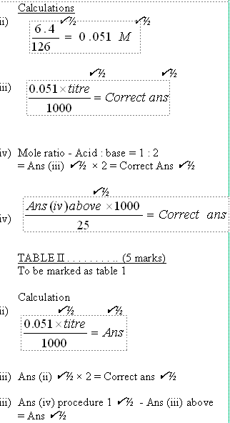

b



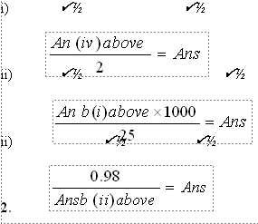

2.

|  |  |  |  |
| --- | --- | --- | --- |
| OBSERVATION | | | INFERENCES |
| a) |  | Colourless filtrate ***✓½*** white residue***✓½*** | K. Contains a ***✓½*** soluble - and insoluble salt ***✓½*** ***2 marks*** |
| b) | i) | No yellow ppt formed ***✓1*** | Pb2+ absent ***✓1 2 marks*** |
|  | ii) | White ppt :***✓½***  ppt dissolve in excess ammonia solution ***✓½*** | Ag+ present ***✓1 2 marks*** |
| c) |  | Bubbles // Effervescence fizzing ***✓1*** | CO2-3 ***✓1*** present ***2 marks*** |
|  | i) | White ***✓½*** ppt soluble in excess ***✓½*** | Zn2+, Al3+, Pb2+ present All 3 ***✓1 Only 2 ✓½ Only 1 - 0 mark 2 marks*** |
|  | ii) | White ppt, ***✓½*** soluble in excess ***✓½*** | Zn2+ present ***2 marks*** |

3.

|  |  |  |
| --- | --- | --- |
|  | OBSERVATIONS | INFERENCES |
| a) | Dissolve to form a colourless solution | -Polar compound ***✓1*** // soluble organic compound **2** |
| i) | Blue litmus turn paper turn to red ***✓½***  Red litmus paper remain red ***✓½*** | H+ // H3O+ // Acidic solution ***✓1* 2** |
| ii) | pH 5 ***✓1*** | Weakly ***✓1*** acidic reject weak acid. ***✓1* 2** |
| iii) | Potassium managanate (VII) is decolourised ***✓1 //*** Potassium manganate VII  turn from purple to colourless | ***✓½***   - C=C-,-C=C- R - OH ***✓½*** Present. **2** |