KAHUHO UHURU HIGH SCHOOL
END OF YEAR 2016 EXAM
FORM 3: BIOLOGY
TIME 2 HOURS
INSTRUCTION: The paper contains three sections A, B and C. answer all questions in all sections on the spaces provided.
Section A
1. Where is glycogen stored in the human body. ( 2mks)

2. State two ways in which a red blood cell differs from other animal cells. (2mks)

3. State two functions of the malpighian layer of the epidermis. (2mks)

4. State three differences between osmosis and active transport. (3 mks)

5. Which two hormones exert their effect in the nephron? (2 mks)

6. What is meant by the terms
- Haemolysis?

- Plasmolysis?

7. The scientific name for French bean is pharseolusvulgaris.
i) What taxon does the term phaseolus represents. ( 1mk)

ii) In which kingdom does French bean belong. (1 mk)

8. Name two glands that secret amylase enzyme. (2mk)

9. Differentiate between respiration and respiratory surface. (2 mks)

10. A man’s urine gave a positive reaction with Benedict’s solution. Name the disease he was suffering from. (1mks)

11. A student collected an organism in the school compound and noted it had a segmented body and two pairs of legs per body segment. Name the class to which the organism belongs. (1 mks)

12.(a) State the functions of the condenser in a light microscope. (1mks)

b) State the functions of the centriole. (2 mks)

c) State the functions of the nucleolus. (1 mk)

13. Distinguish between transpiration and guttation. (2 mks)

14. Distinguish between respiratory quotient and oxygen debt. (2 mks)

15. A flower was found to have the following characteristics.
- Inconspicuous petals
- Long feathery stigma
- Small, light pollen grains
a) What is the likely agent of pollination of the flower? (1 mk)

b) What is the significance of the long feathery stigma in the flower? (1mk)
16(a) What is the main characteristics that is common between the members of the class Aves and the class Mammalia. (1 mk)

17. Name the trophic level that is occupied by the following organisms.
a) Green plants

b) Zebra

18. Give three ways of how water pollution can be controlled. (3 mks)

19. Define population density? (1 mk)

20. What is the role of respiration in living organisms? (2 mks)

21. The diagram below shows how blood glucose in mammalian blood is regulated.
Pancreas secrets
Hormone x
Fall
Rise

Normal glucose level 90mg/100ml
Normal glucose level 90mg/100ml

Fall
Less Hormone X secreted
Hormone Y released
Rise

- Name the hormone X and Y. (2 mks)
X:
Y:

- State two ways by which Hormone X lowers glucose level in the blood when it rises above 90mg/100ml. (2 mks)

- Name the organ that produces hormone Y. (1 mk)

Suppose there is a deficiency of Hormone X, state the disease the person would suffer from (1 mk)

e) Explain how the disease named in (d) above can be controlled (2 mks)

22. The diagram below represents part of a gaseous system in a grasshopper.

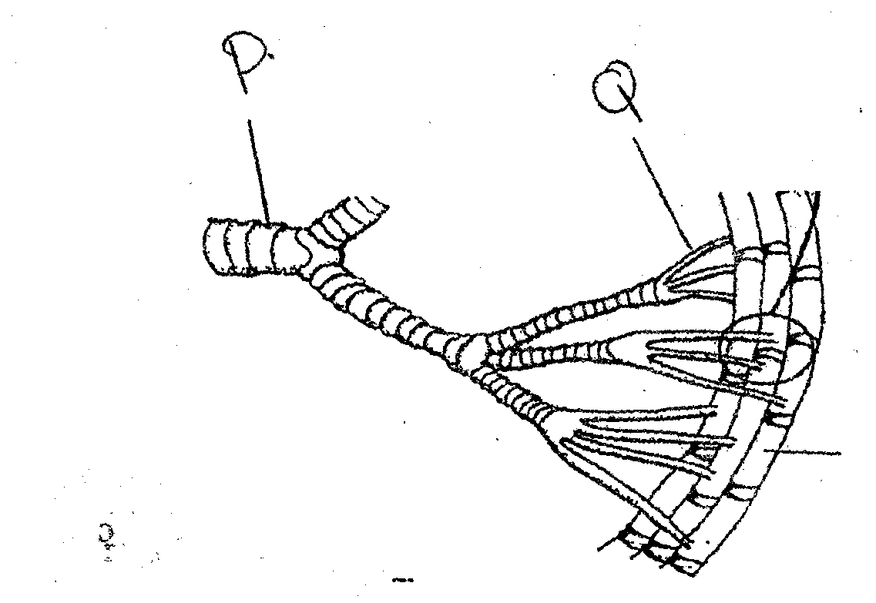
- Name the structures labeled P and Q.
P (1 mk)

Q ( mk)

- State the function of the part labeled P. (1 mk)

- Describe the path taken by carbon (IV) oxide from the tissues of the insects to the atmosphere. ( 3mks)

- How the structures is labeled Q adapted to its function. (2 mks)

23. A drop of blood was placed in each of the three test tubes A, B and C. The conditions in each test tube were as follows:
A – 1cm³ of distilled water
B – 1cm³ of 0.85 sodium chloride solution (Isotonic with blood plasma)
C- 1cm³ of 1.70% sodium chloride solution.

(a) What physiological process was being investigated? (1 mk)

(b)(i) From which test tube were red blood cells observed. ( 1mk)

(ii) Give a reason for your answer in b(i) above. (2 mks)

c)(i) What observation was made of the appearance of red blood cells on the slide prepared from tube C? (1mk)

ii) Give a reason for your answer in c(i) above. (2 mks)

d) What is the functions of red blood cells in human blood. (1 mk)

24. The equation below shows a chemical reaction that takes place in green plants under certain conditions.
Carbon (IV) oxide + water Glucose +X

(a) What is the name of substance x? (1 mk)

b) Other than the reagents, state two conditions necessary for this reaction. (2 mks)

(i)
ii)
c) Name two types fo cells in which this process occurs. (2 mks)

d) Name the process represented by the equation given above. ( 1mk)

- State two importance of the above process. (2mks)

25. An experiment was carried out to investigate the number and distribution of stomata on two different leaves. The results are shown in the table below.
Leaf | Number of stomata on
 | Lower epidermis | Upper epidermis
H | 9 | 1
J | 0 | 20

a)(i) Suggest the type of plant from which the leaves were obtained according to their habitats. (2 mks)
Leaf Type of plant
H
J
(ii) State the structural modifications found in the stomata of the leaf H. (2 mks)

b) Describe how you can estimate the population of grasshoppers in a given area using capture –recapture method. (4 marks)

26.(i) Explain how the testes are adapted to their functions (2mks)

ii) Describe the role of hormones in the human menstrual cycle
(18 mks)

