GATITU MIXED SECONDARY SCHOOL
THIRD TERM 2015
FORM 3 CHEMISTRY ENDTERM EXAM

- The diagram below represents a human foetus in a uterus
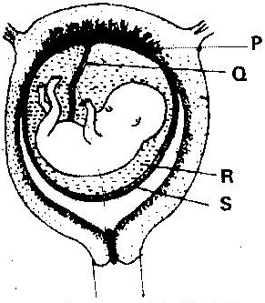

(a) Name the part labeled S (1 mark)
(b) (i) Name the types of blood vessels found in the structure labeled Q ( 2 marks)

(ii) State the difference in composition of blood in the vessels named (b) (i) above(2 marks)

- Name two features that enable the structure labeled P carry out its function ( 2 mark)

- State the role of the part labeled R ( 1 mark)

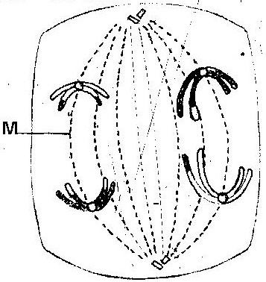
- The diagram below represents a stage during cell division

(a) (i) Identify the stage of cell division ( 1 mark)
(ii) Give three reasons for your answer (a) (i) above ( 3 marks)
(b) Name the structure labeled M ( 1 mark)
- State two disadvantages of sexual reproduction in animals ( 2 marks)
- What is meant by the following terms?
(i) Protandry ( 1 mark)
(ii) Self- sterility ( 1 mark)
- The diagram below shows a stage during fertilization in plant
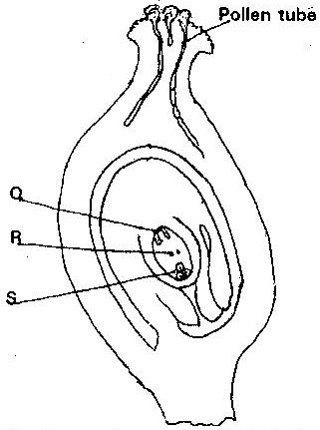

(i) Name the parts labeled Q, R, and S ( 3 marks)

(ii) State two functions of the pollen tube ( 2 marks)

- On the diagram, label the micropyle ( 1 mark
- Describe the role of each of the following hormones in the human menstrual cycle.
(i) Oestrogen

(ii) Progesterone

(iii) Luteinizing hormone (3 marks)

- Describe the role of hormones in the human menstrual cycle (12 marks)

- What part does the placenta play in the
- Nutrition of the embryo

(ii) Protection of the embryo ( 4 marks)

- Explain why several auxiliary buds sprout when a terminal bud in a young tree is removed (2mks)

- Account for loss in dry weight of cotyledons in a germinating bean seed (2mks)

- What is the effect of gibberellins on shoots of plants? (2mks)

- A student set up an experiment as shown in the diagram below
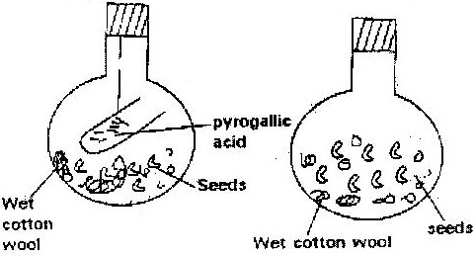

The set up was left at room temperature for a week
- What was the aim of the experiment? (2mks)

- What would be the expected results at the end of the experiment and why? (3mks)

- State two advantages of metamorphosis to the life of insects (2mks)

- During germination and early growth, the dry weight of endosperm decreases while that of the embryo increases. Explain (3mks)

- In an experiment, a group of student set up four glass jars as shown in the diagram below jar A, B and C were maintained at 25⁰C for 7 days. While Jar D was maintained at 0⁰ c for the same period of time.
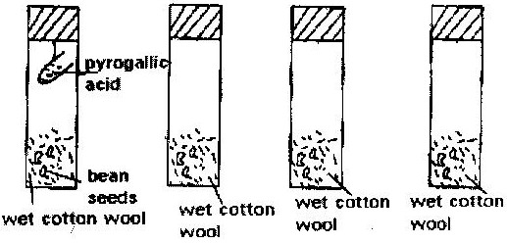

- What was this set up supposed to investigate? (1mk)

- Why was pyrogallic acid included in glass jar A? (2mks)

- Explain why glass jar C and D were included in the experiment (2mks)

- What result would you expect in glass jar A and B at the end of the experiment? (2mks)

- State two artificial ways of breaking seed dormancy (2mks)

Marking scheme (70mks)
1. a) Amnion
b) i) – Umblical vein
- Umblical artery
ii) – Umblical vein – rich in nutrients and oxygen.
- Umblical artery – rich in CO₂ and waste like urea.
c) - Has thin membrane to reduce diffusion distance.
- Has villi which increase surface area for exchange.
- Highly vascularized.
d) - Cushions foetus against shock
- Supports the foetus
- Keeps foetus moist (prevent dehydration)
2 a) i) Anaphase I
ii) - Homologous chromosomes separate at the equator.
- Chromosomes start migrating to opposite poles
- Sister chromatids attached at the centromere.
b) Spindle fibers.
3. - Harmful characteristics from the parents may be passed on to the off springs.
- Takes a longer time
- Few offsprings are produced at a time.
4. a) i) Protandry Stamens mature and pollen grains are shed off before the stigma matures.
ii) Self sterility Pollen grains from the anthers cannot grow on the stigma of the same flower or plant.
b) i) Q- Antipodal cells
R- Polar body / polar nucleus
S- Egg cell
ii) Path through which the male gametes reach the embryo sac to enhance
fertilization.
iii) Prevent other pollen grains from developing into pollen tubes hence no multiple fertilization of embryo sac.
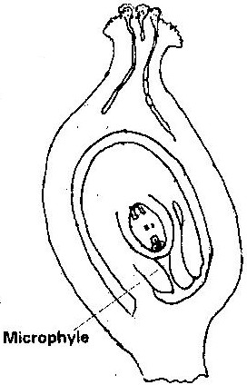
c)

5. a) i) Large brightly coloured corolla / inflorescence / forests / tracts to
attract insects.
ii) Scented to attract insects
iii) Have secreted nectar to attract that direct flowers secrete nectar to
attract insects.
iv) Pollen grains rough/spiky sticky surface to stick on insect’s body.
v) Special shaped corolla tube to enable the insect land.
b) i) Repair / heal endometrium / wall of uterus, which is destroyed in
menstruation. Stimulates pituitary gland to produce the luteinising hormone
ii) Stimulates the thickening of the uterus, increases the blood supply
to the endometrium. Inhibits the production of follicle stimulating hormone
iii) Responsible for maturation of the graafian follicle / causes
ovulation. Stimulates corpus luteum to secrete progesterone.
6. - Interior lobe of pituitary glands secretes follicle stimulating hormones (FSH).
FSH causes Graafian follicle to develop in the ovary. It also stimulates tissues of ovary / all of graafian follicle to secrete oestrogen.
- Oestrogen causes repair /healing of uterine wall; oestrogen stimulates interior lobe of pituitary to produce Luteinsing Hormone which causes ovulation. It also causes graafian follicle to change into corpus luteum and stimulates corpus luteum to secrete progesterone.
- Progesterone causes proliferation of uterine wall in preparation for implementation.
Oestrogen/progesterone inhibits the production of FSH by interior lobe of pituitary thus no more follicles develops and production reduces.
- In the next two weeks, progesterone level lowers and inhibits production of LH
from interior lobe of pituitary.
- The corpus luteum stops secreting progesterone and menstruation occur when
the level of progesterone drops. Interior lobe of pituitary start secreting FSH again.
7. i) It forms a large surface area for the diffusion of nutrient from the maternal
blood to the foetal blood. Glucose, amino acids and salts are transferred.
ii) The placenta isolates the foetus from the higher blood pressure of the mother and from direct connection of the two blood systems. Excretion materials can easily pass from foetus to mother.

- IAA /auxins produced by terminal bud; inhibits growth of lateral buds, when cut the
suppression cease thus auxiliary buds sprouts.
9. Food stored is used in (mobilized) up for respiration and growth.
10. - They promote cell division
- Promote fruit formation without fertilization/ parthenocarpy.
11. a) Oxygen is necessary for germination
b) Germination in B, no germination in A.
12. The adult and larvae exploit different food riches; do not compete for food.
13. Endosperm material was converted into new cytoplasm/ the stored food endosperm is used up to the germination seed while the embryo is growing and adding on more protoplasm.
14. a) Condition necessary for the germination of seed /to show that water, oxygen and
warmth are needed for germination.
b) To absorb all oxygen from the jar
c) C- to show water is needed for germination of seeds.
d) Jar A – seeds would not germinate
Jar B – seeds would has germinated
e) i) Scarification i.e. scratching to make impermeable seed coat permeable
ii) Varnilasation – Cold treatment e.g. species of wheat.
15. a) Apical bud produce auxins which inhibits the development of lateral buds.
Removal of terminal buds cause the growth and development and sprouting of lateral buds.
b) The pruning of coffee/tea.
c) More yield /production
16. a) Low oxygen and increase in CO₂
b) Germinating seeds respire using O₂ and release CO₂ only.
c) Absence of light, impermeability of seed coat to water, immature embryo, lack of growth hormones presence of inhibitors.

