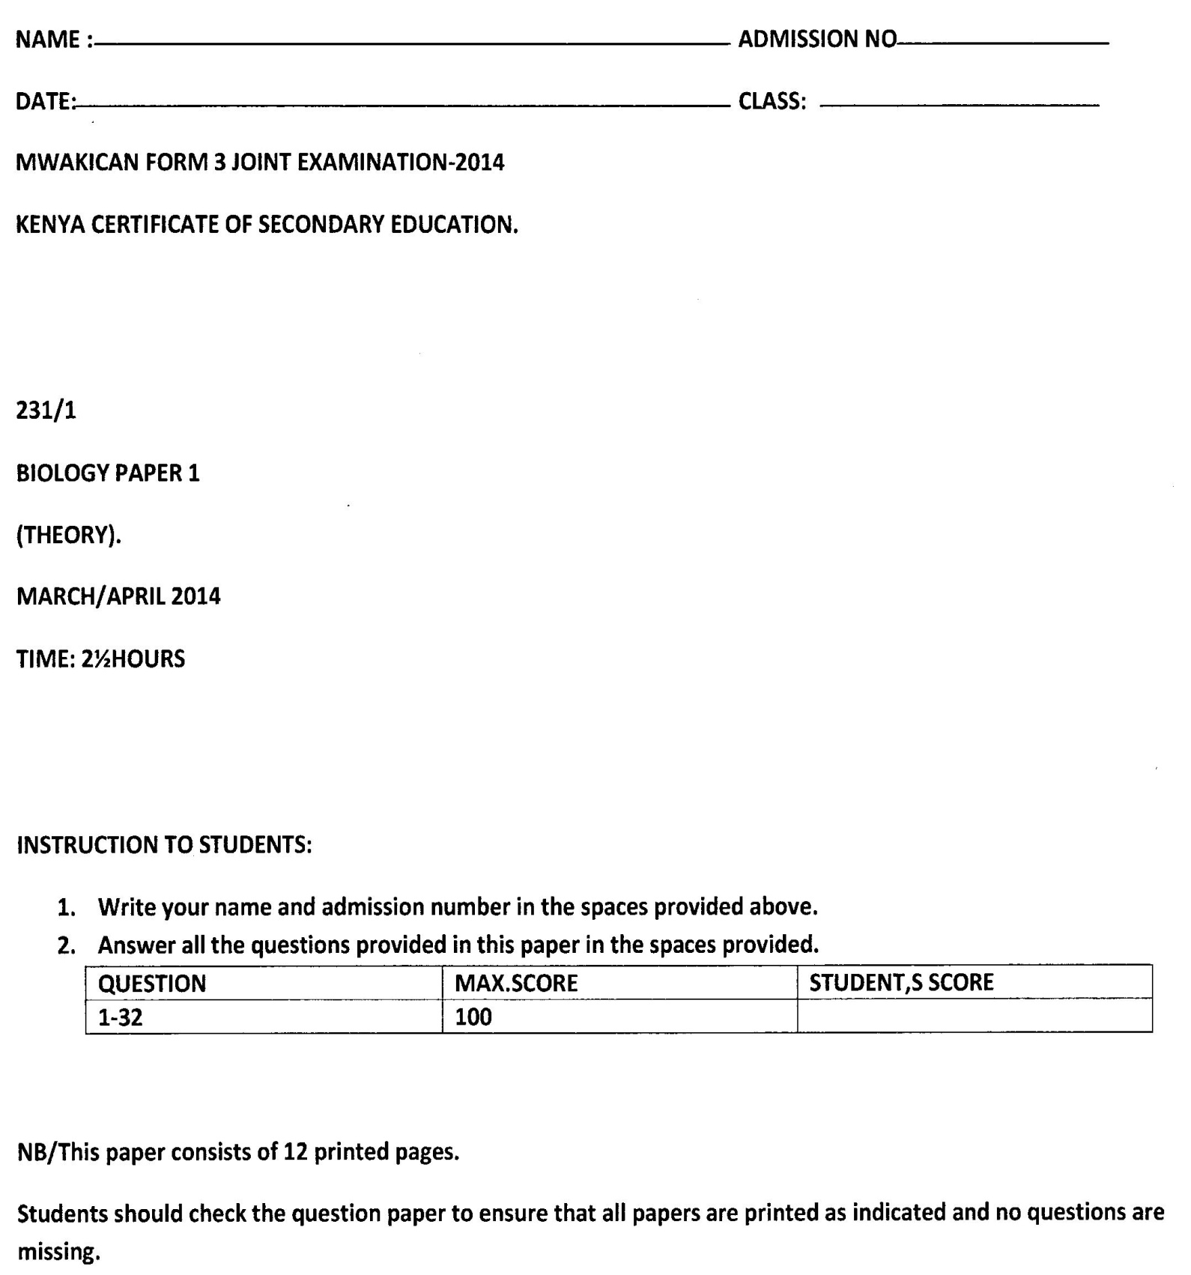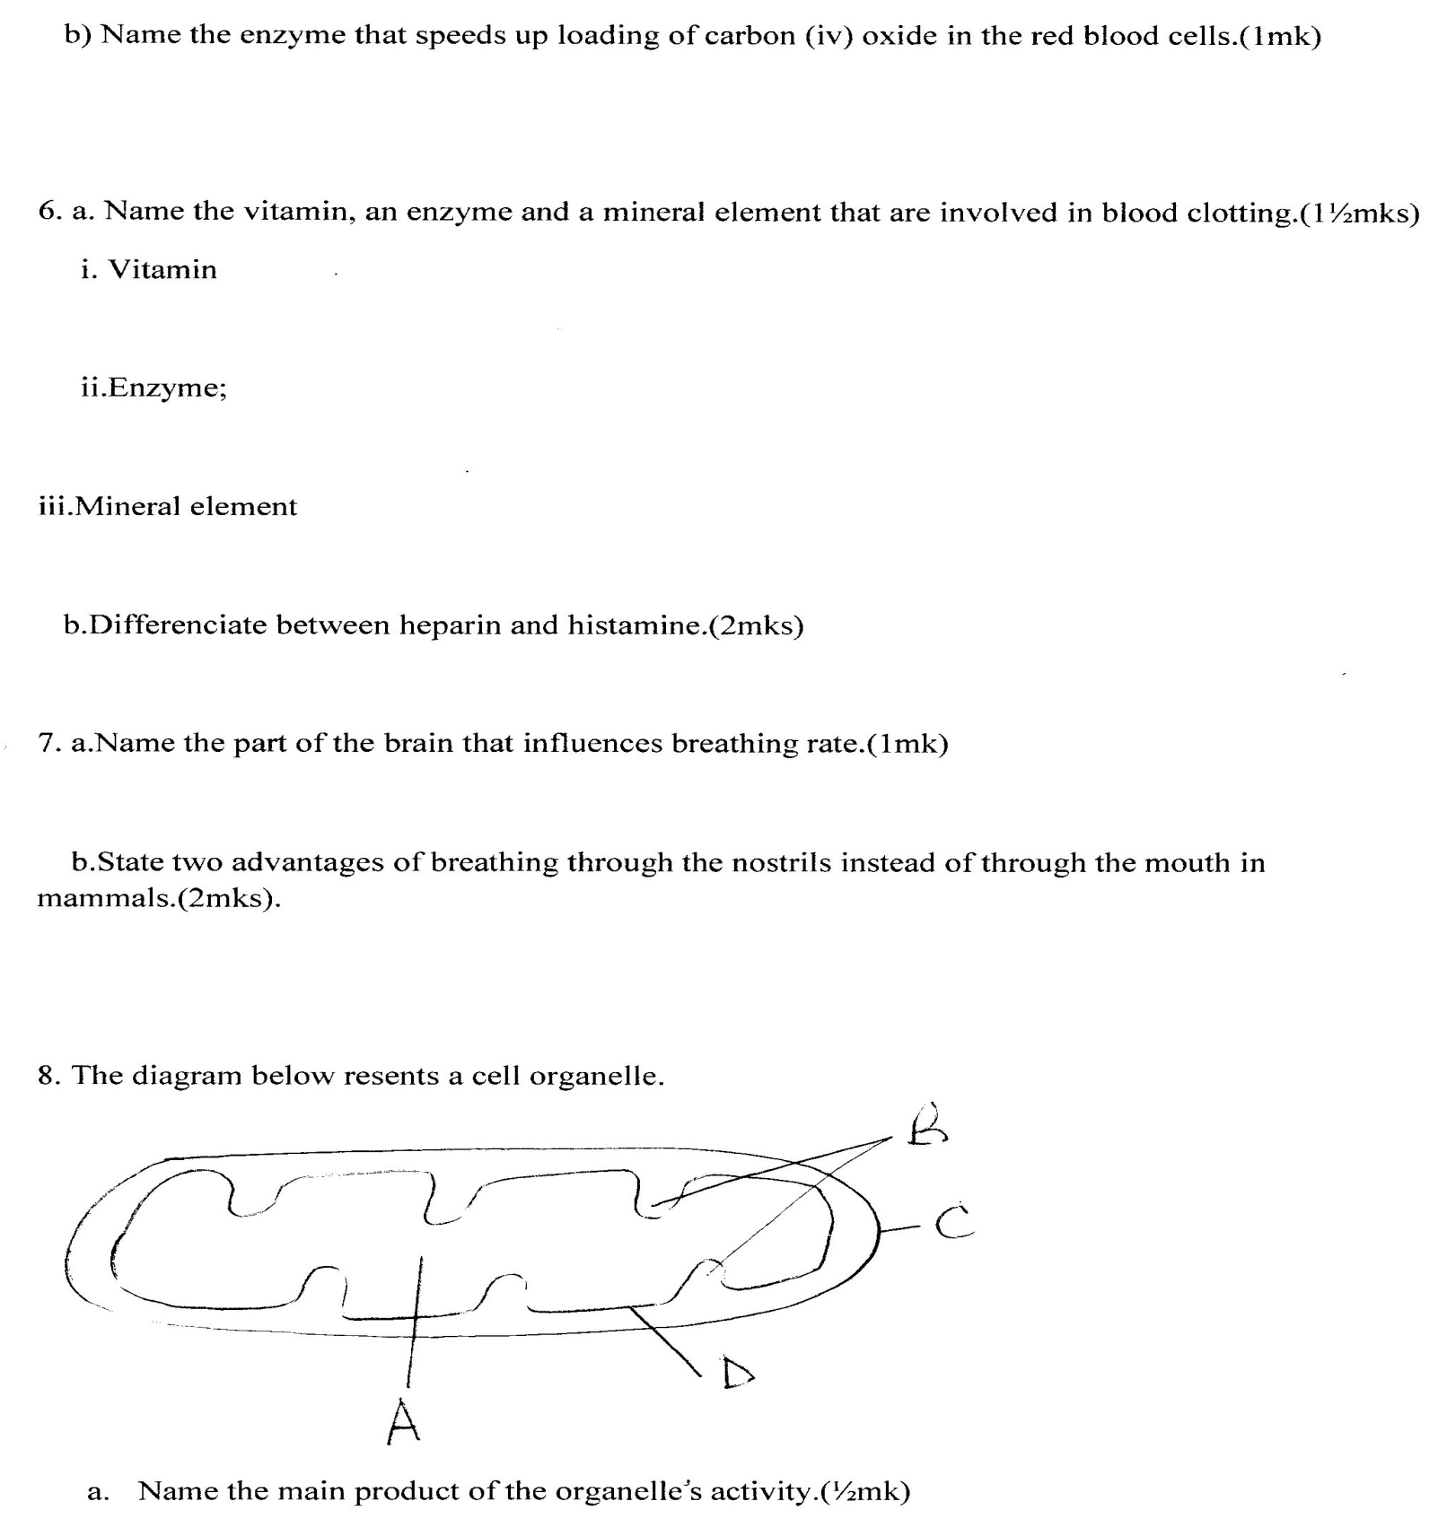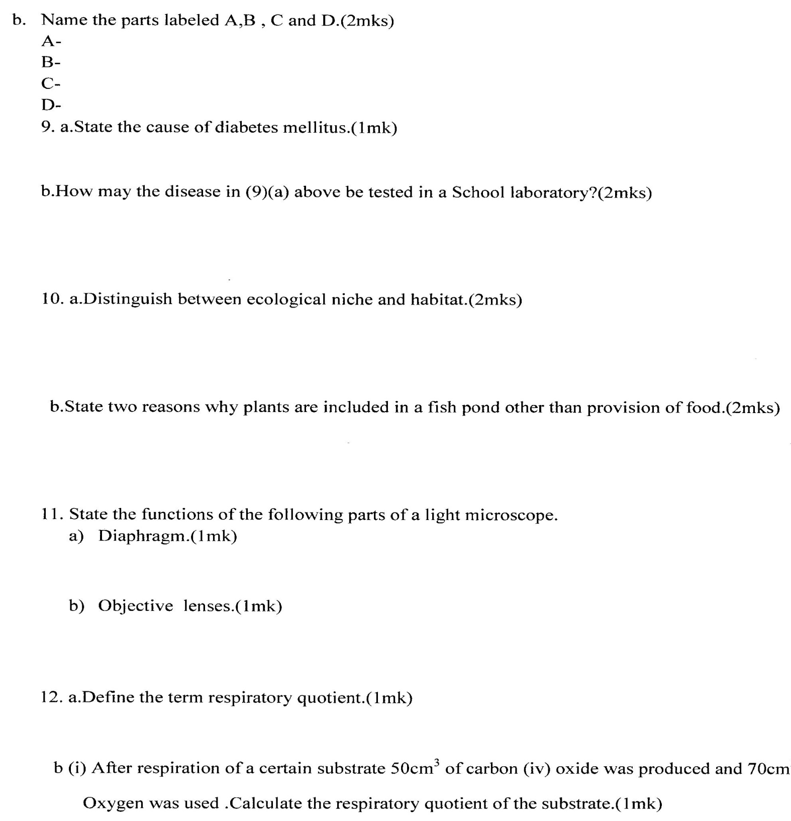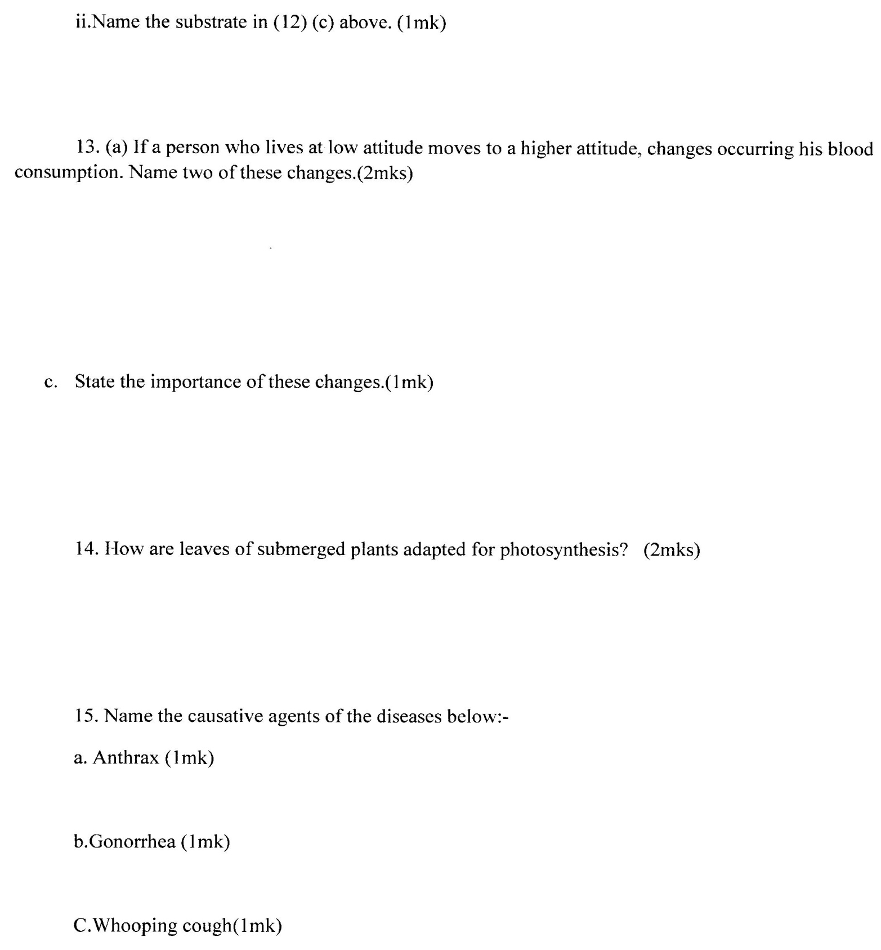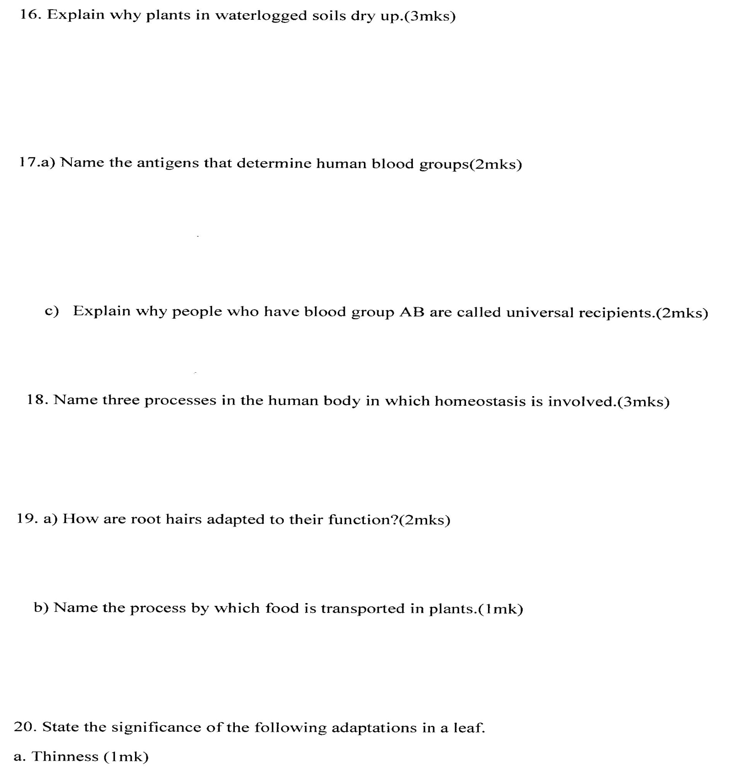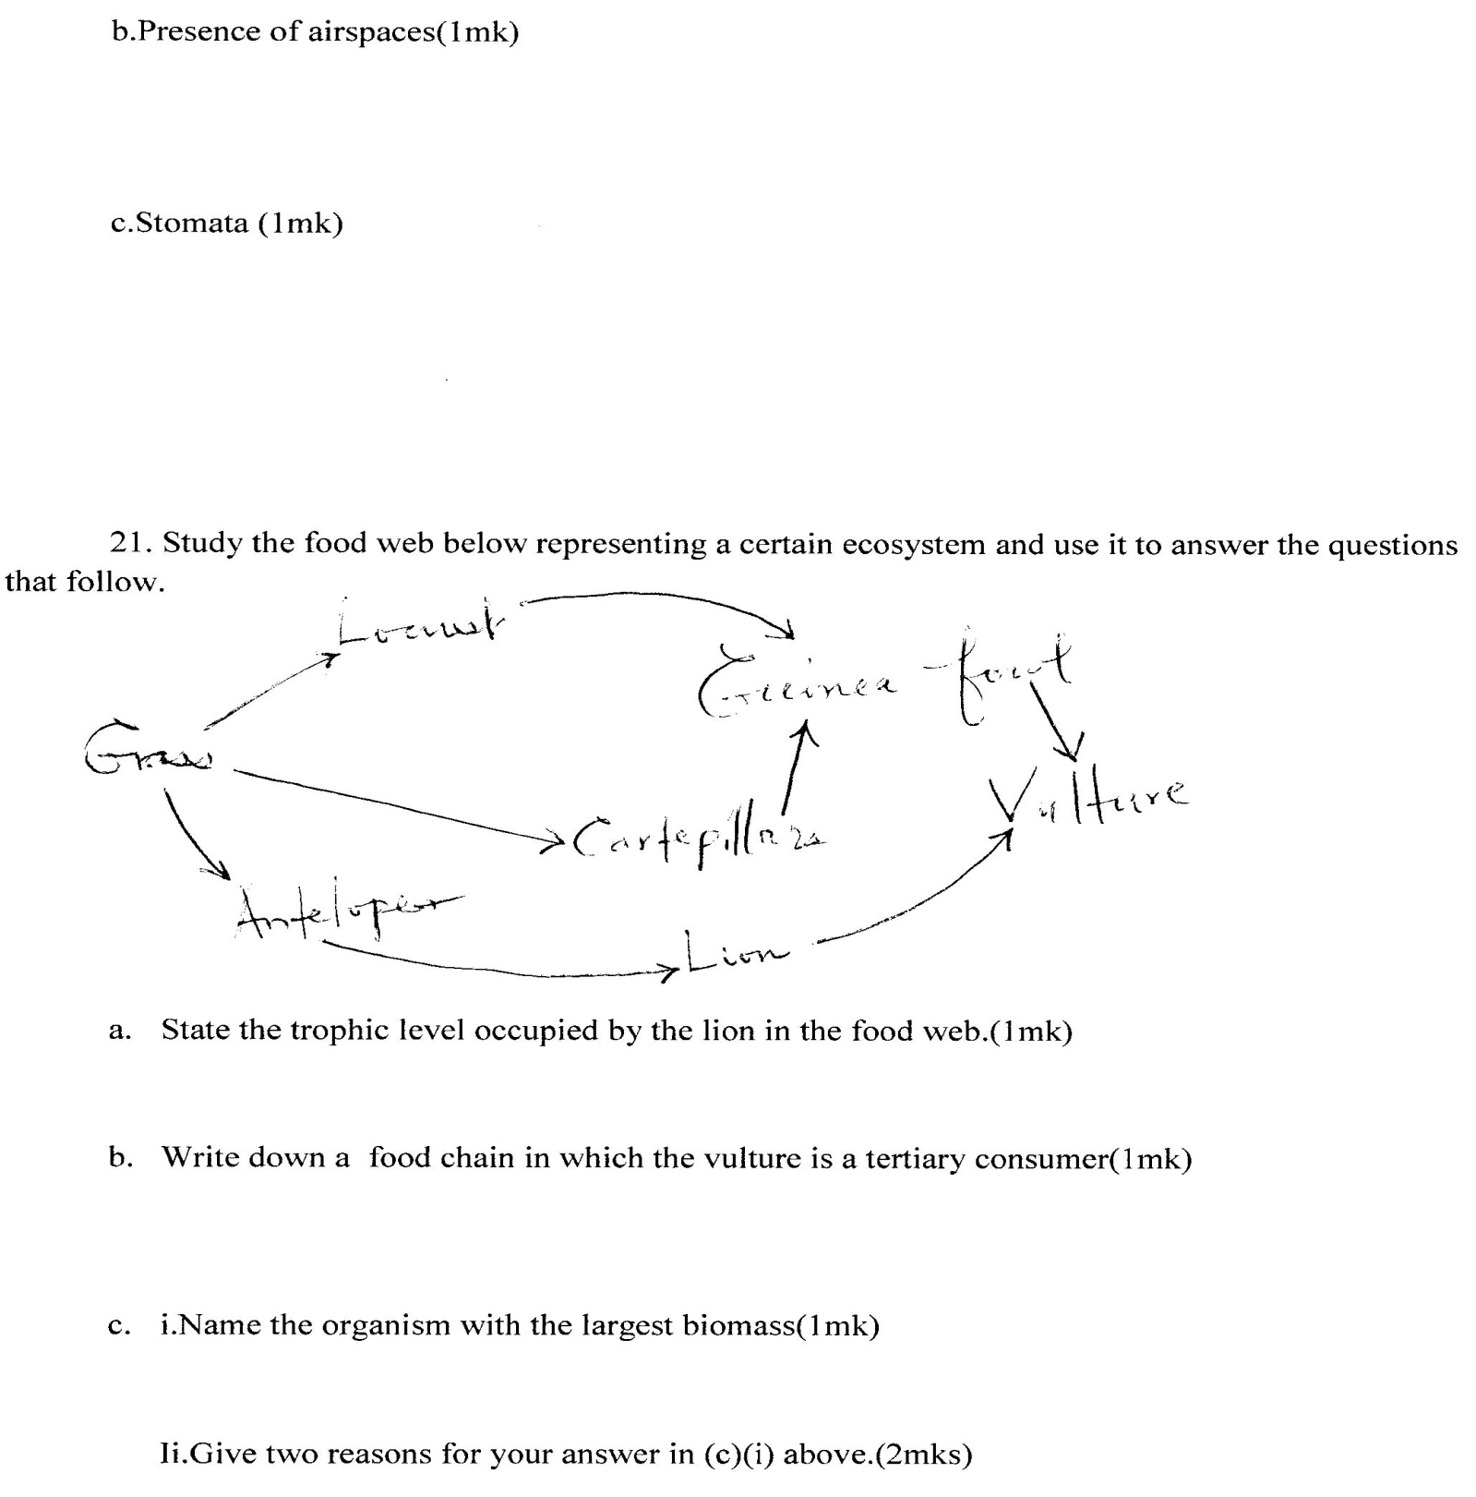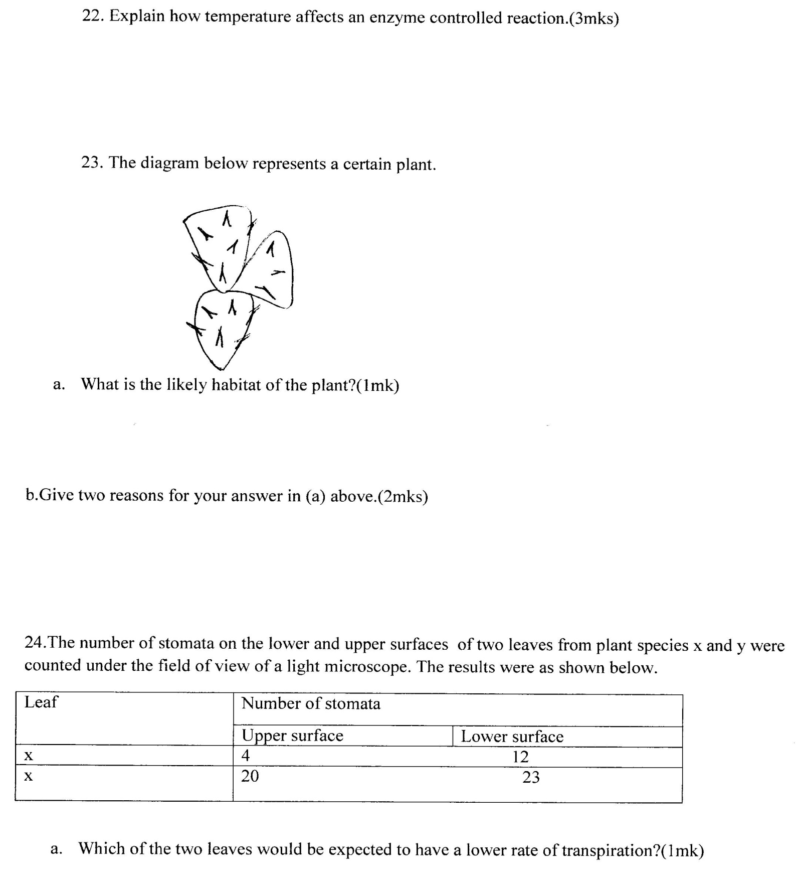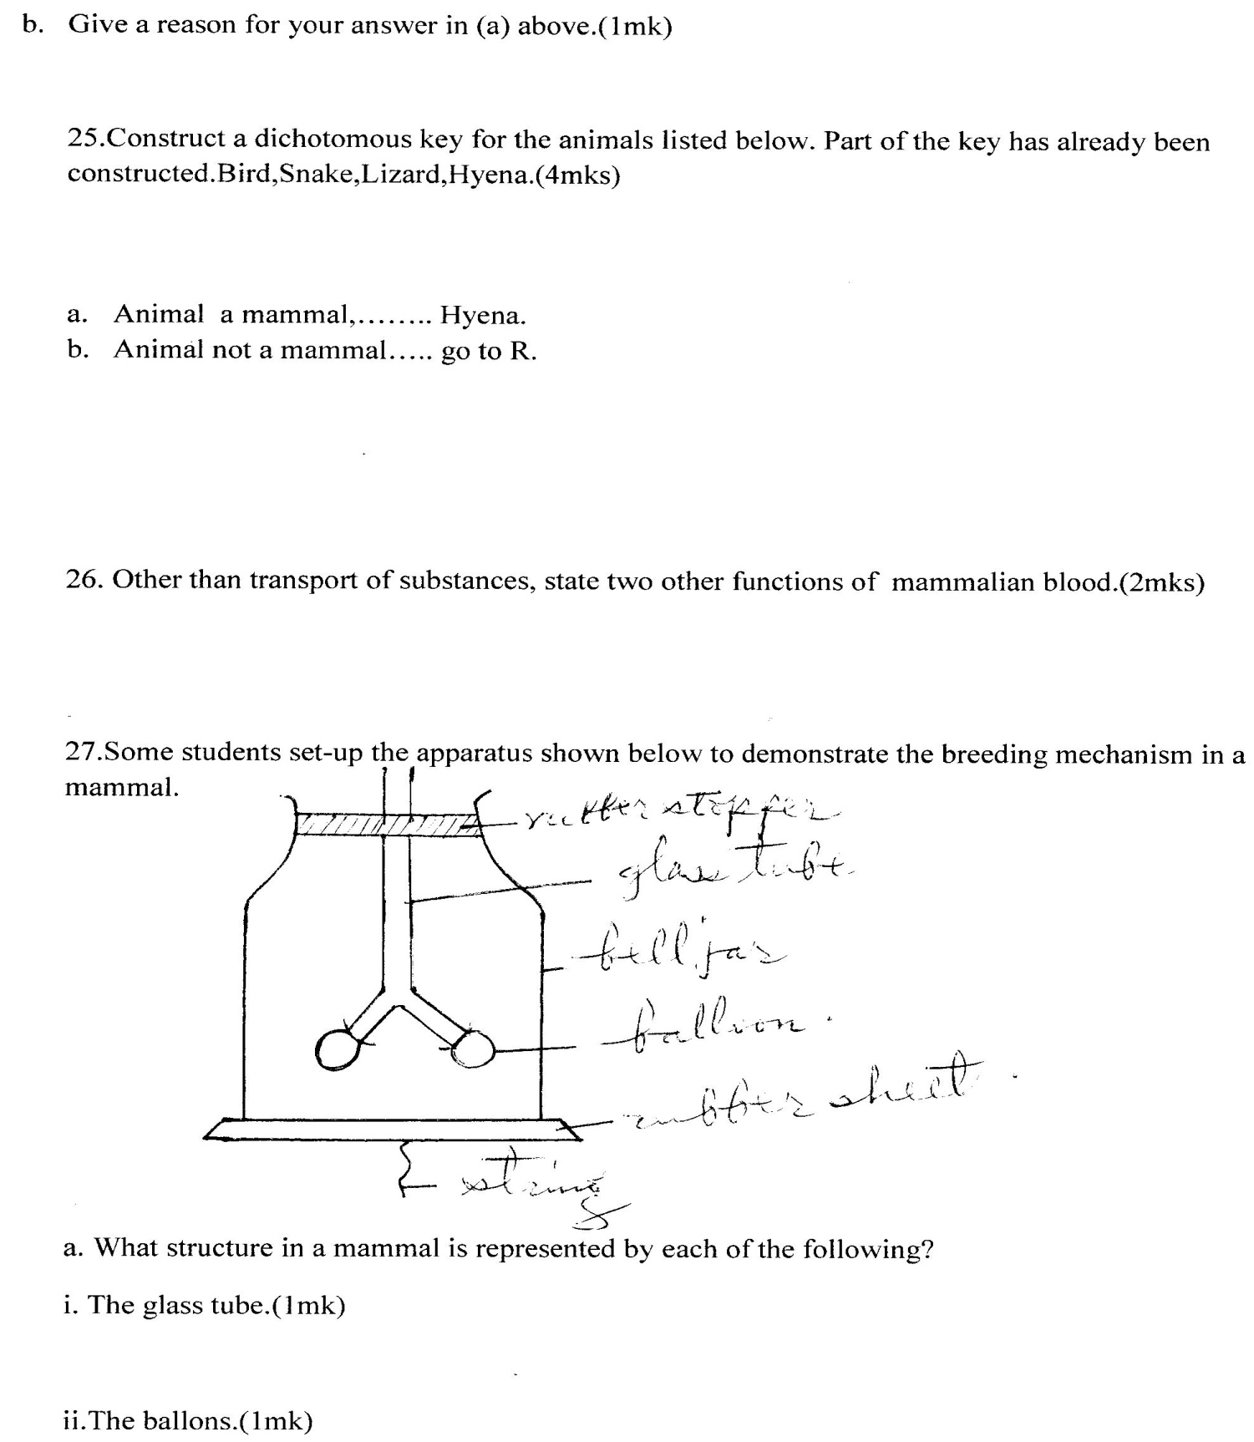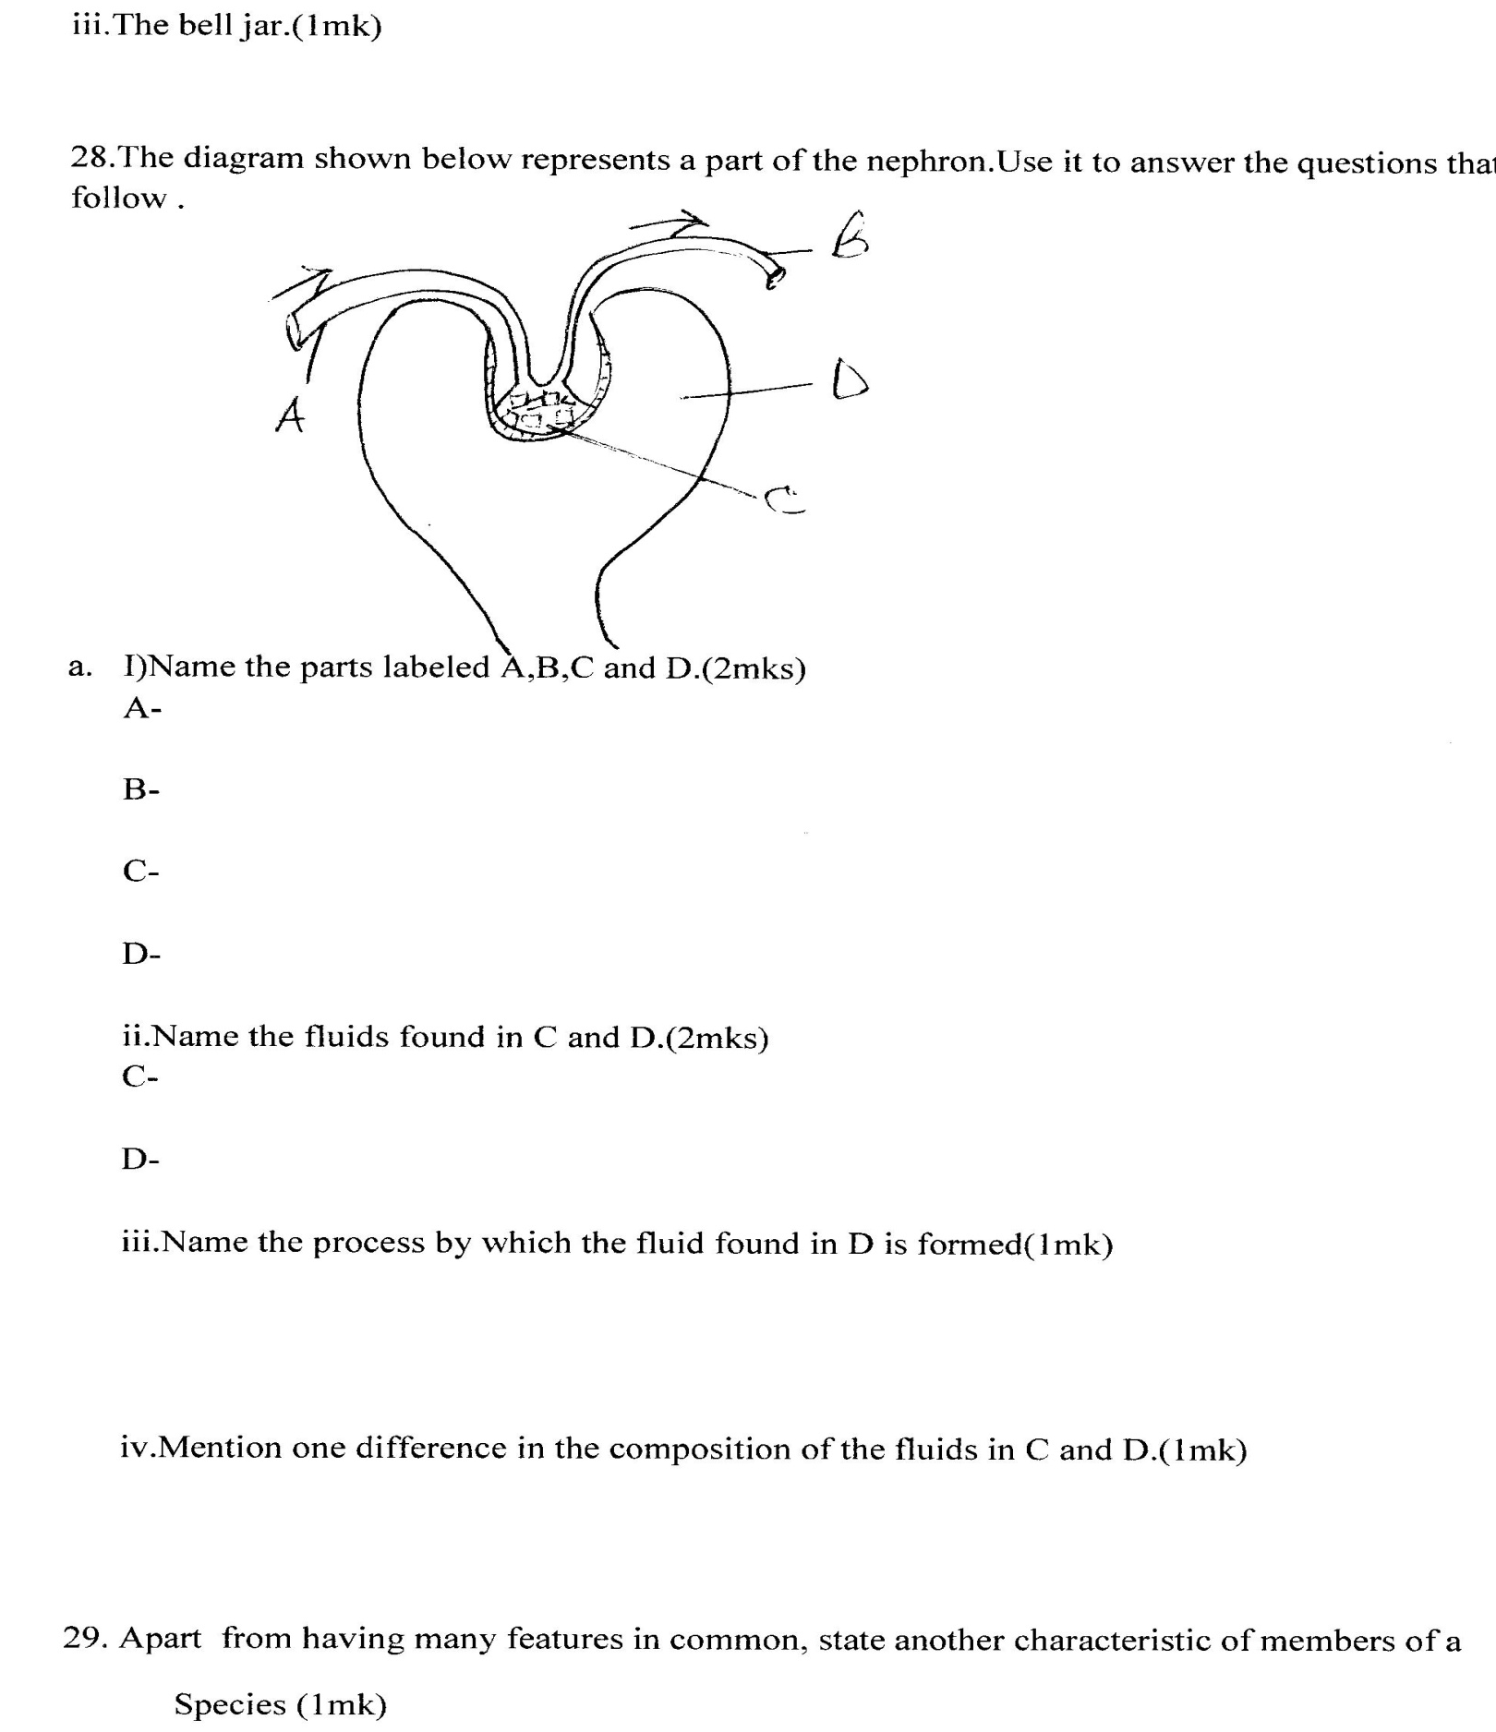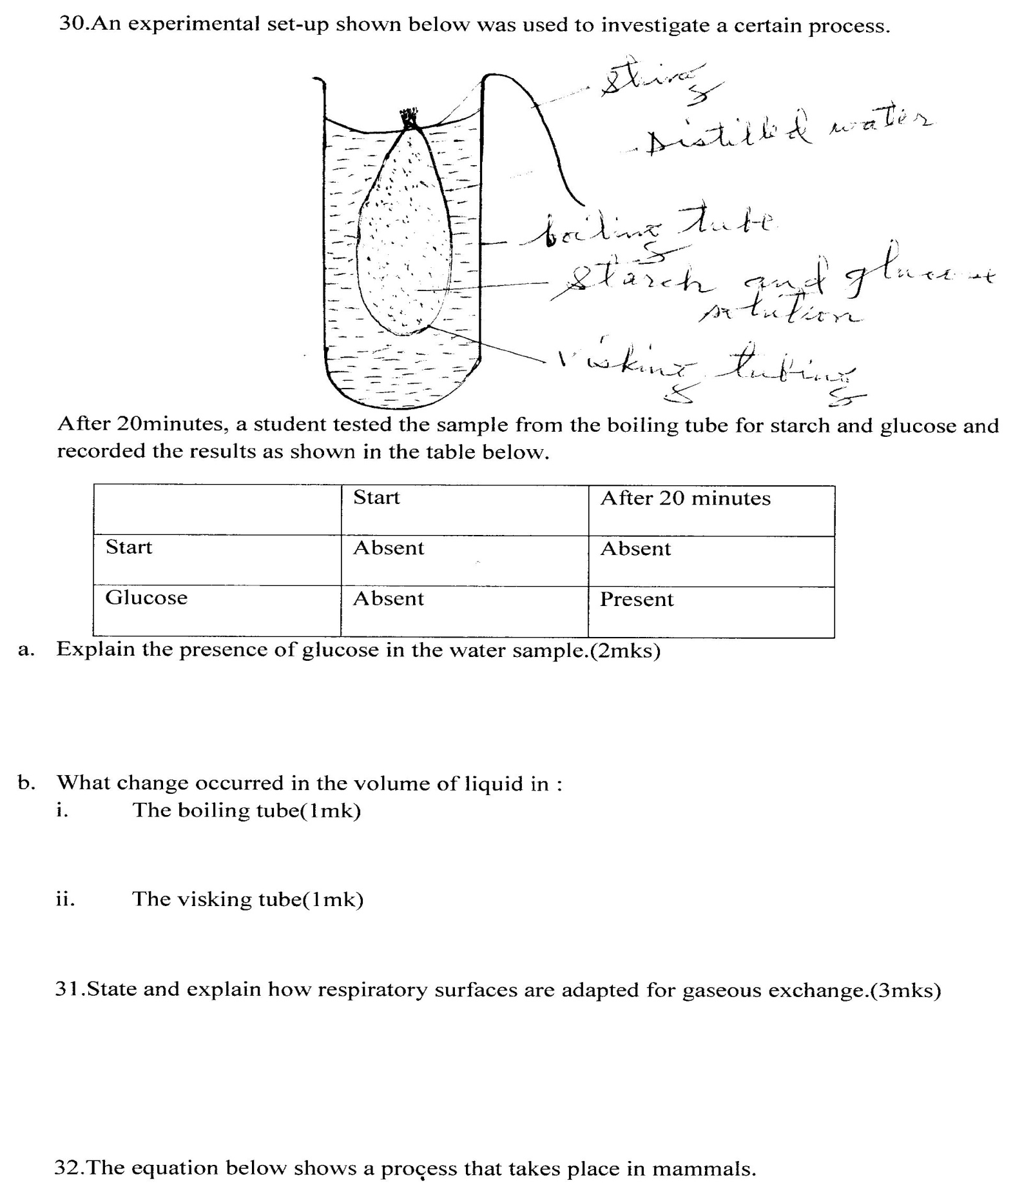

MWAKICAN FORM 3 JOINT EXAMINATYION-2014.
KENYA CERTIFICATE OF SECONDARY EDUCATION.
BIOLOGY PAPER 1 (231/1)- MARKING SCHEME (100MRKS)
- Presence of ribosomes for protein synthesis;
Presence of channels for transport of proteins and other substances; (1mk)
- Number of wings
-number of legs and other appendages;
-number of body parts;
-type of eyes (simple or compound) max;1mk each
- Diffusion is movement of particles(ions ,molecules) from where they are more to where they are few against a diffusion gradient ;(1mk)
Active transport is the movement of ions/molecules from where they are few to where they are more using energy against a concentration gradient; (1mk)
- i.Upper jaw = 8x2=16
ii.Lower jaw=7x2 =14
30;(1mk)
Or (2+5+ 8) x 2 = 30 teeth.
iii.Herbivorous ;(1mk)
it has the molar, premolars and incisors except canines ;(1mk)
- a.To increase the surface area over which gases will diffuse;Acc.oxygen or carbon (vi) oxide for gases.(1mk)
b.Carbonic anhydrase;
- a.Vitamin K;
Thrombokinase /thromboplastin;
Calcium /calcium ions; (½mk)
b.Heparin is a chemical substance that prevents blood form clotting within the blood vessels;(1mk)
Histamine is a chemical substance that is produced by tissue cells after an injury/sting/allergic reaction ;(1mk)
- a.Modulla oblongata;(1mk)
b.the nostrils have a mucus lining that traps dust unlike the mouth;
Nostrils have cilia that facilitate the movement of dust particles outwards;
Nostrils have chemoreceptorۥs for detecting smells/chemicals unlike the mouth ;(max 2=2mks)
- a. Energy/ATP;(1mk)
b.A-Matrix;
B- Cristae;
C.Outer membrane;
D-Inner membrane; (½mk @ max 2mks)
- a. Little or no insulin in the blood;(1mk)
b.Boil a little urine sample with Benedictۥs solution; an orange precipitate confirm presence of sugar in the urine;(2mks)
- a. Ecological niche-the position an organism occupies and the role itpalys in a habitat;(1mk)
b.Habitat – a specific place where an organism lives/adapted to live ;(1mk)

- a. Diaphragm – regulates the amount of light passing through the specimen;(1mk)
b.Objective lenses-for magnification of the specimen;(1mk)
- a. Respiratory quotient-the ratio of the volume of carbon (iv)oxide produced to that of oxygen used in a respiratory process;(1mk)
b.(i)R.Q =70cm³= 0.7;(1mk)
ii.Lipid;(1mk)
- a.An increase in amount of haemoglobin,an increase in the number of red blood cells;(2mks)
b.To increase the surface area for transport of oxygen/to increase the volume of oxygen in the body/to trap more oxygen;(1mk)
- A greater number of chloroplasts that trap light of low intensity;
Their leaves are highly dissected /branched to increase the surface area for photosynthesis;
Epidermis has chloroplasts; (max 2=2mks)
- Bacillus anthracis;(1mk)
Neisseria gonorrheae;(1mk)
Bordetalla pertusis;(1mk)
- Due to anaerobic respiration; hence production of ethanol in the roots; which kills them and the whole plant;(3mks)
- a)A and B ;(1mk each)
b)They may be transfused with all other blood group’s they lack antibodies ‛aۥand‛ bۥ ;max (2mks)
- thermoregulation/regulation of body temperature;
Osmoregulation/regulation of water and salts.
Blood sugar regulation ;(3mks)
- a.are elongated to increase the surface area of absorption;
their hypertonic sap enables osmosis to take place;
Presence of a thin cell membrane to quicken diffusion ;(max 2=2mks)
b.Translocation ;(1mk)
- a.to reduce diffusion distance of carbon (iv) oxide /reduce the penetration distance of light;
b.for gaseous exchange /store gases;
c.allows gaseous exchange /allows transpiration to take place;
a.(1mk)
- a. Secondary consumer;(1mk)
b.(i) Grass antelopes lions vulture;
ii)Grass caterpillars Guinea fowl Vulture;(1mk)
c.i) Grass;(1mk)
ii)Many organism’s depend on it for food/energy, being the primary producer;
-energy is lost during its transfer to higher levels through respiration, excretion and defecation ;(2mks)
- Low temperatures inactivate enzymes;
-increase in temperature up to the optimum increase the reaction rate/turn over;
-higher temperatures above the optimum denatures enzymes;(3mks)
- A.Desert/semi a desert; cc.arid/semi-arid areas;rej. Dry areas(1mk)
B.Presence of large and succulent leaves;
-pressure of thorns /prickles ;(2mks)
- a.X; (1mk)
b.Has fewer stomata on both sides of the leaf than Y;(1mk)
- 1)a.Animal a mammal …………………………………hyena;
b.Animal not a mammal……………… go to 2;

2)a.Animal with body covered with feathers………………. Bird;
b.Animal with body not covered with feathers……………….. go to 3(1mk)

3)a.Animal with legs………………..lizard;(1mk)
b.Animal without legs……………………………………….snake ; (1mk)

Acc.any other correct
Key.
- i.Defense against infections;
ii.Distribution of heat;
(1mk each)

- a.i)Trachea; (1mk)
ii) Lungs (1mk)
iii)Rib cage;(1mk)
iv) Diaphragm;(1mk)

b.Volume in the bell jar will increase ; and pressure will decrease in the bell jar;air will rush into the lungs filling them /inflating them;(3mks)
- a.i)A- Afferent arteriole;
B-Efferent arteriole;
C-Glomerulus ;
D-Bowman’s capsule;(½mk=2mks)

ii. C- Blood;(1mk)
D- Glomerulus filtrate ;(1mk)

iii.Ultrafiltration ;(1mk)

iv.The fluid in C contains blood cells and large protein molecules while the fluid in D does not;(1mk)
- They interbreed to give rise to fertile offspring;(1mk)
- a. The visking tubing is semi permeable; and allows the small glucose molecules into boiling tube by diffusion;(2mks)
b.(i) the volume of the liquid in the boiling tube decreased .(1mk)
ii) The volume of the liquid in the visking tubing increased ;( 1mk)
- are moist to dissolve gases;
-have a dense network of blood capillaries to transport gases;
-They have thin membranes/thin epithelium to reduce the diffusion distance;
-They have a large surface area for transport of more gases;
1mk each=3mks
- a.Deamination;(1mk)
b.Helps to regulate the amount of proteins /amino acids in the body;(1mk)
c.Liver (1mk)

