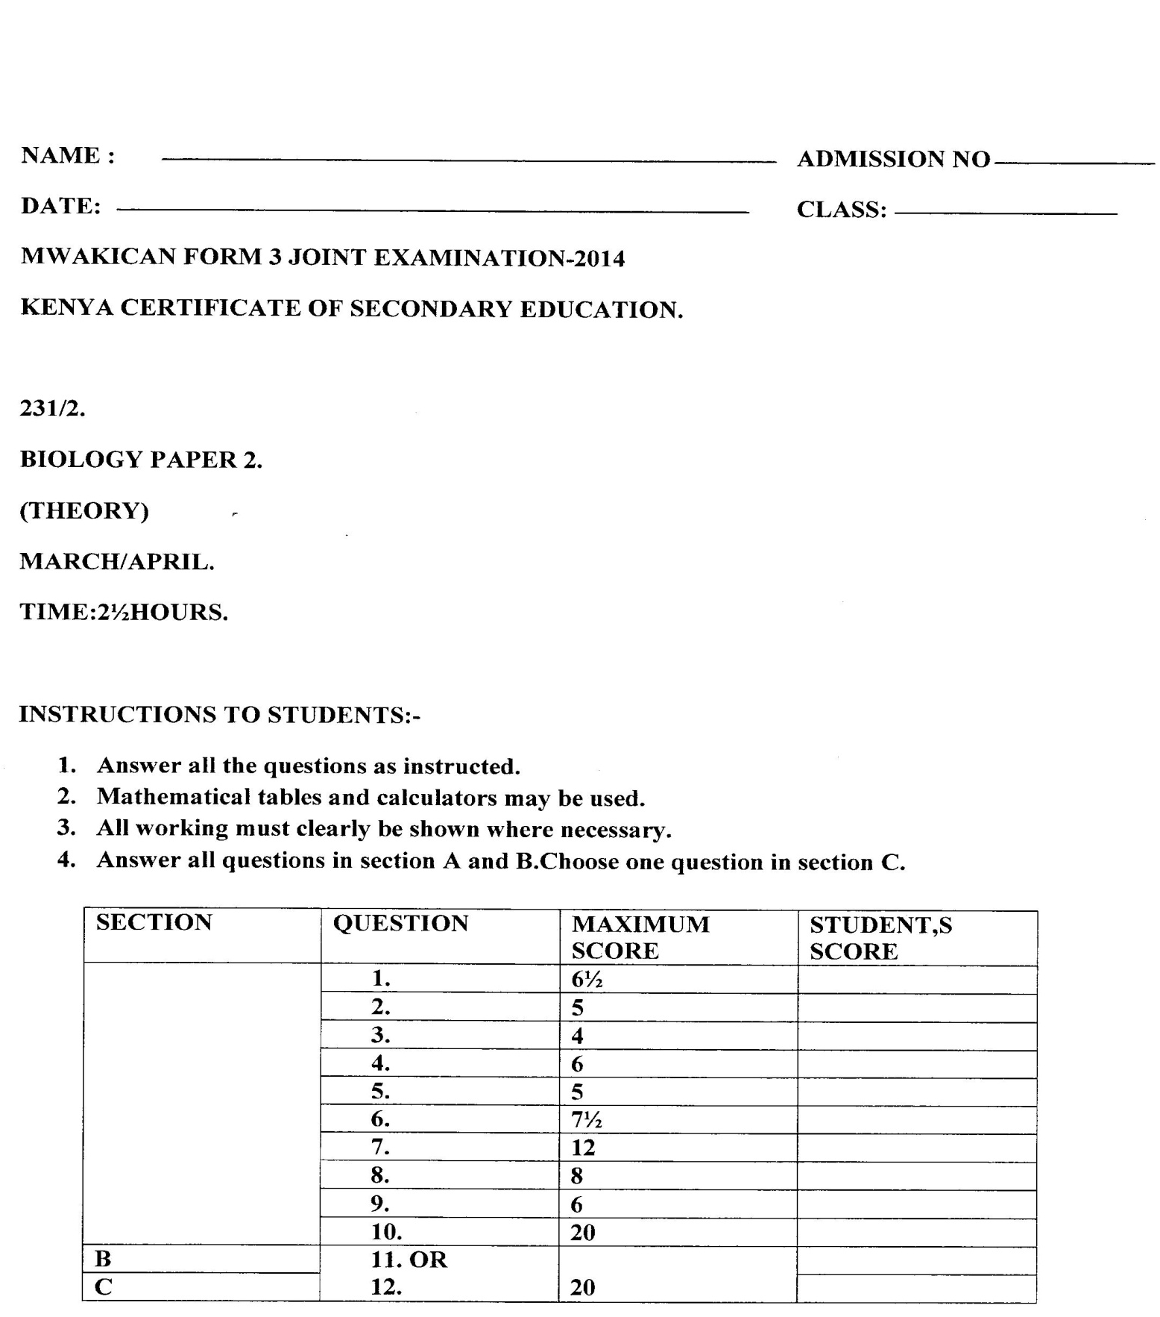
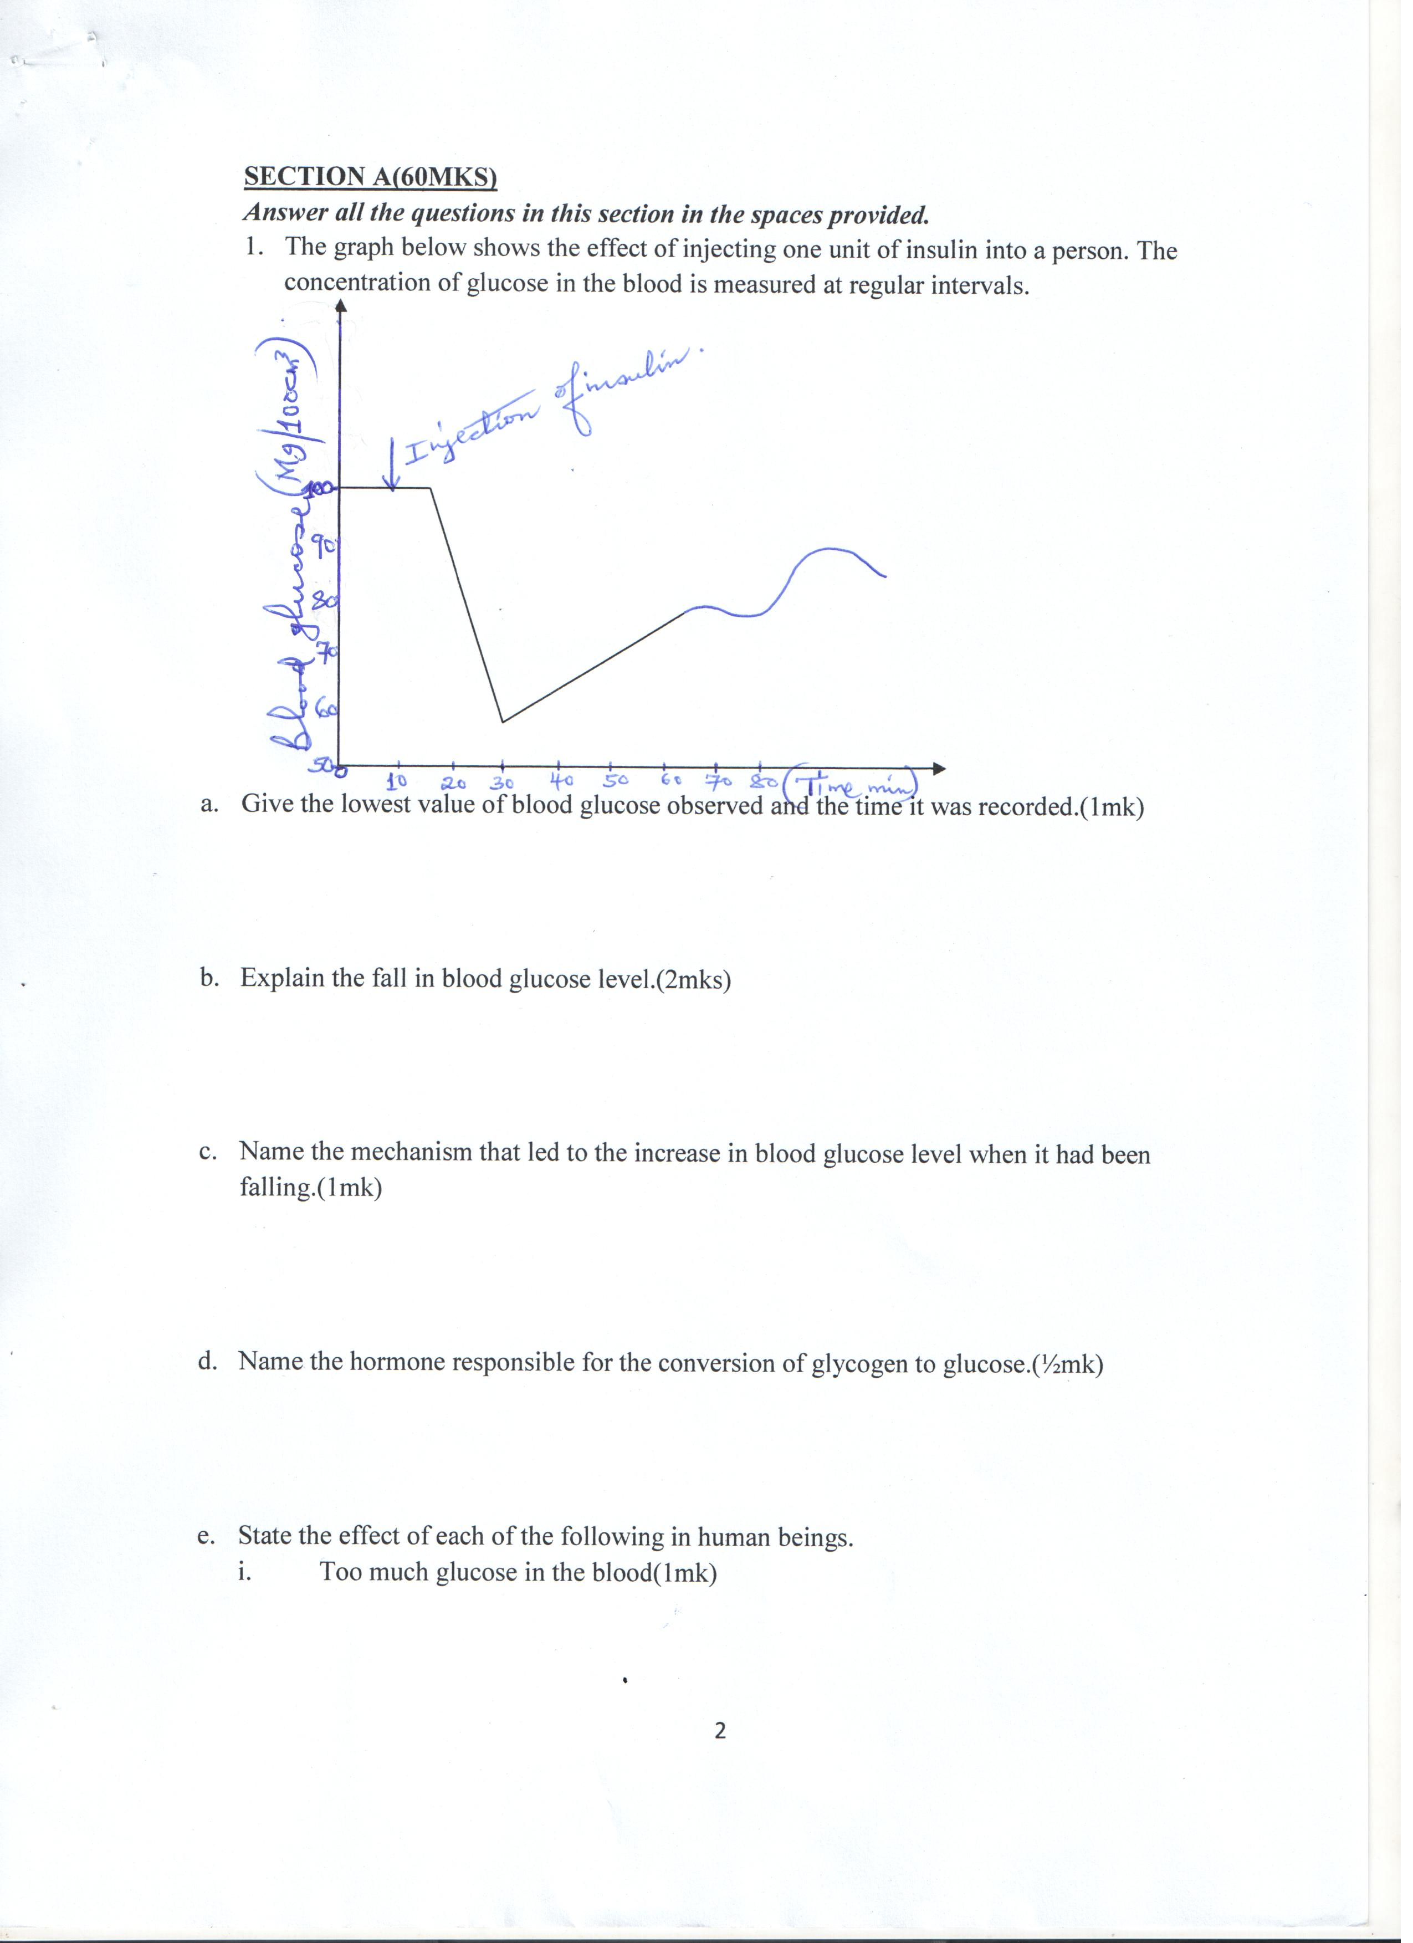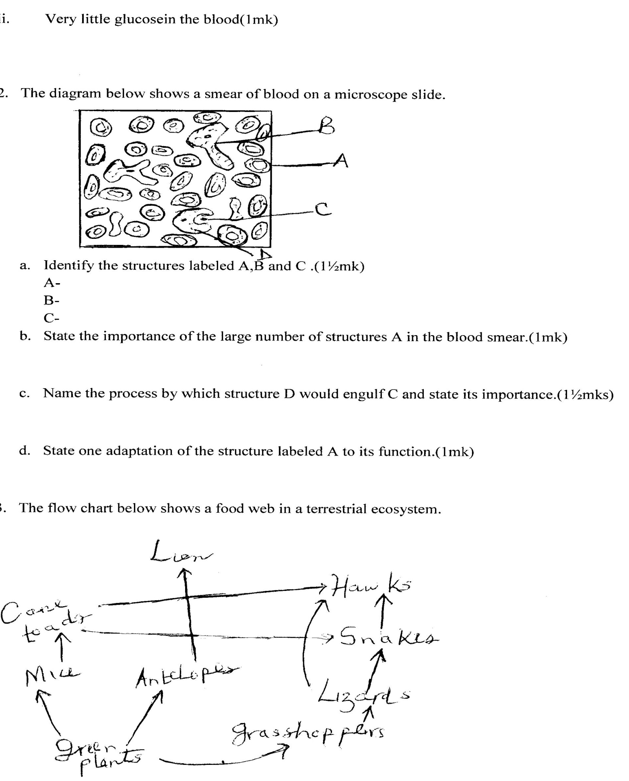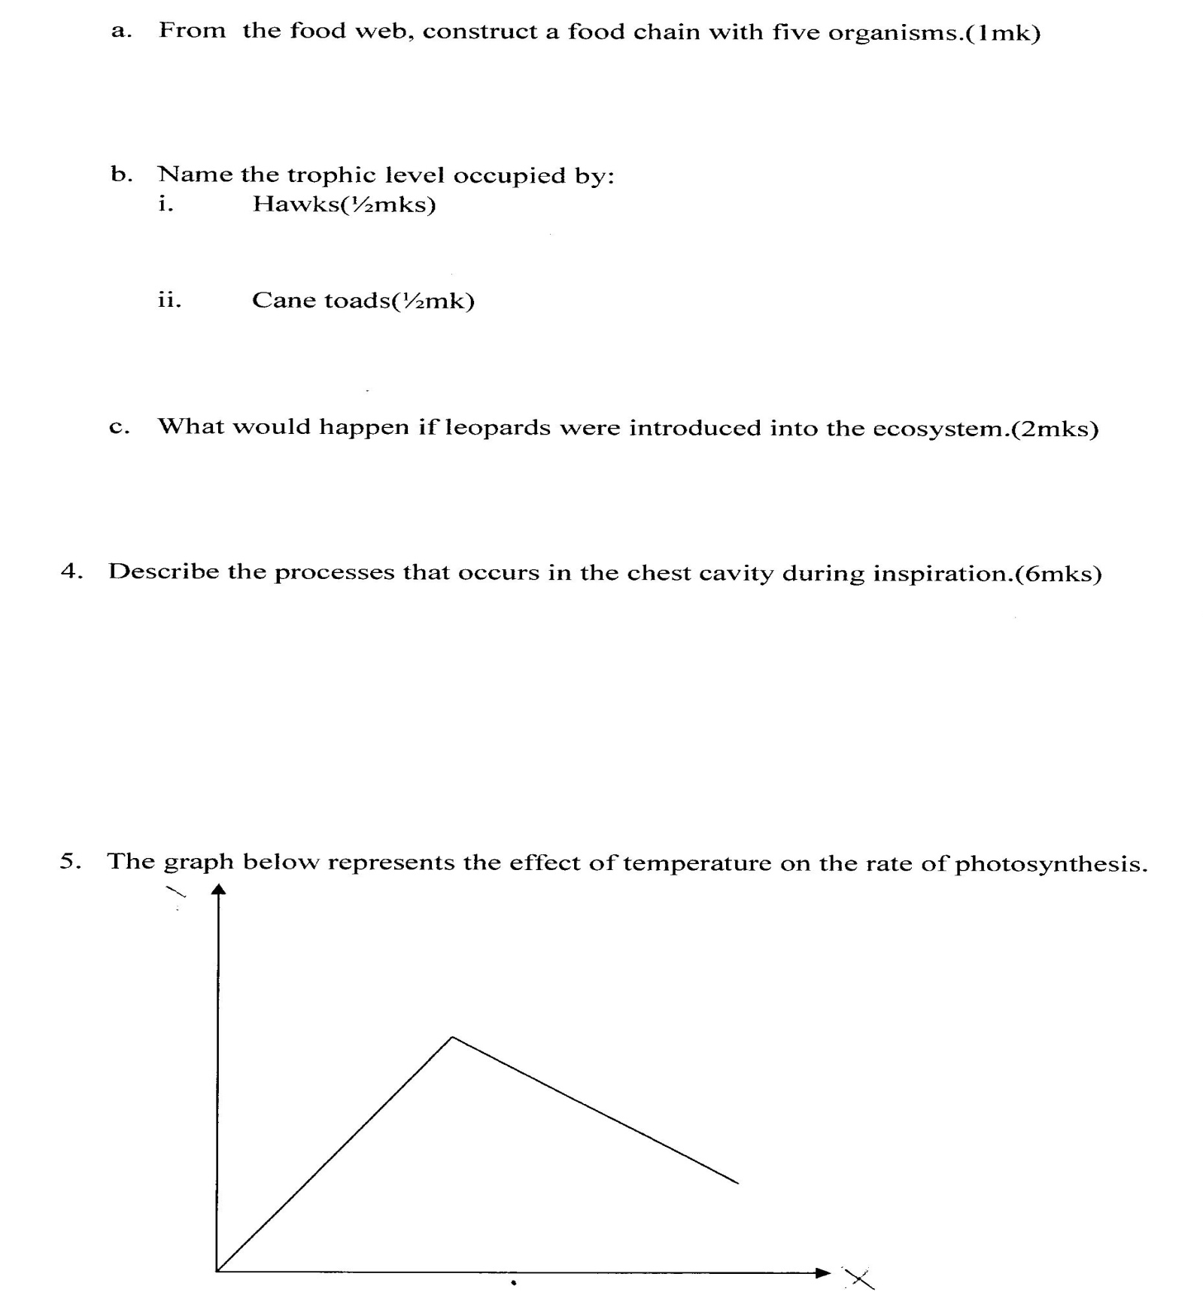
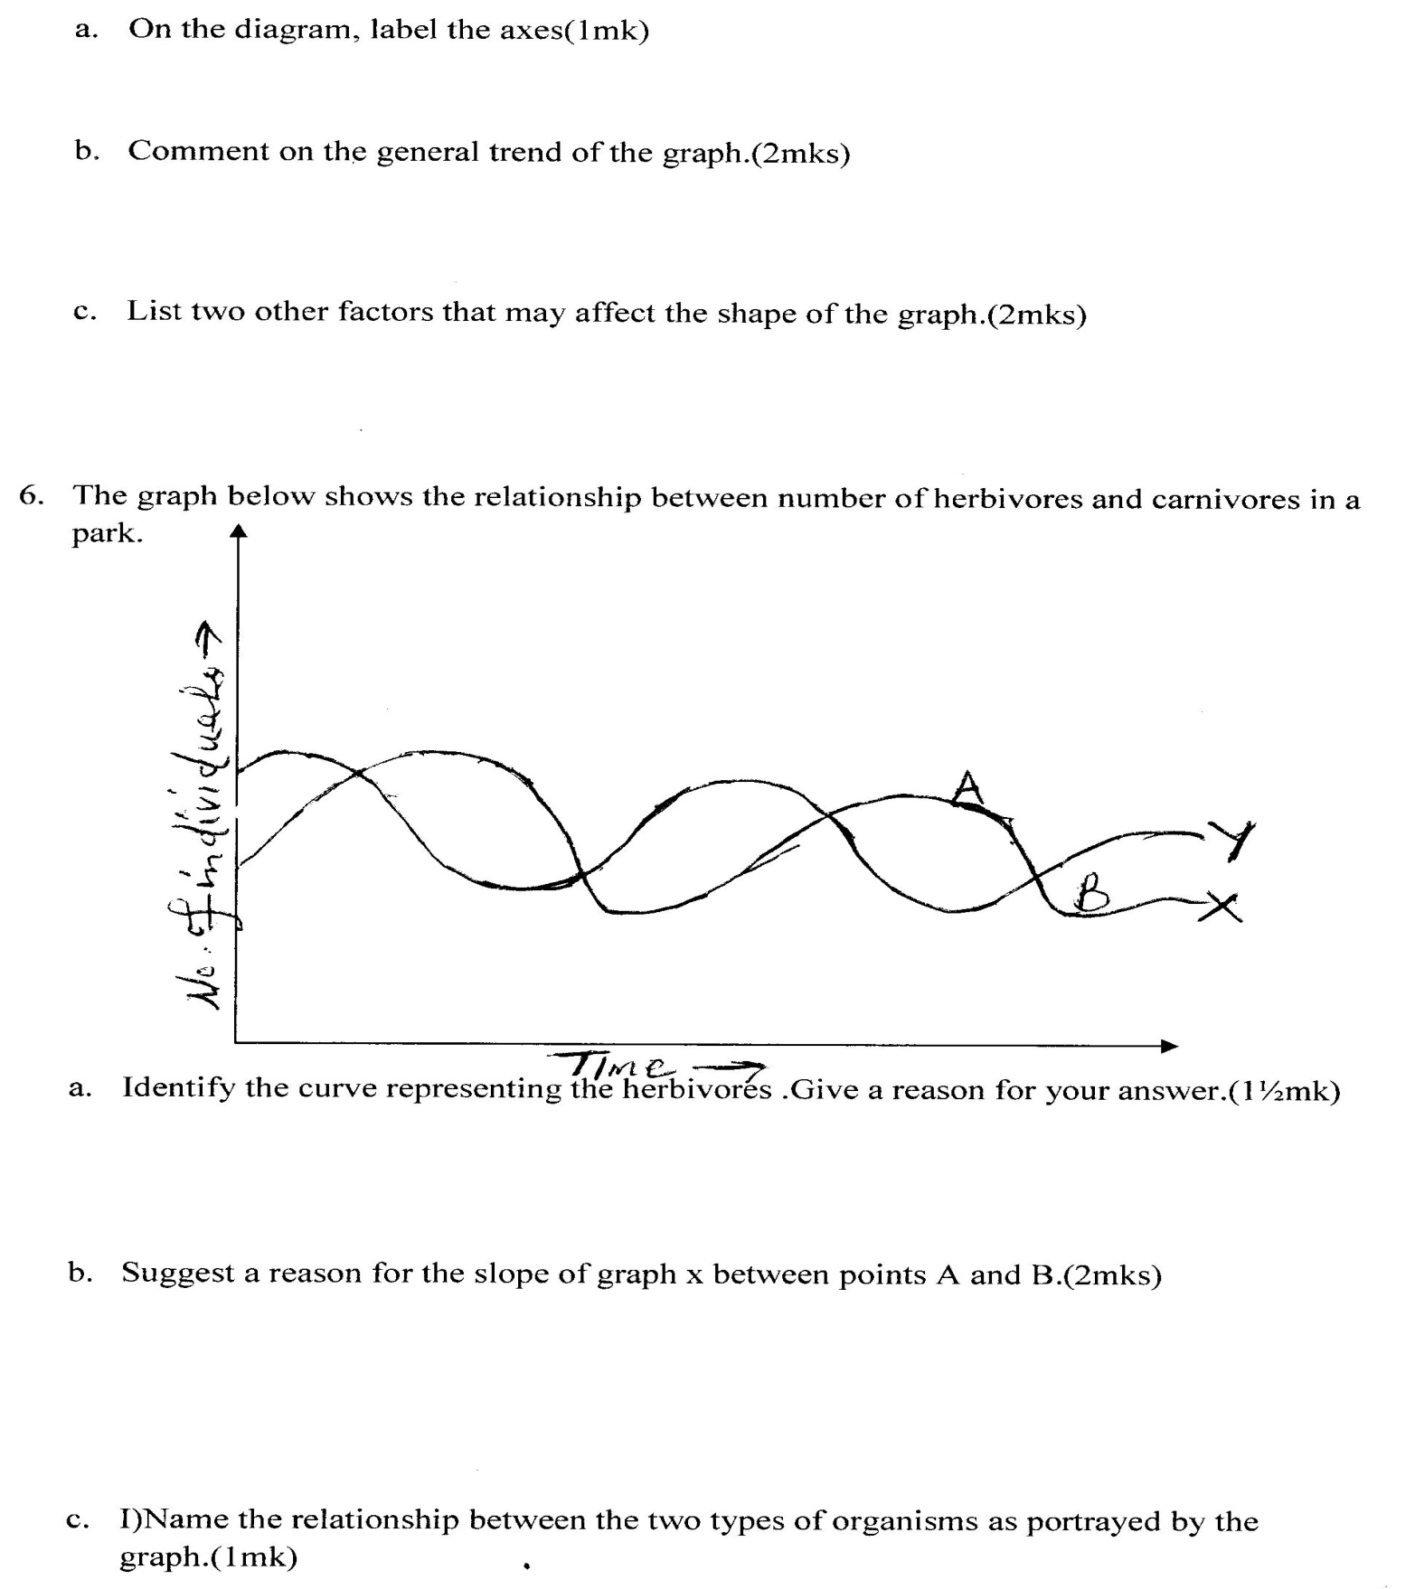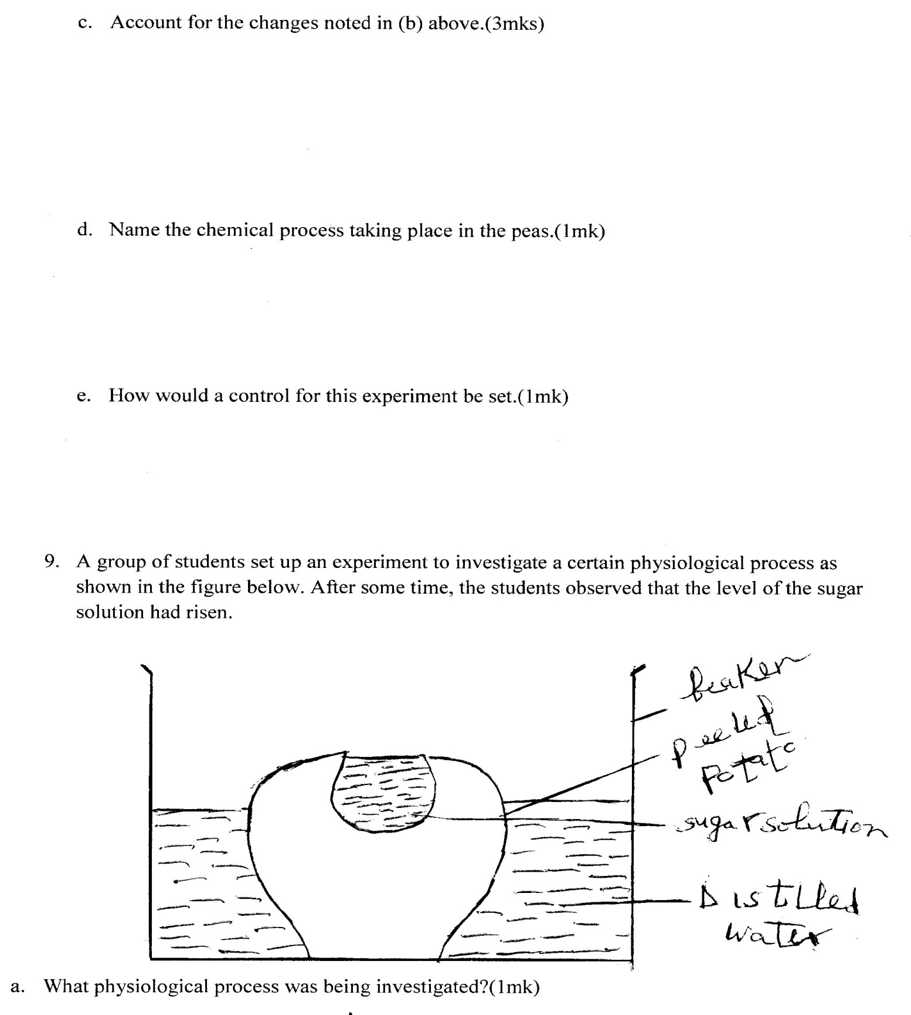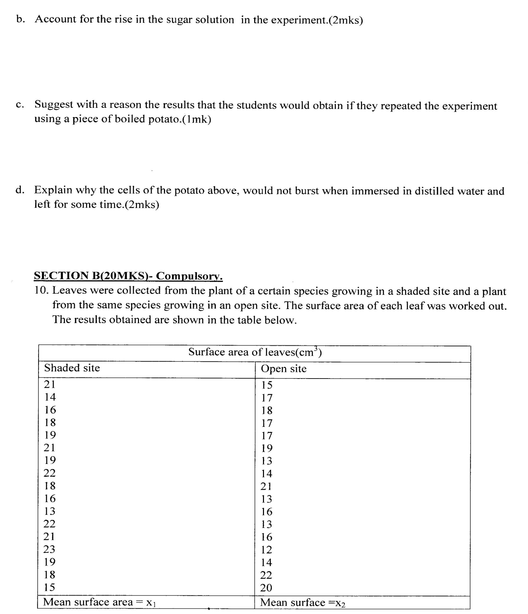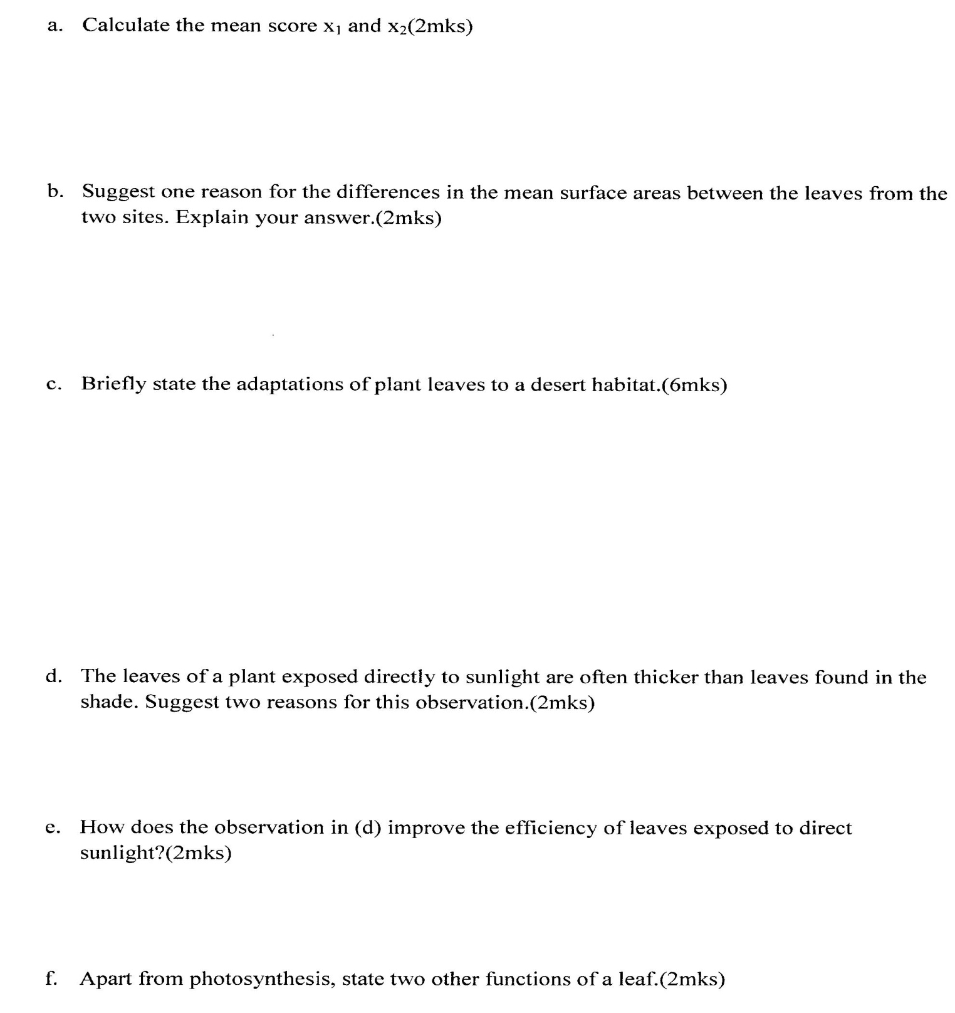

FORM 3 BIOLOGY
MWAKICAN JOINT EXAMINATIONS-2014
KENYA CERTIFICATE OF SECONDARY EDUCATION.
BILOGY PAPER 231/2(THEORY)-MARKING SCHEME.(100MKS)
- a..60mg/100cm³;(½mk)
time when observed –after 30 minutes(½mk)
- b.Insulin stimulated liver cells to convert some glucose to glucogen ;while some of the glucose was oxidized to provide energy; (2mks)
c.Negative feedback mechanism;(1mk)
d.Glucagon;(½mk)
- e)(i)overproduction of energy by tissues which can burn them;(1mk)
- ii.reduction in production of energy in the tissues which may kill the tissues;(1mk)
- a) A- red blood cell; Rej.red blood cell.
B –White blood cell;Rej.white cells.
C- an antigen /bacterium /virus/fungus;(@½ mk =1½mks)
b)To increase the total surface area of oxygen transport;(1mk)
- c)Phagocytosis;(½mk)
- -Helps to destroy disease causing micro organisms;(1mk)
- d.Presence of hemoglobin with a high affinity for oxygen;
- Absence of a nucleus /lacks most of the organelles to pack more hemoglobin;
- Presence of enzyme carbonic anhydase to enhance loading of carbon (iv) oxide gas;
- They are small and able to squeeze through narrow capillaries; (max 1=1mk)
- a. Green plants grasshoppers lizards Snakes

Hawks;

Green plants Mice Cane toads Snakes

Hawks
b.(i) Quartenary consumer;(½mk)
ii) Secondary consumer ;(½mk)

- The leopards would compete with lions for antelope
- the antelopes would reduce in number;
- more grass would be available for mice and grasshoppers
- Leopards and lions would later decrease in number due to migration or death due starvation;(any 2=2mks)
- ribs move upwards and outwards;
  - External intercostals muscles contract; and the internal intercostal muscles relax.
  - The diaphragm flattens;
  - Volume of the chest cavity falls as pressure rises; hence air rushes into the lungs; each 1mk=6mks
- a.x-temperature(½mk)
y-rate of photosynthesis(½mk)
b.rate of photosynthesis increases as temperature increases ;upto the optimum temperature;and starts to fall; due to denaturation of enzymes by the high temperature @½=2mks
c.Light intensity;
conc.of carbon(iv) oxide;
amount of chlorophyll in the leaves;(max 2 = 2mks)
- -a.y ;(½mk)
-it starts with a higher population than x,the preditor;(1mk)
b.-the number /pop. of predators dropped due to increased competition for food ;due to decrease in number of prey;(max 2=2mks)
c(i) Prey –predator/predation;(1mk)
ii.helps to maintain th population of both prey and predators at the carrying capacity of habitat;
-weak organisms are removed from both populations ;(by natural selection) (Accept one=1mk)
d. Pop. of herbivores would increase due to reduced predation;
-Most of the vegetarian would be eaten by the herbivores resulting in soil erosion;
-Eventually the pop. of herbivores would fall due to death or migration due to competition for food.(any 2=2mks)
- 1)a. Leaf simple……. Go to 2;(1mk)
b.Leaf compound……. Go to 3(1mk)
2)a.Leaf with a serrated margin …………………. S;(1mk)
b.Leaf with a smooth margin….. go o 4(1mk)
3)a.Leaf with three leaflets…………………P(1mk)
b.Leaf with more than three leaflets……………Q ;(1mk)
4)a.Leaf with a pointed apex………………………… R(1mk)
b.Leaf with a rounded apex……………………..R(1mk)
Leaf | Steps
O  P  Q  R | 1a,2b,4a;(1mk)  1b,3a;(1mk)  1b,3b;(1mk)  1a,2b,4b;(1mk)

- a.-To show that germination seeds use oxygen and give out carbon(iv) oxide;(1mk)
b.-the level of potassium hydroxide rose in the retort flask; and dropped in the beaker;(2mks)
c-the germinating seeds respire using oxygen and give out carbon (iv) oxide;which is absorbed by potassium hydroxide; The level of potassium hydroxide rise to fill the space formally occupied by oxygen carbon(iv) oxide;(max 3=3mks)
e.Use boiled and disinfected peas/dry seeds ;(1mk)
- a. Osmosis;(1mk)
b.Water is hypotonic compared to sugar solution (OWTTE) hence water is drained from the beaker by osmosis into the sugar solution making it rise;(2mks)

c. No obserrable change /no rise in sugar solution as boiling kills the cells /cells as osmotically dead/protoplasm is killed by boiling ;(1mk)
d.They have rigid cellulose cell walls; that resist outward pressure even after filling with water;(2mks)
- a.X₁- sum of all surface areas=18.53cm²;1/2 mk
17
X_{2 –} Sum of all surface areas =15.71cm²;1/2mk
b.the amount of light the leaves receive;1mk
-leave in shaded areas have larger surface areas to trap light of low intensity;1/2mk
-Leaves in open sites have smaller surface areas as light is of high intensity ;(max2=2mks)
c.Some have their stomata hidden in grooves;
-some have leaves modified to thorns;
-some have hairy leaves;
-All have reduced no. of stomata;
-Some have reversed stomatal mechanism;
-Some have succulent leaves to store water;(max 6=6mks)
-Some have thick cuticles
-NB/All these adaptations help the plant to reduce water loss by transpiration.
d. Leaves exposed to light have more palisade cells hence more chloroplasts and are thicker than those growing in shade;(2mks)
e.Plants exposed to light have higher rates of photosynthesis;
-Due to the greater concentration of chloroplasts; (max 2mks)
f.gaseous exchange;
Transpiration; (@1mk =2mks)
G.Presence of stomata;
Thinness;
Air spaces;
Large surface areas (except for xerophytes) any 2=2mks)
Rolling of leaves reduces the surface area of transpiration ;(1mk)
- a.Rich blood supply to transport gases;
Thin membrane for faster diffusion of gases;
Presence of a gill arches to support more gill filaments;
Presence of gill rakers to trap solid particles in water.
Very many gill filaments to increase the surface area for gaseous exchange ;(@ 1mk =5mks)
b.The mouth opens and the floor of the mouth is lowered ;hence volume of the buccal cavity increases and pressure falls; this causes water to rush into the mouth;
opercula bulge outwards raising the volume; and a fall in the pressure of the buccal cavity.
Water is forced to flow over the gills at high pressure; This is enabled by the higher external pressure; which presses both opercula initially before opening the mouth and the opercula.;
The water entering the mouth has more oxygen; and low in carbon (iv) oxide; which ceates a steep diffusion gradient;
Oxygen diffuses from the water to the blood in the capillaries and combines with hemoglobin;
Carbon (iv) oxide diffuses from the blood capillaries into the water;(max 15=15mks)
- The granular layer contains living cells that give rise to new epidermis /whose cell replace the cornfield layer.
The malphigian layer secrets melanin; which protects the body against harmful ultra violet rays;

Sebaceous glands produce sebum; which keeps the skin soft/is water proof /is mildly antiseptic;
It has blood vessels /arterioles and capillaries; which dilate /vasolidation;to help blood lose heat at hot times; or constrict/vasocoustriction;to prevent heat loss when its cold.
It has erector –pili muscles which contracts when it is cold making hair to stand upright; trapped air helps to insulate the body against heat loss;
When it is hot, the erector –pili muscles relaxes and hairs lie flat; hence no air is trapped and excess heat is lost;
Sweat glands produce sweat; the sweat on the skin surface evaporate hence cooling the body;
The subcutaneous fat/adipose tissue; serves as an insulator to prevent heat loss when its cold;
Nerve endings and sensory receptors;
Perceive any changes around the body; hence detects any dangers ;(max 20mks)

