NAME --------------------------------------------------- CLASS --------------------------- ADM NO --------------
GATITU MIXED SECONDARY SCHOOL
BIOLOGY 231/2
FORM 3
3RD TERM 2013.
2 HRS
SECTION A (40MKS)
ANSWER ALL THE QUESTIONS IN SPACES PROVIDED
- The diagram below shows a section through a leaf.

- Identify the cells A and E 1mk

- Name the main substance whose movement is indicated by arrows X and Y. 1mk

- Name two types of cells that constitute tissue B. 1mk

- Describe how the tissue C is adapted to its functions. 3mks

- Explain the effect of a rise in temperature on the movement of substance indicated by arrow y 2mks

- The graph below shows the population of a certain herbivore in two different ecosystems. 2mks
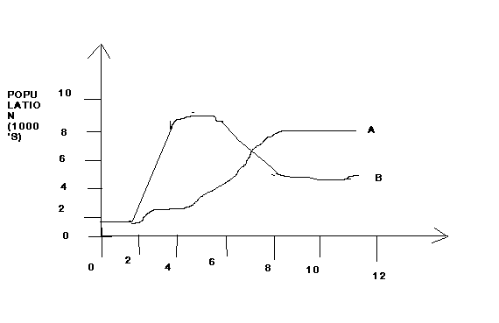

- Account for the shape of the curves between 0-2years. 3mks

- Account for the shape of the curve of population in ecosystem B between 6 -8 years. 3mks

- State two methods which could have been used to determine the population of the organism. 2mks

- Fig 11.28 shows two cells obtained from two different organisms while the cells were undergoing a certain stage of cell division. Study them and answer the questions that follow.

- Name the type of cell division the cells were undergoing. Give a reason for your answer. 2mks

- Name the stage the cells were undergoing. 1mk

- With a reason in each, identify the type of organism from which cell type I and 2 were obtained. 2mks

- What is the significance of the above type of cell division? 1mk

- The diagram below shows the internal structures of a typical flower.

- Name the parts labeled A-H.

- What does structure F change to after fertilization?

- With a reason, suggest the possible agent of pollination of the flower represented above. 1mk

- State two major pollutants of aquatic habitats that may lead to eutrophication. 2mks

- Explain three ways by which extensive use of insecticides can disrupt an ecosystem. 3mks

SECTION B(40MKS)
ANSWER QUESTION 6(COMPULSORY) AND EITHER QUESTION 7 OR 8

- Briefly describe each of the following types of a sexual reproduction :
- Binary fission in amoeba 4mks
- Budding in yeast 5mks
- Spore formation in Rhizopus nigricans. 6mks
- State three advantages and two disadvantages of asexual reproduction. 5mks
- Describe how each of the following factors cause water pollution, suggesting methods for controlling the pollution
- Domestic effluents. 8mks
- Industrial wastes. 5mks
- Agricultural activities. 7mks

- Describe the distinguishing features of the class insect. 8mks
- Describe the mechanism of gaseous exchange in terrestrial plants. 12mks

