NAME ------------------------------------------------ CLASS ---------------ADM NO. -------------------
GATITU MIXED SECONDARY SCHOOL
BIOLOGY 231/1
FORM 3RD TERM 2013
TIME: 2HRS.
Instructions
- Answer all the questions in the spaces provided

- state the functions of the following part of a microscope 1mk
- base

- limb/arm 1mk

- Name two regions in the human alimentary canal where starch is digested 2mks

- Why is it necessary that blood from the digestive system pass through the liver before entering the general circulation? 1mk

- Why are xylem vessels more efficient in transportation of water than tracheids? 2mks

- Explain why taking an under dose of antibiotics may lead to build up of a population of resistant bacteria. 2mks

- The figure below shows a single pair of homologous chromosomes at two stages of meiosis.

- Name the stages A and B 2mks

- Describe the differences between the two stages A and B 1mk

- State two functions of thrombokinase enzyme in blood clotting. 2mks

- State two factors that should be consired when determining intervals in both line and belt transect. 2mks

- Name a disease that can be prevented by efficient sewage disposal. 1mk

- Explain three events in mitosis that ensure number of chromosomes in daughter cells remain the same as in parent cell 3mks

- Define the following terms
- Instar 1mk

- Apical dominance 1mk

- Explain what happens during pupa phase of metamorphosis. 2mks

- state the function of the carnassials teeth 1mk

- Name the spore producing structures in:
- pteridophyta 1mk

- Bryophyta 1mk

- Explain why a rat has a higher food intake compared to a lizard of the same body weight. 2mks

- Name the part of the chloroplast where the following process occur.
a. photolysis 1mk

b. carbon (IV) oxide fixation 1mk

- Name the raw material used in photolysis 1mk

- Explain how an increase in temperature leads to an increase in photosynthesis. 2mks

- Give two disadvantages of external fertilization 2mks

- What is the function of Acrosome in a sperm? 1mk

- An experiment to investigate a certain process was set up as shown below.
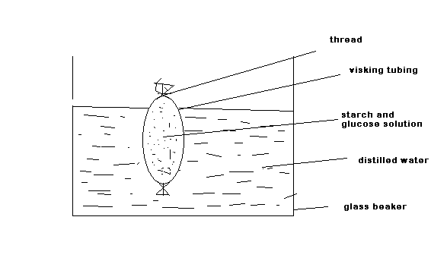
Test for starch and reducing sugars were carried out at the start of experiment and after 20 minutes on a sample obtained from the beaker.
 | Start of experiments | After 20 minutes
starch | absent | Absent
Reducing sugar | Absent | present

- Explain the presence of glucose in the beaker after 20 minutes 1mk

- Identify the colour of the reagent used in testing for reducing sugars. 1mk

- Name the portions of the human nephron found in the cortex of the kidney. 3mks

- Distinguish between active and passive immunity 2mks

- Give two characteristics of heart muscles which distinguish them from other types of muscles. 2mks

- Using simple diagrams differentiate between marginal and parietal placentation 2mks

- Air is forced into the lungs when the pressure in the thoracic cavity falls below atmospheric pressure. How is this fall in pressure brought about? 4mks

- Name the plant hormone that:
- stimulate formation of the callus tissue 1mk

- causes closing of stomata in high concentration 1mk

- Identify the biological representation by the diagram below. Name it

- state its function 1mk

- Explain how the following organelles are adapted to their function
- smooth endoplasmic reticulum 1mk

- vacuole 2mks

- Explain how budding occurs in yeast cells. 4mks

- Explain how the following factors increase the rate of active transport
- Glucose concentration 2mks

- Temperature 2mks

- state the role of each of the following substances present in saliva during food digestion
a. mucus 1mk

b. water 1mk

c. ptyalin 1mk

- Explain why food in living cells is stored in an insoluble form 2mks

- Osmosis is regarded as a special type of diffusion. Explain. 2mks

- Name the appropriate enzymes required for the process below to take place.
- sucrose + water → fructose + glucose 1mk

- lipid + water → fatty acids + glycerol 1mk

- starch + water → maltose 1mk

