GATITU MIXED SECONDARY SCHOOL
ARISE & SHINE
FORM 3 BIOLOGY
NAME…………………………………………………………ADM.NO....

1.The chart below shows a feeding relationship in a certain ecosystem
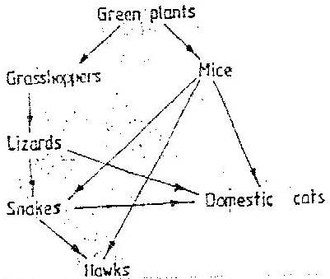

a)Construct two food chains ending with a tertiary consumer in each case( 2 mks)

b)Which organism has the largest variety of predators in the food web?(1 mk)

c)Name secondary consumers in food web (2 mks)

d)Suggest three ways in which the ecosystem would be affected in there was a prolonged drought.(3mks)

2. State three characteristics that ensure cross – pollination takes place in
flowering plants (3 mks)

3.To estimate the population size of crabs in a certain lagoon, traps were laid at random. 400 crabs were caught, marked and released back into the lagoon. Four days later, traps were laid again and crabs were caught. Out of the 374 crabs, 80 were found to be marked.
calculate the population size of the crabs in the lagoon using the formula below
N= n x M
m
Where N = Total population of crabs in the lagoon
n = Total number of crabs in the second catch
M = Number of marked crabs during the first
m= Number of marked crabs in the second catch ( 2 mks)

(b) State two assumptions that were made during the investigation ( 2 mks)

(c) What is the name given to this method of estimating the
population size ( 1 mk)

4.The diagram below represents a simplified nitrogen cycle.
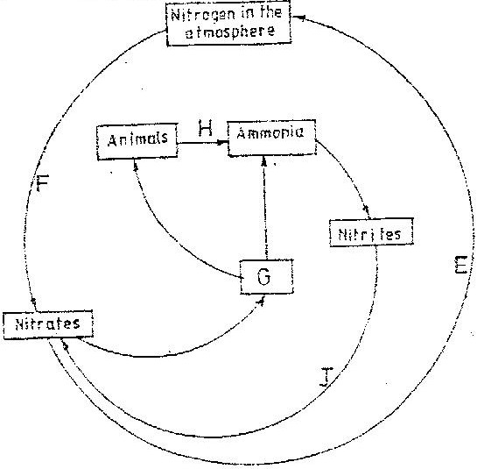

a)Name the organisms that cause process E and J(2mks)

b)Name the process represented by F and H.(2mks)

Name the group of organism represented by G(1mk)

5 (a) List four differences between meiosis and mitosis(4mks)

(b) Which sex chromosomes are found in human? (2mks)
Sperm cell?
Ova?

6.The herbivorous mammalian species were introduced into an ecosystem at the same time and in equal numbers. The graph below represents their populations during the first seven years. Study the graph and answer the questions that follow.
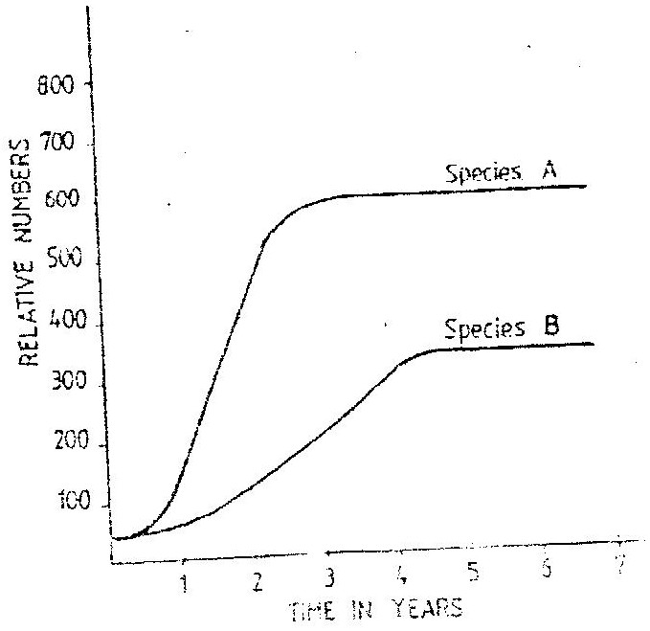

- Which species has a better competitive ability?(1mk)

- Give reason for your answer(1mk)

- Account for the shape of the curve species A between
One year and three years(2mk)

Three years and seven years

iv.A natural predator for species A was introduced into the ecosystem.
With a reason state how the population of each species would be affected.(2mk)

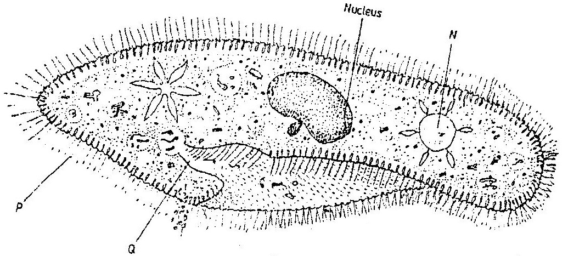
7.A student placed a drop of pond water in a cavity slide and observed it under the microscope. The student observed many fast moving organisms, one of which is represented in the diagram below.

- Name the phylum to which the organism belongs(1mk)

- Give a reason for your answer in (a) (i) above

Name the structures labeled N, P and Q.(3mks)

State two observable features that enable the organism to move fast.

8. Below is a list of organisms, which belong to classes Insecta, Myriapoda and Archnida: Tick, centipede, praying mantis, tsetse fly, millipede and spider.
Place the organisms in their respective classes in the table below.
Give reason in each case.(2mks)

Classes | Organisms | Reasons
Insecta
Arachnida
.

9.a)Distinguish between a community and population.(1mk)

b)Describe how population of grasshoppers in a given area can be estimated.(4mks)

10.
Name the bacteria found in the root nodules of leguminous plant(1mk)

b) State the association of the bacteria named in (a) above with the leguminous plants.

11.Ascaris lumbricoides in an example for an endo – parasite
The name Ascaris refers to(1mk)

State the habitat of the organism(1mk)

State three ways in which the organism is adapted to living in its habitat.(3mks)
12What is meant by:
Autecology
Synecology?
13The number and distribution of stomata on three different
leaves are shown in the table below:

Leaf | Number of stomata
 | Upper epidermis | Lower epidermis
A | 300
B | 150
C | 02

Suggest the possible habitat of the plants from which the leaves were obtained(3mks)
Leaf Habitat
A
B
C
(c) State the modifications found in the stomata of leaf C.(2mk)

14.Fruit formation without fertilization is called (1mk)

15During which phase of meiosis does crossing over occur. (2mks

16 What is the importance of cross pollination? (1mk)

17. a) What is meant by the terms
(i) Epigymous flower (1mk)

(ii) Staminate flower? (1mk)
b) How are the male parts of wild pollinated flowers adapted
to their function? (4mks

18. a) State three characteristics of Monera that are not found in
other kingdoms. (3mks)

b) Name the class to which a termite belongs

19 The diagram below represents a stage during cell division
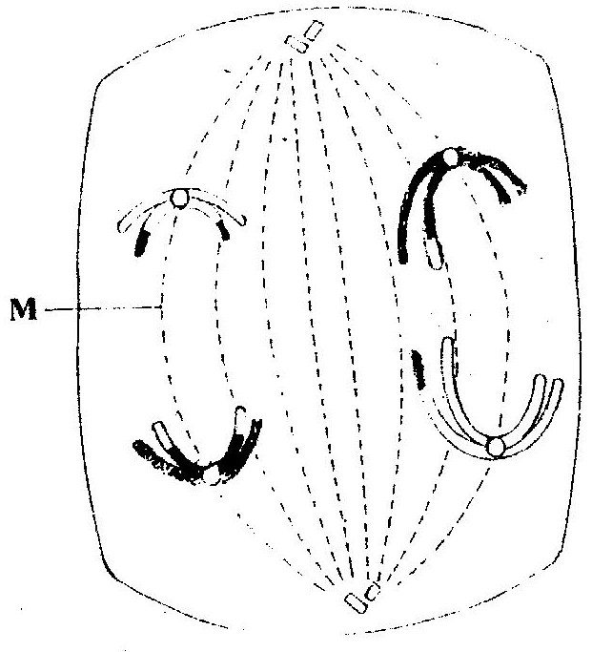

(a) (i) Identify the stage of cell division ( 1 mark)

(ii) Give three reasons for your answer in (a) (i) above ( 2 marks)

(b) Name the structures labeled M ( 1 mark)

20.The diagram below shows a stage during fertilization in a plant
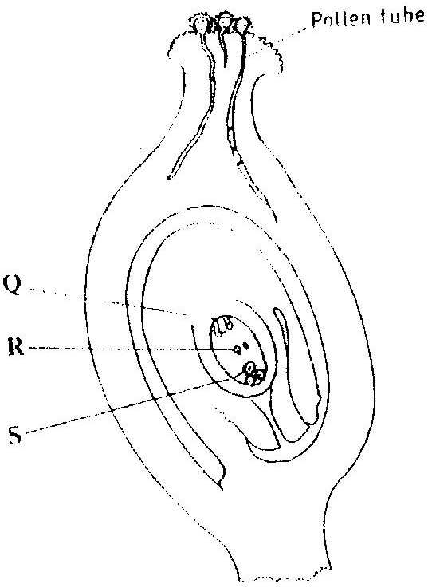

(i) Name the parts labeled Q, R, and S ( 3 marks)
Q
R
S
(ii) State two functions of the pollen tube ( 2 marks)

(c) On the diagram label the micropyle ( 1 mark)

21.a)State three external differences between chilopoda and diplopoda(3mks)

b). State three characteristics of the class crustacean(3mks).

22.a)Using diagrams,describe the process of fertilization in a flowering plant(15mks)
b)State the change that take place in a flower after fertilization(5mks)

