**GIANCHERE SEC SCHOOL**

**FORM THREE BIOLOGY RAT TERM THREE 2021**

1. The diagram below shows a specialized call from a human being.

a) Identify the cell (1mk)

b) Name the part labeled Q, M and N (3mks)

Q –

M-

N-

c) Give two functions of each of the following hormones in female

Menstrual cycle.

1. Progesterone (1mk
2. ii) Luteinizing hormone

(2mk

1. Name the pathogenic organisms which cause
2. syphilis ( 1mk)
3. Gonorrhea (1mk)
4. Distinguish between the essential and non-essential part of a flower ( 2 mks)
5. What is the significance of the testis being non hairy and hanging outside the body? (1,mk)
6. a) Name the hormone that stimulate the maturation of the graafian follicles to release a mature ovum in female reproductive cycle. (1mk)

b) Explain why menstruation does not take place after fertilization in human beings. (2mks)

14. List **three** advantages of asexual reproduction in plants. (3 marks)

1. Examine the microphotographs below and use them to answer questions that following

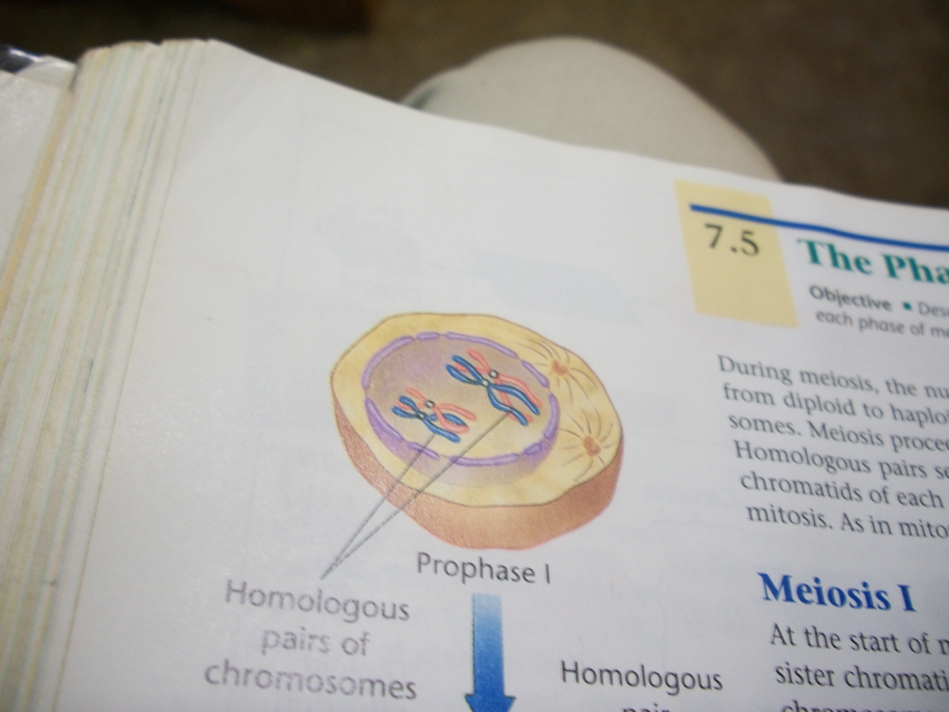

W

X

V

Y

Z

**A**

**B**

1. With reasons Identify the type of cell division shown in the micrograph above
2. Identity… (1,mk)
3. Reasons (2mk)
4. Name the structures labeled X, Y, Z and W (4marks)

X

Y

Z

w

1. What is the function of the structure labeled (2mrks)

X

Y

1. The diagram below shows half a flower.



A

B

C

F

E

D

1. Identify the structure that develop into a fruit wall after fertilization. (1 mark)
2. Name the structure labelled
3. B
4. F. (2 marks)

(c) What is the function of the structure labelled G? (1 mark)

END ©BIOLOGY DEPT