MWAKICAN JOINT EXAM TEAM (MJET)

FORM 1 PHYSICS

END OF TERM 2 – 2015

- Name three physical quantities and their SI units. (6mks)

- Name the instruments you would use to measure each of the following:
- The length of a football field. (1mk)

- The height of a 20 litre jerrican (1mk)

- The circumference of your waist. (1mk)

- A cylinder has a diameter of 4.2cm. How many times would a thread of 132cm be wound around the cylinder ? (3mks)

- A page of a book measures 14.5cm x 21.4 cm. What is its area in square millimetres ? (3mks)

- Define density and state its SI units. (2mks)

- The water level in a burette is 30cm³. If 55 drops of water fall from the burette and the average volume of one drop is 0.12cm³, what is the final water level in the burette ? (3mks)

- A cube of iron of side 4cm has a mass of 512g. Find:
- The volume of the cube in m³ (3mks)

- The density of iron in kgm⁻³ (3mks)

- What is pressure ? State its SI unit. (2mks)

- Explain the action of drinking straw. (3mks)

- Using the crashing can experiment, explain using a diagram the existence of atmospheric pressure (5mks)

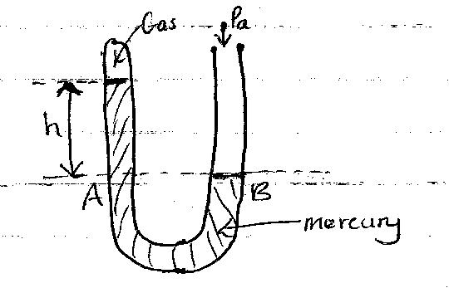
- The diagram below shows a mercury manometer. Some dry gas is present in the closed space in limb A, while limb B is open. If atmospheric pressure Pa = 103 000 pa, h = 30mm and density of mercury is 13 600kgm⁻³. Determine pressure Pg of the gas. (Take g = 10Nkg⁻¹) (4mks)

- The figure below shows a simple hydrauric press used to compress a bale. The cross-section areas of A and B are 0.002m² and 0.30m² respectively:

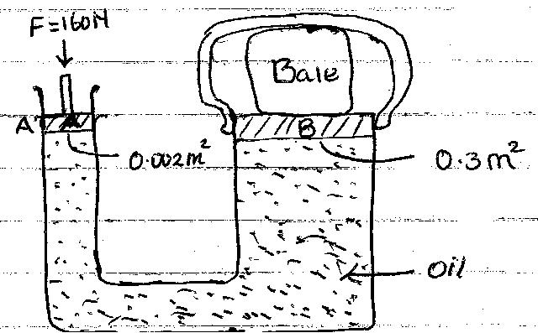

- Pressure exerted on the oil by the force applied at A. (3mks)

- Pressure exerted on B by the oil. (2mks)

- Force produced on B compressing the bale. (3mks)

- A sea diver is 35m below the surface of sea water. If the density of the sea water is 1.03gcm⁻³ and g is 10N/kg. Determine the total pressure on him.
(Atmospheric pressure = 103 000Nm⁻²) (3mks)

- A brick 20cm long, 10cm wide and 5cm thick has a mass of 500g. Determine the:
- Greatest pressure that can be exerted by the brick on a flat surface. (3mks)

- Least pressure that can be exerted by the brick on a flat surface. (Take g = 10N/kg) (3mks)

- Define matter and give the three states of matter. (4mks)

- Explain why the density of a gas is much less than that of a solid or liquid. (2mks)

- Explain the following:
- It is possible to compress gases but not solids and liquids. (2mks)

- A perfume sprayed at one corner of a room spreads quickly to the entire room. (2mks).

- A smoke cell contains a mixture of trapped air and smoke. The cell is brightly lit and viewed through a microscope. Small bright specks are seen dancing in a random manner.
- What are these small bright sperks ? (1mk)

- Why do they move in a manner described above ? (2mks)

- Using pollen grains placed in water, explain how their motion supports the idea that matter is not continuous. (2mks)

- Define force and give its SI units. (2mks)

- A concrete slab of mass 90kg is held by a steel cable of a crane as shown in the fig below.
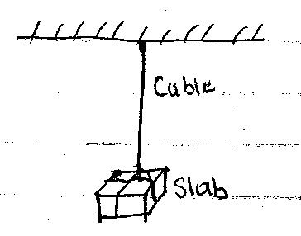

- Draw and name the forces acting on the slab. (2mks)

- Determine the tension in the cable. (3mks)

- When water is poured on a dry glass slab it spreads uniformly but it forms spherical droplets on a waxed glass slab. Explain. (4mks)

- A man has a mass of 70kg. Determine
- His weight on earth, where the gravitational field strength is 10N/kg. (3mks)

- His weight on the moon, where the gravitational field strength is 1.7N/kg. (3mks)

- A mass of 7.5kg has weight of 30N on a certain planet. Calculate the acceleration due to gravity on this planet. (3mks)

- A spring stretches by 6cm when supporting a load of 15N.

- How much would it stretch when supporting a load of 5kg? (3mks)

- What load would make the spring extend by 25mm ? (3mks)

- Describe a method that can be used to open a tight lid of a bottle without damaging it. (2mks).

MWAKICAN JOINT EXAM TEAM

FORM 1 PHYSICS MARKING SCHEME
END OF TERM 2 – 2015

- Length - Metre
Mass - Kilogram
Time - Second
Electric current - Ampere
Thermodynamic temperature – Kelvin
Luminous intensity - Candela
Amount of substance - Mole (Any 3)

2(a) Surveyor’s tape measure
(b) Metre rule
(c) Tailor’s tape measure

3. Circumference = π d

= 22 x 4.2 = 13.2
7
132cm
13.2cm

= 10 times.

4. 145mm x 214mm = 31 030mm²

5. - Mass per unit area
- Kgm⁻³ or Kg/m³

6. Vol of water dropped = 55 x 0.12
= 6.6 cm³

Final water level = 30cm³ – 6.6. cm³ 30cm³ + 6.6cm³ = 36.6cm³
= 23.4 cm³

7(a) 4cm = 0.04m
V = (0.04)³
= 0.000064m³

(b) P = M
V
= 0.512
0.000064
8000Kgm⁻³

- Force acting normally per unit area.
N/m² or Pascals

- When you suck the straw the air pressure inside it decreases making the atmospheric pressure outside to press the liquid hence it rises on the straw.

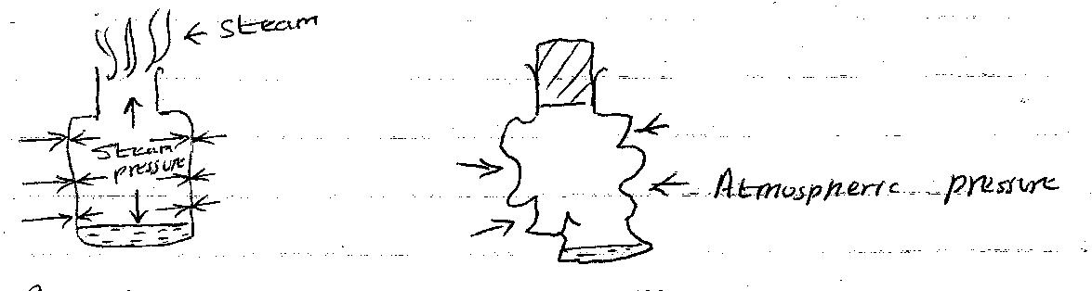

- Boil the water for several minutes.
- Replace the cork and allow the container to cool. You may pour cold water on it to cool it faster.
- The container crushed in.
- On cooling, the steam condenses. A partial vacuum is therefore created inside the container. Since the pressure inside is less than atmospheric pressure outside, the container crushes in.

- Pressure at A = Pressure at B
Pg + hpg = Pa
Pg + 0.03 x 13600 x 10 = 103 000
Pg + 4080 = 103 000
Pg = 98 920 Nm⁻²

- (a) P = F = 160
A 0.002

= 80,000 Nm⁻²

(b) Pressure at A = Pressure at B
= 80 000 Nm⁻²

(c) F = P X A
= 80 000 X 0.3
= 24 000 Nm⁻²

- Total pressure = Pressure of water Atmospheric pressure
= hpg + 103 000
= 35 x 1030 x 10 + 13 000
= 463 500 Pa

- Greatest pressure = Force
Smallest area
= 0.5 x 10
0.05 x 0.1

= 5 = 1000 Nm ⁻²
0.005

Smallest pressure = Force
Largest area

= 5 = 5__ = 250 Pa
0.2 x 0.1 0.002

- Anything that occupies space and has weight.
- Gas
- Liquid
- Solid

- This is because the particles in gases are wide spread compared to liquid and solids which are closely parked.

- (a) This is because the particles in gases are wide spread compared to liquid and
solids which are closely parked.

(b) This is because the particles of the spray move from region of high concentration to region of low concentration.

- (a) Smoke particles.

(b) They collided with denser and invisible air particles.

- The pollen grains are very light and they collided with invisible water particle making them to move in random motion.

- - It is a push or pull
- Newton

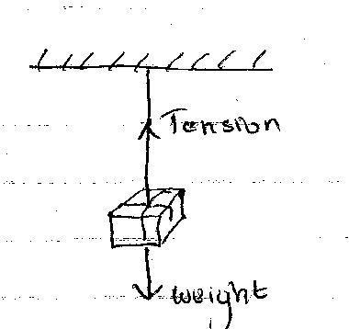
- (a)

(b) Tension = Weight = mg
= 90 x 10
= 900N

22. When the water was poured on a dry glass slab it spread uniformly because the adhensive force was higher than cohesive force but on a waxed glass slab it formed spherical droplets because cohesive force was higher than adhesive force.

23(a) W = mg
= 70 x 10
= 700N

(b) W = mg
= 70 x 1.7
= 119N

24. g = w
m

= 30
7.5
= 4N/kg

25(a) W = mg
= 5 x 10 = 50N
= 15N 6cm
50N ?

50 x 6 = 20cm
15

(b) 6cm 15N
2.5cm ?

2.5 cm x 15N
6cm

= 6.25 N

26. Dip the lid in hot water, it will expand, then dip the bottle itself in cold water, it will
contract allowing the opening of the lid to be easy.

