**Name………………………………………………………………...Index No……………………**

**Candidates Signature…………………………….. Date……………………………….…**

**511/3**

**MUSIC**

**Paper 3**

**March 2019**

**2 ½ hours.**

**MOKASA 2 JOINT EXAMINATION**

Kenya Certificate of Secondary Education

MUSIC

Paper 3

2 ½ hours.

**Instructions to Candidates**

1. *Write your name and index number in the spaces provided above*
2. *Sign and write the date of examination in the spaces provided.*
3. *Answer all questions in this paper*
4. *In question 4 choose any two of the questions numbered (a), (b), (c) and (d)*
5. ***DO NOT*** *remove any pages.*
6. *This paper consists of 11 printed pages*
7. ***Candidates should check the question paper to ensure that all the pages are printed as indicated and no questions are missing.***

**For Examiners Use Only**

|  |  |  |  |
| --- | --- | --- | --- |
| **Section** | **Question** | **Maximum Score** | **Candidate’s Score** |
| A | 1a | 09 |  |
| 1b | 06 |  |
| 2 | 15 |  |
| B | 3 | 14 |  |
| 4 | 14 |  |
| 5 | 10 |  |
| 6 | 10 |  |
| C | 7 | 06 |  |
|  | 8 | 16 |  |
| **Grand Total** | | **100** |  |

**SECTION A: BASIC SKILLS**

1. (a) Continue the following opening to make a melody of 16 bars for voice. Modulate to the relative minor, before returning to the tonic. Incorporate a duplate. Add phrase marks. (9 marks)

C:\Documents and Settings\MUSIC STUDENTS\My Documents\Scores\mokasa121.tif

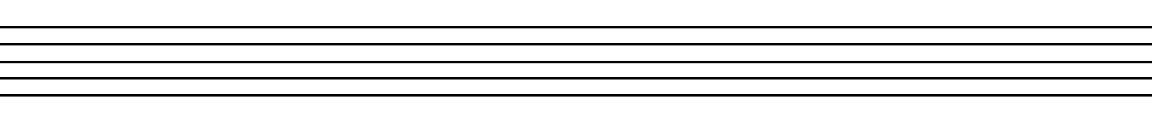









(b) Using staff notations compose a tune to suite the following lyrics. Add phrase marks. (6 marks)

***I will stand and fight to the end***

***For in the end I will rejoice.***







2. Harmonize the following melody for Soprano, Alto, Tenor and Bass.(SATB). Choose appropriate chords from I, ii, IV, V and vi. Use V7 Dominant seventh and a cadential six four. (15marks)

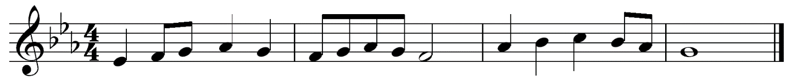





**SECTION B: HISTORY AND ANALYSIS (48 marks)**

**3.AFRICAN MUSIC**

a) Identify each of the following Kenyan instruments: (5 marks)

1. Uta …………………………………………………………………………………………
2. Musherembe ……………………………………………………………………….
3. Mbeve ..……………………………………………………………………….........
4. Kithembe …………………………………………………………………………..
5. Kimeng’eng’………………………………………………………………………..

b) a) The following figure represents an African Instrument. Study it and answer questions i-iv

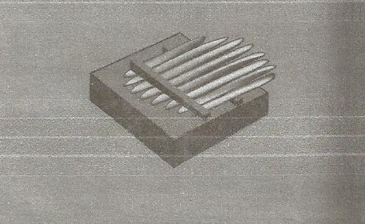

1. Name the instrument. ( 1 mark)

…………………………………………………………………………………………………

1. Under which classification does the instrument fall? (1 mark)

…………………………………………………………………………………………………

1. Name the Community to which the instrument belongs. (1 mark)

…………………………………………………………………………………………………

iv) How is the instrument played? (1 mark)

…………………………………………………………………………………………………

c) Identify the following dances in Kenya. (2 marks)

i.Nduumo ………………………………………………………………………………………………………………………………………………………………………………………………

ii.Lelemama ……………………………………………………………………………………………………………………………………………………………………………………………....

d) State three roles of dance patterns in African traditional performances. ( 3 marks)

……………………………………………………………………………………………....

……………………………………………………………………………………………....

……………………………………………………………………………………………....

……………………………………………………………………………………………....

**4. WESTERN MUSIC**

*Answer any* ***two*** *of the questions (a), (b), (c) and (d).*

**(a) Orlando de Lassus**

(i) Name any two of his contemporaries. (1 mark)

………………………………………………………………………………………………………………………………………………………………………………………………………………

(ii) Name two main influences on De Lassus music in his early years. (2 marks)

…………………………………………………………………………………………………

………………………………………………………………………………………………………………………………………………………………………………………………………………………………………………………………………………………………………………………

(iii) What appointments did Orlando hold during the following years? (2 marks)

1553 ………………………………………………………………………………………………………………………………………………………………………………………………………………

1556 …………………………………………………………………………………………………

…………………………………………………………………………………………………

(iv) Identify the following works by Lassus. (2 marks)

*St. Matthew* ..............................................................

*Prophetiae Sibyllarum* ……………………………..

**b) Johann Sebastian Bach**

i) Name four instruments J. S. Bach played? (2 marks)

………………………………………………………………………………………..

ii) List any **three** factors that influenced Bach during his musical career. (3 marks)

………………………………………………………………………………………………..

………………………………………………………………………………………………………………………………………………………………………………………………………………………………………………………………………………………………………………………………………………………………………………………………………………………………

iii) Outline any **two** characteristics of Bach’s compositions. (2 marks)

…………………………………………………………………………………………………

…………………………………………………………………………………………………

…………………………………………………………………………………………………

…………………………………………………………………………………………………

**c) Ludwig Van Beethoven**

i. Name two great composers who taught Beethoven. (1 mark)

…………………………………………………………………………………………………

…………………………………………………………………………………………………

ii. During which period of music history did Beethoven live? (1 mark)

…………………………………………………………………………………………………

iii. a) What is a Sonata? (1 mark)

…………………………………………………………………………………………………

…………………………………………………………………………………………………

b) What was unique about the Sonatas composed by Beethoven? (1 mark)

………………………………………………………………………………………………………………………………………………………………………………………………………………

iv. Identify the following compositions by Beethoven (3 marks)

*Waldstein* ………………………………………………………………………………………….

*The Emperor* ………………………………………………………………………………………

*The Consecration of the House* …………………………………………………………………….

**d) Guiseppe Verdi**

i) In what three ways did Verdi earn a living through music? (3 marks)

………………………………………………………………………………………………………………………………………………………………………………………………………………………………………………………………………………………………………………………………………………………………………………………………………………………………………………………………………………………………………………………………………………………………………………………………………………………………………………

ii) Apart from Opera, list **two** other works he composed? (2 marks)

………………………………………………………………………………………………………………………………………………………………………………………………………………iii) Outline **two** ways in which Verdi’s political career contributed to his music? (2 marks)

…………………………………………………………………………………………………

…………………………………………………………………………………………………

………………………………………………………………………………………………………………………………………………………………………………………………………….

5. **Prescribed Traditional African Music**

*Meru Folksong by Nkubu High School (PPMC Recording of KMF 2014).*

a) What is the main medium of performance in the recording? (1mark)

…………………………………………………………………………………………………

b) Outline **three** ways in which the climax is achieved in the performance. (3 marks)

…………………………………………………………………………………………………

…………………………………………………………………………………………………

…………………………………………………………………………………………………

…………………………………………………………………………………………………

…………………………………………………………………………………………………

c) Apart from the voice, dentify **three** other media used in the performance and the roles they play. (3 marks)

…………………………………………………………………………………………………

………………………………………………………………………………………………………………………………………………………………………………………………………………………………………………………………………………………………………………………………………………………………………………………………………………………………………………………………………………………………………………………………………

d) Give the features of the final section of the performance. (3marks)

……………………………………………………………………………………………………………………………………………………………………………………………………………………………………………………………………………………………………………………………………………………………………………………………………………………………………………………………………………………………………………………………………………………………………………………………………………………………………………….

6. **Prescribed Western Music**

**G.F.Handel:** *Ode for St. Cecilia- Chorus No. 3 From Harmony*

a) In which era was this music composed?  (1mark)

………………………………………………………………………………………………….

b) Outline two main roles played by the Cello and the Double Bass. (2 marks)

………………………………………………………………………………………………….

………………………………………………………………………………………………….

………………………………………………………………………………………………….

c) Which cadence is used in bar 20 of the music? (1 marks)

…………………………………………………………………………………………………

d) Identify the compositional devises used in the following bars. (4 marks)

i) Bar 22-25 ………………………………………………………………………….

ii) Bar 53-59 (Tenor and Bass)……………………………………………………………..

iii) Bar 60-63……………………………………………………………………………….

1. Bar 45…………………………………………………………………………………..

e) Explain the sign placed under the clef on the Tenor line (2 marks)

…………………………………………………………………………………………………

**7. Unprepared Analysis**

1. Study the music extract below and answer the questions that follow.

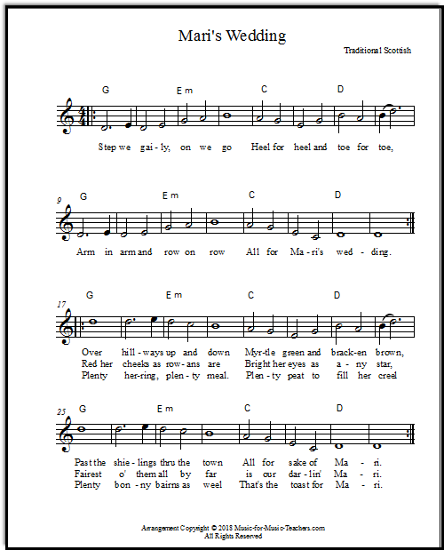

i) State the form of the music above and illustrate it by use of bar numbers. (2 marks)

………………………………………………………………………………………………………………………………………………………………………………………………………………

………………………………………………………………………………………………………

ii) For what media is the music scored? Explain. (2 mark)

…………………………………………………………………………………………………

…………………………………………………………………………………………………

iii) Explain any 2 performance directions indicated in the music. (2mark)

………………………………………………………………………………………………………………………………………………………………………………………………………………………………………………………………………………………………………………………………………………………………………………………………………………………………

**SECTION C: GENERAL MUSIC KNOWLEDGE (16 marks)**

8a) The following melody is for horn in F. Transpose it for clarinet in B flat at the

same pitch. (4 marks)



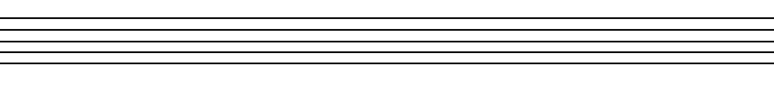

1. State any **two** roles of a ululation in a traditional African folksong performance.

(2 marks)

………………………………………………………………………………………………………………………………………………………………………………………………………………………………………………………………………………………………

c) Write the melody below as it is to be played. (5 marks)







d) Define any **five** of the following (5 marks)

1. Acapella

……………………………………………………………………………………………………………………………………………………………………………………………………

1. Sempre poco forte

……………………………………………………………………………………………………………………………………………………………………………………………………

1. Credo

……………………………………………………………………………………………………………………………………………………………………………………………………

1. Pedal

……………………………………………………………………………………………………………………………………………………………………………………………………

1. Ritornello

……………………………………………………………………………………………………………………………………………………………………………………………………

1. Dorian

……………………………………………………………………………………………………………………………………………………………………………………………………

1. Mentation

……………………………………………………………………………………………………………………………………………………………………………………………………

1. Interlude

……………………………………………………………………………………………………………………………………………………………………………………………………