JOINT PRE-MOCK EXAMS
511/3 MUSIC PAPER 3
2021-2 ½ HOURS
Name _________________________________ Index number____________________
Candidate’s signature______________________ Date ___________________________
Instructions to candidates
- Write your name and index number in the spaces provided
- Sign and write the date of the examination in the spaces provided above
- Answer all the questions in this paper
- In question 4 choose any two of the questions numbered (a), (b), (c) and (d)
- All answers must be written in the spaces provided
- This paper consists of 10 printed pages
- Candidates should check the question paper to ensure that all the pages are printed as indicated and that no questions are missing

For examiner’s use only
Section | Question | Maximum score | Candidate’s score
A | 1 | 15
 | 2 | 15
B | 3 | 14
 | 4 | 14
 | 5 | 10
 | 6 | 10
 | 7 | 6
C | 8 | 16
Total Score |  | 100

SECTION A: BASIC SKILLS (30 marks)
Answer all questions in this section
- a) Starting with the given opening, compose a melody of sixteen bars for voice, with a modulation to the dominant and return to the tonic. Introduce dynamics. (9 marks)

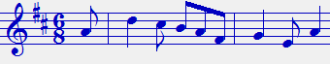

b) Compose a melody and set it to the text given below. Use the treble stave and a key of your choice. (7 marks)
Hivi leo natangaza, mimi nitatenda wema
Sitaacha mila zetu, ili niitwe mtumwa.

- Harmonize the following melody for SATB. Choose appropriate chords from I, ii, IV, V and vi. (15 marks)

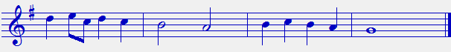

SECTION B: HISTORY OF MUSIC (54 marks)
3. (a) Name the communities that traditionally perform the following dances (4marks)
- Ohangla-
- Gitiiro-
- Eunoto-
- Akisuk-

(b) Outline four advantages of call response style of singing (4 marks)
______________________________________________________________________________________________________________________________________________________________________________________________________________________________________________________________________________________________________________________________________________________________________________________________________________________________________________________________________________________________________________________________

(c) Explain the term idiophones. ( 2marks)
____________________________________________________________________________________________________________________________________________________________

(d) State four ways in which participation in the Kenya music festival is important to a music student. (4 marks)
_____________________________________________________________________________________________________________________________________________________________________________________________________________________________________________________________________________________________________________________________________________________________________________________________________________________________________________________________________________________________________________________________

WESTERN MUSIC
Answer any TWO questions.
(a) 4. WILLIAM BYRD
(i) What nationality was Byrd. (1 mark)
______________________________________________________________________________
(ii) Name any two of his contemporaries (2 marks)
__________________________________________________________________________________________________________________________________________________________________________________________________________________________________________

(iii) Outline any three of his achievements jointly with Thomas Tallis (3 marks)
______________________________________________________________________________________________________________________________________________________________________________________________________________________________________________________________________________________________________________________________________________________________________________________________________

(iv) What does “ My Ladye Novelles Booke “contain? (1 mark
____________________________________________________________________________________________________________________________________________________________

(b) JOSEF FRANZ HADYN
(i) What nationality was Haydn? (1 mark)
__________________________________________________________________________
(ii) For what medium did Haydn mainly compose? ( 1 mark)
___________________________________________________________________________
(iii) Haydn’s symphonies had nick names. Give the reason why he gave the following titles to these symphonies. (2 marks)
The clock symphony
__________________________________________________________________________________________________________________________________________________________________________________________________________________________________________

The surprise symphony
__________________________________________________________________________________________________________________________________________________________________________________________________________________________________________
(iv) Outline any three features of the Strum and drang style. (3 marks)
______________________________________________________________________________________________________________________________________________________________________________________________________________________________________________________________________________________________________________________________________________________________________________________________________

(c) FRANZ LISZT
(i) In which period of music did Liszt Live? (1 mark)
______________________________________________________________________________

(ii) Describe a symphonic poem (1 mark)
____________________________________________________________________________________________________________________________________________________________
(iii) State three features of his symphonic poems. (3 marks)
______________________________________________________________________________________________________________________________________________________________________________________________________________________________________________________________________________________________________________________________________________________________________________________________________

(d) BELLA BARTOK
(i) In which period of music history did he live? (1 mark)
____________________________________________________________________________

(ii) State three early life influences on his music career. (3 marks)
______________________________________________________________________________________________________________________________________________________________________________________________________________________________________________________________________________________________________________________________________________________________________________________________________

(iii) Name the works with the following titles. (2 marks)
Miraculous mandarin-
Blue beards castle-

(iv) What post did he hold together with Zoltan Kodaly (1 mark)
____________________________________________________________________________________________________________________________________________________________

5. PRESCRIBED TRADITIONAL AFRICAN MUSIC.
(Chivoti by diwani nzaro from YouTube.)
- Explain the introductory section of the performance. (2mks)
__________________________________________________________________________________________________________________________________________________________________________

- State three variations used in this performance (3mks)
_______________________________________________________________________________________________________________________________________________________________________________________________________________________________________________________________

- Describe any three musical styles of performance used in this recording (3mks)
_______________________________________________________________________________________________________________________________________________________________________________________________________________________________________________________________

- State the two families of African music instruments used in this performance. (2mks)
__________________________________________________________________________________________________________________________________________________________________________

6. PRESCRIBED WORK FOR ANALYSIS
“Too much I once lamentedby Thomas Tomkins”
- In which music period was the work composed? (1mk)
___________________________________________________________________________

- State the medium used in this performance. (1mk)
______________________________________________________________________________
- Explain word painting by the use of bar numbers. (2mks)
__________________________________________________________________________________________________________________________________________________________________________________________________________________________________________

- Identify the following by use of the bar numbers. (3mks)
- Inversion ___________________________________________________________
- Octave ___________________________________________________________
- Diminuendo ___________________________________________________________

- Identify three musical devices used in bar 13-19. (3mks)
________________________________________________________________________________________________________________________________________________________________________________________________________________________________________________________________________________________________________________________

7. ANALYSIS OF UNPREPARED WORK (6 marks)
Answer the following questions with reference to the piece below.

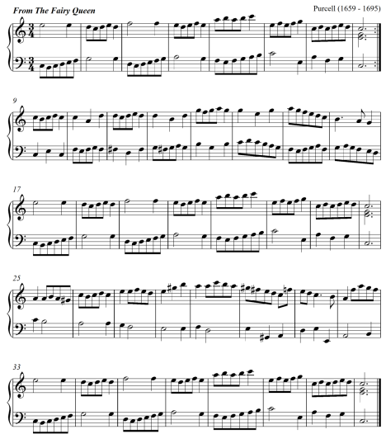

(a). For what medium is this piece written? (1 mark)
_________________________________________________________________________

(b) . Using bar numbers outline the form of the music. (2 marks)
____________________________________________________________________________________________________________________________________________________________

(C). Outline the key scheme of the music. (1 ½ marks)
____________________________________________________________________________________________________________________________________________________________

(d). Using bar numbers and parts, identify where the following compositional devices have been used: (1 mark)
(i) Sequence ____________________________________________________________
(ii) Scalic motion ________________________________________________________

(e) Describe the range of the music. ( ½ mark)
_________________________________________________________________________

SECTION C: GENERAL MUSIC KNOWLEDGE (16 MARKS)
(a)
(i) Differentiate between a whole consort and a broken consort. (2marks)
____________________________________________________________________________________________________________________________________________________________________________________________________________________________________________________________________________________________________________

(ii) Outline three ways through which hip-hop music has influenced the performance of traditional dances in Kenya. (3 marks)
____________________________________________________________________________________________________________________________________________________________________________________________________________________________________________________________________________________________________________ (iii) Outline four factors that influence the quality of sound produced on a traditional African fiddle. (4 marks)
_____________________________________________________________________________________________________________________________________________________________________________________________________________________________________________________________________________________________________________________________________________________________________________________________________________________________________________________________________________________________________________________________________________

(b) The following melody is written for a trumpet in B flat. Write it in its concert pitch. (4 marks)
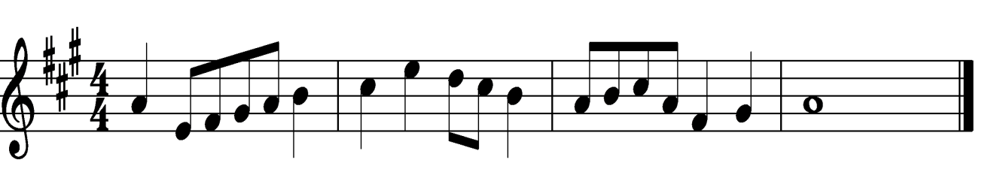

(d) Name any three composers of the Kenya national anthem. (3 marks)
_________________________________________________________________________________________________________________________________________________________________________________________________________________________________________

