Name………………………………………………………………..IndexNo…………………………
Candidates Signature……………. Date………………………………
511/3
MUSIC
Paper 3
July 2021
2 ½ hours.

KASSU JET EXAMINATION
Kenya Certificate of Secondary Education
MUSIC
Paper 3
2 ½ hours.

Instructions to Candidates

- Write your name and index number in the spaces provided above
- Sign and write the date of examination in the spaces provided.
- Answer all questions in this paper
- In question 4 choose any two of the questions numbered (a), (b), (c) and (d)
- DO NOT remove any pages.
- This paper consists of 9 printed pages
- Candidates should check the question paper to ensure that all the pages are printed as indicated and no questions are missing.

For Examiners Use Only
Section | Question | Maximum Score | Candidate’s Score
A | 1a | 09
 | 1b | 06
 | 2 | 15
B | 3 | 14
 | 4 | 14
 | 5 | 10
 | 6 | 10
 | 7 | 06
C | 8 | 16
Grand Total |  | 100
SECTION A: BASIC SKILLS
- a) Continue the given opening to make a melody of 16 bars for voice. Modulate to the Sub-dominant before returning to the tonic. Incorporate a sequence. Add phrase marks. (9 marks)

(b) Using staff notation, compose a tune to suit the following lyrics. Add phrase marks. (6 marks) Ewe mwana nisikiya nikupapo ushauri,
Mwendo wako na tabia lazima utafakari.

- Copy and harmonize the given melody for Soprano, Alto, Tenor and Bass (SATB). Choose appropriate chords from the following; I, ii, IV, V and vi. Use a Cadential six four and a dominant seventh chord. Indicate the chords that you use. (15 marks)

SECTION B: HISTORY AND ANALYSIS (48 marks)
3. AFRICAN MUSIC
Identify each of the following Kenyan dances: (4marks)
- Kilumi - ………………………………………………………………………
- Mukinyo - ………………………………………………………………………
- Ngelem - ………………………………………………………………………
- Owalo - ………………………………………………………………………
- Name any two parts of an adeudeu and state how each contributes to sound production.
(4 marks)
………………………………………………………………………………………………………
………………………………………………………………………………………………………
- State three different ways in which the solo-choral response style is used in the performance of an African traditional folk song (3 marks)
………………………………………………………………………………………………………
………………………………………………………………………………………………………
………………………………………………………………………………………………………
- List any three vocal techniques used to embellish a traditional folk performance. (3 marks)
………………………………………………………………………………………………………
………………………………………………………………………………………………………
………………………………………………………………………………………………………

4. WESTERN MUSIC

Answer any two of the questions (a), (b), (c) and (d).

(a) William Byrd
- State any four factors that influenced his music career. (4 marks)
……………………………………………………………………………………………………………………………………………………………………………………………………………………………………………………………………………………………………………………………………………………………………………………………………………………………………………………………………………………………………………………………………………………………………………………………………………………………………………..
- Describe any three characteristics of his music (3 marks)
……………………………………………………………………………………………………………………………………………………………………………………………………………………………………………………………………………………………………………………………………………………………………………………………………………………………..
b) Haydn Franz Joseph
- Name the four standard classic movements of Haydn’s symphonies. (2 marks)
………………………………………………………………………………………………………
- What is the Nelson mass by Haydn scored for? (1 mark)
………………………………………………………………………………………………………
- Outline any two of Haydn’s contributions to the development of the orchestra. (2 marks)
………………………………………………………………………………………………………
………………………………………………………………………………………………………
………………………………………………………………………………………………………
- Identify the following works by Haydn: (2 marks)
- Creation - ………………………………………………………
- Coronation - ………………………………………………………
- Military - ………………………………………………………
- Life on the moon - ………………………………………………………
c) Franz Liszt
- Outline any three of Liszt’s contribution to music. (3 marks)
………………………………………………………………………………………………………
………………………………………………………………………………………………………
………………………………………………………………………………………………………
………………………………………………………………………………………………………
- State any two characteristics of Liszt’s piano music. (2 marks)
………………………………………………………………………………………………………
………………………………………………………………………………………………………
- Name any two of Liszt’s symphonic poems. (2 marks)
………………………………………………………………………………………………………
………………………………………………………………………………………………………
d) Bela Bartok
- In what musical period did Bela Bartok live? (1 mark)
………………………………………………………………………………………………………
- Apart from Bela Bartok name any other four composers of the musical period named above. (4 marks)
………………………………………………………………………………………………………………………………………………………………………………………………………………………………………………………………………………………………………………………………………………………………………………………………………………………………………………………………………………………………………………………………………
- What was the importance of folk music to Bella Bartok. (2 marks)
………………………………………………………………………………………………………………………………………………………………………………………………………………………………………………………………………………………………………………………

5. Prescribed Traditional African Music Chivoti by Diwani Nzaro from Youtube.
- State any two ways in which variety has been created in this work. (2 marks)
………………………………………………………………………………………………………
………………………………………………………………………………………………………
- Write down the rhythm of the: (2 marks)
- Shaken idiophone.

- Struck idiophone.

- State any three roles of the percussive section in this recording. (3 marks)
………………………………………………………………………………………………………
………………………………………………………………………………………………………
………………………………………………………………………………………………………

- Identify any three characteristics of African Music evident in this recording. (3 marks)
………………………………………………………………………………………………………
………………………………………………………………………………………………………
………………………………………………………………………………………………………

6. Prescribed Western: Too Much I Once Lamented: by Thomas Tallis
- By use of bar numbers, identify any two stylistic devices used in this work. (2 marks)
………………………………………………………………………………………………………
………………………………………………………………………………………………………
………………………………………………………………………………………………………
- Cite any three types of syncopations used in this work. (3 marks)
………………………………………………………………………………………………………
………………………………………………………………………………………………………
………………………………………………………………………………………………………
………………………………………………………………………………………………………
………………………………………………………………………………………………………
………………………………………………………………………………………………………
- By use of bar numbers, identify the texture of this work between bars 24 – 34. Give reasons for your answer. (2 marks)
………………………………………………………………………………………………………
………………………………………………………………………………………………………
………………………………………………………………………………………………………
- What is the genre of this work? (1 mark)
………………………………………………………………………………………………………
- What is the music scored for? (1 mark)
………………………………………………………………………………………………………
- What term is given to the entries at the beginning of the music? (1 mark)
………………………………………………………………………………………………………

7. Unprepared Analysis
Study the music below and answer the questions that follow.
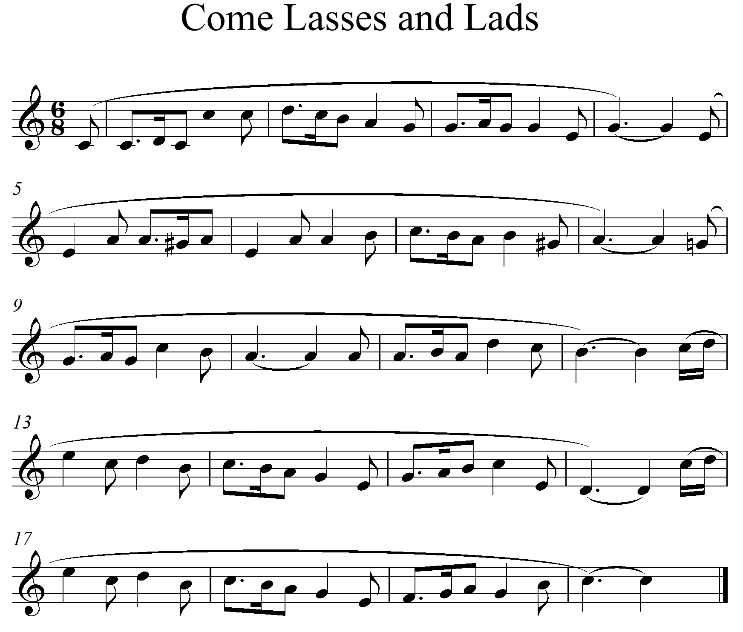
- Name the Tonic key and the key to which the music modulates at bars 7 to 8. (2 marks)
………………………………………………………………………………………………………
- By use of bar numbers, identify the following; (2 marks)
- Exact repetition - ………………………………………………………………
- Sequence - ………………………………………………………………
- Name the cadence at bar 3 to 4. (1 mark)
………………………………………………………………………………………………………
- Write down the most commonly used rhythmic motif. (1 mark)

SECTION C: GENERAL MUSIC KNOWLEDGE (16 marks)
8. a) The following melody is written for a clarinet in B flat. Rewrite it for a violin. (5 marks)
b) (i) Outline any three responsibilities of a Concert promoter. (3 marks)
………………………………………………………………………………………………………
………………………………………………………………………………………………………
………………………………………………………………………………………………………
(ii) State any four ways in which musicians in Kenya earn their living. (2 marks)
………………………………………………………………………………………………………
………………………………………………………………………………………………………
………………………………………………………………………………………………………
………………………………………………………………………………………………………
………………………………………………………………………………………………………
- Define any six of the following terms used in music. (6 marks)
- Arco - …………………………………………………………………….
- Scherzando - ……………………….…………………………………………….
- Fiddle - ……………………….…………………………………………….
- Auditions - ……………………….…………………………………………….
- Piracy - ……………………….…………………………………………….
- Drum major - ……………………….…………………………………………….
- Andante - ……………………….…………………………………………….
- Orchestra - ……………………….……………………………………………..

