3KNT
BIOLOGY 231/2(PAPER 2)
MARKING SCHEME
- (a) To investigate the necessity of water; and appropriate temperature during germination.
(b )- hydrolyse stored food
- To activate enzymes
- Water acts as a solvent and provides a transport medium of hydrolysed food.
- breaking seed dormancy by softening the seed coat/ testa
(c) In set up A – seeds will germinate
In set up B – Seeds will not germinate
In set up C – Seeds will not germinate
- (a) Disaccharide is a sugar molecule formed when two monosaccharide’s units combine through a condensation process resulting to elimination of water molecules (1mk)
Polysaccharide is a long chain sugar molecule formed when several molecules of monosaccharides combine through condensation process releasing water (1mk)

(b) starch; glycogen; cellulose, chitin
(c)(i) Sucrose
(ii) Hydrolysis
(iii) Dilute hydrochloric acid
(iv) To neutralize the acid
- (a) A – Epidermal cell
B – Chloroplast
C – Stoma
D – Guard cell

(b) – it allows exchange of carbon (iv) oxide and oxygen between the inside of the leaf and the surrounding atmospheric air / gaseous exchange.
- It permits exchange of water vapour from the leaf through transpiration.
(c) – photosynthetic theory
- Starch – sugar inter conversion theory
- Potassium ion theory

4. (a) respiratory quotient = volume of carbon (iv) oxide produced
Volume of oxygen consumed
72.9cm³
80cm³ ⁼ 0.91125

(b) Protein
(c) - Helps to identify the type of food/ substrate being broken
- helps to identify the type of respiration taking place
(d)(i)Anaerobic respiration
(ii) Lactic acid and energy

(e) A rat has large surface area to volume ratio, compared to elephant thus looses more energy in form of heat per body weight i.e looses heat faster than the elephant.(accept the reverse)
5. (a) (i) Parental Genotype
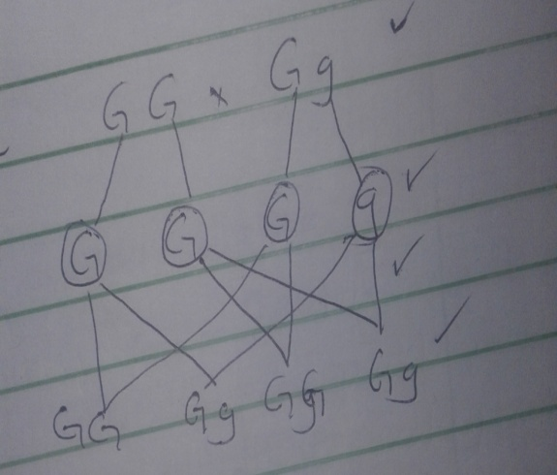

Gametes

offspring

Genotypic ratio2GG: 2Gg
(ii) All offspring have purple grains
(b) (i) Co- dominance
(ii) - inheritance of blood type AB
- sickle celled traits

6a 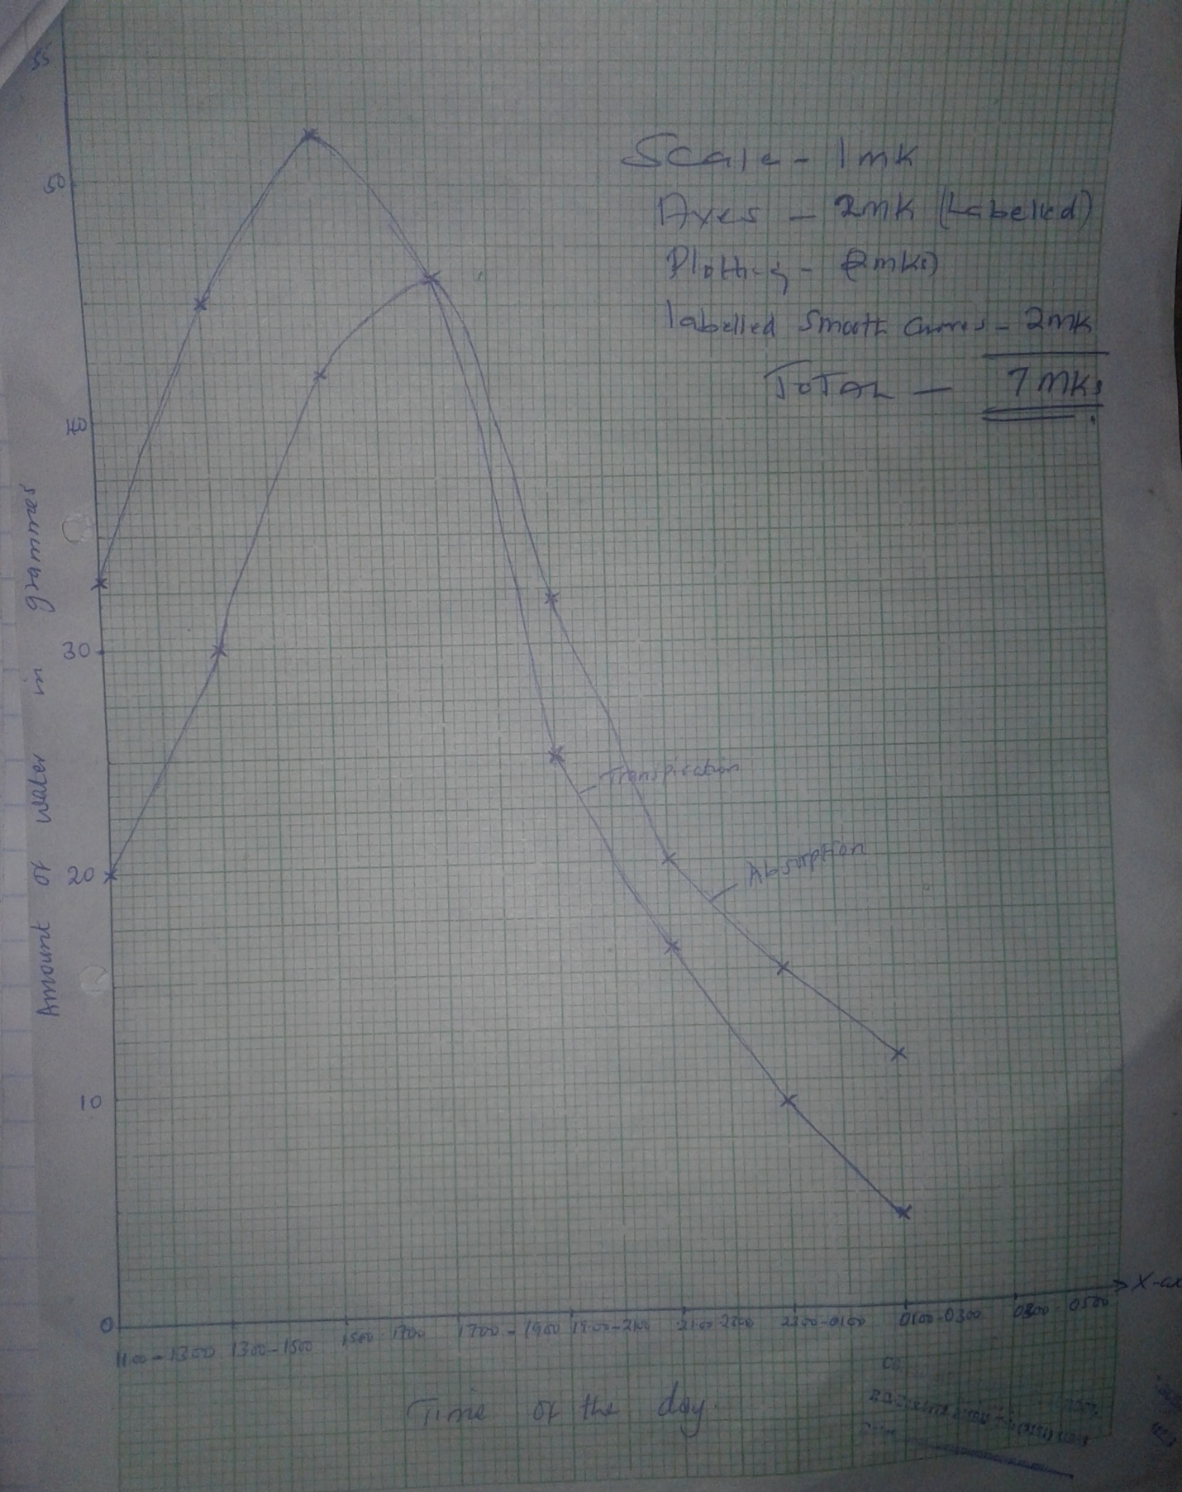

(b) 1700 – 1900hours
(c) (i) 1100 – 1700 hours – rapid rate of transpiration due to high light intensity and high temperature.
1700- 0300 hours – decrease in the rate of transpiration due to low light intensity / and reduced temperature of the day
(ii) 1100 – 1900 hours – increase in rate of absorption of water to replace water lost through transpiration
1900 – 0300hours – decrease in rate of absorption due to decline in the rate of transpiration
(d) Both transpiration and absorption would decrease
(e) Wind , temperature ,humidity, atmospheric pressure, light intensity
(f) (a) cohesion force enables the water molecules to stick together in a continuous column in the vessel since water molecules attract one another
(b) adhesion forces enables water molecules to stick or get attracted to the vessel walls hence water rise up the vessel.

7. – some xerophytes shed their leaves during drought to reduce the surface area exposed to transpiration.
- some xerophytes have superficial roots which grow horizontally close to the soil surface to absorb maximum amount of water after a short or light showers of rain.
- some xerophytes have succulent stems and leaves that store water in large parenchyma cells
- some xerophytes have a thick waxy cuticle to minimize the rate of cuticular transpiration .
-Some xerophytes have leaves with sunken stomata in which humid air accumulates this reduces the saturation deficit and hence reduces the rate of transpiration.
-some xerophytes survive dry periods as seed or spores as method of evading drought.
-Some xerophytes fold their leaves to reduce the surface area exposed to environmental factors such as wind thus reducing the rate of transpiration
-some xerophytes experience reversed stomata rhythm. they open the stomata at night and close them during the day. This reduces the rate of stomata transpiration during the day.
-most xerophytes have reduced number of stomatas.

8. (a) After pollination, pollen grains land and stick on the stigma. The stigma produces a sticky substance that makes pollen grains to adhere to it. A pollen tube starts to germinate downwards along the style. A tube nucleus keeps at the tip of the pollen tube whose role is to control growth of pollen tube, while generative nucleus follows behind, growth of pollen tube is caused by chemical secreted from the ovary . Energy for growth is obtained from tissues of the style, and growth depends on the compatibility between the style and the pollen grains. Generative nucleus divides mitotically forming two male nuclei, the pollen tube enters the embryo sac through the microphyle, after which the tube nucleus disintegrates; one male nuclei fuses with functional egg to form a diploid zygote, while the other male nuclei fuses with the pollen nuclei to form a triploid nucleus that form primary endosperm.

(b) Diploid zygote undergoes mitosis to form embryo, that later differentiate into radical plumule and cotyledons
Triploid zygote /nuclei develop to become primary endosperm nucleus which then become the endosperm i. e food reserves
Integument develops to become the teste /seed coat
Microphyle persists as a small hole in the testa through which water and oxygen imbibes during germination
Ovary becomes fruits while ovary wall become the pericarp that later differentiate into epicarp, mesocarp and endocarp.
Ovules become seeds, floral parts withers and dies or lost in a controlled manner

