3KNT
BIOLOGY 231/3 (PRACTICAL)
MARKING SCHEME
- (a) (i) piece in solution S1 (1mk
firm/hard/stiff/rigid
piece in solution S2
Limp/soft/flexible/flabby

(ii) solution S1 is hypotonic ; water moved into the cells by osmosis; making the cells turgid(3mks)
Solution S2 is hypertonic ; water moved out of the cells by osmosis making the cells flaccid(3mks)
(b) (i) S1 slit open wider ; strip bend outwards; S2 slit remains closed;
(ii) in S1 cells in inner surface enlarged more ; because they took in more water than the outer cells.
In S2 cell in inner surface shrunk; because they lost more water than the cells in the outer surface.(4mks)

- (a) A – Vegetation.(1mk)
Reason : presence of diastema/(1mk)
B – Flesh /meat(1mk)
Reason: presence of pnaelinent canines/presence of carnassial teeth.(1mk
(b) (i)A- - diastema (1mk)
Function – allow manipulation of food by the tongue (1mk)
(ii) molar tooth(1mk)
Function – for grinding and crushing food.(1mk)
(iii) canine(1mk)
Function – catching/ killing the prey.(1mk)
(c) Carnivorous .(1mk)
3(a) (i)
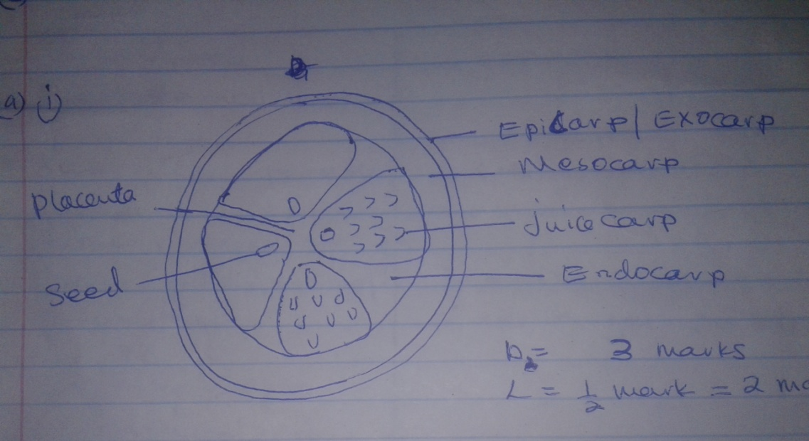
For diagram to be awarded:
- Epicarp with continuous double line
- Mesocarplaryer than epicarp drawn in free hand
- Endocarp with seeds
- Indication of juicy sacs in at least one locules
- Minimum of four loculus drawn
- Centrally placed placenta. Radial arms accepted
NB: Three marks to awarded when evidence of using free hand is noted no shading
(ii) centralAxile/ axile
(b) – succulent /fleshy /juicy to attract animals
- scented /aromatic smell/ sweet smell to attract agent
- hardseedcoat / slippery coat/ indigestible /seed to prevent digestion.(3mks)
Observation | Conclusions
DCPIP decolourised | Ascorbic /vitamin C present
Blue colourpersists | Protein absent
Colour changes to green, yellow,orage,brown/red or colour changes to orange/brown/red | Reducing sugars/present/simple sugars present
(6mks)
Note: conclusion mark tied to observation)

