STUDENT’S NAME………………………………………………...
ADM NO……………………………………...FORM…………………………..
SCHOOL ….DATE

COUNTY MULTILATERAL EXAMINAITON

PHYSICS 232
FORM ONE TERM TWO 2016
TIME: 2 HOURS

INSTRUCTIONS
Write your name and admission number in the space provided Answer all questions in the space provided. A graph paper is attached.,
All working must be clearly shown The paper is out of 100 marks
Calculators are not allowed. KNEC Mathematical tables may be used. *
The paper has 7 printed pages. The student should check the question paper to ascertain that all the pages are printed as indicated and that no questions are missing.
Take:
Earth gravitation strength, g=10N/kg
Density of water as l,000kg/m^{s}
Density of mercury as 13,600kg/m³

For Examiner’s Use Only
Question | Maximum Score | Candidates Score
1 -20 | 100

1. a) Define the term physics (1mk)

- A part from physics, name other three natural sciences. (3mks)

- i) An empty density bottle has a mass of 23.5g. When completely filled with water its mass is 39.0g. What will be its mass if it’s completely filled with an acid of density 1.25g/cm? (Take the density of water to be 1,0g cm³) (4mks)

ii) Distinguish between solid and liquid as states of matter in terms of intermolecular fcrces. (2mks)

2. a) Complete the table below (5mks)
Quantity | S.I. Unit | Symbol
Mass
Temperature
Time
Length
Electric current

b) Define the following terms.
- Fundamental quantity (2mks)

ii) Derived quantity (2mks)

In an experiment to measure the radius of a wire, a form one student cut a piece of wire into 50 identical pieces of length 14mm each. She dipped the pieces into water in a beaker. The Water level rose from 30.5cm³ mark to 80cm³mark. Determine the radius of the wire giving your answer to two decimal places. (4mks)

Explain why h₂ is greater than h₁

- The diagram in figure 2 below shows a drop of liquid X and Y carefully put on a clean flat glass slab.

- Explain the shapes of the drops (4mks)

b) Identify the drop which is likely to be for the following liquids,
- Mercurv (lmk)

- Matter (1mk)

- a) A part from Newton per square metre (N/m²), name any other two units used in measuring pressure. (2mks)
i)

ii)

b) In a hydraulic brake the master piston ha§ an area of,5mm²while the wheel piston each has an area of 6cm². Find the forces applied to the wheel when a force of 12N is applied on the master piston. (4mks)

7. a) What do you understand by the term particulate nature of matter? (2mks)

- What is Brownian motion? (2mks)

- Some cotton wool was soaked in ammonia solution and concentrated hydrochloric acid (HCl)and then placed at the ends of a glass tube as shown in figure 3below.
- After sometime a white deposit of ammonium chloride forms on the walls of the tube. Using a cross x show where the deposit was formed. (2mks)

- Explain your observation (2mks)

- The experiment is repeated at a lower temperature. Explain how time taken to form the white deposit would be affected. (2mks)

- a) The diagram in figure 4 below shows a bimetallic strip at room temperature.

Sketch a diagram to show the appearance of the bimetallic strip if put below 0°C. (2mks)

b) Give four reasons why mercury is a better liquid to use in thermometers over other liquids (4mks)
i)
ii)
iii)
iv)

- a) State four factors that determine the thermal conductivity in a material. (4mks)
i)
ii)
iii)

b) i) Explain why the inner surface of the lampshade is whitened. (2mks)

- Explain why plants in greenhouse, experience higher temperature than ones outside (2mks)

- a) Distinguish between real and virtual images. (2mks)
- A ray of light is incident on a plane mirror as shown in figure 5 below

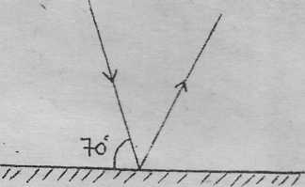

What is the angle of reflection? (2mks)

- What will be the angle through which the reflected ray rotates if the mirror is rotated anticlockwise through an angle of 35°? (2mks)

- What would be the new angle of reflection?

- An object of height 8.5cm stands 30cm in front of a pin-hole camera of length 15cm as shown in figure 6 below.
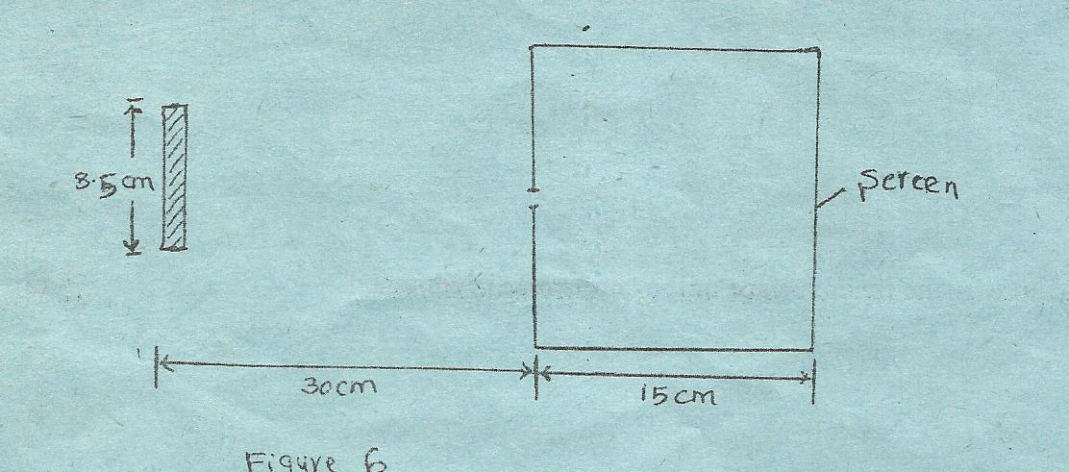

- In the figure draw a ray diagram to show the image is formed. (2mks)

- Describe the image formed. (2mks)

- Calculate the magnification of the image. (3mks)

- Find the height of the image. (1mk)

- a) Define the following term; surface tension. (3mks)

- a) Give three conditions necessary for a siphon to work i)
i)

ii)

b) Give two advantages of a force pump compared to a lift pump, i)
i)

ii)

- Study the diagram in figure 7 below.

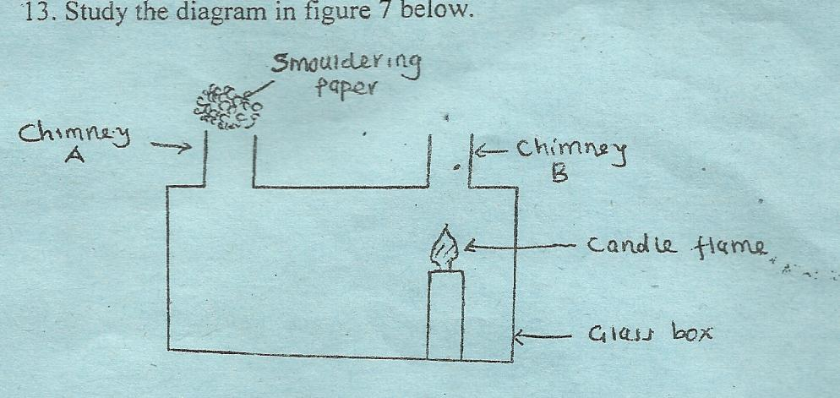

- Sketch in the diagram the path of the smoke from the shouldering paper. (2mks)

- What conclusion can be made from the path in (a) above. (4mks)

- Explain the features in a thermos flask by which heat loss is reduced through;
- Conduction –

- Convection –

iii) Radiation - (6mks)

