GATITU MIXED SECONDARY SCHOOL
PHYSICS FORM 1 MID TERM EXAM TERM 2 2015
- Define physics. 1mk

- Give five first Aid measures. 5mks

- Complete the table below. 7mks
Basic physical quantities | SI units | Symbol of units
Length
Mass
Time
Electric current
Thermodynamic temperature
Luminous intensity
Amount of substance

- Charo found that the perimeter of his farming plot was approximately 200 strides. His stride was 0.9 m long. What was the perimeter of the plot? 3mks

- A metallic rod has a length of 180 cm. The length of its shadow was 116 cm. a student wanted to know the length of a tree and therefore he measured the length of the shadow of the tree and found it to be 840 cm. calculate the height of the tree. 4mks

- The diameter of the capillary tube is 1.0mm. calculate the cross section area of the bore in cm². Take (II = 3.142) 3mks

- The water level in a burette is at the 2.0 cm³ mark. 10 drops each of volume 0.01 cm³ are let out. Find the new burette reading. 3mks

- An empty density bottle has a mass of 25 g. its mass is 50g when full of water and 45g when full of another liquid. What is the density of the liquid in kgm⁻³? 4mks

- 200cm³ of fresh water of density 1000kgm⁻³ is mixed with 2400 cm³ of sea water of density 1025kgm⁻³. Calculate the density of mixture. 4mks

- A length 550cm of thin thread wraps around a cylinder exactly 25 times. Calculate the circumference and the radius of the cylinder.(take II=22/7) 4mks

- Define force and give its SI unit. 2mks

- List in detail the effect of force on objects. 4mks

- List and explain three types of force. 6mks

- The figure shows the shapes of drops of water and mercury placed on the surface of a clean glass plate. Explain the difference in the shapes. 3mks

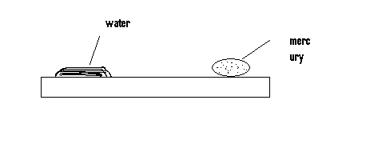
Explain the difference in shapes. 3mks

- A body weighs 200N in air and 80N when submerged in water. Calculate the up thrust acting on the body. 2mks

- Define surface tension and state the factors affecting surface tension and explain. 3mks

- Differentiate between scalar and vector quantities and give two examples of each. 4mks

- Calculate the resultant vector of the figure below. 2mks
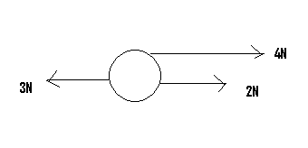

- Define pressure and give its SI units. 2mks

- The figure below show a brick.

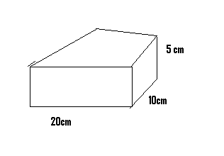

Determine the
- Greatest pressure that can be exerted by the brick on a flat surface. 2mks

- The least pressure that can be exerted by the brick on a flat surface. 2mks

- State two factors affecting pressure. 2mks

- State the Pascal’s principal of pressure. 10mks

