GATITU DAY MIXED SECONDARY SCHOOL
PHYSICS FORM 1
END OF TERM 2 2012
SECTION A
1. Define the following terms (5mks)
a. manometer

b. physics

c. mass

d. pressure

e.force

2. why is mercury used in barometer instead of much cheaper liquids such as water or kerosene. (2mks)

3. What is atmospheric pressure? (1mk)

4. Give two properties of brake fluid used in the hydraulic brake system. (2mks)

5. Explain the following forces (4mks)
a. up thrust
b. gravitational

c. tensional

d. electrostatic

6. Explain why:
a. Bristles of a paint brush spread when the brush is in water and cling together when removed out? (2mks)

b. Water wets clean surfaces of glass but not waxed ones. (2mks)

7. Explain why weight changes from place to place while mass does not. (2mks)

SECTION B
8. Determine the weights of the following masses (2mks)
a. 30g

b. 2.5 kg

9. Convert the following volumes to m3 (3mks)
- 1500000000 cm3

b. 20 litres
c. 1 ml

10. Express the following areas in m2 (2mks)
a. 9000 cm2

b. 0.05 cm2

11. The dimensions of a room are 4 m by 5 m by 2.5 m ,if the density of air is 1.26 kg/m3. Determine the mass in kilograms of the air in the room. (2mks)

12. The mass of an empty density bottle is 20 g its mass when filled with water is 40 g and 50 g when filled with liquid x. Calculate the density of liquid x if the density of water is 1000 kg/m3 (4mks)

13. Find the volume of a sphere whose radius is 3 cm (2mks)

14. The mass of an object is 50 kg, if its weight is 1000N in a certain planet calculate the gravitational field strength of the planet. (3mks)

15. A mass of 30 kg crates a pressure of 15 p.a. calculate the area over which the force is spread.
(3mks)

16. A rectangular concrete block measures 60 cm by 30 cm by 20 cm and has a mass of 30 kg.Calculate the maximum pressure it can exert through its surfaces. (4mks)

17. In the figure below calculate the density of alcohol given that the density of water is 1000kg /m3 (3mks) 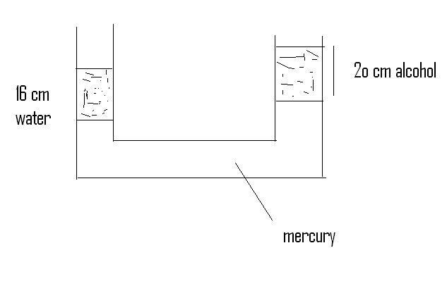
18. The height of mercury in a barometer at a place is 0.75m calculate the atmospheric pressure of the place (density of mercury is 13600 kg /m3 and g- 10 n / kg) (3mks)

19. The barometer height in a town is 70 cmHg , given that the standard atmospheric pressure is 76 cm Hg and density of mercury is 13600 kg/m3. Determine the height of the town (density of air is 1.25 kg /m3) (3mks)

20.A diver is working at a depth of 10 m below the surface of a fresh water lake find the total pressure acting on the diver (assume g -10 N /kg density of water is 1000 kg/m3 and atmospheric pressure is 100.000 N/m2) (3mks)

21. The air pressure at the base of a mountain is 75cm of mercury while at the top it is 60 cm of mercury .Given that the average density of air is 1.25 kg/m3 and the density of mercury is 13600 kg/m3.Calculate the height of the mountain (3mks)

GOOD LUCK AND NICE HOLIDAY

