GATITU MIXED SECONDARY SCHOOL
THIRD TERM 2015
FORM 1 PHYSICS ENDTERM EXAMS

- Figure below shows an arrangement to demonstrate diffusion through solids
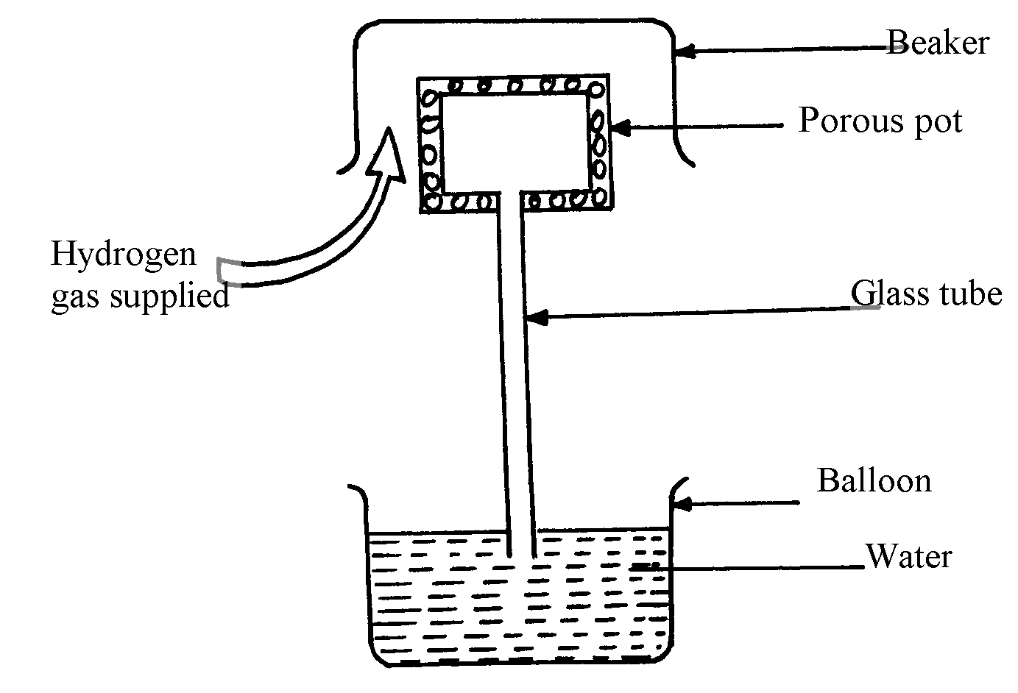

The hydrogen gas is supplied for sometimes then stopped. State and explain what is likely to be observed when
the hydrogen gas supply:-
- Is on (2mks)

(ii) Is stopped (2mk)
2. Two samples of bromine vapour are allowed to diffuse separately under different conditions, one in a vacuum and the other in air. State with reasons the conditions in which bromine will diffuse faster (2mks)

3. In terms of kinetic theory of matter, explain why evaporation causes cooling (2mks)

4. (a) In an experiment to demonstrate Brownian motion, smoke was placed in air cell and observed under a microscope. Smoke particles were observed to move randomly in the cell.
i) Explain the observation (2mks)

- Give a reason for using small particles such as those of smoke in this experiment (1mk)

(iii) What would be the most likely observation if the temperature in the smoke cell was raised? (1mk)
(b) An oil drop of average diameter 0.7mm spreads out into a circular patch of diameter 75cm on the surface of water in a trough
(i) Calculate the average thickness of a molecule of oil (5mks)

- State two assumptions made in (i) above (2mks)

5. Give a reason why gases are more compressible than liquids (2mks)

6. Figure 1 shows a beam balance made out of concrete and reinforced with steel
Concrete
Steel

Use a diagram to explain the behaviour of the shape of the beam when heated up (2mks)

7. (a) Sate two liquids which are used in thermometer (2mks)

(b) With a reason, state which of the two liquids in 3 (a) above is used to measure temperature in areas where temperatures are:
. (i) Below -40⁰c (ii) 150⁰c (2mks)

8. Name two adaptations that can be made to a mercury thermometer to make it more sensitive (2mks)

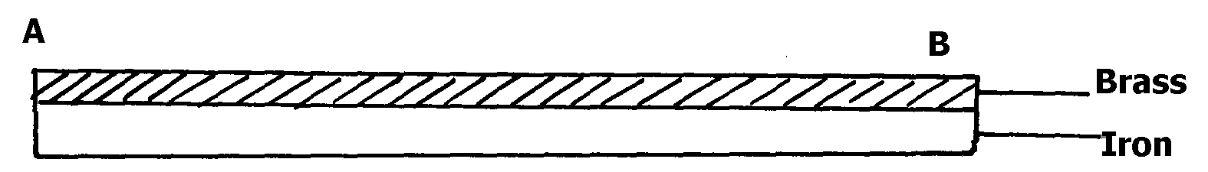
9. Figure 5 shows a bimetallic strip made of brass and iron. A marble is placed at end A of the bimetallic strip as shown below: fig. 5

State and explain what will be observed when the bimetallic strip is strongly cooled (2mks)

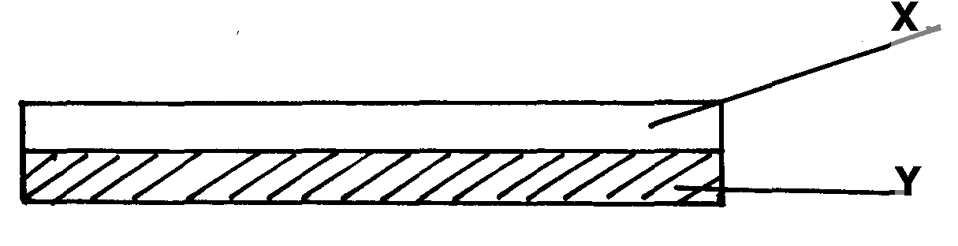
10. The figure below represents a bimetallic strip of metals X and Y at room temperature

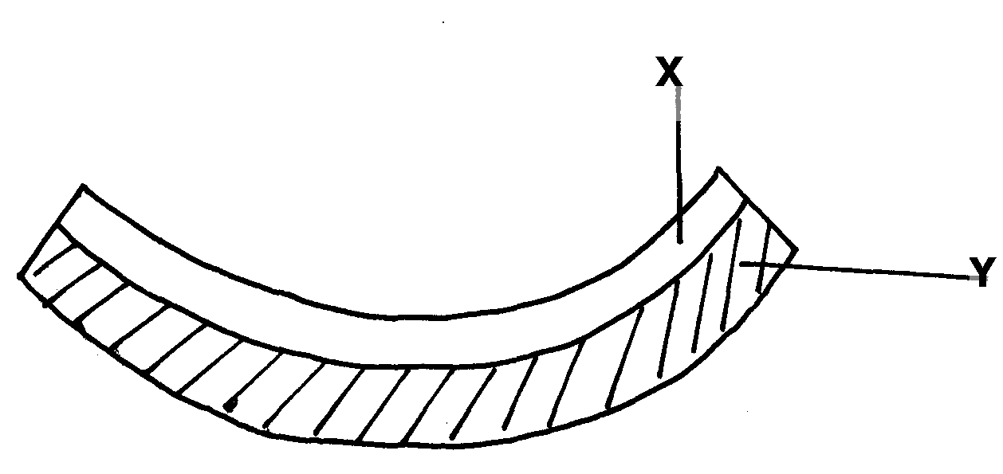
The figure below shows its shape when dipped into crushed ice

Sketch a diagram in the space given below to show the shape when the strip is heated to temperature above the room temperature (2mks)

Marking scheme

1. (i) Hydrogen gas diffuses faster into the porous pot mixing with air initially in the pot, this increases pressure in the pot causing air to move out through the tube forming bubbles.
(ii) Hydrogen gas diffuses faster out of the pot. This reduces the gas pressure inside the pot hence higher atmospheric pressure on the surface of water in the beaker to push water up the glass tube.

2. Diffusion is faster in vacuum √ 1 since there are no air particles to interfere with motion√ 1

3. Energetic molecules gain heat energy from the substance in which the liquid is in contact and escapes. This causes cooling of the latter
4. (a) (i) Air molecules/particles which were in a state of continuous random motion collided with smoke particles
(ii) They are light hence move significantly when bombarded by air molecules
(iii) There would be increased rate of movement
(b) (i) Volume of oil drops = volume f patch
4 R³ = d²t t = thickness
3 4
4 x (7 x 10-4)³
3 2
= (0.75)² t
4
5.7166 x 10⁻¹¹ = 0.1406t
Thickness, t = 5.7166 x 10⁻¹¹
0.1406
= 4.066 x 10⁻¹⁰m (accept other units other than metres
(b) (ii) Assumptions- Oil drop forms a perfect sphere (1mk)
- Patch formed is a perfect circle (1mk) (any 2)

5. The particles making up gases are further apart than those in liquids √
Concrete
6.
Steel

- The beam expands linearly
- The beam remains straight but longer than before heating
- Both concrete and steel have same rates of expansion
- Their value of linear expansivity is 11x10-6
7. a) – Alcohol. 1 mk
- Mercury. 1 mk
b) i) below -40ºc alcohol ½ because it has a low freezing point of –115ºc.
Mercury freezes ½ at -39ºc.
ii) 150ºc mercury ½ because it has a high boiling point of 357º,
alcohol boils at 78ºc. ½
8. - This is the temperature of pure melting ice at standard/normal atmospheric pressure;
(Both pure and standard pressure mentioned;
9. - Using a thin walled bulb √1
- Using a narrower capillary tube √1
10. on cooling, the brass contracts more than iron, hence become shorter than iron and forms upwards curve, making the marble to roll and settle at the centre of the curve.
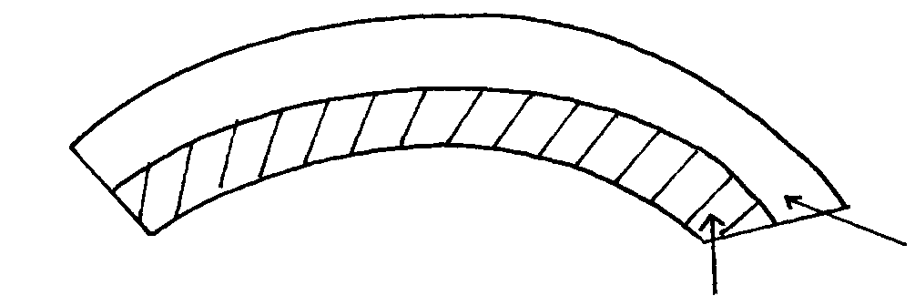

11.

