NAME --------------------------------------- CLASS --------------------------------------ADM NO ------------------
PHYSICS FORM 1 END OF TERM 3 2013 EXAM TIME: 2HRS
ANSWER ALL QUESTIONS
SECTION A (40 MKS)
- State three fundamental quantities and their S.I units. 3mks

- Express the following in millimeters 6mks
- 2.7 m

- 96.9 cm

- 25 km

- A cylinder has a diameter of 2.1 cm. how many times would a thread of 132 cm go round the cylinder? 3mks

- A block of iron has dimensions 4.2 cm × 3.4 cm ×5.0 cm. it has a mass of 535.5 g. calculate
- Volume of the block in mm3 2mks

- Density of the block in g/cm3 2mks

- A tin lead alloy has a mass of 25.5 g and a volume of 3 cm³. Calculate the mass of tin in the alloy.(density is 7.3 g/cm³ and that of lead is 11.3g/cm³. 4mks

- Calculate the weight of the following 4mks
(take g =10n/kg)
- 300g mass of water

- 0.05 mg mass of wool

- Find the resultant of the following forces 4mks
- 150N due East and 200N due west
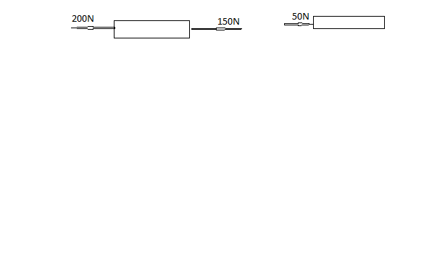

- 450N due North and 1000N due south
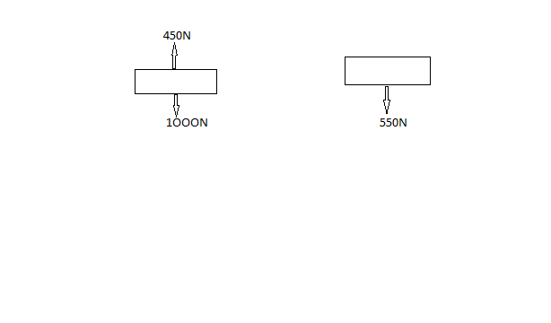
- Give scientific reasons for the following statements
- Water wets glass 1mk

- Mercury meniscus is convex 1mk

- Gravitational pull of the moon is 1/6 of that due to earth. Calculate the weight of a body whose mass is 40kg on
- Moon’s surface

- The earth surface (take g= 10N /kg)

- Give four differences between mass and weight 4mks
mass | Weight
- A concrete slab of 101.5kg is held by a steel cable of crane as shown below

- On the diagram above, mark and name the force acting on the slab 1mk

- Find the tension in the cable 1mk

section B40MKS
- 12 (a) Define pressure and state its S.I unit 2mks

- Sinking of tyres of a car into soft damp sand patch may be prevented by letting off some air in each tyre. Explain 2mks

- Calculate the pressure at the bottom of a beaker when it is filled to a height of 12.5 cm. take density of water as 1 g/cm3 and g =10N /kg. 2mks

- A block of iron measures 6cm ×8cm×1cm. it has a mass of 360g. calculate
- Its density 2mks

- The greatest pressure it can exert on a flat horizontal surface. 2mks

13.
- The figure below shows a lift pump
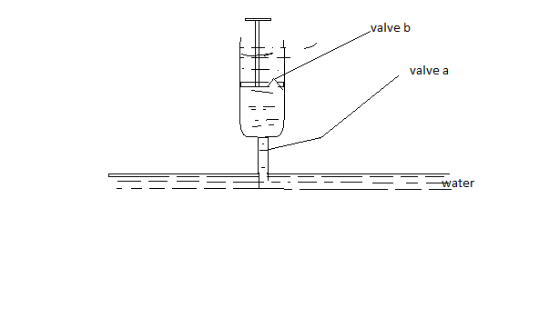
Explain why, when the piston is;
- Pulled upwards, valve A opens while B closes 2mks
- Pushed downwards, valve A close while valve B opens 2mks
- After several strokes, water rises above the piston as shown below
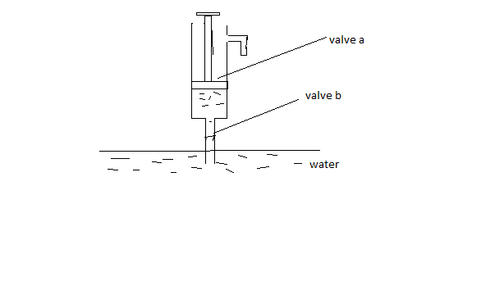
State how water is removed from the cylinder through the spout 1mk

- A lift pump can lift water to a maximum height of 10m. determine the maximum height to which the pump can raise paraffin.(take density of paraffin as 800kgm⁻³ and density and density of water as 1000kgm⁻³) 3mks

- State two factors that determines the height to which a force pump can lift water. 2mks.

- The diagram shows a light container containing two liquids. Water and paraffin.(take density of paraffin =0.8g/cm³). The container rests on a table.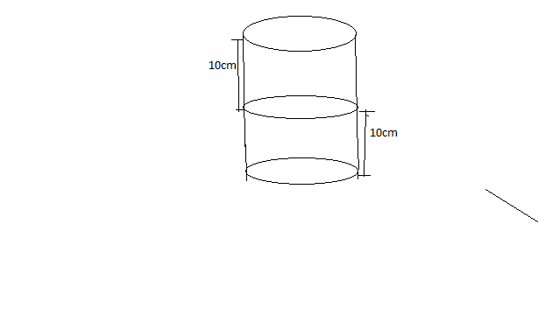
- What is the liquid pressure at point A? 2mks

- What is the liquid pressure at B due to water? 3mks

- Find the total pressure exerted on the table 3mks

WORK TO BE DONE | TYPES OF FORCE
 | Centripetal force
Swimming
 | Gravitational attraction between the earth and the moon
Separate sand from iron fillings

- State the kinetic theory of matter 1mk

- The diagram shows how hydrogen gas was passed to the porous pot connect via a delivery tube to beaker containing water.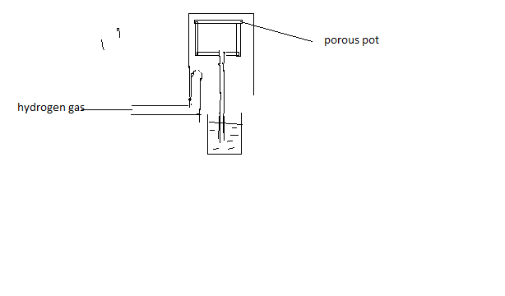
- What would happen when hydrogen has been passed for some time. 1mk

- Explain your answer 2mks

- What will happen when the gas jar is removed? 1mk

- Explain (c ) above 2mks

