MWAKICAN FORM 2 JOINT EXAMINATION
TERM 1 2015
PHYSICS

NAME ___________________________________________________ ADM/NO.___________

Answer all questions in the spaces provided

1. The micrometer screw gauge in the figure below has a thimble scale of 50 divisions.
What is the reading shown? (1mk)
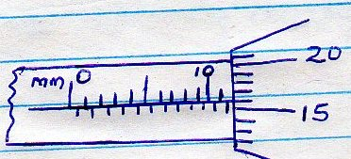

2. A metal pin was observed to float on the surface of pure water. However the pin sank when a few drops of soap solution were carefully added to the water. Explain this observation. (2mks)

3. State one advantage of fitting wide tyres on a vehicle that moves on earth roads (1mk)

4. State two differences between mass and weight (2mks)

5. What property of light is suggested by the formation of shadows? (1mk)

6. A butcher has a beam balance and masses 0.5Kg and 2Kg. how would he measure 1.5Kg of meat on the balance at once (1mk)

7. In an experiment to determine the density of a liquid, a student filled a burette with a liquid to the 0cm³ mark. The figure shows a section of the burette showing the level of the liquid after 54.5g of the liquid had been run out.
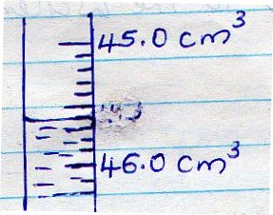

Determine the density of the liquid (3mks)

8. State two advantages of an alkaline battery over a lead acid battery (2mks)

9. In the set-up shown below, water near the top of the boiling tube boils while at the bottom it remains cold.
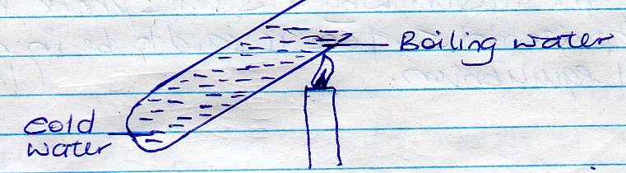

Give a reason for the observation (1mk)

10. You are provided with a charged electroscope, and insulator and a conductor. Describe how you would use these apparatus to distinguish the insulator from the conductor
(2mks)

11. The melting point of alcohol is - 115⁰C. Convert this temperature into Kelvin (K). (1mk)

12. A bag of sugar is found to have the same weight on planet earth as an identical bag of dry sawdust on planet Jupiter. Explain why the masses of the two bags must be different.
(2mks)

13. State the reason why a steel sphere resting on a horizontal surface is said to be in neutral equilibrium (1mk)

14. What is the reading on the vernier calipers shown in the figure below (1mk)
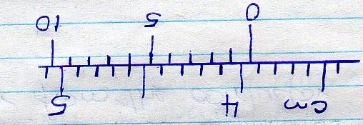

15. the figure below shows water droplets on a waxed wooden surface and on a clean wooden surface.
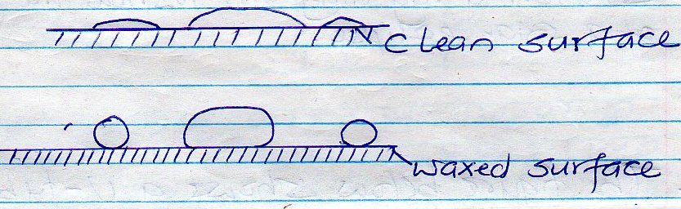

(a)

(b)

Explain the difference in the shapes of the droplets (2mks)

16. Explain the terms scalar and vector quantities (2mks)

17. Distinguish between soft magnetic materials and hard magnetic materials (2mks)

18. The figure below shows a uniform bar of 1.0m in equilibrium.

Determine the weight of the bar. (3mks)

19. Sketch a ray diagram to show the formation of a solar eclipse (2mks)

20. The figure below shows a U – tube containing two liquids L₁ and L₂ of densities 0.8gcm⁻³ and 1.8gm⁻³ respectively in equilibrium.
Given that h₂ = 8cm, determine the value of h₁ (3mks).
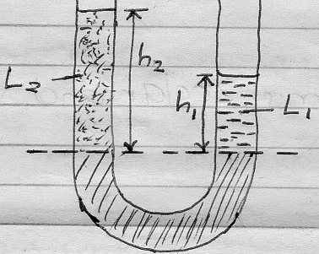

21. Name two forces that determine the shape of a liquid drop on a solid surface (2mks)

22. A battery circulates charge round a circuit for 1.5minutes. If the current is held at 2.5A. What quantity of charge passes through the wire? (3mks)

23. (a) State the law of electrostatic charges (1mk)

(b) The figure below shows two charged identical conducting spheres on insulating stands. Each cross represents a charge. The spheres are briefly brought into contact and then separated
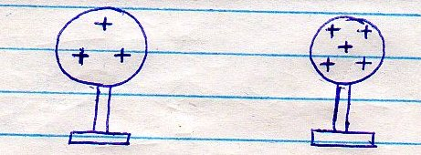

Sketch in the space provided, the diagrams of the spheres showing charge distribution after separation (2mks)

(c) A highly negatively charged rod is gradually brought close to the cap of a positively charged electroscope. It is observed that the lead collapses initially and then diverges. Explain the observation (3mks)

(d) State three uses of as leaf electroscope (3mks)

24. (a) What is meant by the centre of gravity of a body? (1mk)

(b) Using diagrams, illustrate and explain the three states of equilibrium (6mks)

(c) State and explain two factors that affect the stability of a body (4mks)

25. (a) Define the term heat (1mk)

(b) State and explain three factors that affect the rate of heat transfer in solids. (3mks)

(c) The figure below shows a cross-section of a vacuum flask

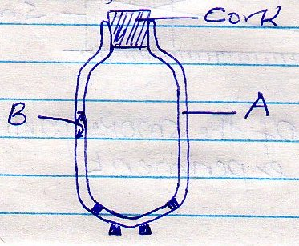

- Name the parts labeled A and B (2mks)

- Explain how the heat losses are minimized when hot liquid is poured into the flask (3mks)

26. (a) Distinguish between solid and liquid states of matter in terms of intermolecular
forces (1mk)

(b) Brownian motion of smoke particles can be studies by using the apparatus shown below. To observe the motion, some smoke is enclosed in the smoke cell and then observed through the microscope.
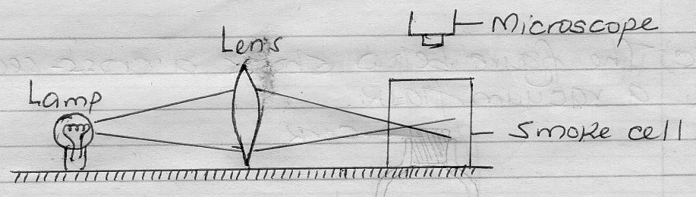

- Explain the role of the smoke particles, lens and microscope in the experiment
(6mks)

- State and explain the nature of the observed motion of the smoke particles. (3mks)

- State what will be observed about the motion of the smoke particles if the temperature surrounding the smoke cell is raised slightly (1mk)

27. (a) State the principle of moments (1mk)

(b) The horizontal bar in the set-up shown in the figure below has a negligible
weight.
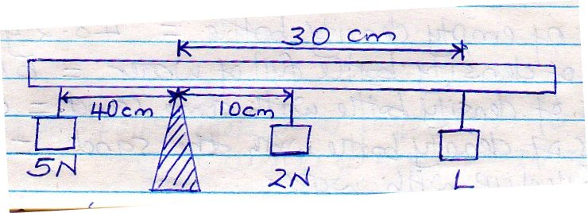

Determine the value of mass L. (3mks)

(c) A metre rule is pivoted at its centre. A glass block is hung from one end and the rule is balanced horizontally by hanging masses of 100g and 50g at 60cm and 80cm marks respectively. Calculate the mass of the glass block (4mks)

28. (a) Define the term density (1mk)

(b) In an experiment to determine the density of sand using a density bottle, the following measurements were recorded
Mass of empty density bottle = 43.2g
Mass of density bottle full of water = 66.4g
Mass of density bottle with some sand = 67.5g
Mass of density bottle with sand = 82.3g
Filled up with water
Use the above data to determine the:
- Mass of water the completely filled the bottle (2mks)

- Volume of water that completely filled the bottle (1mk)

- Volume of the density bottle (1mk)

- Mass of sand (1mk)

- Mass of water that filled the space above the sand (1mk)

- Volume of sand (3mks)

- Density of the sand (2mks)

