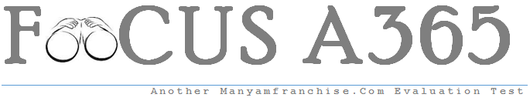

Gatitu Mixed Secondary School
Form 2 | Term 1 | 232 - Physics | 08-Jan-16 | Opener
1. State three types of equilibrium (3mks)
2. State two ways of increasing the strength of an electromagnet (2mks)
3. Distinguish between a real and a virtual image (2mks)
4.complete the table below
Type of cell | Electrodes | Electrolyte
Simple cell
Dry cell
Acid accumulator

5. State two properties that make a liquid suitable as a thermometric substance (2mks)
6. Give two external factors that affect the rate of evaporation of a liquid (2mks)
7. State the major difference between mechanical and electromagnetic waves (2mks)
8. An object is projected vertically upwards at a speed of 15ms-1. How long will it take to return to the same level of projection?(3mks)
9. Explain why a glass container with thick wall is more likely to crack than one with a thin wall when very hot liquid is poured into them (2mks)
10. The pressure of atmosphere is about 1x10^5pa. what force does it exert on a desktop of sides 0.8m by 0.6m? How long can the desktop support this force?(2mks)

