GATITU MIXED SECONDARY SCHOOL
PHYSICS FORM 2 OPENER TERM 2 2015
- Define the following terms 4mks
- Magnetization

- Polarization

- Magnification

- Angle of incidence

- State three ways of magnitising a magnetic material 3mks

- Differentiate between primary and secondary cells 2mks

- Show magnetic field lines around the following magnetic poles. 2mks

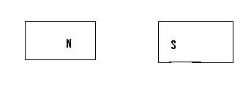

- Using a well labeled diagram draw an electroscope and show its parts correct. 4mks

- Using a well labeled diagram and symbols draw a simple circuit 4mks

- Differentiate between a soft magnetic material and hard magnetic material giving and example in each case. 4mks

- Define magnetic shielding and give an application of it. 2mks

- Give 3 safety precautions to observe when storing a lead acid accumulation. 3mks

- State the principle or reversibility of light . 1mk

- Give one law of reflection. 1mk

