KAHUHO UHURU HIGH SCHOOL

STUDENTS NAME…………………………………..…….……….CLASS…….….ADM. NO…….…..
FORM 2
PHYSICS
2 HOURS

INSTRUCTONS
Write your name and admission number in the space provided.
Answer all questions in the space provided. A graph paper is attached.
All working must be clearly shown.
The paper is out of 100 marks
Calculators are not allowed. KNEC mathematical tables may be used.
The paper has 7 printed pages. The student should check the question paper to ascertain that all the pages are printed as indicated and that no questions are missing.
Take
Earth gravitation strength, g = 10N/ Kg
Density of water as 1,000kg/m³
Density of mercy as 13,600kg/m³

For examiners’ use only
Question | Maximum score | Candidates score
1-20 | 100

Questions
1. The diagram in figure 1 below shows the reading on a burette after 60 drops of liquid have been used.
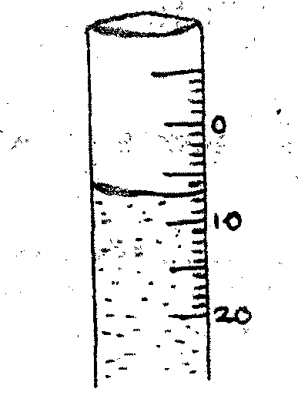
Figure 1
If the initial reading was zero mark, determine the volume of one drop. (2 mks)

2. Study the diagram in figure 2 below.
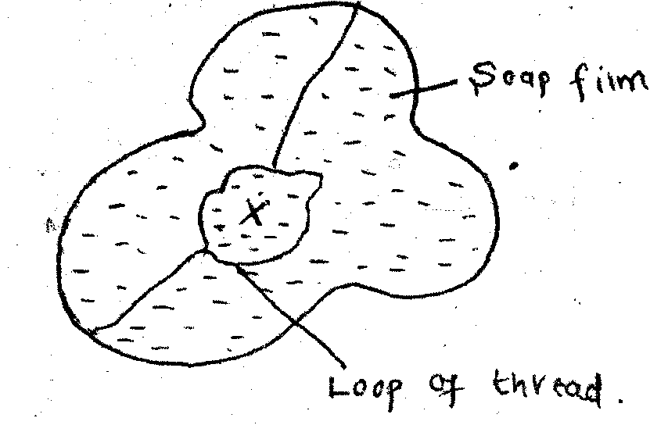

Figure 2
Explain what will happen when the film is punctured at X. (3 mks)

3. What is the reason why trailers carrying heavy loads have many tyres? (1mk)

4. A jug is completely filled with water. A spoonful of common salt is added slowly. The common salt is dissolved and the water does not overflow.
a) Why is common salt added slowly? (1 mk)

b) Explain why water does not overflow. (1 mk)

5. State and explain three effects of anomalous expansion and contraction of water. (6 mks)

6. Hot water in kettle is allowed to cool for 17 minutes. State three factors that will determine the final temperature of the tea. (3 mks)

7(a) What are the conditions necessary for the occurrence of annular eclipse? (2 mks)

b) The diagram in figure below shows two plane mirrors inclined at an angle A from each other. A viewer counts a total of seven images of the object O. determine value of A. (3 mks)

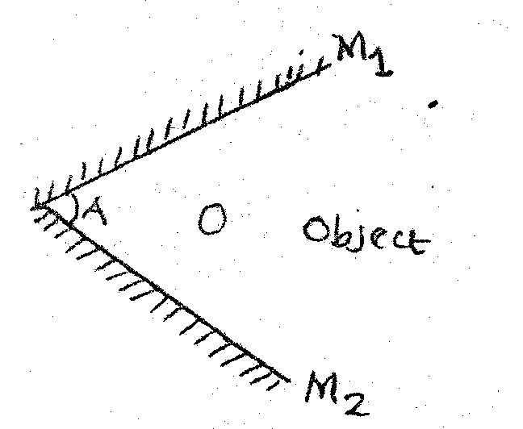
Figure 2

8. A negatively charged electroscope is placed next to positively charge electroscope. Their metal caps are then connected using a wire state and explain observations made. (3 mks)

9(a) A charge of magnitude 5400 coulumbs flows through a point in 45 minutes.Calculate the amount current. (3 mks)

b) Give a reason why it is not advisable to smoke a cigarette near charging battery. (1 mk)

10. In an oil drop experiment a student estimate the diameter of the oil patch to be 0.16m, given that volume of the oil drop was 0.048cm³
a) Estimate the size of a molecule of the oil. (4 mks)

b) What assumptions were made to arrive at your answer in (a) above. (3 mks)

11.(a) Using domains theory explains magnetic saturation. (2 mks)

b) State two uses of magnets. (2 mks)

12.(a) A student measured the diameter of a needle using a micrometer screw gauge. She then measured the diameter again using Vanier calipers. Which instrument gave a more accurate diameter? (1mk)

b) State two environmental hazards that may occur when oil spills over a large surface area of the sea. (2 mks)

13(a) State two factors that affect the spring constant of a helical spring. (3mks)

b) A spring extends by 2cm when a mass of 50g is hanged on it. What force is required to extend it by 2.5cm? (3 mks)

14.a) Define the term centre of gravity of a body. (2 mks)

b) The diagram in figure below shows a liquid in a long cylindrical tube closed at one end with a cork. The cork is tightly fitting out moveable. The system is in equilibrium.
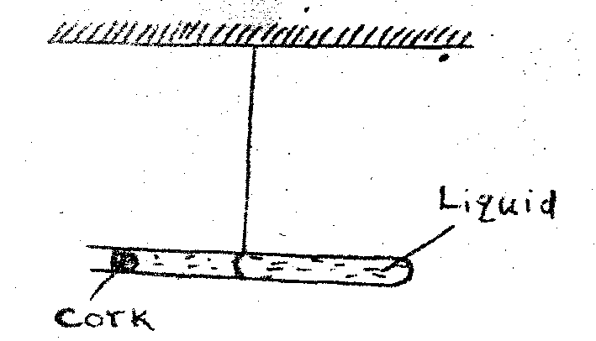
Figure 3

State two observations that will be made when the tube is gently heated uniformly. (2 mks)

c) Briefly explain your observations. (2 mks)

15. A vertical object is placed 15cm infront of convex mirror of a focal length 5cm. by scale drawing determine.
i) The image distance (use graph paper) (2 mks)

ii) The magnification (2 mks)

16 (a) Give a reason why soft iron is commonly used to make the core of a magnetic material. (1 mk)

b) In an experiment to determine the strength of an electromagnet; the weight of pins be supported by the electromagnet was recorded against the number of turns, n. the amount of electric current was kept constant through the experiment. The table below shows the data obtained.
No. of turns, n | 0 | 5 | 10 | 12 | 18 | 20 | 25 | 29 | 33 | 36
Weight (w) of pins x 10^{-3 N} | 0 | 5 | 15 | 30 | 68 | 110 | 205 | 275 | 297 | 310

- Plot a graph of weight, w(Y-axis) against the number of turns, n. ( 5mks)

- Use the domain theory to explain the nature of the curve. (2 mks)

c) Sketch in the same axes the curve would be obtained using a higher current. (1 mk)

17. A meter rule whose centre of gravity is at the 50cm mark balances at the 30cm mark when a mass of 500g is placed at the 25cm mark as shown in the diagram in figure 4 below.

i)Determine the mass of the metre rule. (3 mks)

ii)With the metre rule remaining on the knife edge at the 30cm mark, a mass of 12.5g is suspended from the 70cm mark. The mass 500g is moved until the rule is balanced again. Determine the new position of the 500 g mass. (4mks)

iii) Describe the state of equilibrium of the metre rule giving a reason for your answer. (2 mks)

18.(a) It is much easier to compress a gas than a solid or a liquid. Explain. (2 mks)

b) A physics teacher closed all the windows and doors and then opened a bottle of perfume from one corner of the classroom. The scent spread everywhere in the class.
i) Name the process by which the molecules of the perform spread around the class. (1 mk)

ii) Explain why the scent spread slowly even though the molecules move fast. (1 mk)

iii) Why were the windows and doors closed? (1 mk)

19(a) Explain the meaning of the following terms as used in waves: (10mks)
i) Wave

ii) Wavelength

iii) Period T

iv) Amplitude

v) Frequency

b) How does the change in the frequency of a wave affects its wavelength? (1 mk)

20. (a) It is impossible to distinguish echo and sound in a small room. Explain. (2 mks)

b) In an experiment, it was established that on echo and the sound were differentiated when they reach human ear at lest 0.12 sec apart. How far from a wall must an observer be in order to hear an echo when he /she shouts? (Take speed of sound in air as 330ms) (4 mks)

