NAME _______________________________________ ADM/NO.__________ CLASS______

MWAKICAN JOINT EXAMINATION (MJET) - 2015

FORM TWO PHYSICS TERM II 2015
TIME: 2HRS

INSTRUCTION TO CANDIDATES
- Write your name, admission number and class in the spaces provided above
- This paper consists of TWO Sections; Section A and Section B.
- Answer ALL the questions in both Section A and B in the spaces provided.
- ALL working MUST be clearly shown.
- Candidates should check the question paper to ascertain that all the 10 pages are printed as indicted and that no questions are missing.
- Candidates should answer the questions in English

Where necessary, take
G = 10N/kg
Density of water = 1000kg/m3

SECTION A (25 MARKS)

Answer all questions in the spaces provided

1. The figure below shows a scale which is part of vernier calipers. What is the reading indicated by the scale? (2mks)
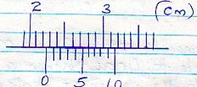

2. The level of liquid in a burette is 32.0cm³. If 15 drops each of volume 0.15cm³ are allowed to fall out of the burette, what is the new level of the liquid? (2mks)

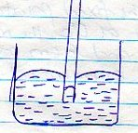
3. The diagram below shows the behavior of mercury in a capillary tube. Explain this observation (3mk)

1
4. A body weighs 600N on the surface of the earth and 450N on the surface of another planet. Calculate the value of g in that planet (g on the earth = 10N/Kg) (3mks)

5. A steel needle when placed carefully on water can be made to float. When a detergent is added to the water it sinks. Explain this observation (2mks)

6. Distinguish between the three states of matter in terms of particle spacing and kinetics (3mks)

7. When marking the fixed points on a thermometer it is observed that at 0⁰C, the mercury 6 thread is of length 1cm and 6cm at 100⁰C. what temperature would correspond to a length of 4cm? (3mks)

2
8. The micrometer screw gauge below has a zero error of -0.19mm.
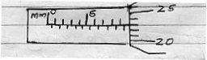

Determine the actual thickness of the object. (2mks)

9. Distinguish between hard magnetic material and a soft magnetic material (2mks)

10. Describe a simple experiment to show that pressure in liquids increases with depth
(3mks)

3

SECTION B (55 MARKS)

11. (a) State Hooke’s law (1mk)

(b) In an experiment to verify Hooke’s law, a piece of rubber was fixed to a rigid support and the other end pulled with a force of ranging magnitude. The values of force and the extension were recorded as in the table below:-

Force (N) | 0 | 0.25 | 0.50 | 0.75 | 1.00 | 1.25
Extension(cm) | 0 | 1.5 | 2.5 | 3.5 | 4.4 | 6.0

- Plot a graph of force ( Y axis) against extension (X-axis) on he gird provided
(5mks)

- From the graph, determine the spring constant of the rubber within elastic limit
(3mks)

- What is the size of force at the elastic limit (2mks)

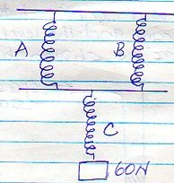
(c) Three identical springs A, B and C of negligible weight are connected as shown below:

4
The springs support a load of 60N. if the spring constant of each is 150N/m, determine the total extension of the springs (3mks)

12 (a) State the Pascals principle (1mk)

(b) The diagram below shows part of a hydraulic lift

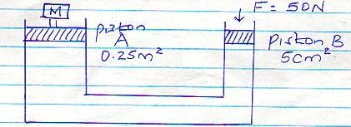

Determine the value of M, the load that could be lifted using this system (3mks)

(c) A gas supply was connected to U – tube containing mercury and the level of mercury in the tube was as shown below
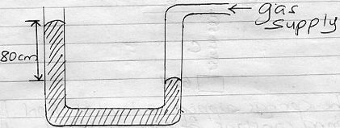

5
Given that the density of mercury is 13.6g/cm³ and that atmospheric pressure is
1 x 105Nm-².
Determine the pressure of the gas in Nm⁻² (3mks)

13. (a) The set up below is used to demonstrate Brownian motion using smoke particles
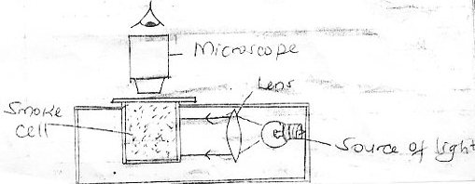

- What is the purpose of the len? (1mk)

- Describe the motion of the smoke particles as observed through the microscope
(1mk)

- Explain how the motion in (b)(ii) occurs (2mks)

6
- What would be observed in the motion in (b) (iii) if the temperature in the smoke cell is increased (1mk)

(b) In an experiment to determine the diameter of an oil molecule, an oil drop of radius 0.02cm was placed in a trag of water in which hydropodium powder had been sprinkled oil drop spread to a circular patch of radius of 0.2cm

Determine
- The volume of the oil drop (2mks)

- The area of the path (2mks)

- Diameter of the oil molecule (3mks)

14. (a) What property of light is suggested by the formation of shadows? (1mk)

7

(b) A building standing 200m from a pinhole camera produces on the screen of the camera an image 2.5cm high 5.0cm behind the pinhole.
Determine the acutal height of the building (3mks)

(c) An object of height 2.0cm is placed 5.0cm infront of a convex mirror of focal length 10.0cm
(i) Draw to scale, a ray diagram to locate the position of the image (3mks)

On the grid provided.

(ii) Calculate the magnification produced by the mirror. (3mks)

15. (a) State the principle of moments (1mk)

(b) A uniform metre rule of mass 95g is balanced on a pivot when a mass of 5g is hung from the 10cm mark. Find the position of the pivot (3mks)

8
(c) A uniform metre rule pivoted at the 60cm mark is kept horizontally by placing a 50g mass on the 80cm mark. Calculate the mass of the metre rule (3mks)

16. The figure below shows an electromagnet
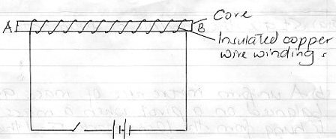

- Explain why the cord is made up of iron and not steel (5mks)

- On the same diagram indicate the direction of the current flow when the switch is closed (1mk)

9

- Whether current is allowed to flow, through the electromagnet it is magnetized.
Identify the poles of the magnet (2mks)

- __________________________________

- ___________________________________

(iv) State three factors that affect the strength of the electromagnet (3mks)

