GATITU MIXED SECONDARY SCHOOL
PHYSICS FORM 2 MID TERM EXAM TERM 2 2015
- The diagram below shows the magnetic field pattern between two magnets X and Y.
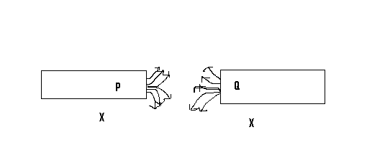

- Identify the poles P and Q 2mks

- State which of the two magnets X and Y is stronger. 1mk

- Sketch the magnetic field pattern around the following arrangement. 2mks

- State the magnetic law. 2mks

- Define the following terms.
- Magnetic field 1mk

- Magnetic poles 1mk

- Differentiate between magnetic material and non - magnetic material and give example of each. 4mks

- Explain the domain theory. 5mks

- Explain four methods of magnetization of a magnetic material. 8mks

- Give two applications of magnets. 2mks

- Give three types of calipers. 3mks

- Label the figure below. 5mks

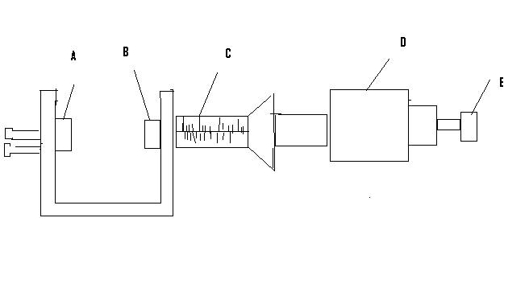
A
B
C
D
E
- Define the term pitch. 1mk

- Find the area of the rectangle measuring 3-93 cm by 5.35 cm. express your answer to 2 d.p. 3mks

- A sphere of diameter 6.0 cm is moulded into this uniform wire in metres. (take II =22/7) 3mks

- 100cm³ of fresh water of density 1000kg m⁻³ is mixed with 100cm³ of sea water of density 1030 kg m^{-3.}. calculate the density of the mixture. 4mks

- Complete the graph below showing the anomalous expansion of water. 2mks

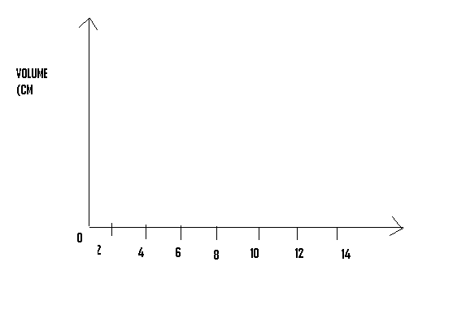
- Define the anomalous expansion of water. 1mk

- Define centre of gravity and state factors affecting stability of objects. 3mks

- State the principle of moment. 2mks

- The figure below shows a metre rule balanced by a weight of 2N.

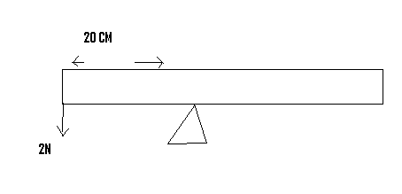

Determine the weight of metre rule. 3mks

- The figure below shows a claw hammer removing a nail from a piece of wood.

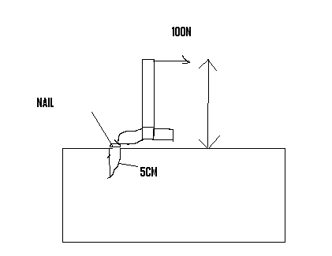
- By mean of an arrow shows on the diagram the direction of the load. 1mk

- What physical law is involved in the removal of the nail? 1mk

- State three application of anti parallel forces. 3mks

- Define the following terms.
- Centre of curvature ½ mk

- The principle focus 1mk

- Focal plance ½ mk

