GATITU MIXED SECONDARY SCHOOL
TUNE UP EXAM TERM 2 2013
PHYSICS FORM TWO
- Define the following terms.
- magnetic field 2mks

- ferromagnetic materials 2mks

- Neutral point 2mks

- Koech had two magnets and when he brought them together they attracted each other and when he changed side of one magnet, the magnet moved away. what was the reason behind this observation 2mks

- Draw the magnet field lines for the bar magnet shown below 2mks

- Give two examples of non- magnetic materials. 1mk

- a. How many images would be seen from two mirrors when their reflecting surfaces make an angle of 60 with each other 2mks

b. i. State the laws of reflection 4mks

ii. Name three applications of reflection of light in everyday life 3mks

iii. Distinguish between luminous and non luminous objects giving two examples of each. 3mks

- a. i. A student carried out the experiment shown below
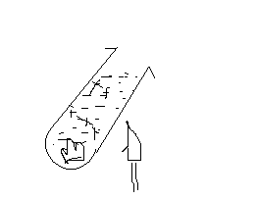

Even after heating the water at the point of location of the flame, it was observed that the ice could not melt. Explain this phenomenon. 2mks

ii. What was the purpose of the wire gauze? 1mk

b. i. Explain why the hand feel colder when a person holds a metal than when he holds a piece of wood. 2mks

ii. While heating water in a beaker, wire gauze is place below the beaker. Explain 2mks

- i. Define pressure and state its SI units 2mks
ii. In a hydraulic press, a force of 200N is applied to a master piston of area 25cm2. If the press is designed to produce a force of 500n, determine:
a. the area of the slave piston 3mks

b. the radius of the slave piston 3mks

- a. Define current and state its SI units 2mks

b. Give three differences between primary and secondary cells 3mks
Primary cells secondary cells

Mr Karanja
“Do not put off till tomorrow what you can do today”

