GATITU MIXED SECONDARY SCHOOL
END OF TERM II EXAMS
PHYSICS FORM II

NAME:………………………………………….ADM NO:……………..

Monday 3^{rd July} 2013
Time:2hrs
From:8:00-10:00 A.M

INSTRUCTIONS
- Write your name and ADM number in the spaces provided above.
- Answer all the questions in the spaces provided
- All working must be clearly shown
- Mathematical tables and Electronic calculators may be used.

1. Explain why if air gets in the brake system would reduce the efficiency of the brakes. (2 marks)

2. A cube of side 2.0cm is placed on a balance.

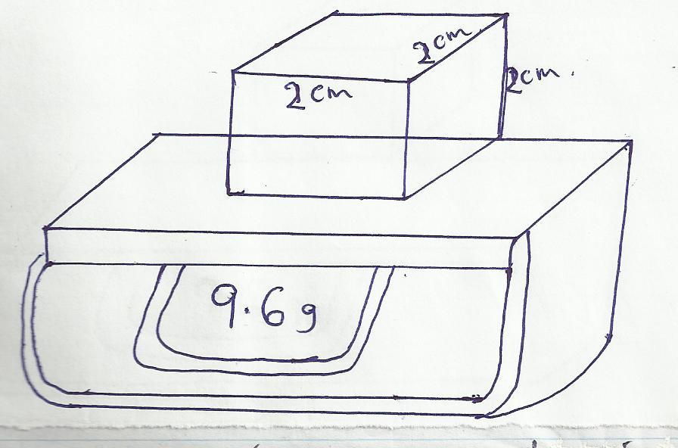

What is the density of the cube? (2 marks)
3.Vernier calipers has an error of -0.07cm. it is used to measure the diameter of boiling tube 0.0213m.
- What would be the reading on the vernier callipers (1 mk
- Draw a section of the vernier callipers showing the reading (2 mk)

4. The height of mercury column in a barometer is found to be 63cm at a certain place. What would be the height on a water barometer in the same place. (Density of water is 1000kg/m³ and density of mercury is 13600kg/m³). (3 mark
- In the set up below, it is observed that the level of water initially drops before starting to rise.
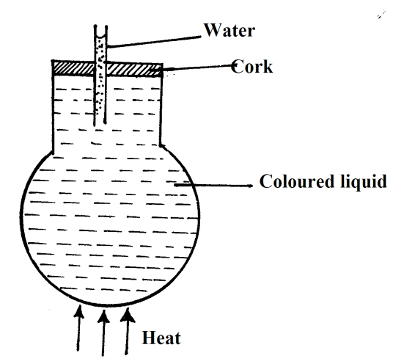
Explain the observations. (2 mks)
- State and explain any changes observed in a Brownian motion, when the temperature of the air in the smoke is increased (2mks)
- The mass of a density bottle is 20g when empty 70g when full of water and 695g when full of another liquid.
- Calculate the density of the other liquid(take density of water as 1g/cm3) (3 marks)
Mass of 20cm³ of the liquid (2 marks)

8. The figure below shows iron and steel rods placed in contact with a map net.
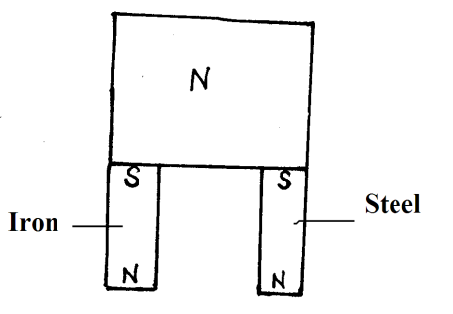

State with a reason what is observed when this magnet is removed from the rods. (2mks)
- Three bulbs are connected in series with a battery of dry cells. At first, the bulbs shine brightly but gradually become dimmer. Using the same cells, explain how you would increase the brilliance of the bulbs. (2mks)
- A mine worker stands between two vertical cliffs 600m from the nearest cliff. The cliff are x distance apart. Every time he strikes the rock once, he hears two echoes, the first one comes after 2.5 sec while the second one follows 2 sec later. From this information, calculate the speed of sound in air. (2mks)
- A block measuring 20cm by 10cm by 4cm rests on a flat surface. The block has a weight of 6N. Determine:
    - The minimum pressure it exerts on the surface. (2 marks)
.
    - The density of the block in kg/m³ (3 marks)
- (a) State the kinetic theory of matter. (2mks)
(b) State two reasons why gas particles diffuse faster than solid particles (2mks)
- 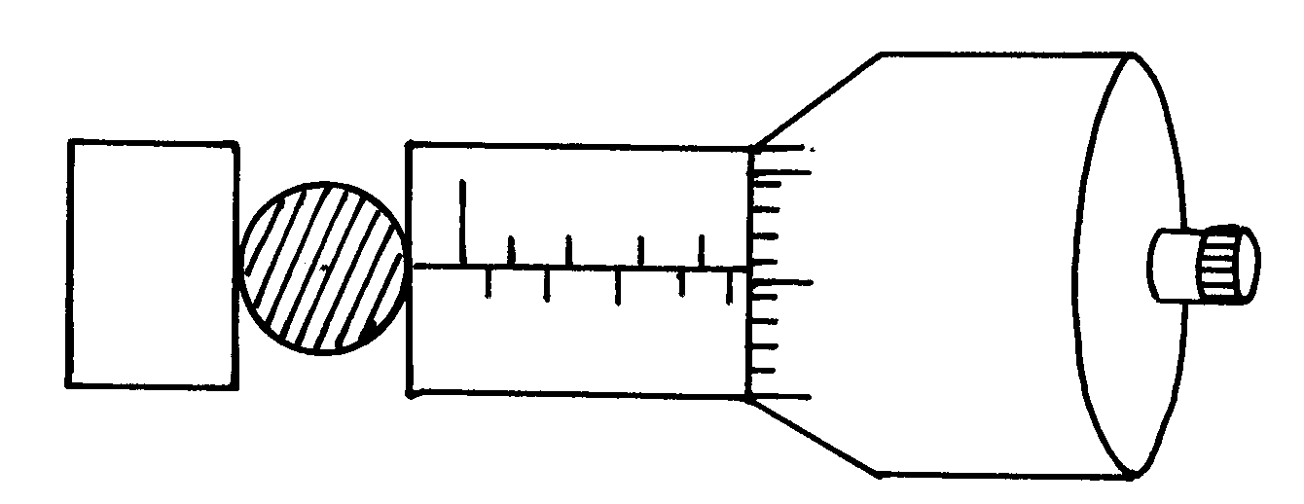A ball bearing of mass 0.0015 kg is held between the anvil and spindle of a micrometer screw gauge. The reading on the gauge when the jaws are closed without anything in between is 0.11mm. Use this information and the position of the scale in the figure below to answer the questions (a) and (b) below:
0
25
20

- What is the diameter of the ball bearing? (2mks)
Find the density of the ball bearing giving your answer correct to three significant . (3mks)
- (a)Suggest one reason why on hot day, heat loses in mains electricity transmission lines may generally be greater than on a cold day.(1mk)
(b) Why is a gap left between one end of a metal bridge and the end of a road leading to the bridge (1mk)

Soft iron plate
14. Spring
N S
X Y

S
A

The diagram above shows a permanent magnet suspended by a spring. State with reason the
behaviour of the magnet when the switch s is closed. (2 marks)

………………………………………………………………………………………………………………………………………………………………………………………………………………………………………………………………………………………………………….
15. State any 2 ways of in increasing the size of an image formed by a fixed pinhole camera. (2 marks)
…………………………………………………………………………………………………………………………………………………………………………………………………………………………………………………………………………………………………………………………………………………………

