GATITU MIXED SECONDARY SCHOOL
END OF MID-TERM EXAMS TERM III 2014
Physics form ii
INSTRUCTIONS
- Answer all the questions in the spaces provided.
- Use g-10N/Kg;density of water 1g/cm3; density of mercury 13.6 g/cm3 in the prompted questions.
- Mathematical tables and silent scientific calculators are allowed.
- Explain two reasons why water is unsuitable thermometric liquid. (2mks)

- A pinhole camera is 8cm long is focused towards a tree 10metres away from it. If the trees image has a height of 5cm, calculate the height of the tree. (3mks)

- Explain why television or computer screens often become very dusty as compared to their neighboring surfaces. (3mks)

- State two factors that affect the turning effect of a force. (2mks)
- Explain why a sharp wire with positive charges causes a candle to be deflected as shown below. (2mks)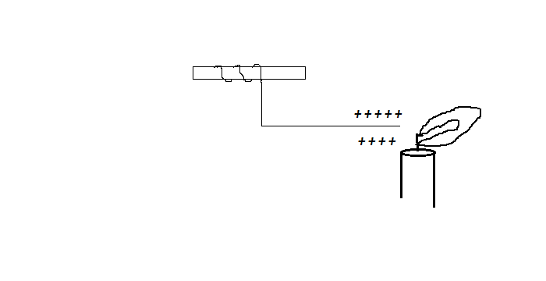
- The figure below shows a solenoid. Sketch the magnetic field pattern around the solenoid. (2mks)

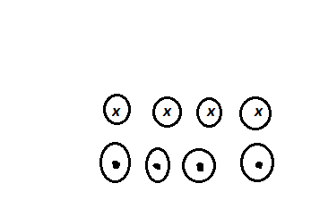
- With the aid of a sketch, describe FOUR ways in whch a thermos flask keeps liquids hot. (4mks)

- A uniform horizontal plank 10 m long resting on one support and is loaded with two masses of sizes 20kg and 5kg respectively as shown in the figure below. If it is in equilibrium, determine the mass of the plank. (*4mks)
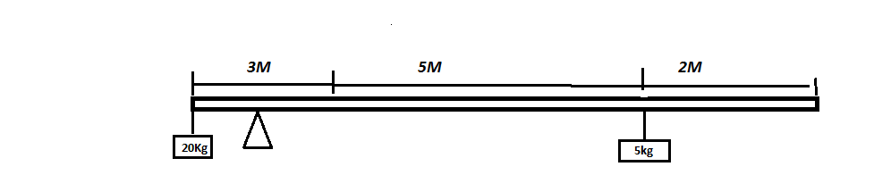
- Explain why a coin falling between the poles of a magnet and move sfaster in the surface without magnetic field. (2mks)

- (a) State hook’s law. (2mks)

(b) Define the following terms.
i. Elastic limit. (1mk)

ii. Plastic deformation. (1mk)

(c) Two springs connected in series have a spring constant of 15N and 25N/M respectively. Determine the total extension of the load. (3mks)

- Define the following terms. (5mks)
- Wave.

- Frequency.

- Wavelength.

- Amplitude.

- State Pascal’s principle. (2mks)

- State two ways of increasing the strength of an electromagnet. (2mks)

- Complete the table below. (6mks)
Type of cell | Electrodes | Electrolyte
Simple cell
Dry Cell
Acid accumulator

- Distinguish between a real and a virtual image. (1mk)

- A current of 0.5A flows in a circuit. Determine the charge that crosses a point in 4 minutes. (3mks)

- State two variables that must be controlled when comparing conductivities of different metal rods of the same diameter. (3mks)

- Winnie, a form two student in Gatitu secondary school poured hot water from the flask into a thick glass. The glass cracked into two suddenly. What caused the crack? (2mks)

- What is the difference between the motion of smoke particles in Brownian motion and motion of dust particles due to conventional currents? (2mks)

- (I) define spherical aberration. (2mks)

(ii) State two applications of each of the following: ((4mks0
- Convex mirror

- Concave mirror

- Explain the cause of random motion of chalk dust suspended in water as observed by Brownian motion. (2mks)

- (a) State the function of lycopodium powder in oil drop experiment. (2mks)
(b) 100,000 liters of oil spilled in the ocean covered an area of 200km2. What is the size of each molecule? (4mks)

****SUCCESS LIES ON THE POWER OF EFFORTS APPLIED DAY IN DAY OUT ***
**MR KARANJA, BEN**

