GATITU MIXED SECONDARY SCHOOL
PHYSICS FORM TWO CAT 1 TERM 3 2014
TIME: 1 HR
- State Hooke’s law 1mk

- Define the following terms ;
- Pitch 1mk

- Echo 1mk

- State the principle of moments 1mk

- Differentiate between a streamline flow and turbulent flow. 2mks

- List the factors affecting the speed of sound in air and their effects. 4mks

- The diagram below shows a uniform bar 1m long in equilibrium under the action of the forces shown.
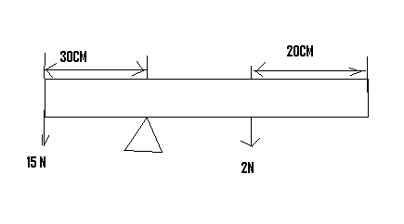
Determine the,
- Total clockwise moments. 2mks

- Total anti clockwise moments 1mk

- Weight , N, of the bar 2mks

- The wavelength of a local fm radio station is rated 120 MHZ. Determine its wavelength if the speed of light is given as 3 × 10⁸ ms⁻¹ 3mks

- A pipe of uniform cross – sectional area of 1.0 × 10 ⁻⁴ m² and length 5.0 × 10⁻¹ m lets in water from one end to the other in 5 seconds. Calculate the rate of flow of the water. 3mks

- A girl standing some distance away from a cliff blows a whistle and hears the echo 1.10 s later. If the speed of sound in air is 350ms⁻¹, determine how far the girl is from the foot of the cliff. 3mks

- Two springs of negligible weights and of constants K₁ = 50Nm ⁻¹ and K₂=100Nm⁻¹ respectively are connected end to end and suspended from a fixed point. Determine ;
- The total extension when a mass of 2.0 kg is hung from the lower end. 3mks

- The constant of the combination. 2mks

- List five factors that affect the spring constant of a spring 5mks

- Give the difference between stable and unstable equilibrium. 2mks

- When a strong wind blows over a gently sloping iron roof of a building , the roof is likely to be blown of . Explain this observation. 2mks

- State the Bernoulli’s principle 2mks

- Water ripples are produced by a straight vibrator such that the distance between successive crests is 6 cm and the waves travel 72 cm in 2.45s. calculate in SI units;

- The wavelength of the waves 2mks

- The velocity of the waves 2mks

- The frequency of the vibrator 2mks

- Name two hazards of Bernoulli’s effect. 2mks

- List two assumptions necessary to derive the Bernoulli equation. 2mks

