NAME ……………………………...................................................ADM. NO……………CLASS:...........

MWAKICAN JOINT EXAMINATION TERM 3 - 2014

232/2
FORM THREE PHYSICS PAPER 2
TIME: 2 HOURS

INSTRUCTIONS TO CANDIDATES
- Write your name, admission number and class in the spaces provided
- This paper consists of TWO sections: section A and B
- Answer all question in the both section A and B in the spaces provided
- Mathematical tables and electronic calculators may be used
- All working MUST be clearly shown.
- Candidates should check the question paper to ascertain that all the pages are printed as indicated and that no questions are missing.
- Candidates should answer the questions in English.

SECTION A: (25 MARKS)
- State two properties of the image formed by a plane mirror (2mks)

- Two mirrored walls stand at an angle to each other. A student standing in the room counts nine images of himself in the mirrors. Determine the angle between the walls
(3mks)

- The figure below shows a positively charged rod brought near a metallic sphere. Draw the distribution of charges on the sphere (2mks)

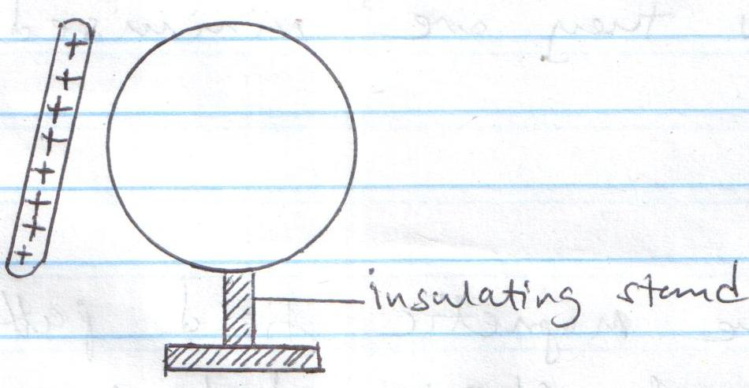

- 200 coulombs of charge passes through a point in a circuit for 0.6 minutes. What is the magnitude of the current flowing? (3mks)

- Using the domain theory, explain magnetic saturation (2mks)

- The figure below shows a ray of light incident on a plane mirror.
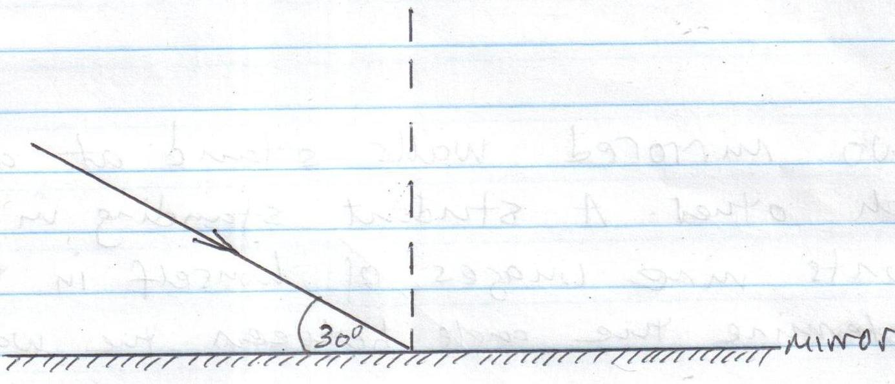
- What is the angle of reflection? (1mk)

- The mirror is rotated clockwise through an angle of 10º. Through what angle does the reflected ray rotate? (2mks)

- A simple cell has two major defects. State the two and how they are minimised. (2mks)

- Draw the magnetic field pattern around the arrangement shown below (2mks)

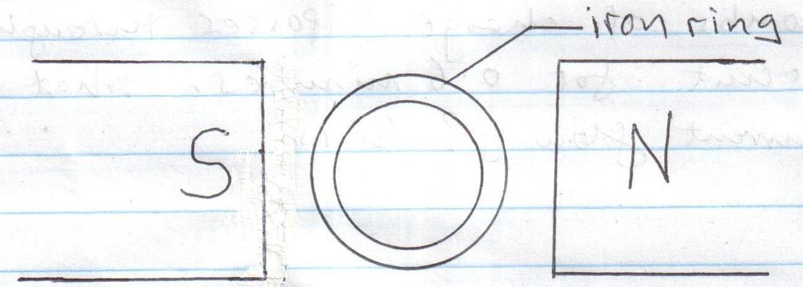

- State two factors that affect the speed of sound in air. (2mks)

- The figure below shows white light entering a triangular prism. Complete the diagram to show what appears on the screen (2mks)

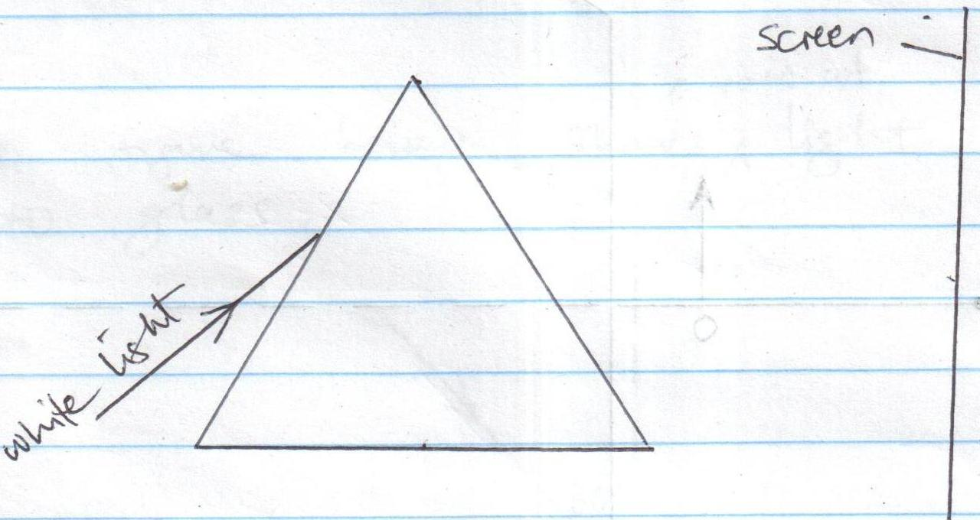

- Draw a ray diagram to show how a ray of light may be totally internally reflected two times in an isosceles right angled glass prism. (Assume that the critical angle of glass is 42º) (2mks)

SECTION B: (55mks)
- a) With reference to a concave mirror explain the meaning of:
- Focal length (1mk)

- Principal focus (1mk)

- The figure below shows an object placed in front of a concave mirror
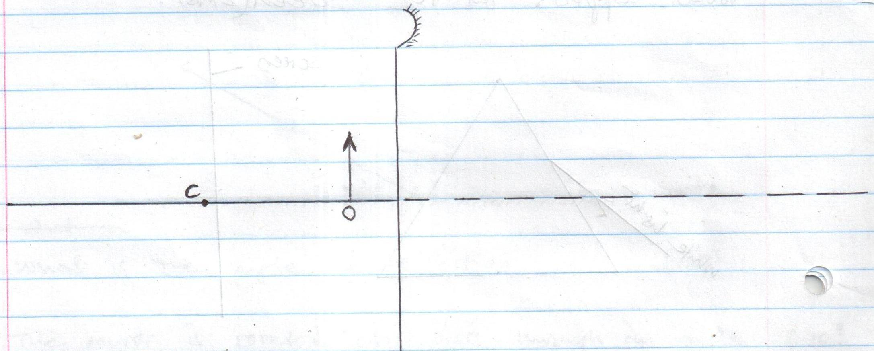

- On the same diagram, locate the position of the image (3mks)
- What is the magnification of the image? (3mks)

- The photographic film of a pinhole camera is 15cm away from the pinhole. A girl of height 1.2m stands 6m away from the pinhole. Find the height of the girl’s image.
(3mks)

- Draw a diagram to show the appearance of the sun during the annular eclipse (2mks)

- a) State two conditions necessary for total internal reflection to occur (2mks)

- The figure below shows a ray of light entering from air into glass.
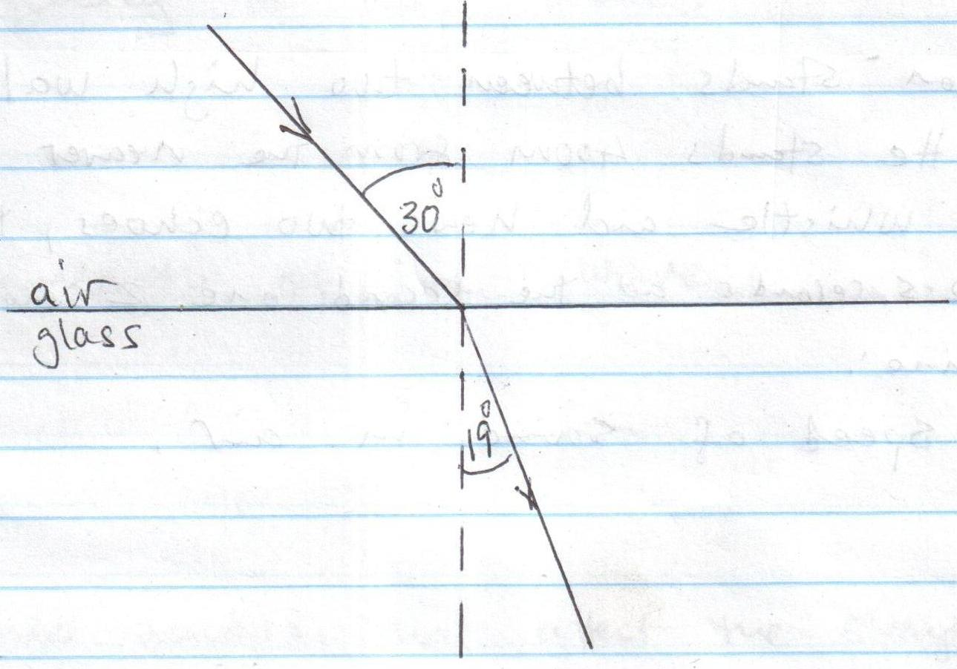
Determine:
- The refractive index of glass (3mks)

- The critical angle of glass (3mks)

- The speed of light in glass (3mks)
(Speed of light in air = 3.0 x 10⁸ms⁻¹)

c) State two applications of total internal reflection. (2mks)

- A dam appears 3m deep when viewed from above. If the refractive index of water is ⁴/₃, what is the depth of the dam? (2mks)

- a) Differentiate between longitudinal and transverse waves (2mks)

- A person stands between two high walls d metres apart. He stands 400m from the
nearer wall. He blows a whistle and hears two echoes, the first one after 2.5 seconds and the second one 2 seconds later. Determine:
i) The speed of sound in air (3mks)

ii) The value of d (3mks)

- The figure below shows a displacement-time graph for a wave travelling at 0.4ms-1
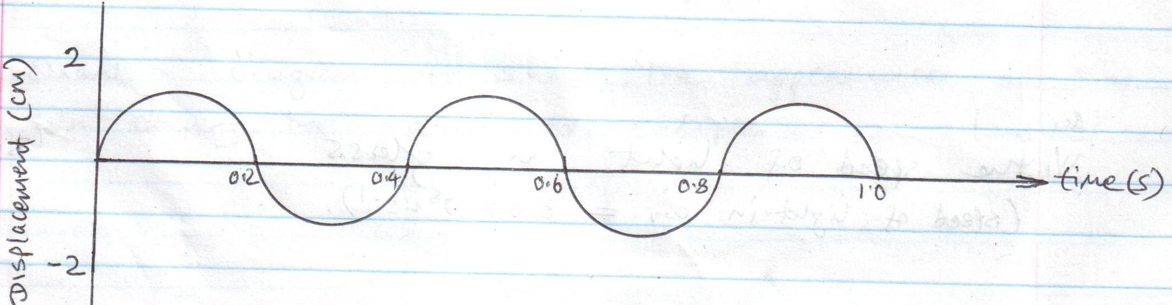

i) How many complete waves are shown? (1mk)

ii) Determine:
- The periodic time of the wave (1mk)

- The frequency of the wave (2mks)

- The wavelength of the wave (3mks)

- a) State two factors that affect the strength of an electromagnet (2mks)

b) Between iron and steel, which one would you recommend for use as the core of an electromagnet and why? (2mks)

c) Draw the magnetic field pattern around a conductor carrying current into the page
(2mks)

d) The diagram below shows a dry leclanche cell
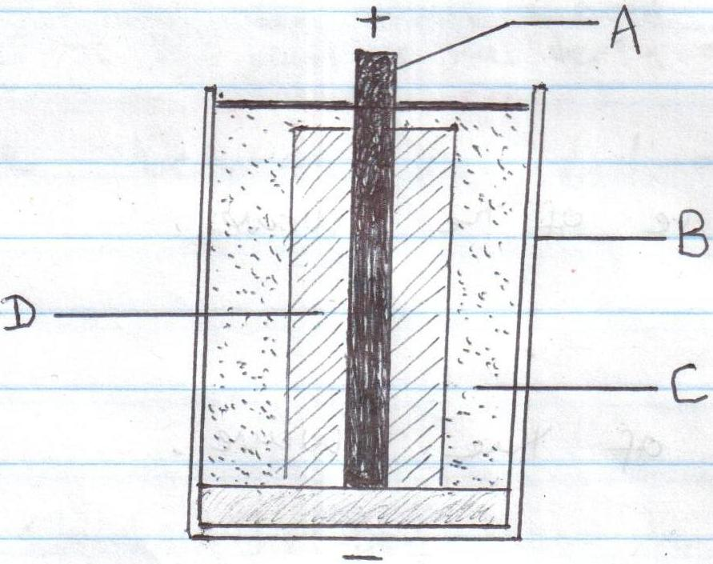

i) Name the parts labelled A, B and C (3mks)
A –
B –
C –
ii) What is the purpose of the part labelled D? (1mk)

- State two precautions necessary to maintain the well being of a lead-acid accumulator
(2mks)

