NAME …………………………….. INDEX NO. ……..…
DATE ……………………………. CLASS ……………..
MWAKICAN FORM 3 JOINT EXAMINATION – 2015 TERM II
KENYA CERTIFICATE OF SECONDARY EDUCATION
232/1
PHYSICS
PAPER 1
TIME: 2 HRS

INSTRUCTION TO CANDIDATES:
- Write your name and Admission number in the spaces provided.
- Answer all the questions in the spaces provided.
- Mathematical tables and electronic calculators may be used.
- All workings must be clearly shown where necessary.

FOR EXAMINERS USE ONLY:

SECTION | QUESTIONS | MAXIMUM SCORE | CANDIDATES SCORE
A | 1 – 13 | 25
B | 14 | 14
 | 15 | 08
 | 16 | 11
 | 17 | 12
 | 18 | 10
TOTAL |  | 80
SECTION A: (25 MARKS)
Answer all question
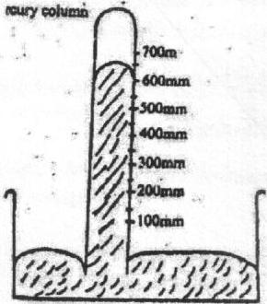
- The figure below shows a mercury column.

Given that the height of the mercury column is calibrated in mm, state the reading of the column height. (1 mk)

- Two springs of negligible weights and of constants K₁=50N/M and K₂=100N/M respectively are connected end to end and suspended from a fixed point as shown in the diagram.

A 200g mass was hung on the lower end.
Calculate the spring constant of the combination. (2 mks)

- A nurse applies a force 30N to syringe. Given that the cross-sectional area of the tip of the needle is 1.0 x 10⁻⁷m², calculate the pressure produced at the tip of the needle. (2 mks)

- Define diffusion. (1 mk)
- The pressure exerted by a gas of volume 0.024m³ at room temperature is 4.2x105 pa. Determine the pressure at which the volume of the gas reduces to 0.018m3 at the same temperature. (3 mks)

- State principle of moments. (1 mk)

- Droplets of water sprinkled on greasy glass plate form spherical shapes. Explain. (1 mk)

- A boy throws a ball of mass 100g vertically upwards to a height of 5m. Calculate the kinetic energy with which the ball leaves the hand. (2 mks)

- Give a reason why a house constructed with concrete beams reinforced with steel does not crack when subjected to temperature changes. (1 mk)

- The figure below shows two balloons inflated with air at room temperature.
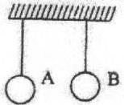

Balloon A is painted black and balloon B is painted white. A little amount of ice-cold water is poured on each balloon. State and explain the observation made. (2 mks)

- The diagram shows a paint spray gun.
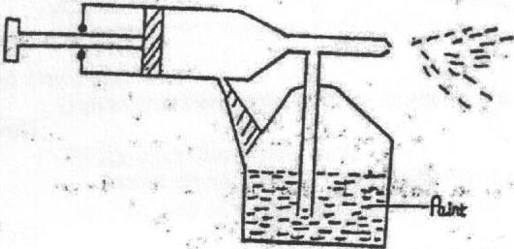

Explain how the gun works. (3 mks)

- A drop of oil of volume 5.0 x 10⁻³cm³ forms a patch of diameter 35cm on a water surface. Calculate the diameter of a molecule of oil. (3 mks)

- A uniform metre rule pivoted at the 70cm mark balances when a mass of 100g is hung at the 90cm mark. Calculate the mass of metre rule. (3 mks)

SECTION B: (55 MARKS)
- (a) Differentiate between distance and displacement. (1 mk)

(b) A car starts from rest and accelerates uniformly to 15m/s in 5 seconds. It then continues at that speed for 40 seconds and then decelerates uniformly to a stop in 3 seconds.
- Sketch the velocity – time graph for the motion. (3 mks)

- Determine the distance covered by the car. (2 mks)

- Find the average speed of the car during the journey. (2 mks)

(c) A trolley of mass 1.4kg moving at 0.8ms⁻¹ on a frictionless horizontal surface was acted on by a force of 0.7N. If the resulting speed of the trolley was 1.7ms⁻¹, determine
- The change of momentum of the trolley. (2 mks)

- The time interval the force acted on the trolley. (2 mks)

- The acceleration of the trolley. (2 mks)

- The figure shows a mass of 50kg pulled along an inclined planed by a force of 300N parallel to the inclined plane. The mass moves through a distance of 30m along the plane and rises a vertical height of 12m.
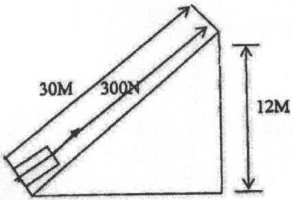

(a) Determine:
- The work done on the load. (2 mks)

- The work done by the force. (2 mks)

- Efficiency of the inclined plane. (2 mks)

(b) Give two ways by which the efficiency of the inclined plane can be improved. (2 mks)

- (a) Write the expression for the equation of continuity and define each component of the equation. (2 mks)

(b) The figure below shows a Bunsen burner in operation with the air hole open.
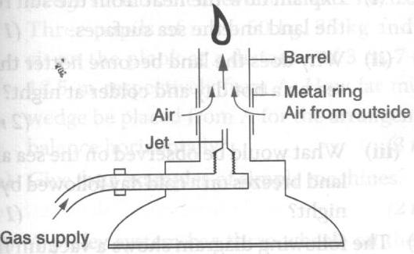

- Explain how the air is drawn into the barrel when the gas supply is opened. (2 mks)

- What is the purpose of the metal ring? (2 mks)

(c) A pipeline is 15cm in diameter at one point and 7.6cm in diameter at another point. If the speed of water in the wider section is 1.2m s⁻¹, determine:
- The speed of water in the narrow section. (3 mks)

- The rate of discharge. (2 mks)
- (a) The diagram below shows a water pump designed to raise water from a well.
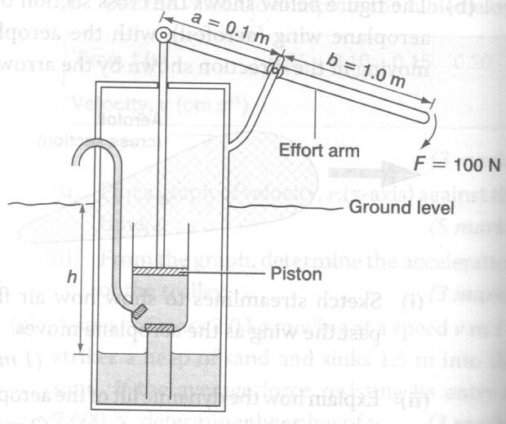

Take a=0.1m, b=1.0m, F=100 N, the diameter of the piston = 5cm, g=10 N kg⁻¹ and the density of water = 1.0 x 10³ kg m⁻³.
- Determine the maximum force on the piston when a force of 100 N is applied at the end of the effort arm during the downward stroke. (3 mks)

- Calculate the maximum pressure exerted by the piston on the water. (4 mks)

- Determine the maximum height to which the water can be raised. (2 mks)

(b) The height of a mercury barometer at a place is found to be 58 cm. what is the atmospheric pressure at the place? (Density of mercury is 1.36 x 10⁴ kg m⁻³.) (3 mks)

- (a) In an experiment to demonstrate Brownian motion, smoke was put in an air cell and observed under a microscope. Smoke particles were observed to move randomly in the cell.
- Explain the observation. (1 mk)

- Give a reason for using small particles such as those of smoke in this experiment. (1 mk)

- What would the most likely observation be if the temperature in the smoke cell was raised? (1 mk)

(b) An oil drop of average diameter 0.7mm spreads out into a circular patch of diameter 75cm on the surface of water in a trough.
- Calculate the average thickness of a molecule of the oil. (4 mks)

- State two assumptions made in (b) (i) above when calculating the thickness of the oil molecule. (2 mks)

