NAME ……………………………..................................................ADM. NO……………CLASS:...........

MWAKICAN JOINT EXAMINATION TERM 2 - 2015

232/2
FORM THREE PHYSICS PAPER 2
TIME: 2 HOURS

INSTRUCTIONS TO CANDIDATES

- Write your name, admission number and class in the spaces provided
- This paper consists of TWO sections: section A and B
- Answer all question in the both section A and B in the spaces provided
- Mathematical tables and electronic calculators may be used
- All working MUST be clearly shown.
- Candidates should check the question paper to ascertain that all the pages are printed as indicated and that no questions are missing.
- Candidates should answer the questions in English.

SECTION A: (25 MARKS)
- Under which condition is the potential difference across the terminal of a cell equal to its e.m.f? (1mk)

- The figure below shows a ray of light incident on a plane mirror
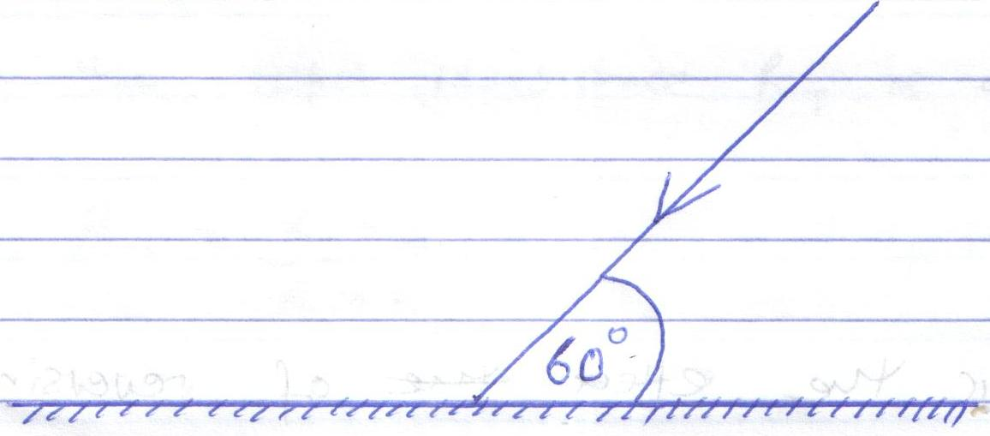
Determine the angle of reflection when the mirror is rotated 10º anticlockwise (2mks)

- A soldier standing some distance from a wall blows a whistle and hears its echo 1.8 seconds later. How far is the wall from the soldier? (Speed of sound in air = 330ms⁻¹)
(3mks)

- Other than temperature, state any other factor that affects the resistance of an ohmic conductor (1mk)

- Using the domain theory, differentiate between magnetic and non-magnetic materials
(1mk)

- The figure below shows circular waves approaching a plane barrier.
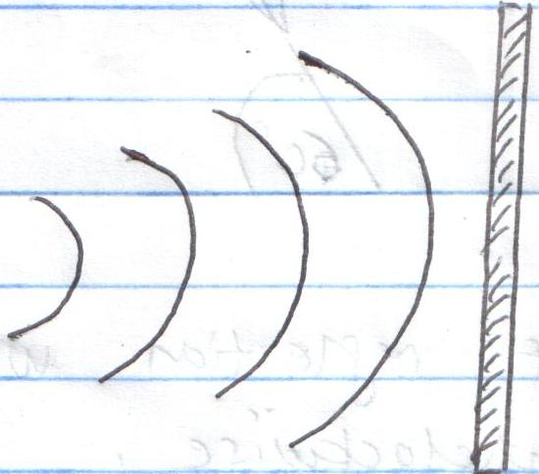

On the same diagram, sketch the reflected rays (1mk)
- State one application of the following: (2mks)
- Convex mirrors

- Parabolic mirrors

- A pin is placed below the surface of transparent water of depth 10cm and refractive index 1.33. Calculate the vertical displacement of the pin (3mks)

- The figure below shows an arrangement of resistors in a circuit.
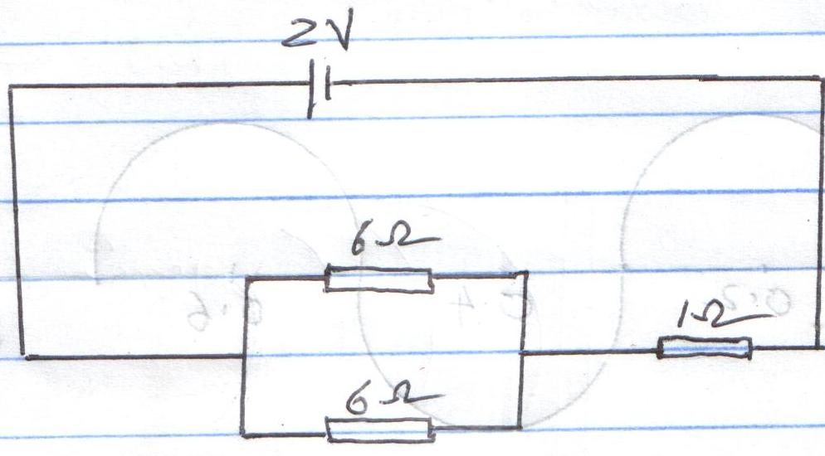
Determine:
- The effective resistance (2mks)

- The voltage drop across the 1Ω resistor (3mks)

- The figure below shows the image I formed by a concave mirror. Using ray diagrams, locate the position of the object (3mks)
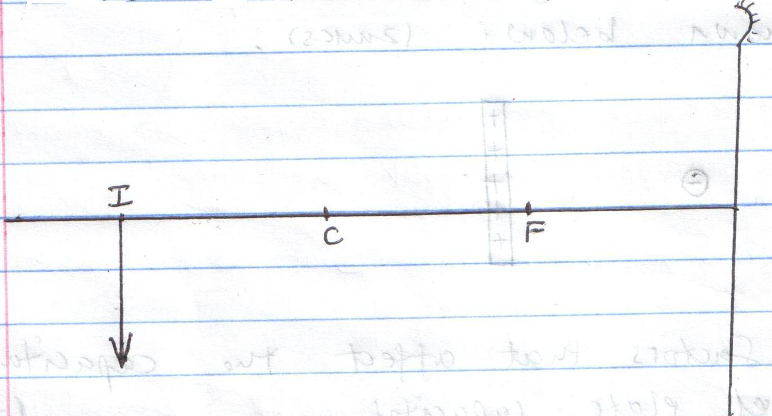
- The figure below shows a displacement-distance graph of a wave travelling at 2ms⁻¹
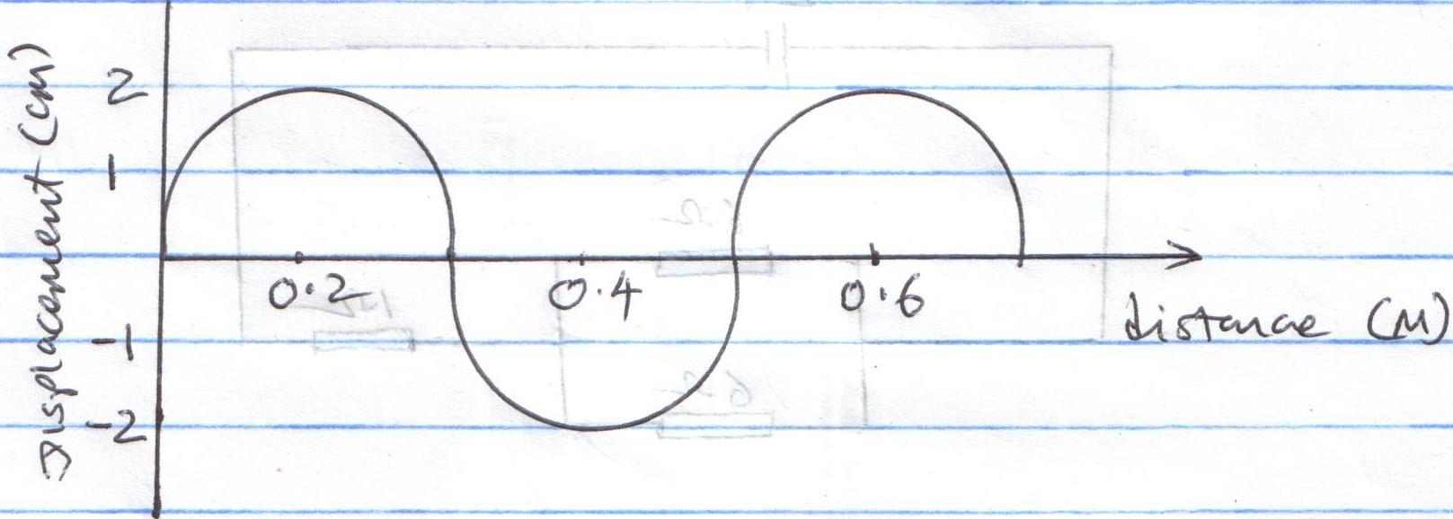
Determine:
- The amplitude (1mk)

- The wavelength (1mk)

- The frequency of the waves (2mks)

SECTION B (55MARKS)
- a) Draw the electric field pattern between the charges shown below (2mks)

- State two factors that affect the capacitance of a parallel plate capacitor (2mks)

- The figure below shows a network of resistor connected to a 100V power source.
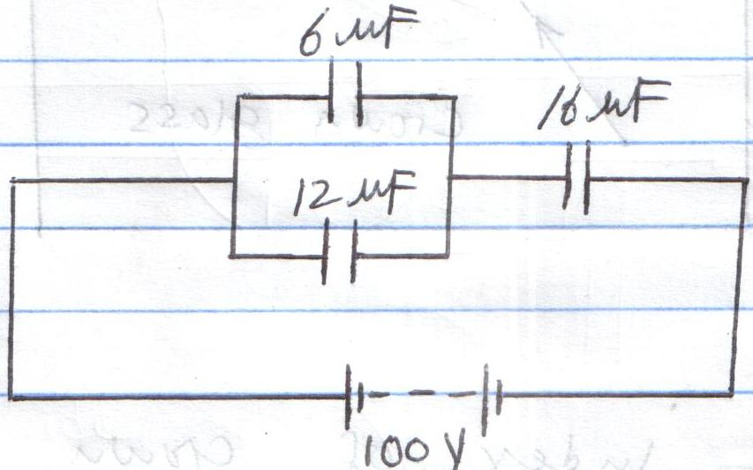
Determine:
- The effective capacitance of the circuit (3mks)

- The charge on the 16uF capacitor (3mks)

- The p.d. across the 12uF capacitor (3mks)

- a) State the Snell’s law of refraction of light (1mk)

- The figure below shows a ray of light travelling from crown glass to air.
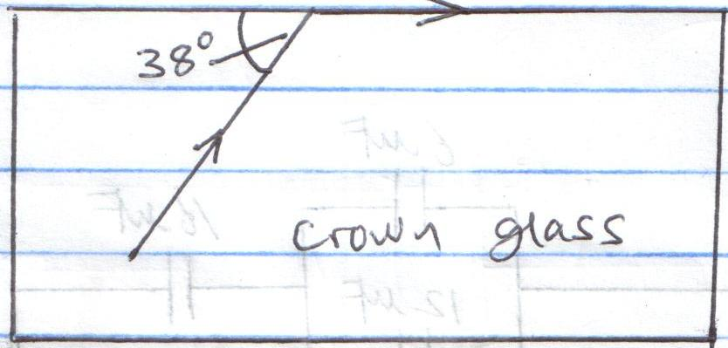
Determine:

- The refractive index of crown glass (3mks)

- The speed of light in crown glass. (3mks)
(Speed of light in air = 3.0x10⁸ms⁻¹)

- i) What would be the effect on the image of increasing the length of a pinhole
camera? (1mk)

- A girl stands 5m in front of a pinhole camera of length 50cm. If the girl is 1.2m tall, determine the size of her image as formed by the pinhole camera
(3mks)

- The figure below shows an object in front of a plane mirror. Using rays, locate the image as seen by the eye shown (3mks)
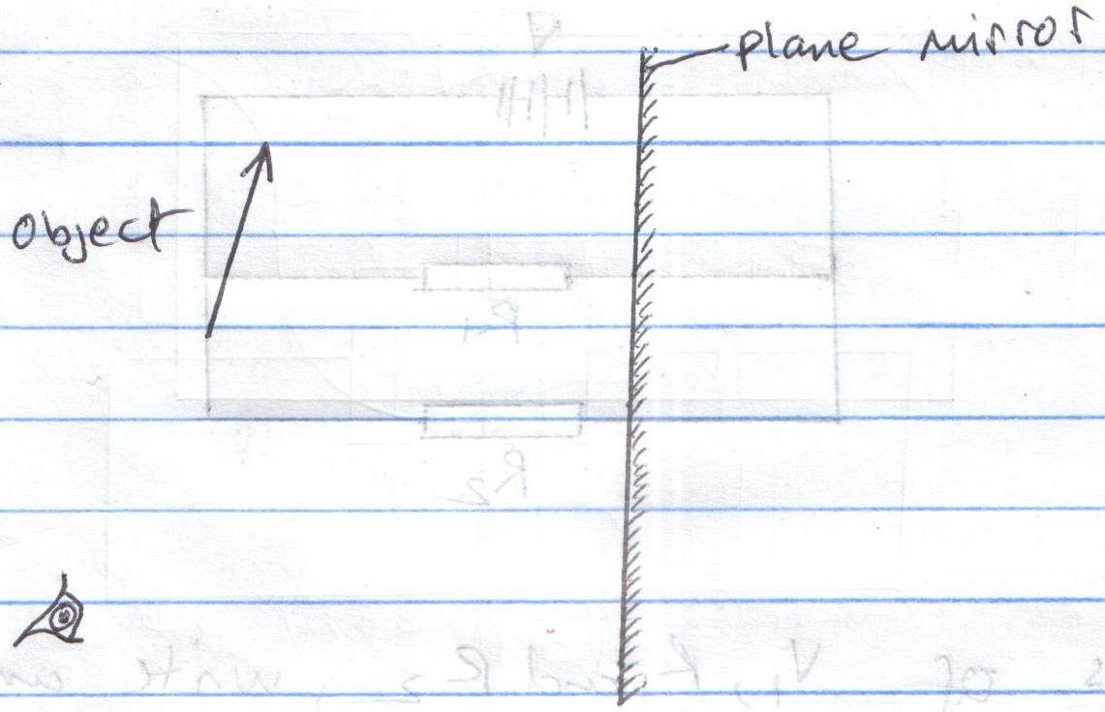
- a) State the Ohms law (1mk)

b) State the effect on the resistance of a conductor when the conductor is heated (1mk)

- Three identical dry cells each of e.m.f 1.6V are connected in series to a resistor of
resistance 11.4Ω. If a current of 0.32A is flowing through the circuit, determine:
- the total e.m.f of the cells (1mk)

- the internal resistance of each cell (3mks)

- The figure below shows resistors R₁ and R₂ connected in parallel. Their ends are connected to a battery of potential difference V volts.
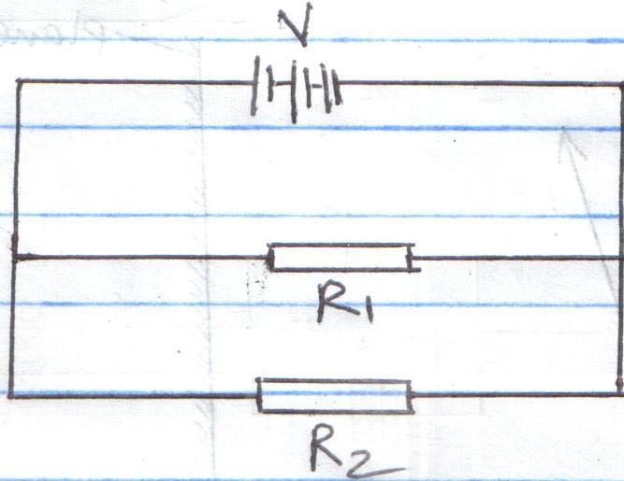
- In terms of V₁, R₁ and R₂, write an expression for:
- Current I₁ through R₁ (1mk)

- Current I₂ through R₂ (1mk)

- Total current in the circuit (1mk)
- Show that the total resistance R_{T} is given by (3mks)
R_{T} = R₁R₂
R₁+R₂

- a) State two factors that affect the strength of an electromagnet (2mks)

- In the set up shown below, the suspended metre rule is balanced by the magnet and the weight shown. The iron core is fixed to the bench.
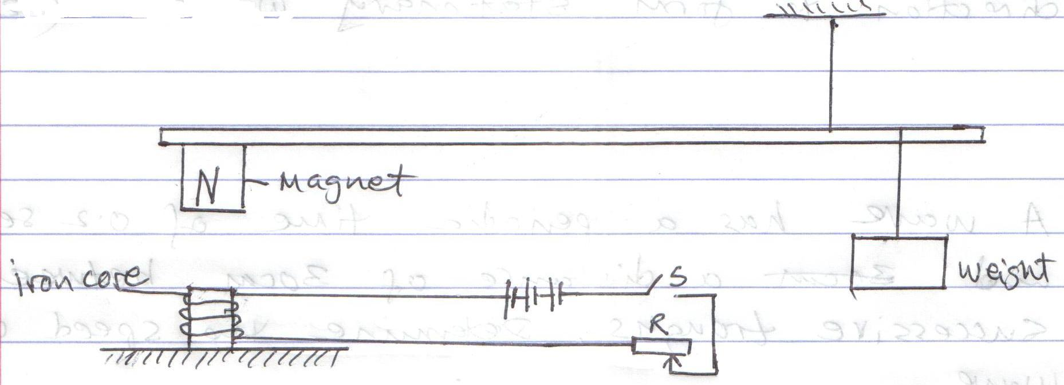
i) State and explain the effect on the metre rule when the switch is closed (3mks)

ii) What is the effect of reversing the battery terminals? (1mk)

- State one defect of a simple cell and how it is corrected (2mks)

- a) Differentiate between transverse and longitudinal waves (2mks)

- State two conditions necessary for two progressive waves travelling in the opposite
direction to form stationary waves (2mks)

- A wave has a periodic time of 0.2 seconds and a distance of 30cm between successive
troughs. Determine the speed of the wave (3mks)

