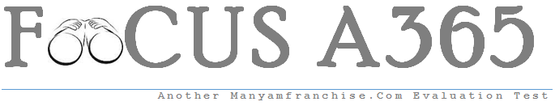

Gatitu Mixed Secondary School
Form 3 | Term 1 | 232 - Physics | 08-Jan-16 | Opener
1. List two factors affecting surface tension. (2mks)

2. State the principle of moments (1mk)

3.State Hooke’s law (1mk)

4. A uniform metre rule is pivoted at its centre. A force of 65N is applied at a point which is 15cm from one end of the rule. What is the moment of the force? (3mks)

5
(a)In a vacuum flask the walls enclosing the vacuum are silvered on the inside. State the reason for this.(1mk)

(b)Explain how the flask minimizes heat loss through radiation (1mk)

(c)Why is it that boiling water is not used for sterilization of clinical thermometers?

(d)State one application of expansion in gases (1mk)

6
(a)Define linear expansivity (1mk)

(b)When a liquid is heated in a glass flask, its level at first falls then rises.Explain this observation.(2mks)

(c )List three effects of anomalous expansion.(3mks)

7.
(a)1600cm³ of fresh water of density 1g/cm³ are mixed with 1400cm³ of sea water of density 1.25g/cm³. Determine the density of the mixture. (3mks)

(b)The density of liquid X is 13.6g/cm³. Calculate the mass of 19.4cm³ of the liquid.(2mks)

(c)State why the weight of an object on the surface of the earth varies from one place to another.(1mk)

8.
(a)List three factors that affect the spring constant.(3mks)

(b)A spring whose spring constant is 0.073N/mm produces an extension of 3mm when a certain force is applied on it. Find the magnitude of the force applied.(3 mks)

(c)A radio wave has a frequency of 3MHz and travels with a velocity of 3.0$×$10⁸ms⁻¹. What is its wavelength? (3mks)

