GATITU MIXED SECONDARY SCHOOL
FORM THREE PHYSICS MIDTERM 2015
PAPER TWO
SECTION I (25MARKS)
- Define length (1mark)

- Name the instrument that would be most suitable for measuring the thickness of one sheet of paper (1mark)

- Give two reasons why soft iron is used as a a core of the coil of an electric bell (2marks)

-=
- State Pascal’s principle (1mark)

- Explain the difference between a liquid and a gas in terms of intermolecular distance and forces (2marks)

- An electromagnet is made by winding insulated copper wire on an a iron core. State two changes that could be made to increase the strength of the electromagnet (2marks)

- State the number of images formed when an object is between two plane mirrors placed in parallel (1mark)

- Give a reason why it is necessary to leave the caps of the cells open when charging an accumulator (1mark)

- State the following laws
a. ) Pressure law (1mark)

b )Combined gas law (1mark)

c)Boyle’s law (1mark)
10. What do you understand by the terms?
a) Diffusion (1mark)

b) Brownian motion (1mark)

11. What happens to an image when
a) the size of the pinhole is increased (1marks)

b) the object distance is increased (1mark)

12. A block of copper of density 8.9 g/cm3 measures 5cmx3cmx2cm. Give that g=10N/kg determine;
a) The maximum pressure it exerts on a horizontal surface (2marks)

b) The minimum pressure it exerts on a horizontal surface (2marks)

13. State the three factors that influence the force on a current carrying conductor (3marks)

SECTION II (45MARKS)
14.A woman wearing shoes with high pointed heels exerts more pressure than an elephant
a) Explain why this is so (2marks)

b) If the weight of the woman is 600N and her heels have an area of 1.0 cm² each and the elephant has a weight of 30500N and each foot has an area of 730 cm³ , calculate by how much more the woman exerts pressure on the ground than the elephants (4marks)

c) On a certain day, atmospheric pressure read on a mercury barometer was 750mmHg
Express this in N/m² (Density of mercury =13.6g/cm³ g=9.8m/s⁻¹) (3marks)

15 a).State charles’ law (1mark)

b) Describe an experiment to verify Charle’s law (5marks)

c)Show that the density of a fixed mass of gas is directly proportional to the pressure at constant temperature (3marks)

16.a) State the law of magnetism (1marks)

b) Define non-magnetic materials and give an example (2marks)

c) (i) Define demagnetization (1marks)

(ii) State three ways of demagnetizing a magnet (3marks)

d)State two uses of magnets (2marks)

17. a)Define the following terms
(i) ray (1mark)

(ii) beam (1mark)

b) State the laws of reflection (2marks)

c) Name two characteristics of an image formed by a plane mirror (2marks)

d) The figure below shows two mirrors PQ and QR inclined at an angle of 110º . A ray of light is incident on mirror PQ at an Angle of 60º
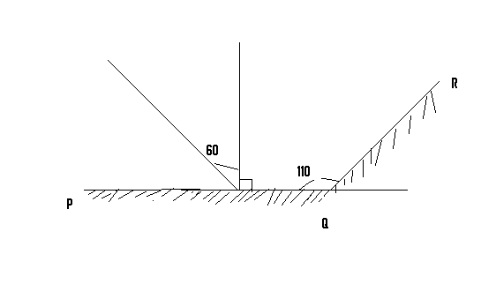

Complete the diagram to determine the angle of reflection of the ray in mirror QR (3marks)

18. a)A diver is working at a depth of 20m below the surface of a fresh water lake .Find the pressure acting on the diver .Assume g=10ms⁻¹ density of water= 100kgm⁻³ atmospheric pressure =760mmHg (5marks)

b)When you carry a heavy load on your bare head ,you find it painful but when you put a ring of cloth on your head then place the heavy loads you will find it more comfortable .Explain (2marks)

c) How does a syringe draw water from a beaker (2marks)

