OPENER EXAM PHYSICS FORM 3
GATITU MIXED SEC SCHOOL
- State two ways in which polarization reduces the current produced by a simple cell. 2mks

- Explain any two special features of clinic thermometer. 2mks

- Give the difference between cohesion and adhesion. 2mks

- Explain three factors affecting thermal conductivity. 3mks

- List two defects of a simple cell 2mks

- Explain how you can minimize the two defects. 2mks

- Explain why the lead acid accumulator must not be left discharged for a length of time.1mk

- State two ways of maintaining an accumulator so that it serves you for a longer period of time.2mks

- Ventilation is normally placed high on the wall next to the ceiling. Explain why. 2mks

- Distinguish between a transverse and a longitudinal wave. 2mks

- A current of 0.08A passes in a circuit for 2.5 minutes. How much charge passes through a point in the circuit? 2mks

- State three uses of an electroscope. 3mks

- Give the difference between a real and a virtual image. 2mks

- State two ways of increasing the size of the image formed by a pinhole camera. 2mks

- The figure below shows a light bar pivoted at a point and cuted on by various forces such that it remains in equilibrium. Determine the

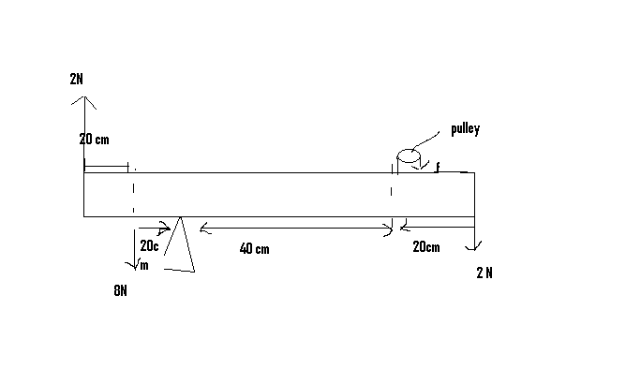

- Total clock wise moments. 3mks

- Total anti clock wise moments 3mks

- Force f 2mks

- An object is placed 30 cm from a concave mirror of focal length 20 cm. calculate:
- The image position 2mks

- The magnification 2mks

- In an experiment, a spiral spring was hung vertically from a stand and various weights was noted. The results were recorded as shown in the table.
LOAD (N) | 0 | 0.2 | 0.4 | 0.6 | 0.8 | 1.0 | 1.2
EXTENSION(CM) | 0 | 0.95 | 1.9 | 2.9 | 3.9 | 5.5 | 7.25

- Plot the graph of load (y – axis) against the extension of the spring. 5mks
- From the graph determine the elastic limit of the spring. 1mk

- From the graph, determine the spring constant within Hooke’s law. 2mks

