GATITU MIXED SECONDARY SCHOOL
FORM 3 PHYSICS
PAPER 1
TIME: 1 HR 30MIN 70MKS
- The figure below shows a measuring cylinder containing some water.

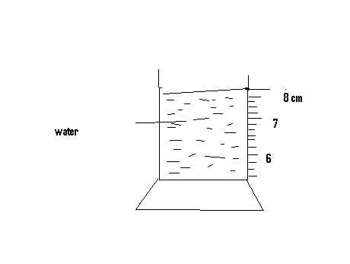
Determine the readings on the measuring cyclinder, after three drops of volume 0.6 cm3 are added 2mks

- List two factors affecting surface tension. 2mks

- Give the difference between a scalar and vector quantity, and give examples for each. 2mks

- State the principle of moments. 1mk

- Give the difference between unstable and neutral equilibrium. 2mks

- A uniform metre rule is pivoted at its centre. A force of 65N is applied at a point which is 15 cm from one end of the rule. What is the moment of the force? 3mks

- Explain why a matatu is more likely to topple over when the roof rack is heavily loaded than when the roof rack is empty. 2mks

- State Hooke’s law. 1mk

- Define the following
- Wave 1mk

- Pulse 1mk

- Amplitude 1mk

- Frequency 1mk

- Period 1mk

- Define an echo 1mk

- State two practical application of echo sounding under water. 2mks

- State three factors that determine the pitch of sound from a stringed instrument. 3mks

- A young boy claps his hands once at a distance of 500m from a vertical cliff. If the temperature of the surrounding is 10 c , how long does it take for him to hear the echo? 3mks

- Determine the following terms
- Streamline flow 1mk

- Turbulent flow 1mk

- Dynamic lift 1mk

- List three assumptions necessary to derive the Bernoulli equation. 3mks

- State three applications of Bernoulli’s effect 3mks

- State the equation of continuity as applied in fluid flow. 3mks

- A water pipe of cross sectional area 4 cm² and with water flowing in it at 10ms⁻¹ is connected to another pipe of cross –sectional area 1 cm^{2.} Determine the velocity of water in the 1cm³ pipe. 3mks

- In a vacuum flask the walls enclosing the vacuum are silvered on the inside. State the reason for this. 1mk

- Explain how flask minimizes loss of heat through radiation. 1mk

- Why is it that boiling is not used for sterilization of clinical thermometer? 1mk

- State one application of expansion in gases. 1mk

- Define linear expansivity. 1mk

- When a liquid is heated in glass flask, its level at first falls then rises. Explain this observation. 2mks

- List three effects of anomalous expansion. 3mks

- 1600 cm³ of fresh water of density 1 g/cm³ are mixed with 1400 cm³ of sea water of density 1.25 g/cm³. Determine the density of the mixture. 3mks

- The density of liquid X is 13.6 gcm⁻³. Calculate the mass of 19.4cm³ of the liquid. 2mks

- State why the weight of an object on the surface of the earth varies from one place to another. 1mk

