PERFECT STEPS PUBLISHERS
END TERM EXAMS 2015
0721 745374/ 0721 707626 NAIROBI
232/2
PHYSICS
PAPER 2(THEORY)

INSTRUCTIONS TO CANDIDATES
- Write your name and index number in the spaces provided above.
- Sign and write the date of the examination in the spaces provided above
- This paper consists of TWO sections A and B.
- Answer all the questions in section A and B in the spaces provided in this booklet
- All working MUST be clearly shown.
- KNEC Mathematical tables and non-programmable silent electronic calculators may be used.
- Take: Acceleration due to gravity, g = 10m/s², Density of water 1g/cm³,
S.H.C. of water is 4200JKg⁻¹K⁻¹.
FOR EXAMINER’S USE ONLY
Section | Question (s) | Max. Score | Candidates Score
A | 1-12 | 25
B | 13 | 12
 | 14 | 10
 | 15 | 10
 | 16 | 13
 | 17 | 10
 | Total | 80

This paper consists of 8 printed pages. Candidates should check the question Paper to ensure that all the pages are printed as indicated and no questions are missing

SECTION A(25 MARKS)
Answer ALL the questions in this section in the spaces provided
1. State the property of light associated with formation of shadows (1mk)

2. Explain why soft iron keepers are suitable for storing magnets (2mks)

3. The figure below shows a conductor carrying current placed in the magnetic field of two magnets. Complete the diagram by showing the field pattern and the direction of force F that acts on the conductor (2mks)

4. State two quantities that are used to determine whether accumulator require recharging or not (2mks)

5. The figure below shows the image I, formed in a convex mirror. Complete the ray diagram to show the position of the object. (2mks)
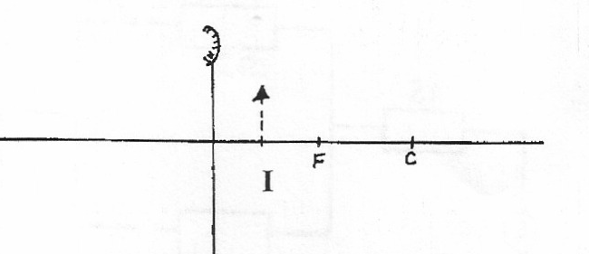

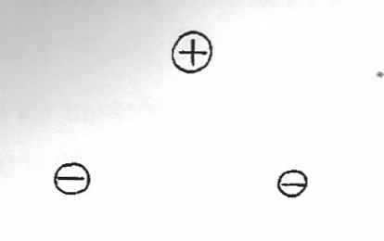
6. Draw the electric field around the charges shown below (2mks)

7. The figure below shows a displacement –time graph for a wave with a period of 0.5 seconds

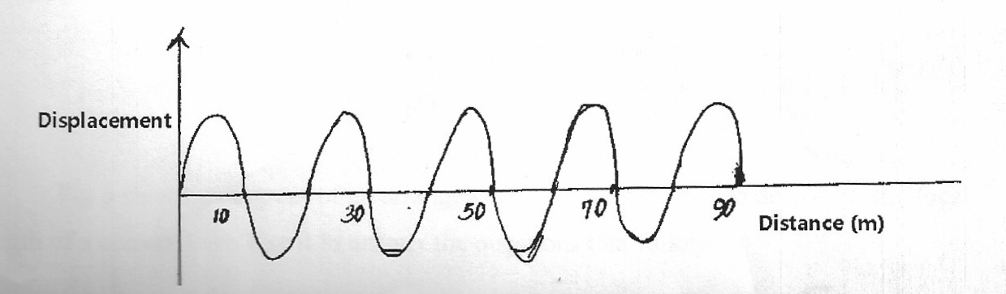

Displacement

Calculate the velocity of the wave (3mks)

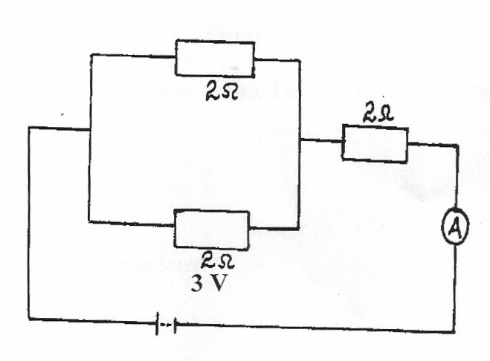
8. Determine the ammeter reading in the figure below (3mks)

9. The figure below shows a negatively charged object suspended using a thread. A glass rod was rubbed using a woolen cloth and then brought closer to the object

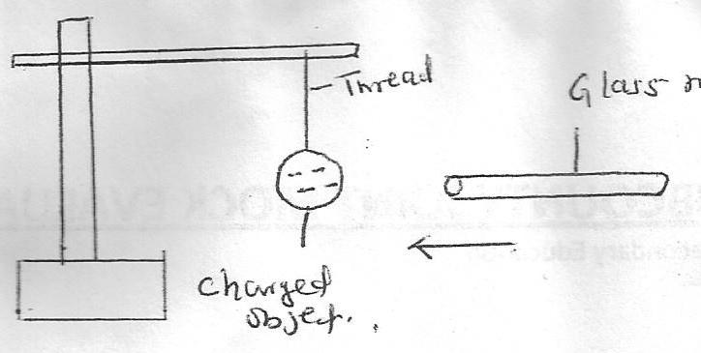

Thread
Charged object
Glass rod

State the observation made when a rubbed glass rod is brought closer to the object (1mk)

10. In the figure below the lamps in the two circuits A and B are identical and the cells have the same electromotive force.
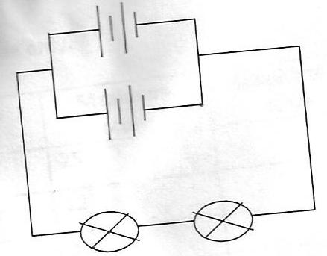
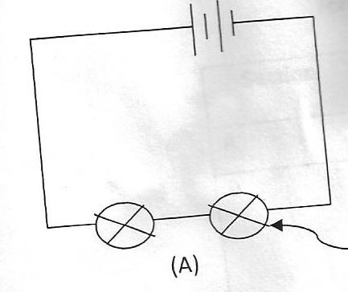

Lamp
A
B
Explain why the lamps in B may glow brighter than those in A when the circuits are closed at the same time (2mks)

11. (a) A compass needles is placed below a current carrying conductor as shown below
Conductor

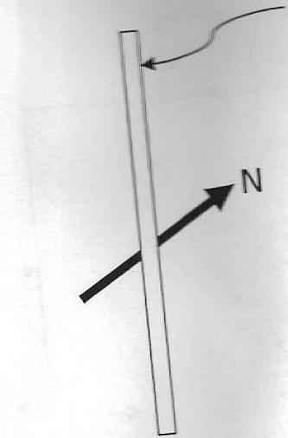

Indicate on the diagram the direction of the current (1mk)
(b) State the difference between a soft magnetic material and hard magnetic material (1mk)

12. (a) Define diffraction with respect to waves

(b) In the diagram below the size of the aperture at the barrier is 10cm while the distance between two consecutive wave fronts is 3cm. if the waves are moving towards the barrier, draw the wave fronts as they appear after passing through the aperture (2mks)
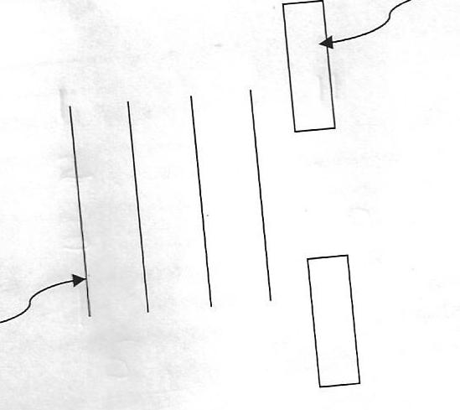
Wave front
Barrier

SECTION B (55 MKS)
Answer all questions in the spaces provided
13. (a) Figure 7 below shows a ray of white light incident on the surface of a glass prism

Prism
60º
60º

Figure 7
60º
Screen

(i) Complete the path of the ray until it reaches the screen. (Use only two extreme rays) (2mks)

(ii) Mark on the diagram the two rays as they appear on the screen (1mk)

(iii) What colours will be observed on the screen if white light was replaced by yellow light? (1mk)

(b) (i) Distinguish between reflection and refraction of light (1mk)

(ii) The figure (I) and (II) show refraction of light at air-water interface
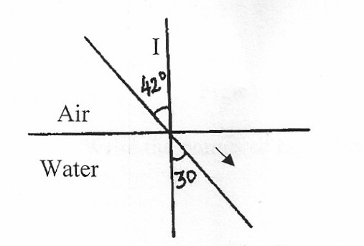
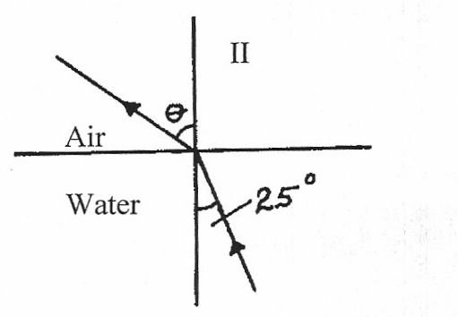

Determine angle θ in figure (II) (3mks)

(iii) State two laws of refraction (2mks)

( iv ) State two conditions necessary for total internal reflection to occur (2mks)

14. (a) Define 1Amphere (1mk)

(b) Figure 7 shows a single cell oaf a lead acid accumulator

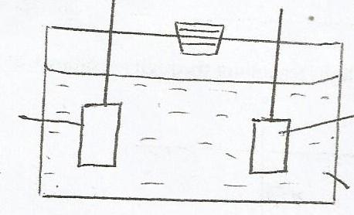

R
Lead

Acid

(i) Name the electrode labeled R (1mk)

(ii) Explain how the state of charge in the cell can be tested (2mks)

(iii) State the main reason why the cell should not be left in discharge conditions for long (1mk)

(c) The figure shows three resistors of values 2Ω,3Ω and 1Ω connected in a circuit of 4 voltages

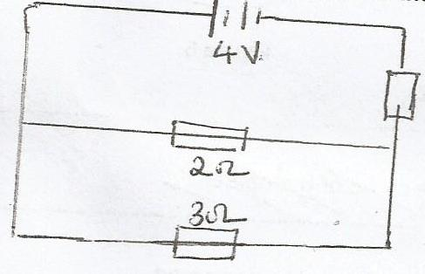

4v
2Ω
3Ω
1Ω

Determine:
(i) Effective resistance in the circuit (3mks)

(ii) Current through the 3Ω resistor (2mks)

- (a) The figure below shows an arrangement of capacitor connected to a 10V DC supply.

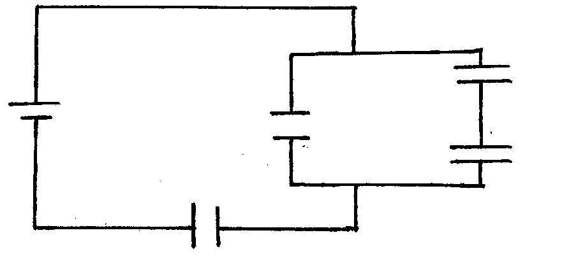
3µF

1µF
10v
2µF
3µF

Determine
- The combined capacitance of the arrangement. (3mks)

- The total energy stored. (2mks)

(b) The graph below shows the variation of potential difference V with current, I for a certain cell.
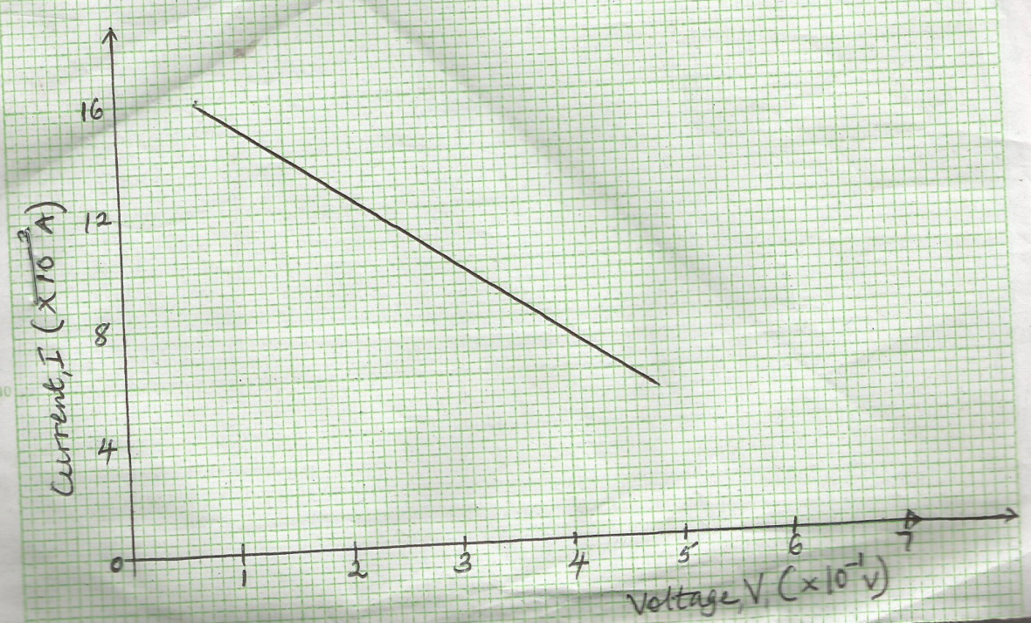

From the graph determine:
- Internal reaction of the cell. (3mks)

- The e.m.f of the cell (2mks)

- (a) Define capacitance (1 Mark)

(b) In the figure below, a sharp pin is fixed on a cap of a leaf of the electroscope. The electroscope is highly charged and then left for some time.

Sharp pin
Charged electroscope

State and explain the observation made after sometime (2 Marks)

(c) The figure below shows a circuit where a battery of e.m.f. 4.5V, switches A and B, two capacitors
C₁ =0.6μF and C₂ = 1.0μF and a voltimeter are connected.
4.5 V
V
A
B
C₁ = 0.6μF
C₂ = 1.0μF

(i) Determine the charge on C₁ when both switch A is closed and switch B is open.(2 Marks)

(ii) What is the effective capacitance when both switches are closed? (2 Marks)

(iii) State and explain what is observed on the voltmeter when;
- Switch A is closed and switch B is open (2 Marks)

- Switch A is closed and B is closed (2 Marks)

(d) State two ways in which the capacitance of a parallel plate capacitor can be reduced. (2 Marks)

- (a) State ohms law (1mark)

- A battery of Emf E drives a current of 0.25A when connected to a 5.5Ω resistor. When the 5.5Ω resistor is replaced with 2.5Ω resistor the current flowing becomes 0.5A.Find the emf, E and the internal resistance, r, of the battery. (4marks)

- A capacitor of capacitance 6μF capacitor is charged using a 6v d.c source. It is then connected across a 12μF capacitor. Find :-
- Final voltage (3 marks)

- Charge stored in each capacitor (2marks)

