## PERFECT STEPS PUBLISHERS

END TERM EXAMS 2015

**0721 745374/ 0721 707626 NAIROBI**

**FORM 3 PAPER 2**

**PHYSICS 232/2**

**MARKING SCHEME**

1. Rectilinear property/light travels in a straight line;

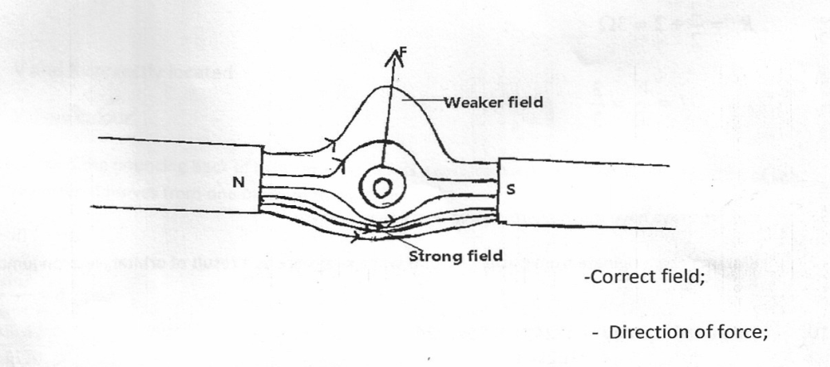2. Magnetism is easily induced in them. The dipoles of the keepers form a closed loop with those in the magnets hence protecting the magnets from being demagnetized;

4. Relative density of the acid;

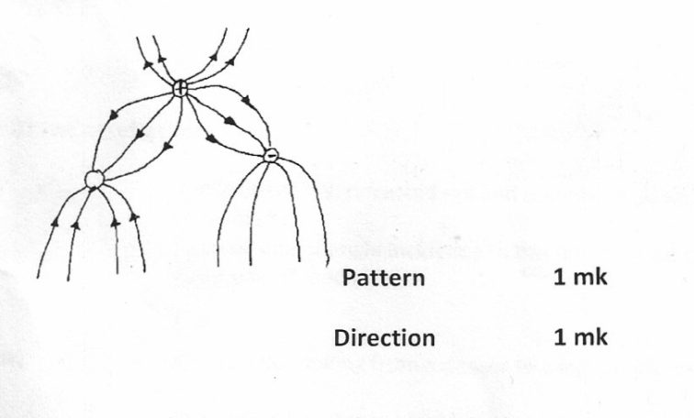 The voltage output;

5.

6.

2 correct rays=2mks

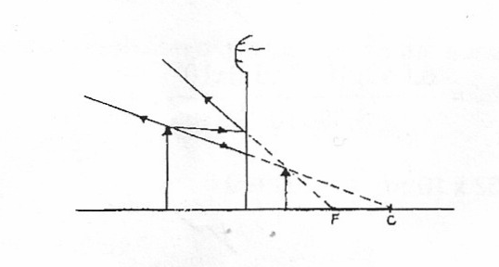

7. V=fλ

But f= 

∴V=2.0x20

=40

8. 



=1A

9. The object is repelled

10. Cells in B has a low effective internal resistance √

This is so because the cells are arranged in parallel√ 2mks

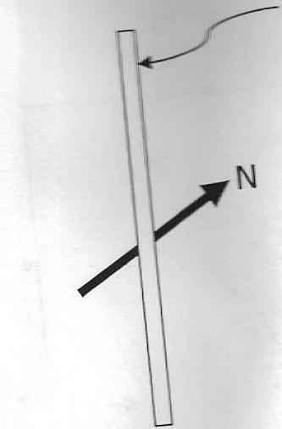11. (a)

√1

(b) Soft magnetic is easily magnetized and demagnetized while a hard magnetic material is difficult to magnetize and demagnetize√1

12. (a) The spreading out of waves past an apparture or barrier√1

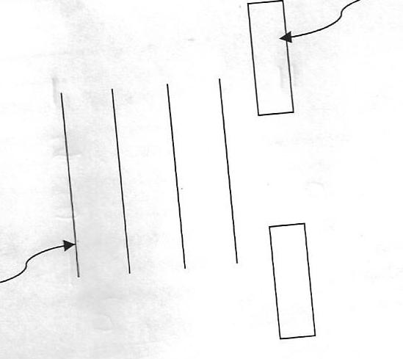(b)

**Barrier**

**Wave front**

***Straight wave fronts-1mk***

***Spreading out (enlarging of wave fronts -1mk***

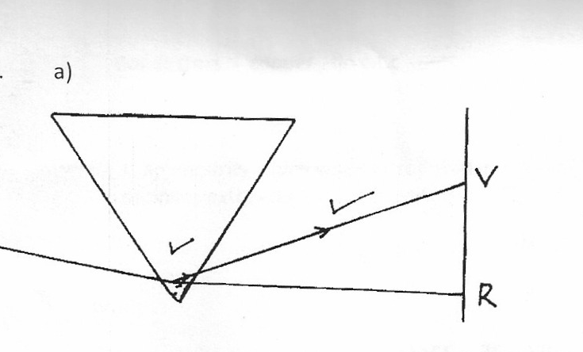13. (a)

(i) V and R correctly located

(iii) Yellow colour

(b) (i) Reflection is the bouncing back of light ray when it hits a surface, while refraction is the bending of light ray when it moves from one medium to another

(ii) 



∴

Sin θ=n sin 25o

=1.34sin 25

Θ=34.5o

(iii) Laws of refraction

* The incident ray, refracted ray and the normal at the point of incident all lie in the same place
* Ratio of sine of angle incidence to the sine of angle of refraction is constant for a given pair of media;

(iv) Light must be moving form a denser to a less dense medium;

The angle of incidence must be greater than the critical angle;

14. (a)Amount of current passing when a charge of one contains flows in one second

(b)(i) Real dioxide √1

(ii) Hydrometer ids immersed in to sulphuric acid solution to measure the speed the gravity of to cell

(iii) solution –occur which impedes recharging

(i)  3mks

(ii) Total current = 

Current 3Ω= 2/5 x1.818=0.7272A

15 a) i) = 3.5(i) √1

4.5

= 0.778mf √1

ii) E = 1 cv2 √1

2

= ½(3.5/4.5)102 x 10-6√1

= 3.89x 10-5√1

b) i) –v = 1

slope

= 12 - 8

2.6 – 4 √1

= 0.352Ω √1

ii) E = 6.8 x 10-1 v √1

1. (a) The measure of the amount of change a capacitor can store when connected to a given voltage or

change stored per unit voltage✓

(b) The leaf falls. ✓ The sharp pin discharges the electroscope by concentration of charges at sharp points. Leading to leakage of charges.

(c) (i) Charge Q1 on C1 is given by

Q1 = C1V or Q1 = C1V

= 0.6μF x 4.5 = 0.6 x 10-6 x 4.5

= 2.7μC = 2.7 x 10-6C

(ii) CT = C1 + C2

= (0.6 + 1.0) μF

= 1.6μF

= 1.6 x 10-6F

(iii) 4.5V, All the voltage drop is across C1. No current through C2.

Voltmeter reading p.d drops below 4.5✓; the charge on C1 is distributed to C2. Since the value of C1 and C2

remain constant, when Q on C1 reduces, then Q1 = C1V implies V must reduce also, hence voltmeter reading.

(d) – Reduce the area of overlap for the plates ✓

- Increase the distance between the plates ✓

17.

1. The current through a conductor is proportional to the p.d across the conductor provided all physical

quantities are kept constant.(1mk)

1. E=I(R+r)

Case1=E=0.25(5.5+r)

E=1.375+0.25r………….. (i)🗸1

Case 2=E $0.5\left(2.5+r\right)$

E=1.25+0.5r……………….(ii)🗸1

Solving (i) and (ii) simultaneously

(i)-(ii)

0=0.125-0.25r

r=0.5Ω🗸1

E=1.25+0.5r

=1.25+0.5x0.5

=1.5V🗸1

1. Q=CV

=6x

=36x

1. Q=Q1+Q2

=C1V+C2V

36x√1

V=

=2V √1

1. Q1=C1V

=6x

=12x

Q2=C2V

=12x

=48x C √1