PERFECT STEPS PUBLISHERS
END TERM EXAMS 2015
0721 745374/ 0721 707626 NAIROBI
Physic Form 3 pp 3
- You are provided with the following apparatus
  - Ammeter
  - Two dry cells (1.5 V)
  - A switch
  - 1 m long resistance wire mounted on a scale
  - Five connecting wires with crocodile clips
  - Micrometer screw gauge
- Measure the diameter, d, of the resistance wire. (1 mrk)
d = ………………………………….. m
- Calculate the cross-section area of the resistance wire, A. (2 mks)

- Set-up the apparatus as shown below:
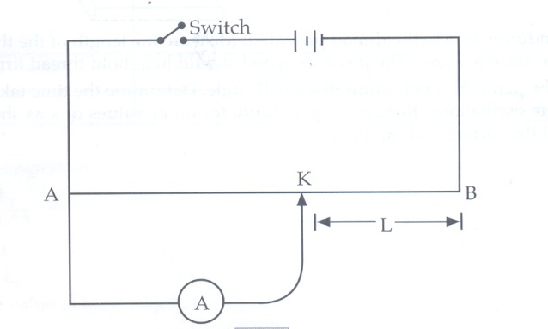
- Set the length of the resistance wire, L=0.1m and record the corresponding current, I. repeat the procedure for other values of length and complete the table below. (8 mks)

Length L (m) | 0.1 | 0.2 | 0.3 | 0.4 | 0.5 | 0.6 | 0.7 | 0.8 | 0.9
$\frac{1}{L}$ (m⁻¹)
Current I (A)

- (a) Plot the graph of $\frac{1}{L}$ (y axis) against I (5 mks)
(b) Calculate the gradient of the graph (3 mks)

(c) What will be the length of the resistance wire when a current I=0.54A. (1 mrk)
- You are provided with the following apparatus;
  - A glass block
  - A soft board
  - A plain paper
  - Four optical pins
  - Four thumb pins
  - A protractor
  - A ruler
- Fix the plain paper on the soft board using the thumb pins
- Place the glass block on the paper fixed in (a) above
- Trace the outline of the glass block using a pencil
- Remove the glass block.

Mark point X, 2 cm from the edge on one of the longer sides of the traced glass block as shown below

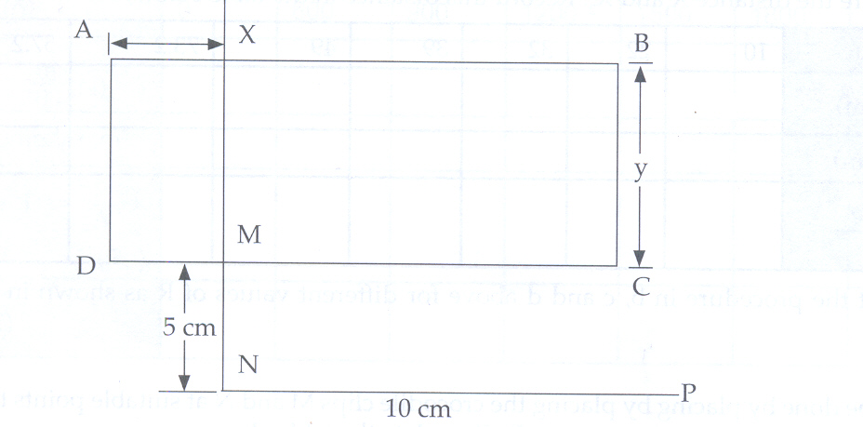
- Construct a normal at x, to emerge through line DC, let this normal meet line DC at M
- Mark point N along the emergent normal, 5cm from M
- Construct line NP to meet the normal at N at 90⁰. Line NP can be about 10cm.
- Construct an incident ray RX at an angle of incidence i=10⁰ and fix two pins P₁ and P₂ along it.
- Replace the glass block to the traced figure
- View the path of the incident ray RX through the glass block using the other two pins P₃ and P₄
- Remove the glass block and draw the emergent ray through P₃ and P₄

- Measure the distance of the emergent ray from point N along line NP as shown below
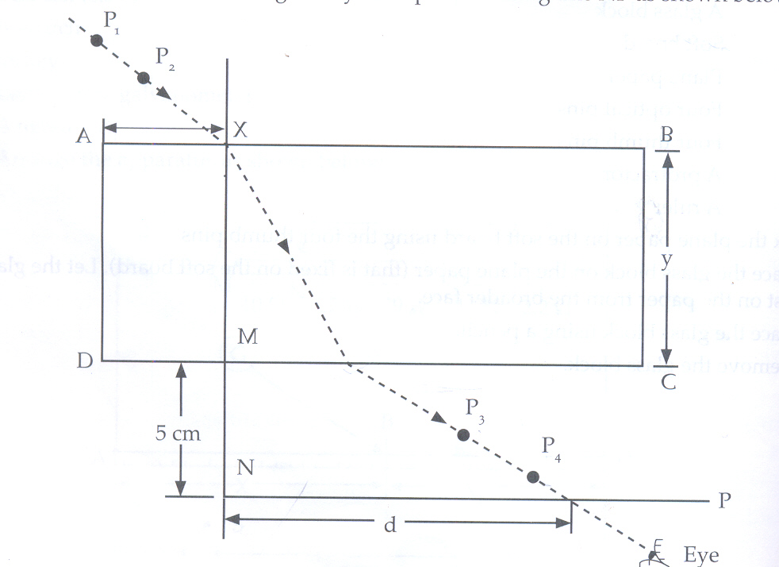

- Record the corresponding values of d in the table below
- Repeat the procedure for other values of i

Angle of incidence i⁰
Distance d (cm)
Sin i
Sin²i

()
- (i) Plot the graph of Sin²i (y axis) against d
(ii) Calculate the gradient of the graph

