FORM 3 PP1– 2015 (MARKING SCHEME)
SECTION A (25 MKS)
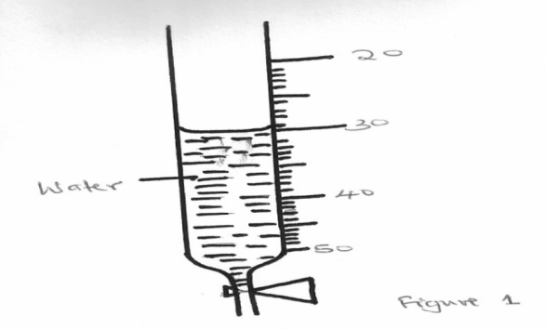
1. The figure below shows a section of a burette containing some water

20
30

40
Water
50

Determine the reading on burette if four (4) drops of water each of volume 0.5cm³ are added. (2mks)
Vol of 4 drops = 4x0.5
=2.0cm³√
New reading =30.0-2.0
=28.0cm3 √
2. A uniform wooden plank weighing 50N and 5m long is suspended by two ropes A and B, 1.5m apart. A is 2m from one end and B is 1.5m from the other end as shown in figure 2 below. A concrete block of weight 100N is suspended from the centre of the plank
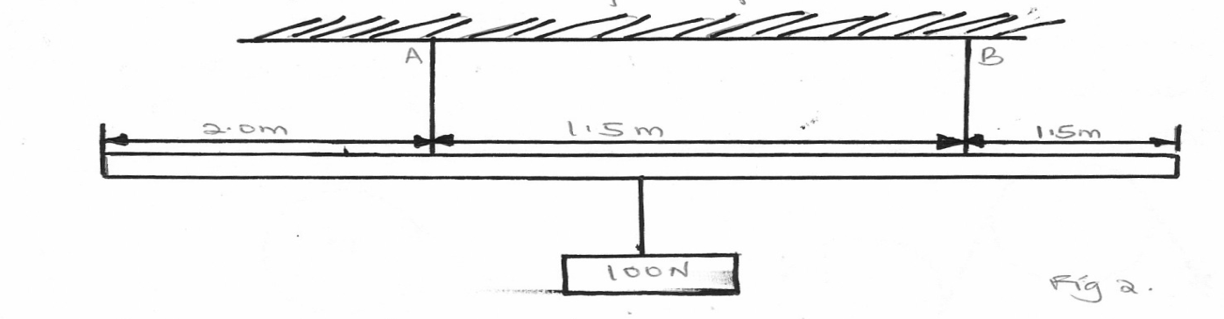Calculate the tension T_{A} in string A (3mks)

2.0m
1.5m
1.5m
100N
Taking moments about end A
T_{A}+T_{B}=150N…….(i)
=T_{B}=150-T_{A}
c.m=150x2.5
=375
ACM=T_{A}x2.0xT_{B}x3.5
2T_{A}+3.5(150-T_{A})=375√
2T_{A}+525-3.5T_{A}=375
1.5T_{A}=150
T_{A}=100N√

3. A steel sphere released in a tall transparent water jar attains a constant velocity after a while. The same sphere released in air falls at a constant acceleration. Explain with a reason the difference in its motion in water and in air (2mks)
Terminal velocity is attained after a given time depending on the coefficient of viscosity of the fluid√
Air has much smaller coefficient of viscosity compared to water √
4. The stability of a body can be increased by increasing the base area and lowering its centre of gravity. Give one way of lowering its centre of gravity. (1mk)
Concentrating most of the mass close to the base
5. A body of mass 25kg moving with uniform accelaration has an initial momentum of 60kgm/s and after 10s the momentum is 90kgm/s.calculate the acceleration of thebody Ma=
√
a= 0.15m/s²√
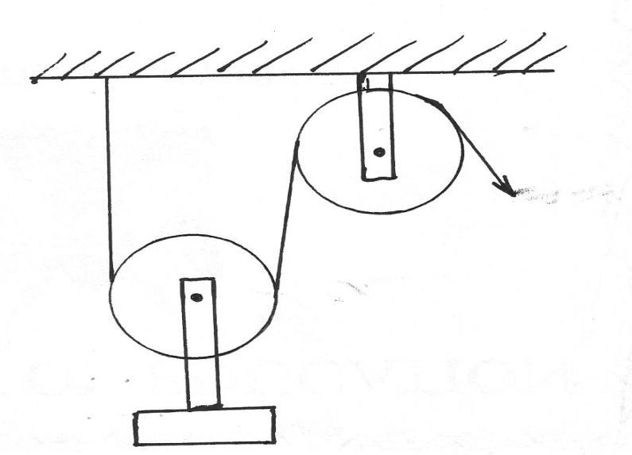
6. A load was raised using the system shown below. The system was then modified as in (b) and used to raise the same load
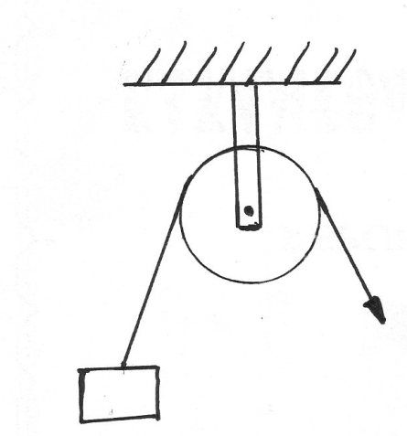
E
E
L
a
b
Figure 3

State and explain the change in efficiency (2mks)
(a) Eff = L/Ex100
(b) Eff= x100
Efficiency of (a) is half that of (b) due to doubled velocity ratio√
7. State two physical properties of a material medium which may be used to measure temperature (2mks)
Should have a wide range of temperature√
Should expand and contract uniformly over a wide range of temperature
Should be visible√ any 2
8. Give the reason why it is easier to separate water into drops than to separate a solid into small pieces (1mk)
There is a weaker intermolecular force in liquids than in solids
9. A drug manufacturer gives the mass of the active ingredient in a tablet as 5mg. express this quantity in Kilogram and in standard form (1mk)
5x 10⁻⁶kg
10. Some water in a tin can was boiled for some times, the tin was then sealed and cooled. After some time it collapsed. Explain this observation (2mks)
When the can is heated, air molecules are expelled from the can. When sealed the steam pressure from the can. When sealed , the steam pressure balances the atmospheric pressure on cooling , the steam condences, creating partial vacuum on the outside makes the can collapse
11. The figure below shows a micrometer screw gauge being used to measure the diameter of a metal rod. The thimble scale has 50 divisions. The reading on the gauge when the jaws were fully closed without the rod was 0.012cm
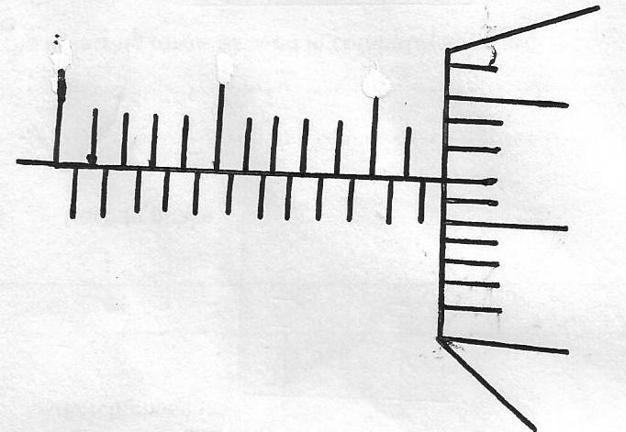
0
10
15
20
25

What is the actual diameter of the rod (2mks)
The reading = 11.72mm
Error 0.12mm
Actual diameter 11.60mm
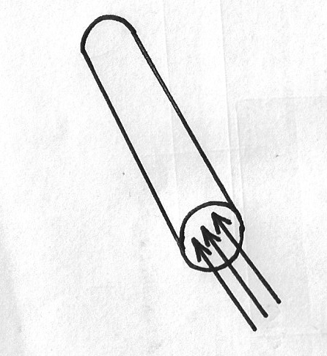
12. The figure shows a sheet of paper rolled into a tube

Paper tube

When a stream of air is blown into the tube as shown into the diagram, the paper tube collapses. Explain the observation (2mks)
Blowing into the tube reduces air pressure inside the tube, pressure from outside is greater than inside, hence pressure difference between the inside and outside causes it to collapse
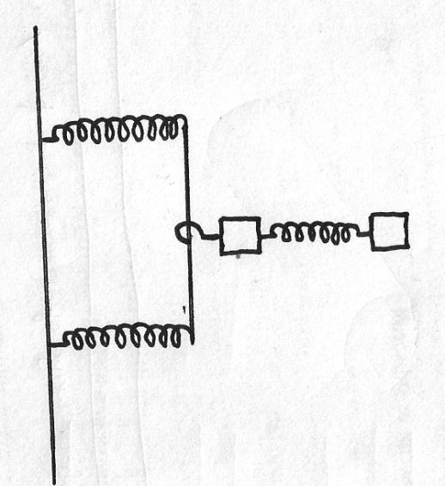
13. The three springs shown in the figure below are identical and have negligible weight. The extension produced on the system of the spring is 20cm

20N

20N

Determine the constant of each spring (2mks)
Parallel =F =2ke,
40=2ke,
e,=²⁰/_{k}
single =F=2ke₂
20= Ke₂
e2=20/k
e_{T} = e₁ +e₂
20= 20 + 20 = 40 = 2N/cm
K K K

SECTION B (55 MKS)
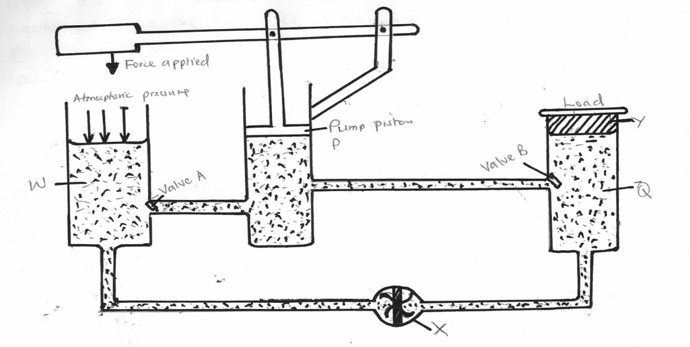
14. The figure below is a hydraulic jack system

Q
Y
Valve B
Pump piston P
Valve A
W
Atmospheric pressure
Forced applied

(a)Name the parts labeled W, X and Y (3mks)
W-Fluid reservours√
X-release value√
Y-Load piston√
(b) Briefly explain how the device may be used to raise a load at the position shown (3mks)
Effort applied downwards causes high liquid pressure below pump piston√. This keeps valve A closed while B opens so that liquid flows to force up the load piston hence raising the load√
(c) Part W is left open to the atmosphere as indicated. Explain (2mks)
So as during upstroke atmospheric pressure causes valve A to open to let fluid into P√
(d) State two ways by which the mechanical advantage of the device may be increased - Increasing the cross-sectional area of Q√
- Reducing the cross sectional area of P√
(e) One such hydraulic brake system was used to lift a car whose mass was 1200kg. The cross sectional area of Q was 5000cm² and that of P was 5cm². Determine the force exerted on the pump piston (3mks)
If force p is F1
Then P1= F1/A=F1÷ 5/ 100x100√
But this is the pressure transmitted to Q
∴P at Q=F2/A
F1=120N

15. (a) A tape attached to a moving trolley is run through a ticker timer. The figure shows a section of the tape after running
1.5cm
B
C
3.2cm
D
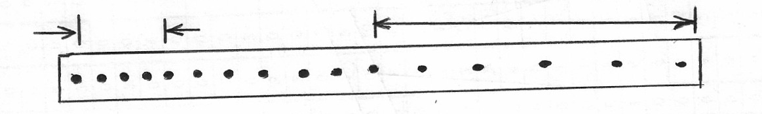

A
If the frequency of the ticker timer is 50Hz, calculate
(i) Average velocity at intervals AB and CD (2mks)
Time between two dots = 1/50=0.02
Velocity AB=
Velocity CD=
(ii) Average acceleration of the trolley (3mks)
Accelaration = V_{CD}-V_{AB} = 32-15
t 0.5
=34cm/s²
(b) A stone is released from a height h, of the acceleration due to gravity is g, derive an expression of the velocity of the stone just before hitting the ground (2mks)

(c) The figure shows, velocity time graph of an object in motion
Velocity
Displacement
Time
Time

(i) (ii)
Sketch on the axes provided in c, the displacement time graph of the motion. (Motion upwards is taken as positive) (1mk)

16. (a) Define the term velocity ratio of a machine (1mk)
It’s the ratio of distance moved by effort to the distance moved by load
(b) The figure below shows part of hydraulic press. The plunger is the position where the effort is applied while the Ram piston is the position where load is applied. The plunger has cross section area am² while the Ram piston has cross section area Am²
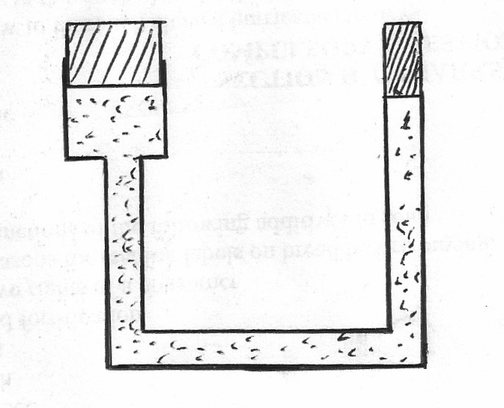
Plunger of cross sectional area=a
Ram piston cross sectional area =A

Oil

When the plunger moves down a distance d, the Ram piston moves up distance D
(i) State the property of liquid pressure on which the working of the hydraulic press operates(1mk)
Pressure in liquid is transmitted equally to all the parts of an enclosed liquid
(ii) Derive an expression for the velocity ratio (V.R) in terms of A and a (3mks)
Volume of liquid by plunger = volume of liquid moved by RAM
Axd AxD
But V.R= distance moved by plunger = D
Distance moved by Ram d
= D = A
D a
∴V.R = A
a
(c) A machine of velocity ratio 45, overcomes a load of 4.5x 103N when an effort of 135N is applied. Determine
(i) The mechanical advantage of the machine (2mks)
M.A = Load = 4.5x10³=33 ¹/₃
Effort 135
(ii) Efficiency of the machine (2mks)
Efficiency = MA x 100% = 33.33 x 100=74%
VR 45
(iii) The percentage of the work that goes to waste (1mk)
% work wasted = 100%-74%
= 26%

- (a) State the law of inertia (1mk)
a body remains at rest if moving or if moving continue to move in a straight line unless acted upon by an external force ;
- A ball of mass 50kg is thrown from the top of a cliff 20m high with a horizontal velocity of 20m/s. On reaching the ground it completely covered arm X of a hydraulic lift such that no water splashed out. The other arm Y has a weight of 25200N. Assuming the tap was opened when the ball struck the surface of water.

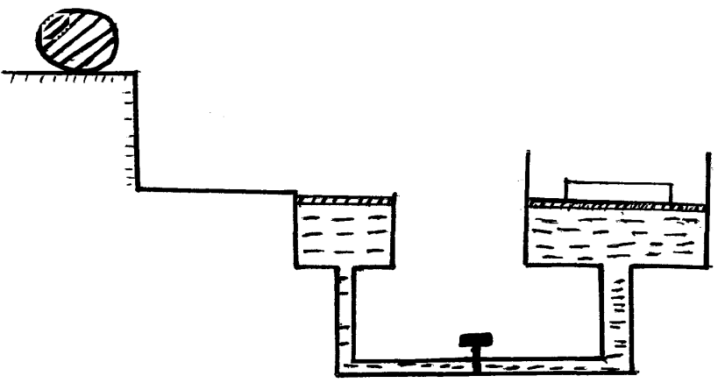
X
Ball

A = 50cm²

Determine

- The time taken by the ball to strike the surface of water at arm X (3mks)
horizontal = 20 mls but vertical = 0mls
Ѕ= ⅟2 gt²
20 = ½ x 10 x t²
t² = 4
t = 2 see;
- The distance from the foot of the cliff to where the ball strikes the surface of water. (2mks)
R = ut
= 20 82;
= 40m;
- The vertical with which it struck the surface of water at arm X (2mks)
v = u + gt;
= 0+10-x2
= 20mls
- The force with which the ball struck the surface of water (2mks)
F = ma
= 50 x10 ;
= 500N
- The distance moved by the 25200N load arm Y if the level of water in arm X and arm Y was initially the same. (2mks)

P = f₁/A₁ = F₂/A₂
500/50 = 25200/2520 at equilibrium
The ratio is 10:10
The same = no change in position
- a) Define pressure and state its S.I Units. (2 marks)
Pressure is the force acting normally/perpendicular per unit area. The SI unit is Pascal.
b) State Pascal’s principal. (1 mark)
Pressure applied at one part in an incompassible fluid is transmitted equally to all other parts of the enclosed fluid.
c) In construction of a mercury barometer care is taken to make sure it has no gas in the space above mercury.
i) How would you test whether there is gas above? (1 mark)
The tube is tilted gradually below atmospheric pressure and if there is air in the tube, the mercury will not fill the tube completely.
- State the problem caused by the presence of gas in the barometer. (1 mark)
The value of pressure indicated by a barometer with gas inside is less than the actual value
d) Find the total pressure experienced by a diver 8 meters below the sea surface.
Take; Atmospheric pressure = 103 360N/m². Density of sea water 1030kg/m³(3 marks)
Total pressure = P_{w} + P_{a}
= 1030kg/m³ x 8m x 10N/kg + 103360N/m²
= 82400 + 103360
= 185760N/m²
e) i)The air pressure at the base of a mountain is 75.0cm of mercury while at the top it is 60.0cm of mercury. Given that the average density of air is 1.25kgm⁻³ and the density of mercury is 13600 km⁻³, calculate the height of the mountain. (3 marks)
h_{a}p_{a}g = h_{m}p_{m}g
h_{a} = 75 x 60 X 13600x10
100 10 1.25x10
0.15 x 13500x10
1.25 x 10

= 1632m
ii) State factors that affect pressure due to liquid column. (2 marks)
- Height h of the column
- The density of the liquid

