PHYSICS REVISION QUESTIONS.
- State the purpose of the grid in the cathode ray oscilloscope. (1mk)

- Explain why CRO is a more accurate voltmeter than a moving coil voltmeter. (1mk)

- The figure below shows a circuit of a modern X-ray tube

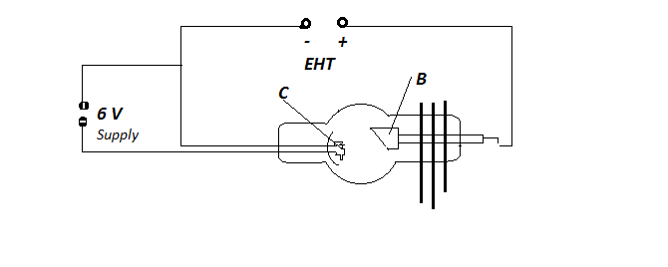i. Indicate the path of the X-ray beam supplied by the tube. (1mk)

- Name the part labeled C and state its function. (1mk)

- Name a suitable metal that can be used for the path labeled B and give a reason for choice.(2mks)

- How can the intensity of X-rays of the tube be increased? (1mk)

- An X-ray tube operates at i30kV through it is 2 mA, calculate the electric power dissipated. (3mks)

- A transformer is connected to a d.c source. The secondary to a centre zero galvanometer. State and explain the observations made on the galvanometer. (2mks)

- State three ways in which energy is lost in a transformer and how it can be minimized in each case. (3mks)

- The figure below shows a transformer with 960 turns in the primary coil and N turns in the secondary coil connected to a 240 V supply. Given that the transformer is 100% efficient and it will operate a 6 V 24 W bulb, find;
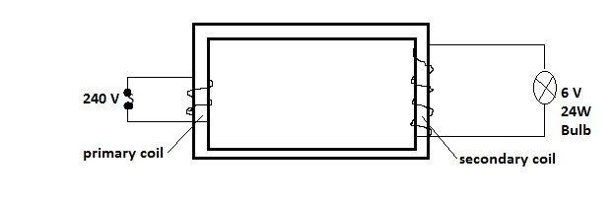
- The number of turns in the secondary coil. (3mks)

- The current flowing in the primary coil. (3mks)

- The figure below shows a Cathode ray oscilloscope.
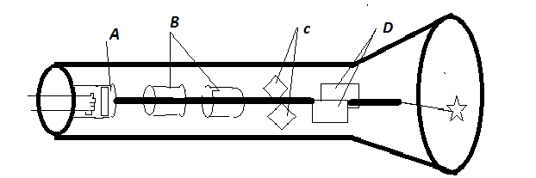
- Name the part labeled A and B. (2mks)

- What are the functions of the part labeled C and D? (2mks)

- Explain how electrons are produced. (2mks)
- Give a reason why the tube is evacuated. (1mk)
- a. Define radio activity. (1mk)

b. Radon gas has has a nuclide ²²²Ra decays to Polonium by emission of α
⁸⁶
particles. Show by use of an equation the transformation of the gas. (2mks)
- (a) define specific heat capacity. (2mks)

(b) A block of metal is heated from 30⁰c to 50⁰c by an electric heater rated54 W. The process takes 8 minutes and 20 seconds. Calculate the heat capacity of the metal. (3mks)

(c) Define latent heat of vaporization. (1mks)

(d) Explain why it is dangerous to be burned by steam than boiling water. (2mks)

**PRACTICE MAKES IT PERFECT**
MR. KARANJA BEN.

